Presentation of Pressure Stimuli

In this test you will manually stimulate the subject with rectangular pressure stimuli. The purpose is twofold; one to familiarize the subject with the stimuli and teach them how to rate them with the VAS scale, secondly to find the starting intensity.
To do this you will gradually increase the intensity, for each intensity stimulate, and then ask them to rate the stimulus with the VAS scale. This is done with the test user interface shown below:
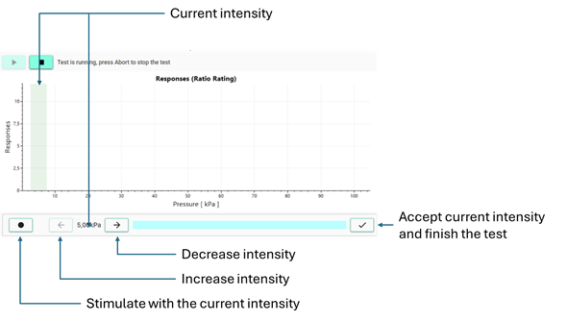
Once they feel comfortable to perform the rating and you found an intensity that they rate as VAS 5-6, click the 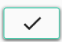 button to finish the test.

