Cogni Pain II

Laura Petrini

Summary of the protocol

Contents

Introduction 2

Experimental Setup 2

Protocol 2

Analysis 2

Discussion 2

# Introduction

# Experimental Setup

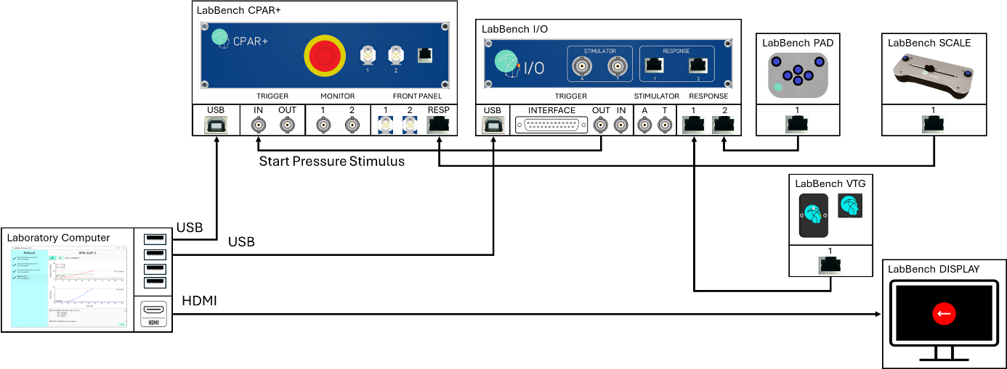

Figure : Illustration of the experimental setup, which consists of a LabBench I/O, LabBench CPAR+, LabBench PAD, LabBench SCALE, LabBench VTG, and LabBench DISPLAY as well as a laboratory computer that run LabBench.

# Protocol

# Analysis

# Discussion