COVAS Training

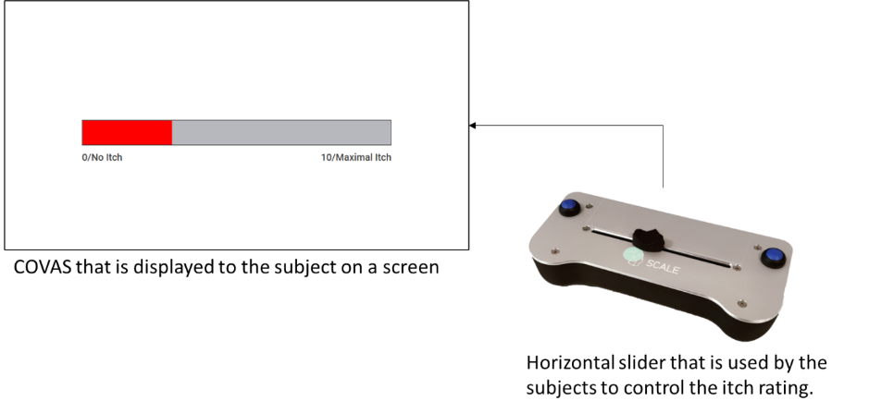

Instruct the subject according to the COVAS script.

