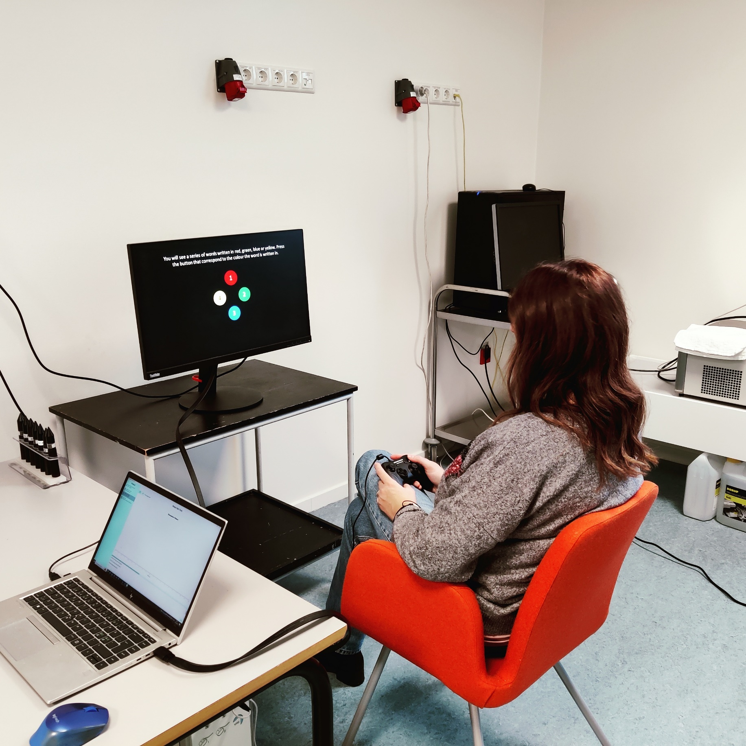
Short description of the protocol

Stroop TAsk
Laura Petrini


Introduction

Experimental Setup

Protocol

Using the protocol
The protocol can be installed from the (labbench.io) repository, which is available by default when LabBench is installed.

Required devices

Installing the protocol

Results

Discussion

