HOW TO PERFORM THE MEASUREMENT
For the alloknesis measurement start from the center of the are of interest (AOI). You will perform 3 measurements, each consisting of three brush strokes. Starting about 1.5 cm outside the area, gently stroke the skin in the same direction 3 times in short succession (approximately 1 s in between) for a length of approximately 3 cm. Remember always to perform the strokes holding the brush perpendicular to the skin surface and with a speed of 3-6 cm/sec (See figure 1A). During the stimulation, please ask the subject to close their eyes or look away and to only focus on their sensation. After the 3 stimulations, you should ask the subject to rate the itch sensation on the chosen scale. Remember to always check with the subject if their rating corresponds to the felt sensation. Repeat the sequence two more times, each time moving the brush in a different direction (See Figure 1B).
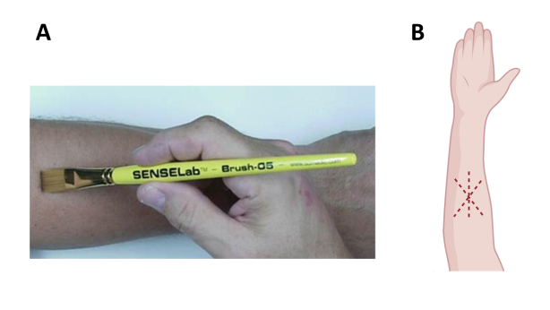
HOW TO INSTRUCT THE SUBJECT
The Stimulation will be performed using this brush (show the brush to the subject). During the stimulation, I will stroke your skin 3 times. While I perform this procedure, I will ask you to look away or alternatively close your eyes so that you can only focus on your perception. After the 3 strokes, you should rate the mean intensity of the itch sensation you perceived on a scale ranging from 0 to 10, where 0 means “no itch” and 10 means “worst imaginable itch”. You will use the side slider on the scale to choose the rating number that corresponds to your feeling, as show in the picture (the picture below will appear on the screen in front of the subject).
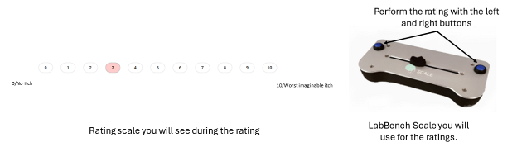
The all procedure will be repeat two more times, and after each stimulation, I will ask you to rate the itch intensity on the scale. It is important you understand that there is not right or wrong answers, but I ask you to be focused during the entire procedure and to be as honest as possible about what you will feel during each stimulation.

