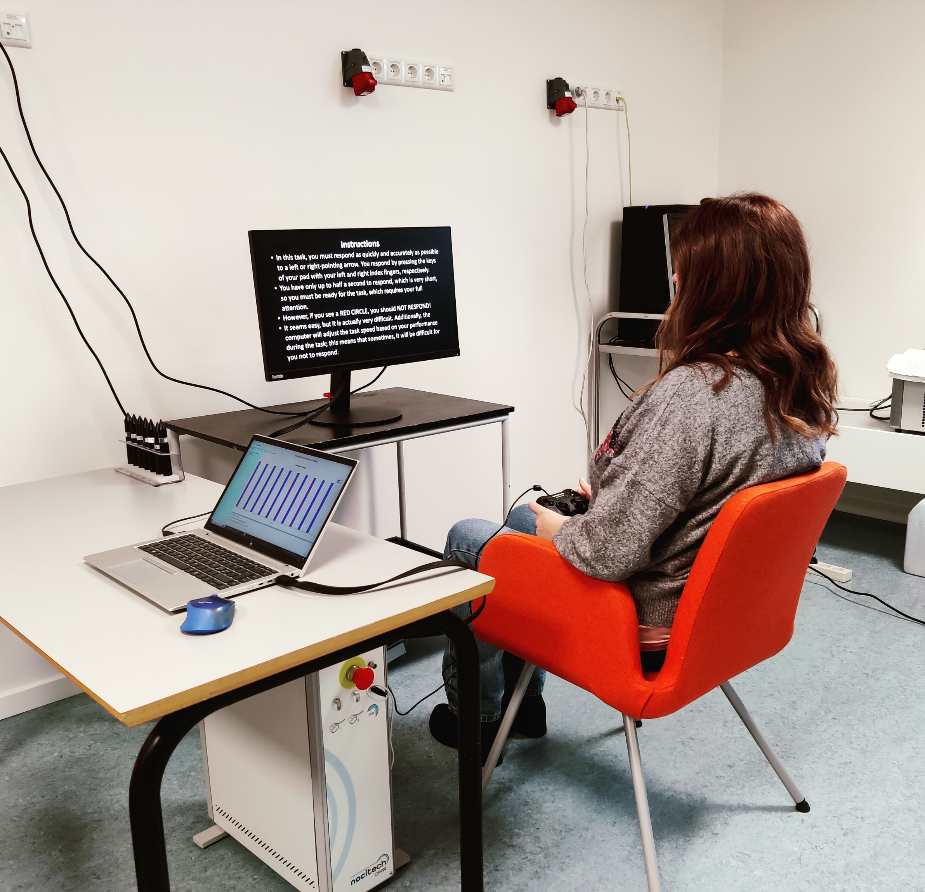

Introductions
AUTHOR

Summary of the protocol


Contents
Introduction 2
Experimental Setup 2
Protocol 2
Analysis 2
Discussion 2

Introduction

Experimental Setup

Protocol

Analysis

Discussion

