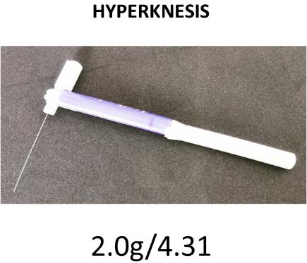
Mechanically evoked itch is measured by using mildly pruritic, non-painful von Frey nylon filaments. These stimulators are moved in intervals of 0.5 cm outside the area of the itch provocation. Perform three stimulations (a single stimulation is composed of three pricks in short succession, approximately 1 s in between) with the filament. Subjects will rate the itch intensity elicited by each stimulation (nine in total) on a numerical rating scale (NRS) from 0 to 10 (0 = “no itch”; 10 = “worst imaginable itch”).

