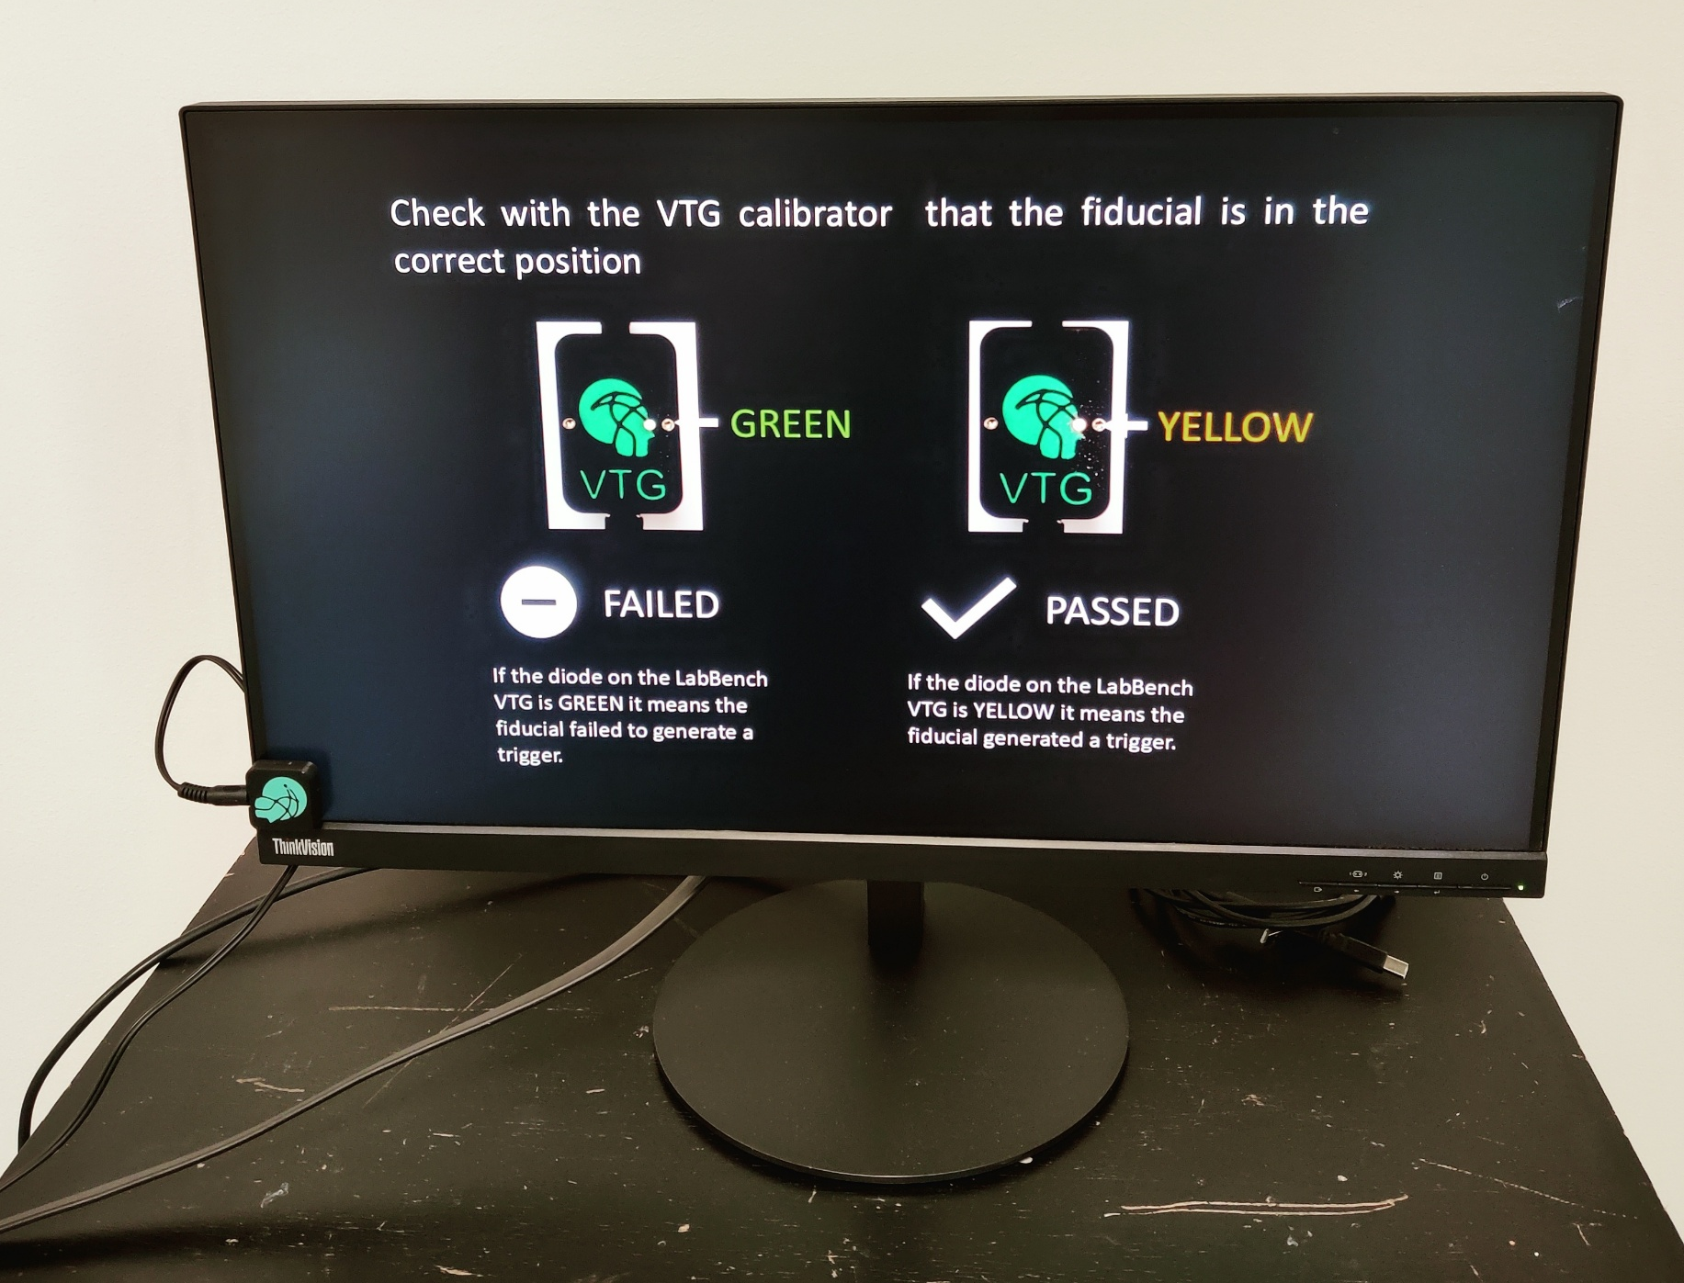
Screen and Fiducial Calibration Protocol

Protocol for calibrating a secondary screen that can be used to display visual stimuli to participants. These visual stimuli can be generated with a physical size or visual angle for the participants, and with fiducials for precise temporal synchronization with sensory stimuli. For these to be generated, the screen size must be correctly calibrated; this protocol provides the calibration.



Introduction
LabBench allows the use of a secondary screen to display items, such as visual stimuli, to participants. These visual stimuli can be generated with a physical size or a visual angle. However, the operating system does not provide reliable information about the screen's physical size; consequently, for the physical sizes or visual angles to be generated correctly, the screen must be calibrated.
To generate physical sizes, LabBench must know the screen's diagonal size. The operating system provides information about the screen height and width in pixels, which together determine the aspect ratio; the vertical and horizontal sizes can be calculated automatically from the screen's diagonal size. To generate correct visual angles, the distance from the subjects’ eyes to the screen must also be calibrated.
This calibration is also used to generate fiducials that are used to synchronize visual stimuli with other sensory stimuli, such as pressure, thermal, or electrical stimuli. These fiducials are small visual dots that are embedded into the visual stimulus in one of the corners of the screen, which can then be detected with a photosensor (LabBench VTG) to generate a trigger that can start other sensory stimuli and can be used as a trigger input to recordings of biophysical signals such as EEG.
The present protocol guides an operator through performing this calibration and checking that fiducials are detected correctly by the photosensor (LabBench VTG).

Experimental Setup
The experimental setup consists of the following equipment:
- LabBench I/O
- LabBench VTG
- A secondary screen
- Measurement tape
The experimental setup is shown in Figure 1; it consists of a LabBench I/O device connected via USB to the lab computer running LabBench, to which the secondary screen is attached. The LabBench VTG is connected to response port 1 on the LabBench I/O. However, its photosensor is not initially mounted on the secondary screen.
The subject’s chair should face the secondary screen and be placed in a fixed position marked on the floor with permanent markers.
On the lab computer, create the folder C:\CalibrationData. The protocol will use this folder to save the calibration record.

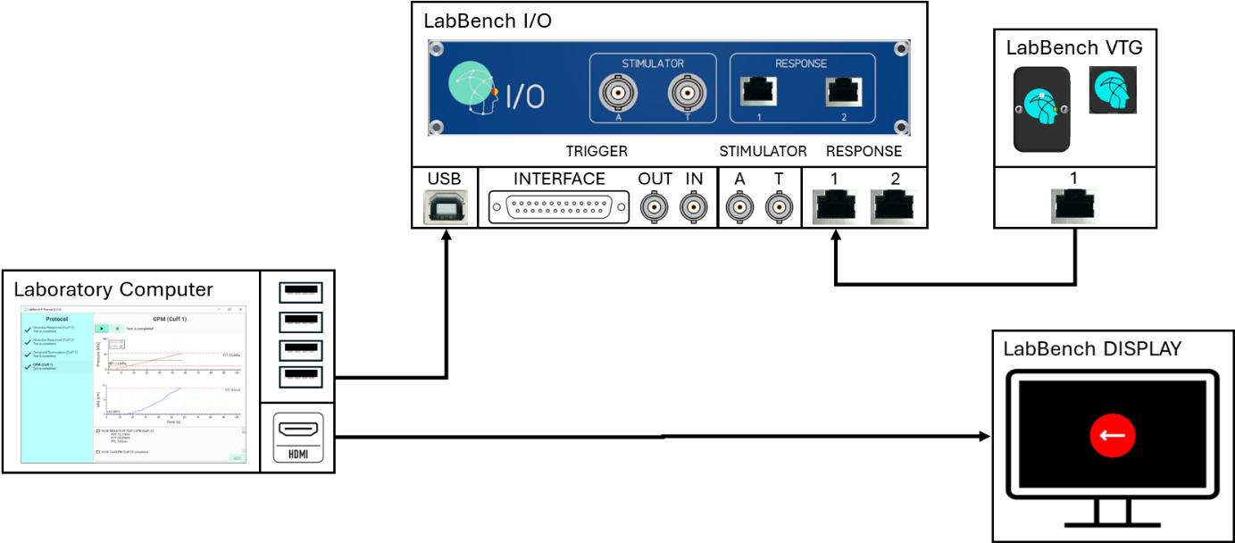
Figure 1: Illustration of the experimental setup that consists of a LabBench I/O, LabBench VTG and the secondary screen that is to be calibrated.
For the secondary display to be usable by LabBench in Settings > System > Display, the displays must be configured as “Extend these displays,” and LabBench Runner must be displayed on the main display. To enable this, click Identify, then set the screen the operator should be using as “Make this my main display”.
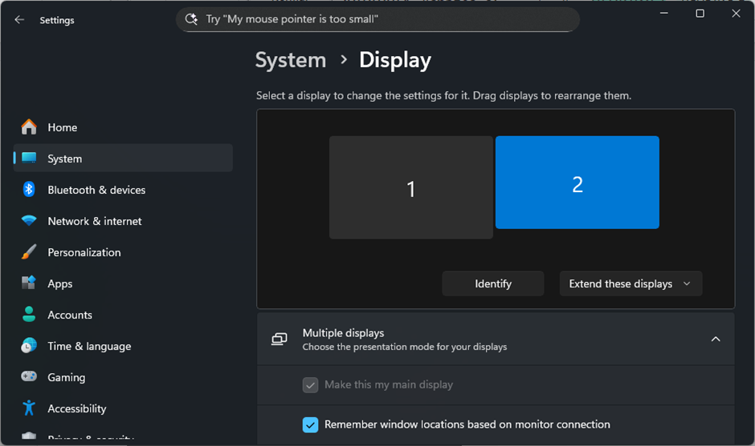
Figure 2: Windows display configuration for the secondary display to be usable by LabBench.

Protocol
The protocol consists of the following tests:
# | Test | Procedure
1 | Screen Size | The diagonal size of the screen is measured and entered into a questionnaire.  Note: LabBench uses this measure, together with the screen's aspect ratio, which is automatically derived from its vertical and horizontal resolutions, to convert physical lengths into pixels.
2 | Screen Position | The distance from the screen to the eyes of the participant is measured and entered into a questionnaire.  Note: LabBench uses this measure to normalize physical lengths so they occupy the same visual angle as they would at a given normative distance.
3 | Fiducial Position | The x and y offsets required for displaying the fiducial is measured and entered into a questionnaire.  Note: The LabBench VTG photosensor is positioned with an offset of 17mm in both the horizontal (x) and vertical (y) direction. However, because of the bezel on the screen, these offsets may need to be reduced to position the fiducial directly under the photosensor.
4 | Update Calibration | At this time in the protocol, close the LabBench Runner and open the pdf file in C:\CalibrationData that contains the calibration data recorded in Tests 1 to 3.  Open the LabBench Designer, navigate to System => Display Calibration, and enter the values from the calibration record.  Close the LabBench Designer and restart the session with the LabBench Runner. Run the test to confirm you have calibrated the screen.
5 | Verify Physical Size | This test will display a 10 x 10 cm square on the screen. Measure the square with a ruler to verify that the screen size is calibrated correctly.
6 | Verify Visual Angle | This test will verify that a normalized 10cm visual analog scale can be displayed on the screen.
7 | Verify Fiducial | This test will verify that the fiducial positions are correctly calibrated so the LabBench VTG's photosensor can detect them.
8 | Trigger Detection Test | This test will verify that a sequence of visual stimuli with embedded fiducials is reliably detected.
Throughout the protocol the operator is guided by instructions displayed on in test window and on the secondary screen.

Discussion
The screen calibration will be used for all studies on the laboratory computer. Consequently, as long as the secondary screen is not changed, the calibration data in LabBench Designer does not need to be updated. However, if multiple types of secondary screens are used with the same laboratory computer, the calibration data must be updated before each type of screen is used.

