**Mechanical**

alloknesis

Silvia Lo Vecchio

Summary of the protocol

This protocol describes the concept of alloknesis, a brief overview of the mechanism behind it and the assessment technique applied to quantify it.

Contents

Introduction 2

Experimental Setup 3

Protocol 3

Analysis 3

Discussion 3

REferences 3

# Introduction

The term alloknesis, first coined by LaMotte et al. in 19881–4, represents one of the mechanical itch dysesthesias, that describe dysfunctional sensory states, in which itch is evoked by light tactile stimuli (e.g. from clothing or touch), or by stimuli which normally would only induce mild itching 1,5–8. Alloknesis (“allo”, and “knesis”, an ancient Greek word for itching) is described as a pruriceptive sensation or a scratching behavior evoked by a stimulus that is normally non itchy, such as light stroking of the skin with a cotton swab or a brush (Fig. 1) 1,9. This concept reflects a similar dysfunctional state evoked by pain and termed allodynia, in which pain is cause by a stimulus that normally does not provoke pain 10,11. Often, alloknesis represents a symptom in acute itch, chronic itch conditions such as neuropathic itch and atopic dermatitis but could also be induced experimentally in healthy volunteers 1,10,11. The primary cause of alloknesis is the sensitization of itch signaling pathways inducing amplified response to pruritogens and increased reactivity to other types of stimuli1,11–13. Moreover, also the dysregulation of the inhibitory systems in the spinal cord seems to contribute to alloknesis11. In humans, the intensity of alloknesis is often assessed by using brush strokes 1,14, as illustrated below under the section “protocol”.

Fig. 1: Graphical representation of the alloknesis phenomenon. The curve represents the stimulus-response curve, that is the association between the intensity of the applied stimulus (x-axis) and the itch response (Y-axis) under normal condi­tions and when dysesthesias are present. Created with BioRender.com and adapted from Andersen et al. 1with inspiration from Sandkühler J 13.

# Experimental Setup

Somedic SENSELab Brush no. 5 is used to determinate the intensity of alloknesis.

LabBench System

The NRS values are collected by LabBench program.

Computer-assisted Visual Analog Scale (COVAS)

# Protocol

Alloknesis will be measured using a standardized sensory brush (SENSELab Brush-05, Somedic AB, Hörby, Sweden) exerting a force of in the range of 200 +/- 100 mN. The investigator should perform 3 stimulations, in different directions, along the diagonals of the area of interest (AOI). Each stimulation consists of a set of 3 brush strokes (2-3 cm in length) in short succession (approximately 1 s in between) over the treated/control areas. The strokes are applied by keeping the brush perpendicular to the skin with a speed of 3-6 cm/sec. After each set of 3 brush strokes, the participant rates the sensation induced by the brush on a NRS scale from 0 to 10 (0 = “no itch”; 10 = “worst imaginable itch”). Alternatively, the COVAS system can be used for ratings.

## Instruction to subjects

### Numerical Rating Scale

The Stimulation will be performed using this brush. During the stimulation, I will stroke your skin 3 times as showed in figure.

While I perform this procedure, I will ask you to look away or alternatively close your eyes so that you can only focus on your perception. After the 3 strokes, you should rate the mean intensity of the itch sensation you perceived on a numerical scale ranging from 0 to 10, where 0 means “no itch” and 10 means “worst imaginable itch”. You will use the side buttons on the scale showed in figure to choose the rating number that correspond to your feeling.

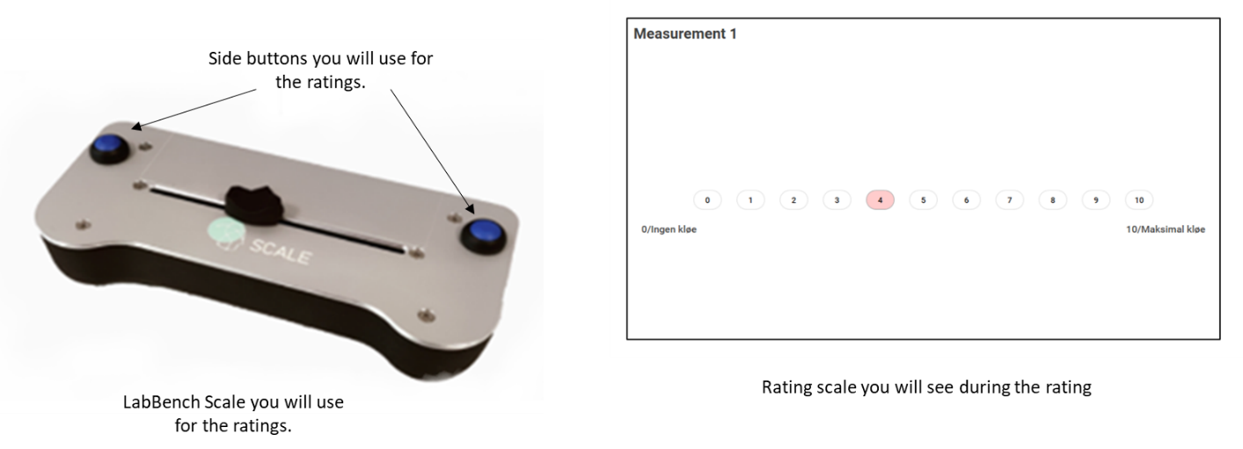

The all procedure will be repeat two more times, and after each stimulation, I will ask you to rate the itch intensity on the scale. It is important you understand that there is not right or wrong answers, but I ask you to be focused during the entire procedure and to be as honest as possible about what you will feel during each stimulation.

### COVAS Scale

The Stimulation will be performed using this brush. During the stimulation, I will stroke your skin 3 times as showed in figure.

While I perform this procedure, I will ask you to look away or alternatively close your eyes so that you can only focus on your perception. After the 3 strokes, you should rate the mean intensity of the itch sensation you perceived on a visual scale ranging from 0 to 10, where 0 means “no itch” and 10 means “worst imaginable itch”. You will move the horizontal scroll bar until you reach the point on the scale that corresponds to your feeling.

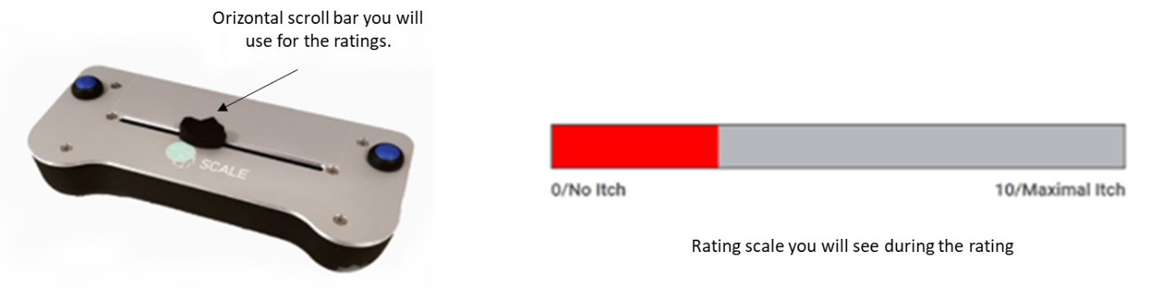

The all procedure will be repeat two more times, and after each stimulation, I will ask you to rate the itch intensity on the scale. It is important you understand that there is not right or wrong answers, but I ask you to be focused during the entire procedure and to be as honest as possible about what you will feel during each stimulation.

## INSTRUCTION to experimenter

For the alloknesis measurement start from the center of the are of interest (AOI). You will perform 3 measurements, each consisting of the brush strokes. Starting about 1.5 cm outside the area, gently stroke the skin in the same direction 3 times in short succession (approximately 1 s in between) for a length of approximately 3 cm. Remember always to perform the strokes holding the brush perpendicular to the skin surface and with a speed of 3-6 cm/sec. During the stimulation, please ask the subject to close their eyes or look away and to only focus on their sensation. After the 3 stimulations, you should ask the subject to rate the itch sensation on the chosen scale. Remember to always check with the subject if their rating corresponds to the felt sensation. Repeat the sequence two more times, each time moving the brush in a different direction.

# Analysis

To perform statistical analysis, a total average will be calculated. Data output documented in source as NRS value between 0 (no itch) and 10 (maximal itch). An integer value or a decimal value (one digit) can be selected and stored.

# Discussion

# REferences

1 Andersen HH, Akiyama T, Nattkemper LA, *et al.* Alloknesis and hyperknesis—mechanisms, assessment methodology, and clinical implications of itch sensitization. *Pain* 2018; **159**:1185–97.

2 Bickford RGL. Experiments relating to the itch sensation, it’s peripheral mechanism, and central pathays. *Clin Sci* 1938; **3**:377–86.

3 LaMotte RH. Subpopulations of “nocifensor neurons” contributing to pain and allodynia, itch and alloknesis. *APS Journal* 1992; **1**:115–26.

4 LaMotte RH. Psychophysical and neurophysiological studies of chemically induced cutaneous pain and itch: the case of the missing nociceptor. In: *Progress in brain research*. , Elsevier, 1988; 331–5.

5 Andersen HH, Elberling J, Sølvsten H, *et al.* Nonhistaminergic and mechanical itch sensitization in atopic dermatitis. *Pain* 2017; **158**:1780–91.

6 G. Atanassoff P, Brull SJ, Zhang J, *et al.* Enhancement of experimental pruritus and mechanically evoked dysesthesiae with local anesthesia. *Somatosens Mot Res* 1999; **16**:291–8.

7 Ikoma A, Fartasch M, Heyer G, *et al.* Painful stimuli evoke itch in patients with chronic pruritus: central sensitization for itch. *AAN Enterprises*URL https://n.neurology.org/content/62/2/212.short [accessed on 22 November 2021].

8 Schmelz M. Itch and pain differences and commonalities. In: *Pain Control*. , Springer, 2015; 285–301.

9 LaMotte RH. Allodynia and Alloknesis. In: *Encyclopedia of Pain*. Berlin, Heidelberg, Springer Berlin Heidelberg; 52–5.

10 Jensen TS, Finnerup NB. Allodynia and hyperalgesia in neuropathic pain: clinical manifestations and mechanisms. *Lancet Neurol* 2014; **13**:924–35.

11 Tsagareli Merab. Hyperalgesia and Allodynia: A Closer Look. Symptoms, Mechanisms and Treatment. , Nova Science Publishers, 2019.

12 LaMotte RH, Dong X, Ringkamp M. Sensory neurons and circuits mediating itch. *Nat Rev Neurosci* 2014; **15**:19–31.

13 Sandkuhler J. Models and mechanisms of hyperalgesia and allodynia. *Physiol Rev* 2009; **89**:707–58.

14 Weisshaar E, Dunker N, Gollnick H. Topical capsaicin therapy in humans with hemodialysis-related pruritus. *Neurosci Lett* 2003; **345**:192–4.