Visual Evoked Potentials

Kristian Hennings and Sabata Gervasio

Summary of the protocol

Contents

Introduction 2

Experimental Setup 2

Protocol 2

Analysis 2

Discussion 2

# Introduction

# Experimental Setup

# Protocol

## Visual Evoked Potentials

Visual evoked potentials are elicited with a checkerboard pattern displayed on a monitor. This checkerboard pattern consists black and white checks (squares) with a phase that will be alternate between black and white (see Figure 1).

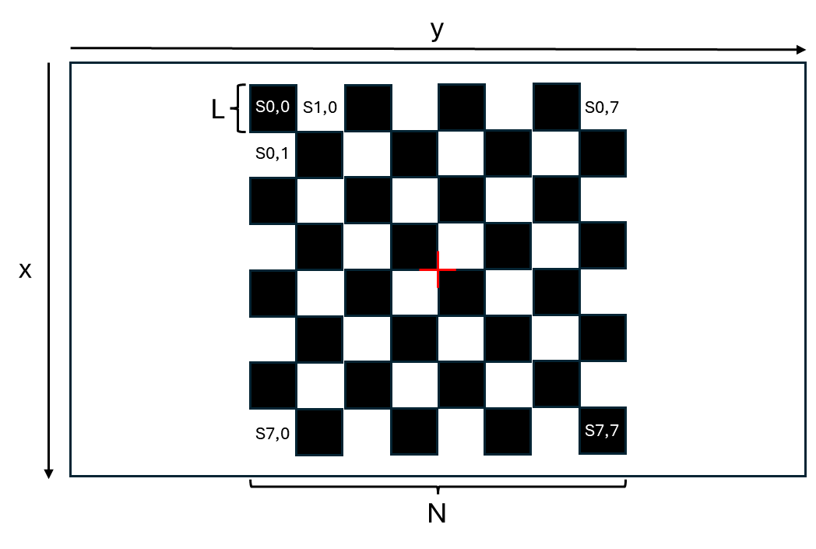

Figure : Checkerboard pattern used for eliciting visual evoked potentials.

The size of the screen is given as its width (Ws) and height (Hs). Coordinates on the screen (x,y) are from the upper left corner.

The size of the checks is measured by its visual angle (A), which is used to calculate its physical size in pixels (L). Each square is identified by its position (n, m) in the checkerboard pattern, which are used to calculate its x and y coordinates on the screen:

# Analysis

# Discussion