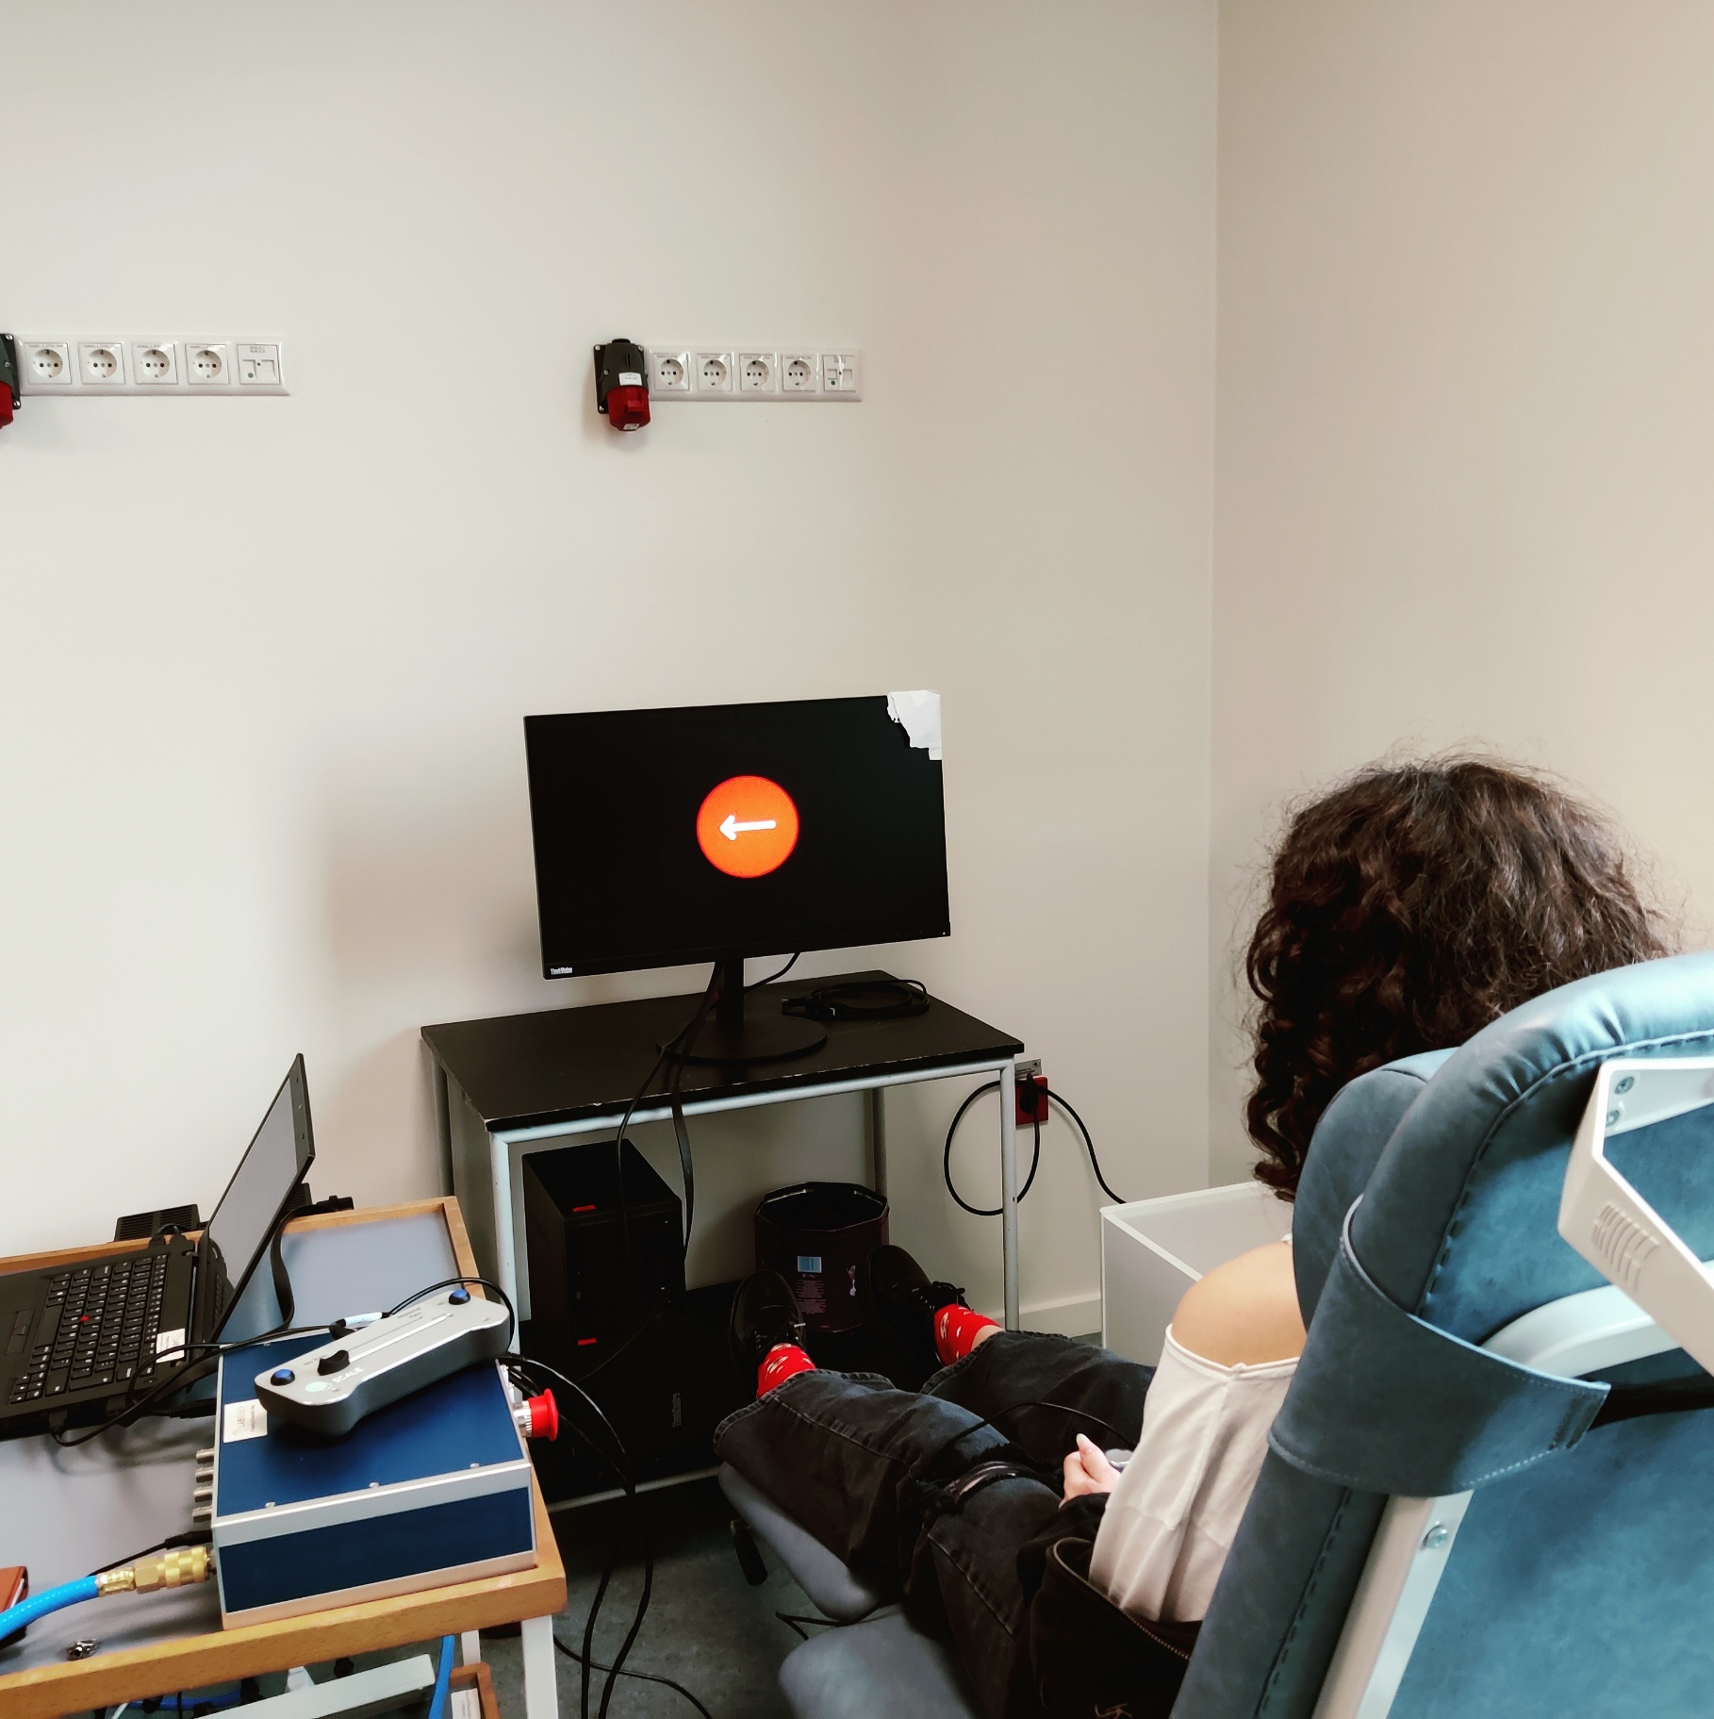

This protocol is a study of the correlation between depression, anxiety, and stress, and response inhibition as measured with the Stop-Signal Task. It is written to demonstrate the capabilities of LabBench to automate experimental protocols, providing guidance to operators and subjects, and for automatic processing and export of experimental data.

Introduction to LabBench

**Kristian Hennings**

# Introduction

# Experimental Setup

# Protocol

# Using the protocol

The protocol can be installed from the (labbench.io) repository, which is available by default when LabBench is installed.

## Required devices

Before the protocol can be installed a LabBench I/O device must first be added to the LabBench installation (see Figure X). First start the LabBench Designer, to check that a LabBench I/O device is present or to add such a device if it is not, and then: 1) Select the Protocols Page, 2) Select the LabBench I/O device, 3) check that a LabBench I/O device is installed and available.

If a LabBench I/O device is not installed, then install one by first ensuring that the device is connected to the computer and then clicking on the (+) add device button.

Figure 4: Illustration of how to check if a LabBench I/O has been added to the LabBench system.

## Installing the protocol

To install the protocol; 1) Select the Protocols page, 2) Select the labbench.io repository, 3) Select the Alloknesis protocol, and 4) click the (+) add protocol button.

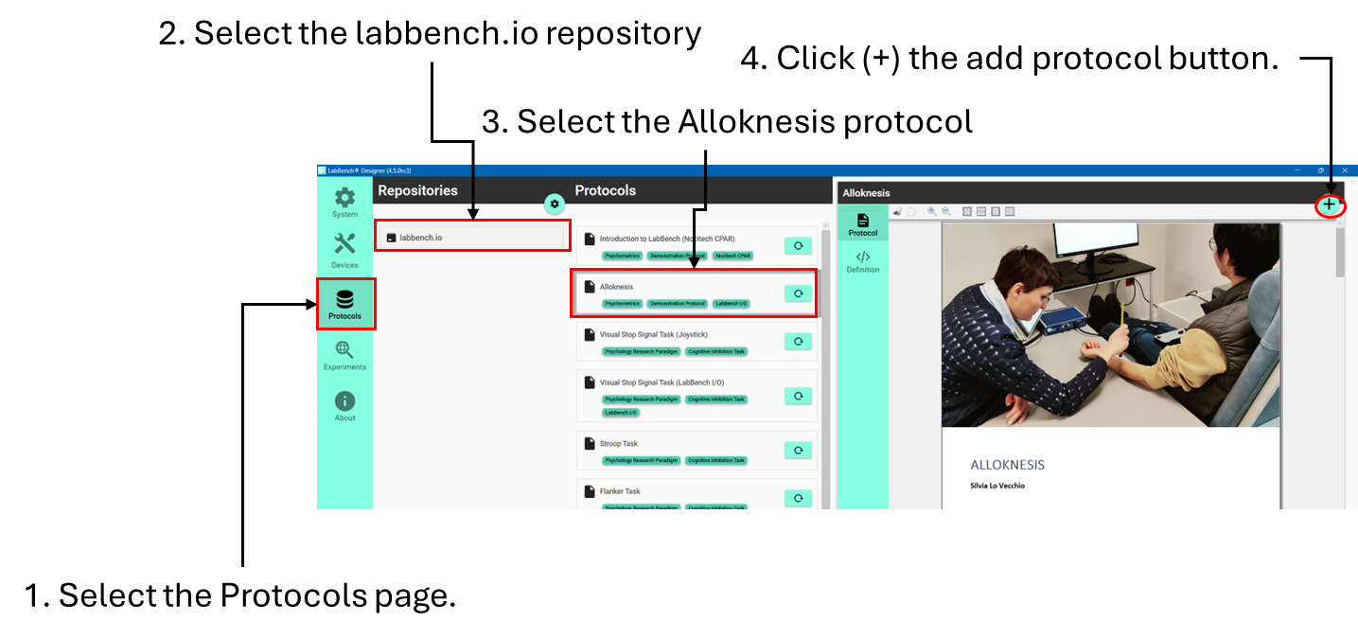

Figure 5: Procedure for how to install the protocol.

# Results

# Discussion

# License

The Introduction to LabBench Protocol (introdemo@labbench.io) © 2024 by Inventors’ Way ApS is licensed under Creative Commons Attribution-NonCommercial-ShareAlike 4.0 International.

For a full explanation for the conditions of its use and the full license text, please refer to: https://creativecommons.org/licenses/by-nc-sa/4.0/

# References