This demonstration protocol describes the concept of alloknesis, a brief overview of the mechanism behind it and the assessment technique applied to quantify it. As a demonstration protocol it is not intended to be a protocol for an actual experiment. Instead, it is intended as a demonstration of one specific experimental procedure that can be used as a building block in more comprehensive protocols.

alloknesis

**Silvia Lo Vecchio**

# Introduction

The term alloknesis, first coined by LaMotte et al. in 19881–4, represents one of the mechanical itch dysesthesias, that describe dysfunctional sensory states, in which itch is evoked by light tactile stimuli (e.g. from clothing or touch), or by stimuli which normally would only induce mild itching 1,5–8. Alloknesis (“allo”, and “knesis”, an ancient Greek word for itching) is described as a pruriceptive sensation or a scratching behavior evoked by a stimulus that is normally non itchy, such as light stroking of the skin with a cotton swab or a brush (Figure 1) 1,9.

Figure 1: Graphical representation of the alloknesis phenomenon. The curve represents the stimulus-response curve, that is the association between the intensity of the applied stimulus (x-axis) and the itch response (Y-axis) under normal condi­tions and when dysesthesias are present. Created with BioRender.com and adapted from Andersen et al. 1with inspiration from Sandkühler J 10.

This concept reflects a similar dysfunctional state evoked by pain and termed allodynia, in which pain is cause by a stimulus that normally does not provoke pain 11,12. Often, alloknesis represents a symptom in acute itch, chronic itch conditions such as neuropathic itch and atopic dermatitis but could also be induced experimentally in healthy volunteers 1,11,12. The primary cause of alloknesis is the sensitization of itch signaling pathways inducing amplified response to pruritogens and increased reactivity to other types of stimuli1,10,12,13. Moreover, also the dysregulation of the inhibitory systems in the spinal cord seems to contribute to alloknesis12. In humans, the intensity of alloknesis is often assessed by using brush strokes 1,14, as illustrated below under the section “protocol”.

Alloknesis can be assessed by applying brush strokes to the skin of a subject and asking them to rate the evoked itch on a rating scale. This demonstration protocol provides two alternative experimental procedures for assessing alloknesis; one where the evoked itch is rated on a numerical rating scale (NRS), and one where it is rated on a visual analog scale (VAS). In an actual experiment, only one of these procedures should be used. This demonstration protocol can be used to evaluate which experimental procedure (NRS or VAS) is appropriate for your experiment. Once a decision is made the chosen experimental procedure can be copied from this demonstration protocol into the protocol for your experiment.

# Experimental Setup

The experimental setup is designed to record the itch ratings of the subject automatically without the need for manual actions taken by the investigator, and to display instructions to the investigator and subject throughout the experiment.

The experimental setup consists of a computer running LabBench with two screens attached. The primary screen is used for displaying LabBench to the investigator and the secondary screen is used to display instructions to the subject prior to running an experimental procedure and to display either the NRS or VAS scale on which the subject rates their sensation (see Figure 2).

Figure 2: Illustration of the experimental setup that consists of a computer running LabBench to which two screens are attached. One screen is used to display LabBench to the operator, and one is used to display rating scales and instructions to the subject. A LabBench SCALE is used by the subject to perform the rating on either NRS or VAS scales, which is connected to LabBench with a LabBench I/O device.

Typically, laptops for experimental setups, and in that case the screen of the laptop should be configured to be the primary display. Connect the external screen to an HDMI port on the laptop and configure this screen as a secondary display. Connect the LabBench I/O with the USB cable to the computer and to power with its accompanying power supply. Connect the LabBench SCALE to Response Port 1 on the LabBench I/O.

Somedic SENSELab Brush no. 5 is used to determinate the intensity of alloknesis.

# Protocol

Alloknesis will be measured using a standardized sensory brush (SENSELab Brush-05, Somedic AB, Hörby, Sweden) exerting a force of in the range of 200 +/- 100 mN. The investigator should perform 3 stimulations, in different directions, along the diagonals of the area of interest (AOI).

Each stimulation consists of a set of 3 brush strokes (2-3 cm in length) in short succession (approximately 1 s in between) over the treated/control areas. The strokes are applied by keeping the brush perpendicular to the skin at a speed of 3-6 cm/sec.

Fig 3: Application of brush strokes perpendicular to the skin while the subject rates the sensation of itch on a Numerical Rating Scale.

After each set of 3 brush strokes, the participant rates the sensation induced by the brush on a:

1. NRS Test: NRS scale from 0 to 10 (0 = “No Itch”; 10 = “Worst Imaginable Itch”).
2. VAS Test: VAS scale of 10cm in length, with a lower anchor of “No Itch” and upper anchor of “Worst Imaginable Itch”.

# Using the protocol

The protocol can be installed from the (labbench.io) repository, which is available by default when LabBench is installed.

Before the protocol can be installed a LabBench I/O device must first be added to the LabBench installation (see Figure X). First start the LabBench Designer, to check that a LabBench I/O device is present or to add such a device if it is not, and then: 1) Select the Protocols Page, 2) Select the LabBench I/O device, 3) check that a LabBench I/O device is installed and available.

If a LabBench I/O device is not installed, then install one by first ensuring that the device is connected to the computer and then clicking on the (+) add device button.

Figure 4: Illustration of how to check if a LabBench I/O has been added to the LabBench system.

To install the protocol; 1) Select the Protocols page, 2) Select the labbench.io repository, 3) Select the Alloknesis protocol, and 4) click the (+) add protocol button.

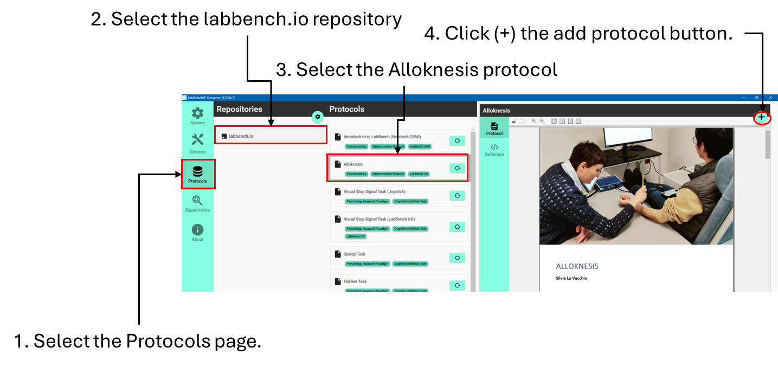

Figure 5: Procedure for how to install the protocol.

# Results

Data is saved automatically by LabBench during the experiment as three NRS values between 0 (no itch) and 10 (maximal itch) or three VAS values between 0cm and 10cm; one for each measurement that is performed in the experimental procedure.

# Discussion

Measurement of itch intensity is essential to evaluate the severity of a pruritic disease, or to assess the efficacy of a treatment 15. Different types of scale are available to measure pruritus intensity, and the most used are mono-dimensional scales such as the visual analog scale (VAS) and the numerical rating scale (NRS) 16,17.

The VAS consists of a 10 cm horizontal line with one endpoint on either side corresponding to 0=no itch, and 10=worst imaginable itch. The subjects are asked to mark on the line, the point in between these endpoints or on them that corresponds to their feeling 15–17.

The NRS are essentially VAS, but with tick marks every centimetre that create an 11-point scale ranging from 0 to 10. Subjects can rate the itch severity by assigning it a number between 0 and 10 15–17. Recently, a score cutoff for the two scale has been proposed so that the scoring can be translated as showed in figure 6 15,18–20.



Figure 6: Proposed score cutoff for VAS and NRS scales. Between 0 and 3=mild itch, between 3 and 7= moderate itch, between 7 and 9 =severe itch, and above 9=very severe itch.

Although, these two scales have been initially developed for assessing pain intensity, they are also widely used to assess itch severity, even though their validation for pruritus assessment have only been explored recently, proving both scales valid and reliable for itch assessment and correlated with each other (correlation coefficient above 0.85) 15,16,18,21,22. However, even if the two scales present many similarities, NRS showed lower missing values compared with the VAS in the validation study, so it is recommended to have the participant familiarize with the VAS scale before starting the study, to decrease the number of missing data 16,17,21 . Moreover, NRS is associate with slightly but significant higher score values than VAS, so it is recommended that the two scale are not used interchangeably when assessing itch intensity 15. Lastly, it is important to underline that VAS are ratio scales, while NRS are ordinal scales, so parametric statistics are more appropriate for the VAS outcomes because they have ratio scale (and therefore interval scale) properties, while are considered less appropriate for NRS 23.

# License

Alloknesis Demonstration Protocol (alloknesisDemo@labbench.io) © 2024 by Inventors’ Way ApS is licensed under Creative Commons Attribution-NonCommercial-ShareAlike 4.0 International.

For a full explanation for the conditions of its use and the full license text, please refer to: https://creativecommons.org/licenses/by-nc-sa/4.0/

# References

1 Andersen HH, Akiyama T, Nattkemper LA, *et al.* Alloknesis and hyperknesis—mechanisms, assessment methodology, and clinical implications of itch sensitization. *Pain* 2018; **159**:1185–97.

2 Bickford RGL. Experiments relating to the itch sensation, it’s peripheral mechanism, and central pathays. *Clin Sci* 1938; **3**:377–86.

3 LaMotte RH. Subpopulations of “nocifensor neurons” contributing to pain and allodynia, itch and alloknesis. *APS Journal* 1992; **1**:115–26.

4 LaMotte RH. Psychophysical and neurophysiological studies of chemically induced cutaneous pain and itch: the case of the missing nociceptor. In: *Progress in brain research*. , Elsevier, 1988; 331–5.

5 Andersen HH, Elberling J, Sølvsten H, *et al.* Nonhistaminergic and mechanical itch sensitization in atopic dermatitis. *Pain* 2017; **158**:1780–91.

6 G. Atanassoff P, Brull SJ, Zhang J, *et al.* Enhancement of experimental pruritus and mechanically evoked dysesthesiae with local anesthesia. *Somatosens Mot Res* 1999; **16**:291–8.

7 Ikoma A, Fartasch M, Heyer G, *et al.* Painful stimuli evoke itch in patients with chronic pruritus: central sensitization for itch. *AAN Enterprises*URL https://n.neurology.org/content/62/2/212.short [accessed on 22 November 2021].

8 Schmelz M. Itch and pain differences and commonalities. In: *Pain Control*. , Springer, 2015; 285–301.

9 LaMotte RH. Allodynia and Alloknesis. In: *Encyclopedia of Pain*. Berlin, Heidelberg, Springer Berlin Heidelberg; 52–5.

10 Sandkuhler J. Models and mechanisms of hyperalgesia and allodynia. *Physiol Rev* 2009; **89**:707–58.

11 Jensen TS, Finnerup NB. Allodynia and hyperalgesia in neuropathic pain: clinical manifestations and mechanisms. *Lancet Neurol* 2014; **13**:924–35.

12 Tsagareli Merab. Hyperalgesia and Allodynia: A Closer Look. Symptoms, Mechanisms and Treatment. , Nova Science Publishers, 2019.

13 LaMotte RH, Dong X, Ringkamp M. Sensory neurons and circuits mediating itch. *Nat Rev Neurosci* 2014; **15**:19–31.

14 Weisshaar E, Dunker N, Gollnick H. Topical capsaicin therapy in humans with hemodialysis-related pruritus. *Neurosci Lett* 2003; **345**:192–4.

15 Reich A, Szepietowski JC. Measurement of Itch Intensity. In: *Itch: Management in Clinical Practice.* . , 2016; 29–34.

16 Misery L, Ständer S, eds. Pruritus. Cham, Springer International Publishing, 2016 doi:10.1007/978-3-319-33142-3.

17 Yosipovitch G, Arendt-Nielsen L, Andersen H. Itch and Pain: Similarities, Interactions, and Differences. , Wolters Kluwer Health, 2020URL https://books.google.dk/books?id=LwnYDwAAQBAJ.

18 Reich A, Heisig M, Phan N, *et al.* Visual Analogue Scale: Evaluation of the Instrument for the Assess­ment of Pruritus. *Acta Dermato Venereologica* 2012; **92**:497–501.

19 Kido-Nakahara M KNSHMHHATSNTMKTRNHOYMKFM. Comparative cut-off value setting of pruritus intensity in visual analogue scale and verbal rating scale.". *Acta Derm Venereol* 2015; **95**.

20 Reich A, Chatzigeorkidis E, Zeidler C, *et al.* Tailoring the Cut-off Values of the Visual Analogue Scale and Numeric Rating Scale in Itch Assessment. *Acta Dermato Venereologica* 2017; **97**:759–60.

21 Phan N, Blome C, Fritz F, *et al.* Assessment of Pruritus Intensity: Prospective Study on Validity and Reliability of the Visual Analogue Scale, Numerical Rating Scale and Verbal Rating Scale in 471 Patients with Chronic Pruritus. *Acta Dermato Venereologica* 2012; **92**:502–7.

22 Furue M, Ebata T, Ikoma A, *et al.* Verbalizing Extremes of the Visual Analogue Scale for Pruritus: A Consensus Statement. *Acta Dermato Venereologica* 2013; **93**:214–5.

23 Price D, Staud R, Robinson M. How should we use the visual analogue scale (VAS) in rehabilitation outcomes? II: Visual analogue scales as ratio scales: An alternative to the view of Kersten et al. *J Rehabil Med* 2012; **44**:800–1.