Contents

Introduction 1

Experimental Setup 2

Protocol 3

Analysis 3

Discussion 3

# Introduction

The stop-signal task has become a popular tool for the study of response inhibition in cognitive psychology, cognitive neuroscience, and psychopathology (Verbruggen and Logan, 2008). Cognitive psychologists suggested that the response inhibition should be seen as a race between a go process and a stop process (horse-race model). Cognitive neuroscientists showed that these processes might activate brain regions differently, and psychopathologists showed selective deficits in inhibition.

Response-inhibition deficits have been linked to several psychopathological and neurological disorders. Some disorders, such as autism, and schizophrenia are associated with general cognitive impairments in addition to inhibitory deficits. identified in several neuropsychiatric conditions associated with impulsivity such as ADHD, trichotillomania, OCD, and chronic substance abuse (Chamberlain & Sahakian, 2007).

A cognitive task that can effectively measure inhibition is the stop-signal task. The use of this task, developed for the first time by Vince in 1948, allows to obtain an index of the reaction time (Stop Signal Reaction Time (SSRT)), necessary for the individual to successfully inhibit a motor response already programmed and in the execution phase.

The Stop-Signal task was created to study the control of thought and action by testing subjects' ability to hold back a planned movement in response to a stop signal (Logan, 1994; Logan & Cowan, 1984). Subjects are instructed to respond as quickly as possible to a go signal (go-signal trial). In a smaller percentage of trials, a stop signal is presented following which the subject must inhibit the previously planned response.

The subject's ability to inhibit the response is probabilistic and depends on the interval between go-signal and stop-signal which is referred to as Stop Signal Delay (SSD). Generally, as the SSD increases, the probability that the subject can inhibit the motor response decreases. The trials in which the response was correctly inhibited are defined as signal inhibit, while the trials in which the subject was not able to inhibit the response are called signal respond.

The protocol (vstopsignal@labbench.io) presented here demonstrates how a visual stop-signal task can be implemented in LabBench.

# Experimental Setup

The protocol is implemented for two different experimental setups; one based on a standard USB joystick, and one based on the LabBench I/O, PAD, ATG devices. The joystick-based setup offers a cost-effective version of the protocol albeit at the expense of accuracy, whereas the LabBench I/O based setup offers the most intuitive setup for the subjects with a high timing accuracy (< 1ms).

## Joystick

## LabBench I/O

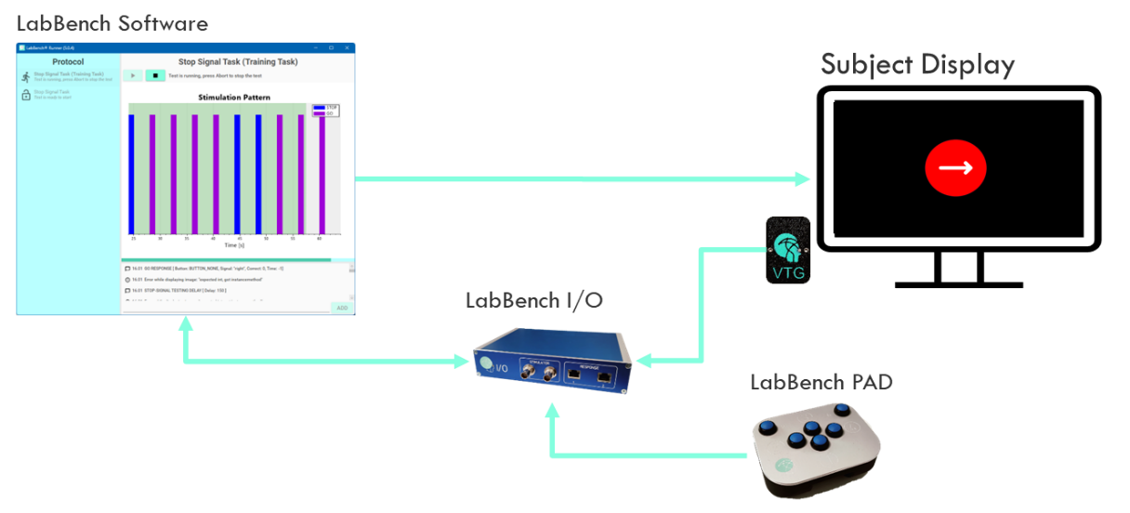

Figure :

# Protocol

Figure 1:

# Analysis

# Discussion