User Guide
to the Luminescence Macro

The purpose of this user guide is to provide easy instructions on how to use the luminescence macro for data analysis in the TZM-bl neutralizing antibody assay.

I. Introduction

Overview

The luminescence macro is a series of commands and functions embedded in an Excel workbook that can automate a repetitive task for rapid data reduction.

Once the macro is properly installed, it can be initiated whenever the task needs to be performed.

The luminescence macro can:

- Calculate the percent neutralization for each serum dilution.
- Calculate neutralizing antibody titer.
- Create a chart that plots neutralization curves for each sample

Download Source

The luminescence macro can be downloaded from the website www.hvtn.org.

The full name of this macro program file is: Luc5samples02.xlt.

- Luc is short for Luciferase assay
- 5 refers to 5 samples per plate
- 02 is the macro version number

Features

Below is the screenshot of a blank macro file when you open it.

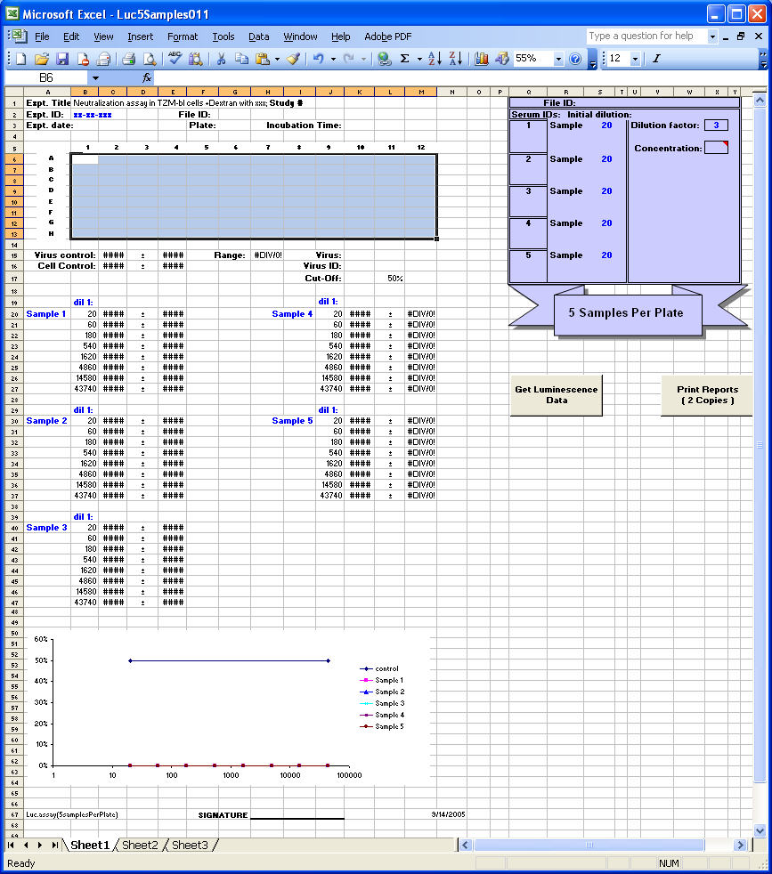

Below is the screenshot after a data file is imported.
Starting concentration/dilution, sample dilution factor, and appropriate code for concentration or dilution should be entered in this box.

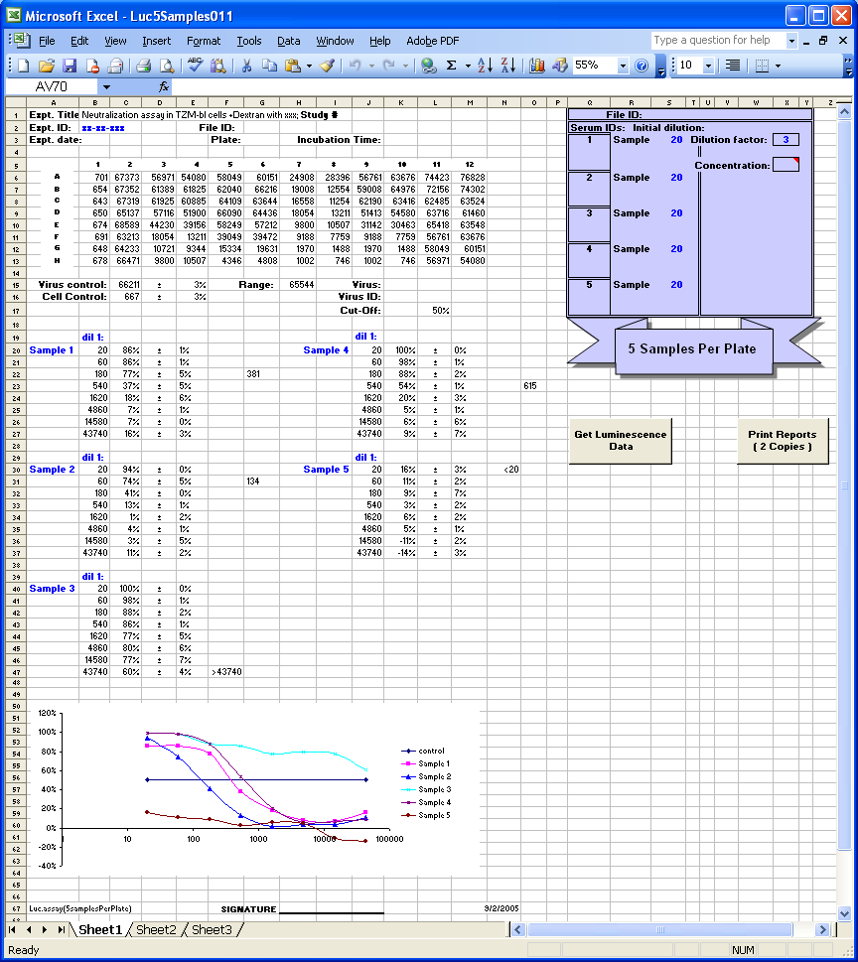
Graph Area
Data Import Button
Print Data Reports Button
Raw luminescence values imported from
data file.
Information for assay name, user signature, and current date
Title
Main data area
Security Feature

In order to protect the worksheet from accidental changes, information in the shades areas (see picture below) are locked with password protection.

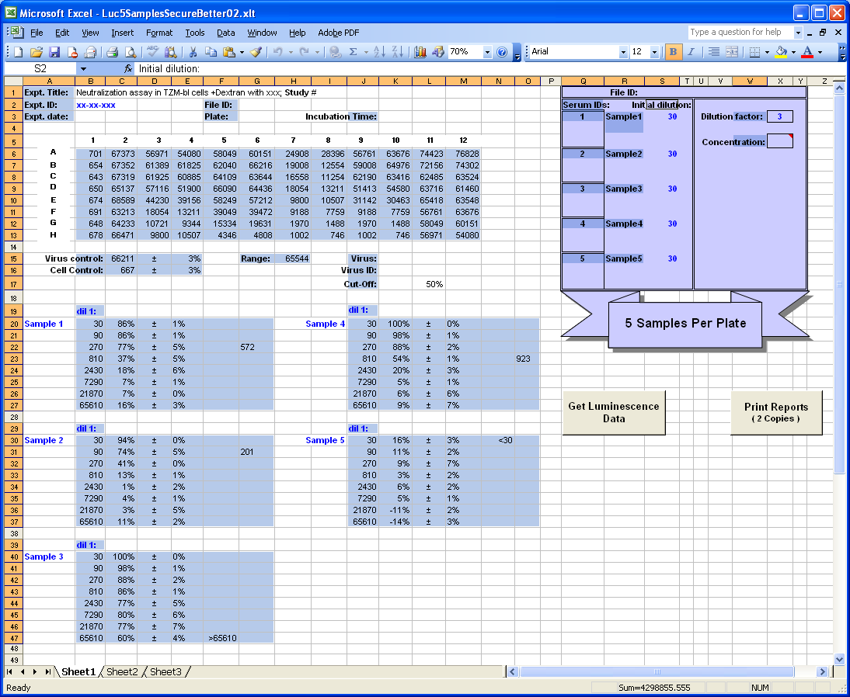

Any attempt to enter information in a restricted cell (shown as shade section above) will give you a warning dialog box (see below).

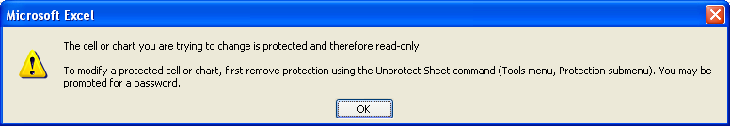
Template of 5 Samples per Plate
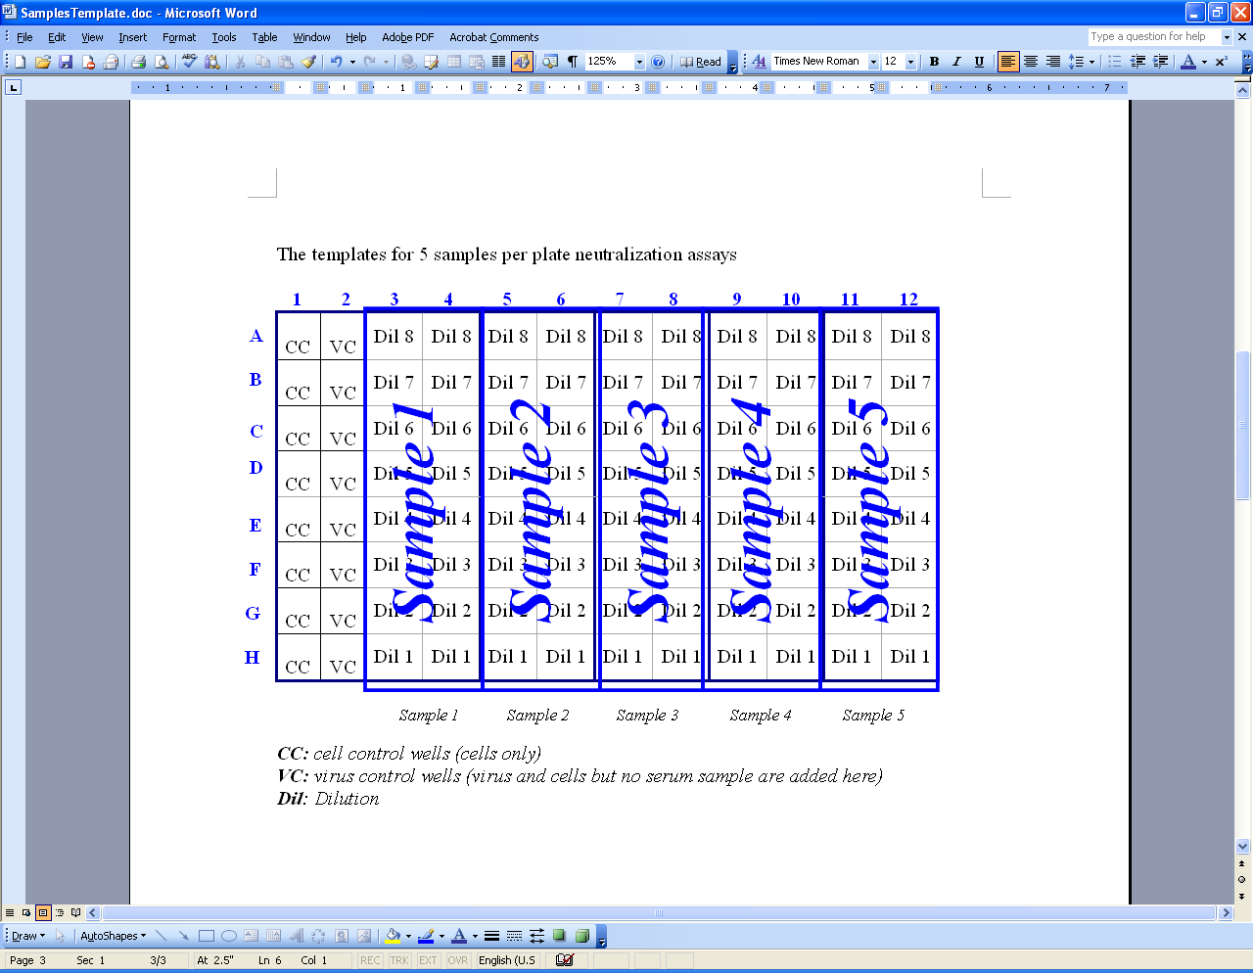
Plate set-up in the protocol

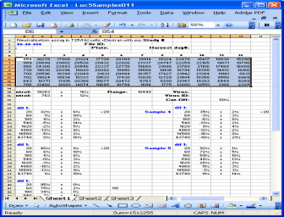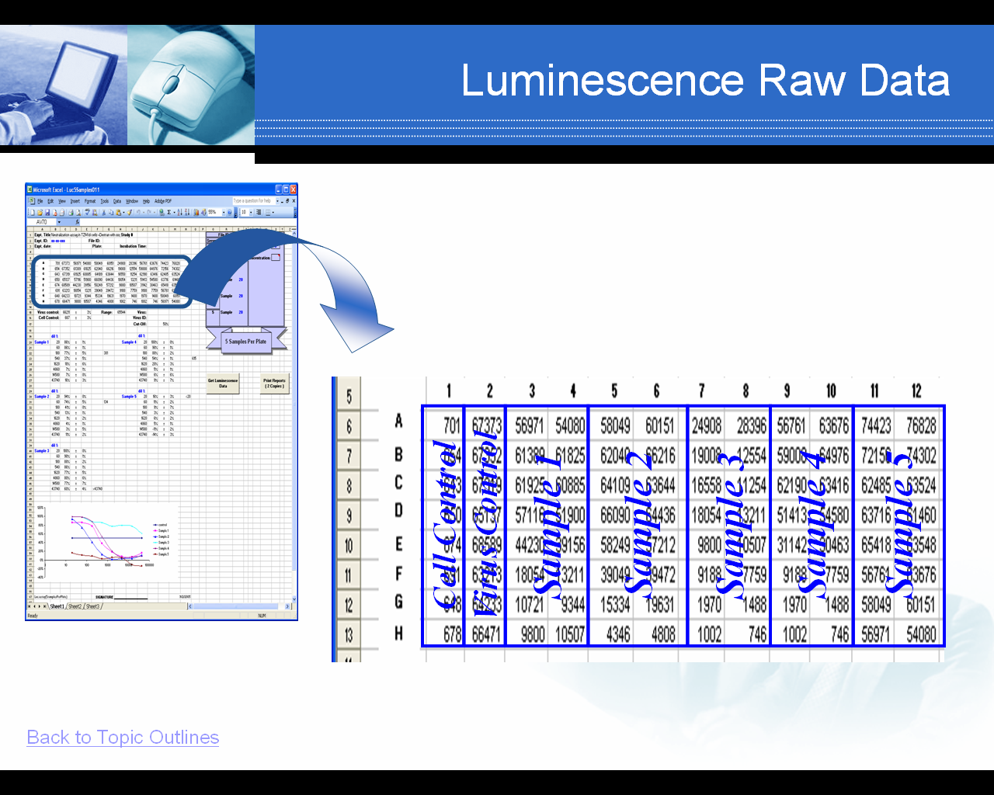

(In the program file)

Below are the positions of the 5 samples in the main data area.

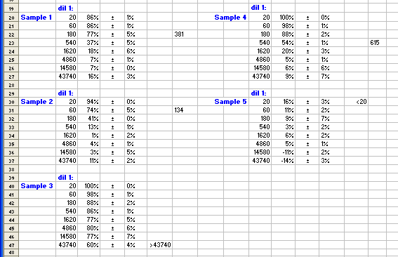

Sample 1

Sample 2

Sample 4

Sample 5

Sample 3
Let’s take sample 1 as an example. From the top to bottom are dilutions 1 - 8.

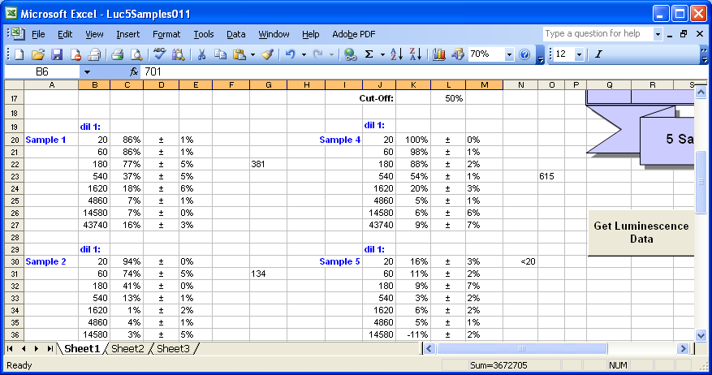
Dilution 1= 1:20
Dilution 2= 1:60
Dilution 3= 1:180
Dilution 4= 1:540
Dilution 5= 1:1620
Dilution 6= 1:4860
Dilution 7= 1:14580

Dilution 8= 1:43740

Note: dil stands for dilution.

Column Information

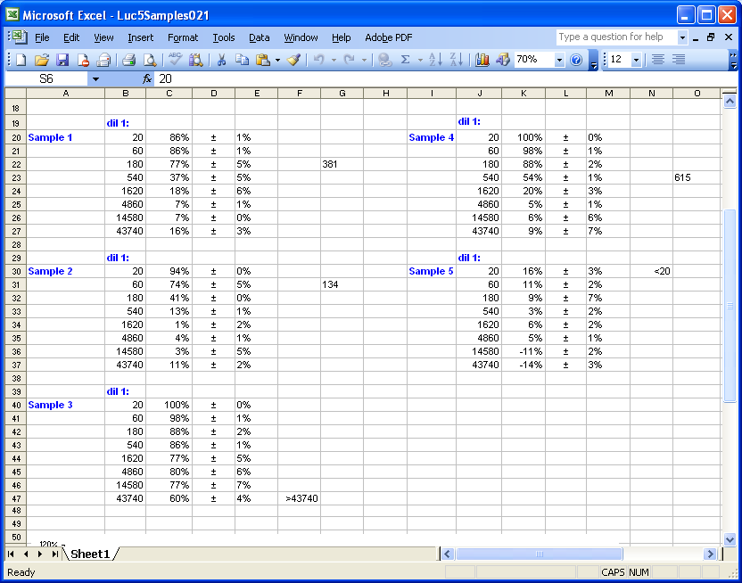

Column A and I: Sample name, bleed date, etc
Column B and J: Dilution or concentration of each test sample
Column C and K: Neutralization Efficiency (%) for each sample
Column E and M: Standard Deviation of Neutralization Efficiency
Column F, G and N, O: Showing titer value (dilution or concentration)

Luminescence Data File Format

** Data files should be in Excel and have .xls extension.

The data file may be saved with a name in the format of Xmmddyy$$;####.xls.

Raw data are generated from Luminometer (Wallac 1420 software package from PerkinElmer Life Sciences). These raw files will be exported individually from Wallac1420 Manager and renamed in the format of “Xmmddyy$$;####.xls” .

- X: a unique character assigned to the person who did this experiment
- mm: current month
- dd: current day
- yy: current year
- $$: plate number(1-99)
- #### : Four digit number automatically assigned by Luminometer( for example 3767)

For example: A07220512;3767 corresponds to the twelfth plate read by operator “ A” on July 2 , 2005. The 3767 corresponds to the unique number assigned by the luminometer.

If you save the data file in the format of “Xmmddyy$$;####.xls”, some information (like Experiment Date, plate number, File ID) indicated by the red boxes below in the Title Part will be automatically filled in.

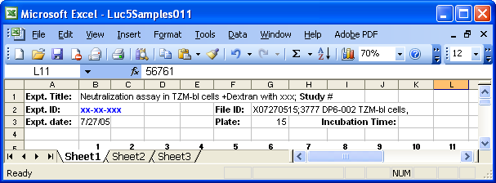

Or you can name it differently.

The program will accept any file name. However, the information in the red box shown above will not appear automatically.

II. Configuration

Macro Security Setting Change

The first time you start the luminescence macro program, you may encounter the following dialog box, which prompts that you need to change Excel Macro security settings.

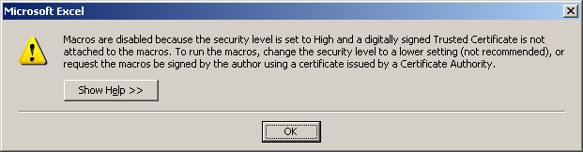

To change the macro security level, please follow these steps.
- Click OK button in the above dialog box.
- On the Tools menu, click Options.
- Click the Security tab.
- Under Macro Security, click Macro Security.
- Click the Security Level tab, and select Medium.
- Click Ok to close the dialog boxes.
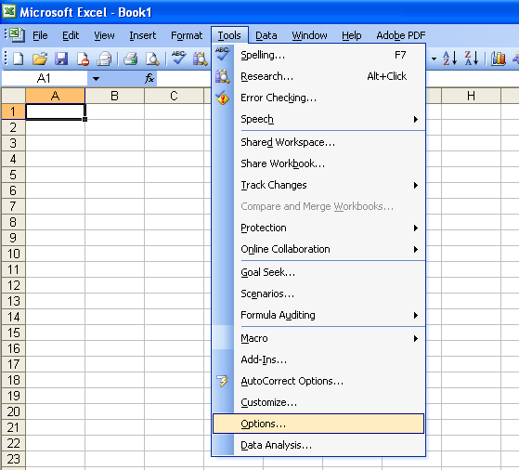
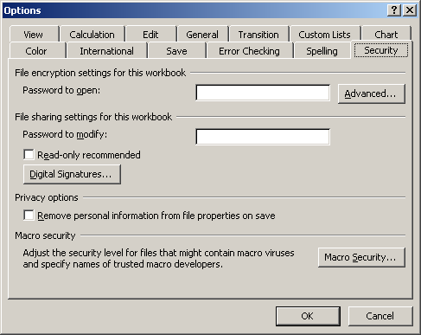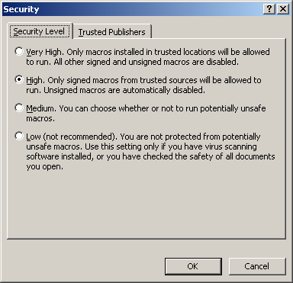
Close and then restart the Excel program. The disabled macros message should not appear.

After this configuration is completed, it will not be necessary to change the macro security settings each time you use the macro.

III. Step by Step

1. Import the macro file entitled “Luc5Samples02.xlt”

2. Double click to open this file.

3. Click “Enable Macros”.

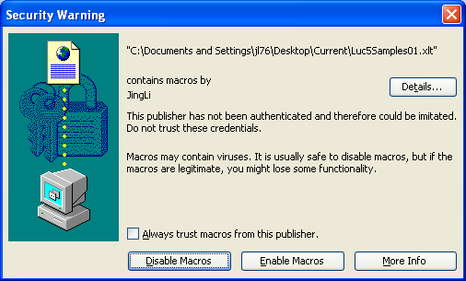

4. Click “OK” button in the following dialog box.

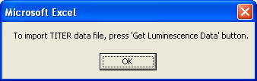

After you open the macro file, the data area is blank waiting for data input.

5. Click the “Get Luminescence Data” button to open TITER data file.

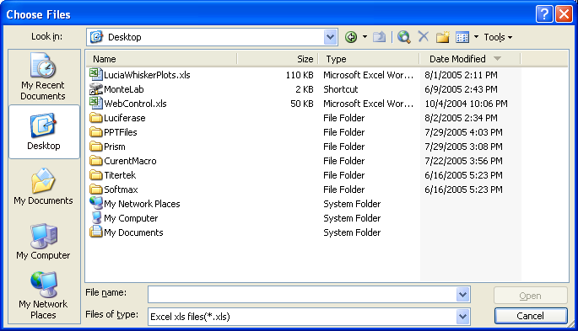
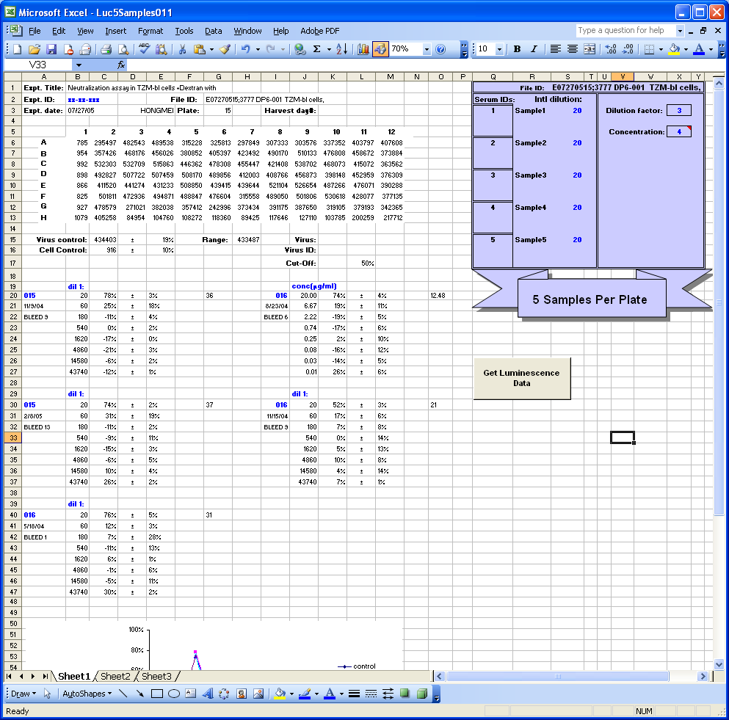

After click “Get Luminescence Data”, Choose Files Dialog box appears. Locate your luminescence raw data file that was exported from the Luminometer.
6. Enter appropriate sample starting dilutions (or concentrations) and dilution factor.
file.

Enter the starting dilution, concentration code (if required) and dilution factor directly as indicated below.

Enter a value in Column S (indicated by red rectangle) to set the starting dilution or concentration value.
Enter a value in cell “X3” (indicated by yellow rectangle) to set the dilution factor.

7. Enter the appropriate code for samples that have a known concentration.
file.

The macro has separate functions that allow samples to be analyzed either as dilutions (e.g., serum and plasma) or concentrations (e.g., MAbs, μg/ml). No action needs to be taken if all 5 samples are to be analyzed as dilutions. A special code must be entered if one or all samples are in concentration:

Go to cell “X5” (indicated by a green rectangle in above Figure for Step 6). The program can only accept the following codes: “1”, “2”, “3”, “4”,”5”,“y”, “Y” and blank value.

“1” only sample #1 is in concentration
“2” only sample #2 is in concentration
“3” only sample #3 is in concentration
“4” only sample #4 is in concentration
“5” only sample #5 is in concentration
“Y” or “y” means showing all samples in concentration.
Blank value means showing all samples in dilution.

8. Enter additional experiment Information in the Title section.
(e.g. Experiment title, Experiment ID, Study No, Incubation time.)
file.

9. Enter general sample information in column A and column I indicated by green rectangles.
(e.g. Sample name, bleed number for each sample.)

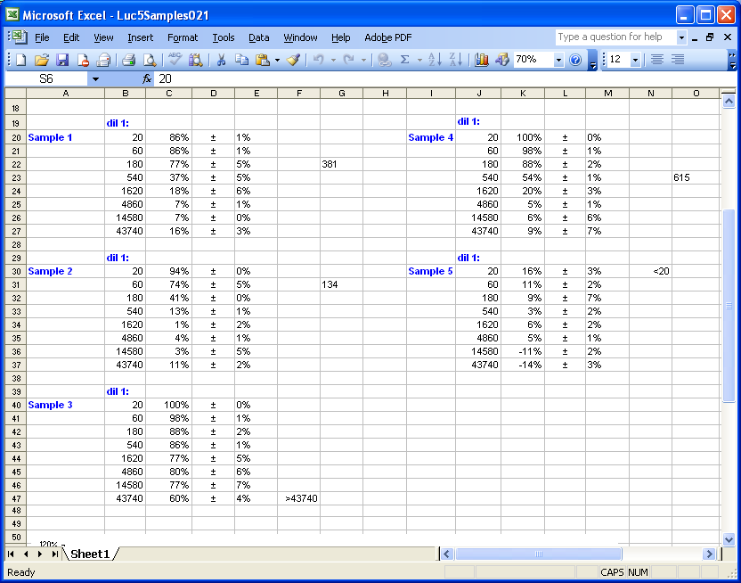

10. Print out data.

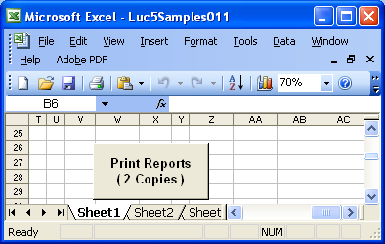

Click this button to get two copies of your data report. One for the Principal Investigator, the other one will be kept by the technician.

11. Click “Get Luminescence Data” button to open another data file or close the macro program without saving any change.

Help

Please feel free to contact Jing Li ((jing.li@duke.edu) if you have any question about this guide or encounter any problems. Any suggestions for improvement are also welcome.

