IERG2602 LAB REPORT 1

NAME : Yeung Tang, SID : 1155144676, Email : 1155144676@link.cuhk.edu.hk

### Task 1.1

Run at server VM

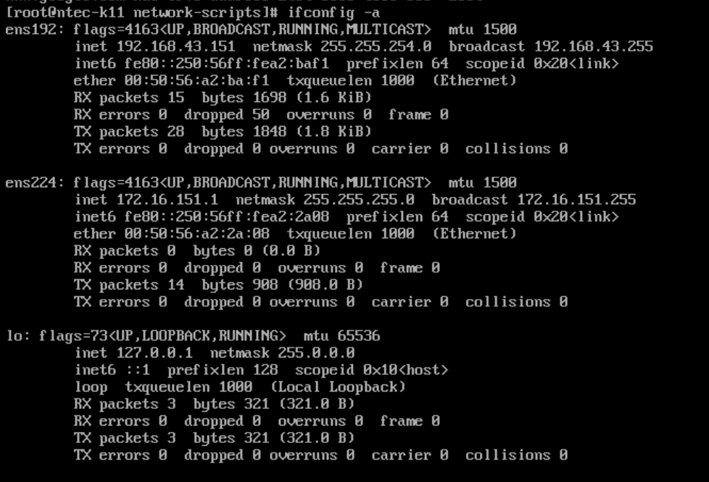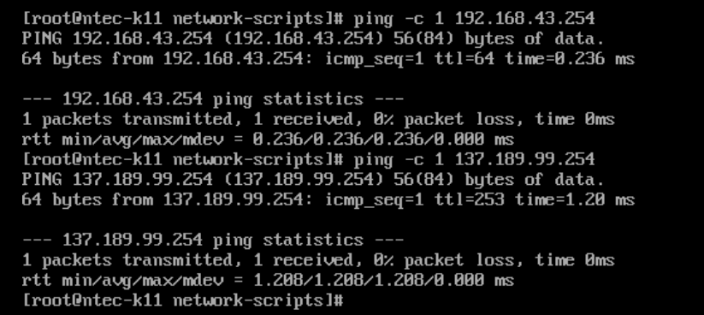

### Task 1.2

Run at client VM

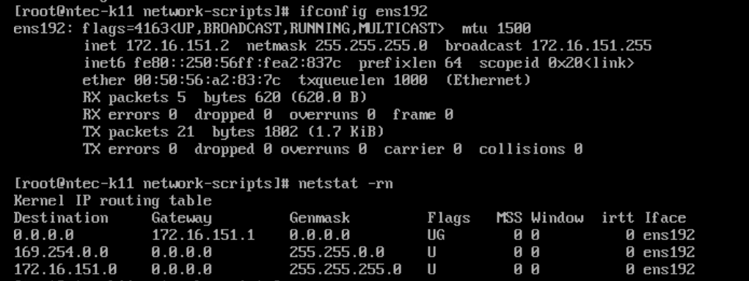

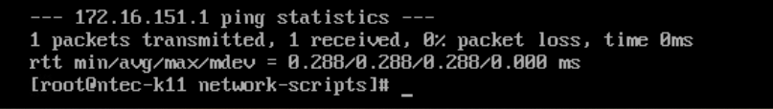

Check point 1.3

Run at Server vm

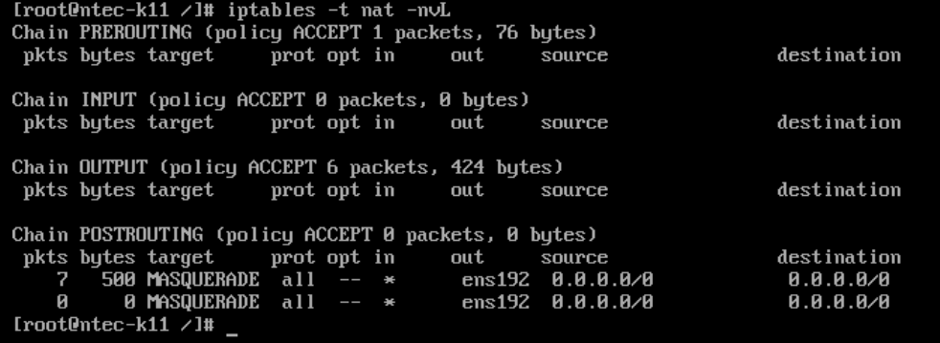

Run at Client VM

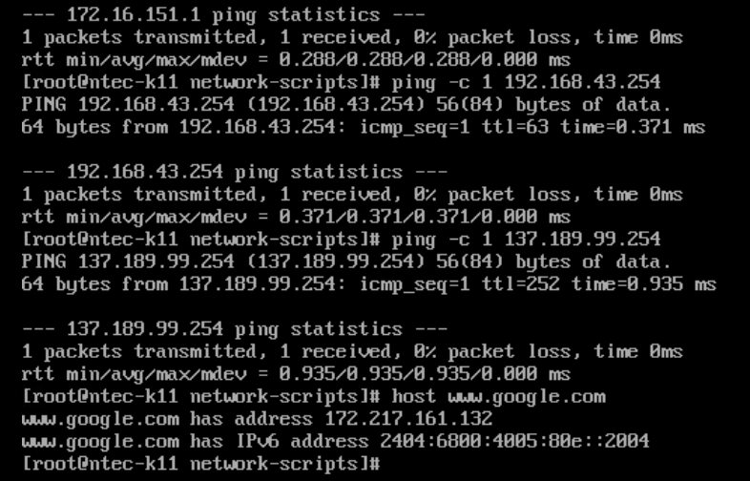

Task 2.1



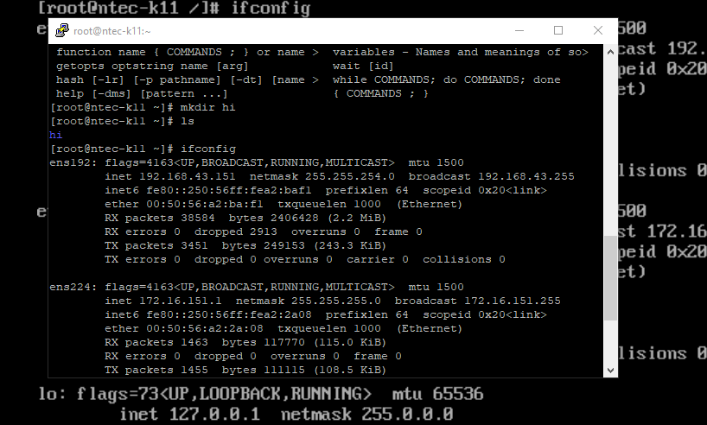

### Task 2.2

At the Client VM, show the content of ~/.ssh/authorized_keys

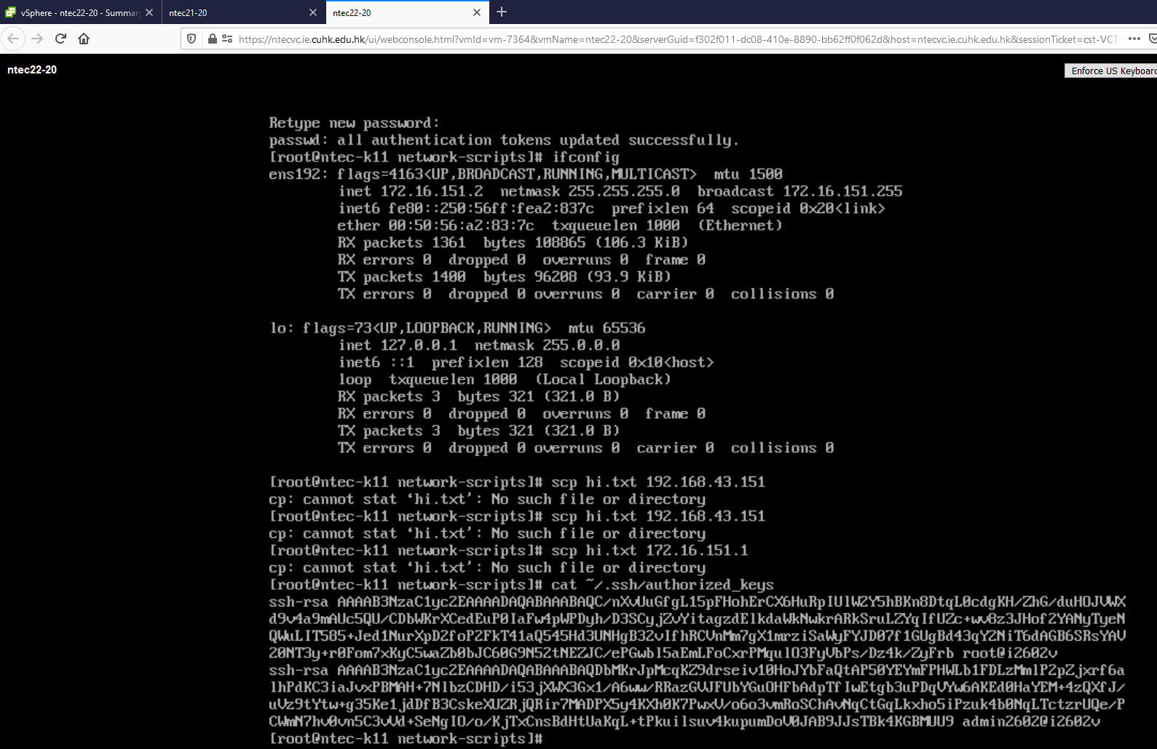

### Task 2.3

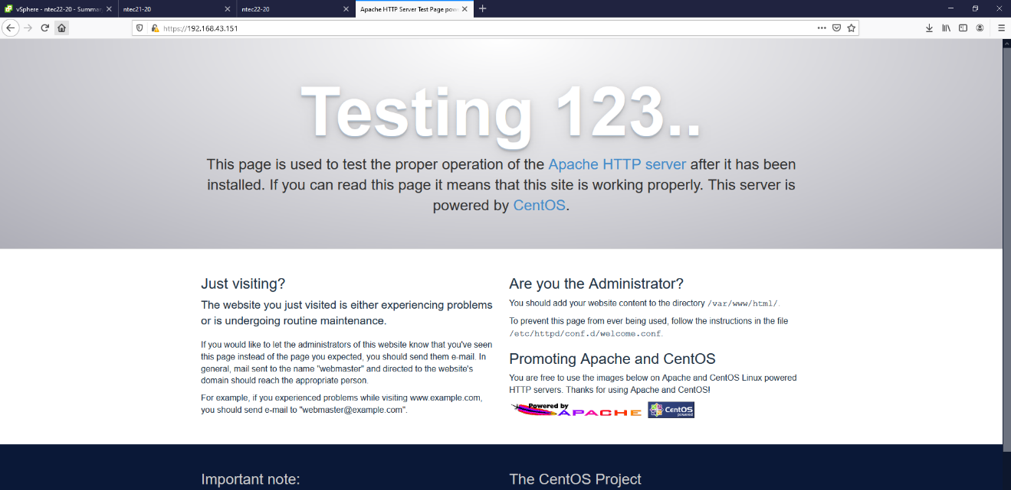

### Task 2.4

At Client VM

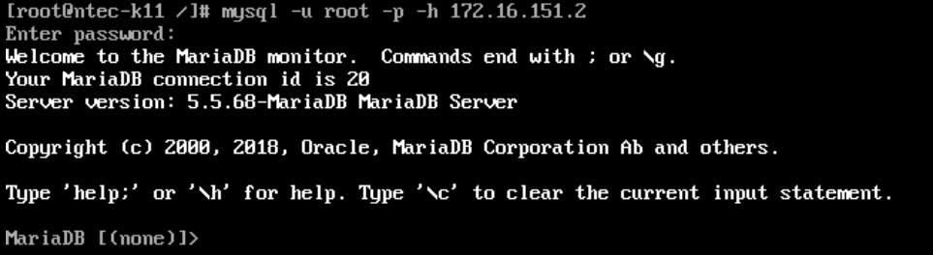

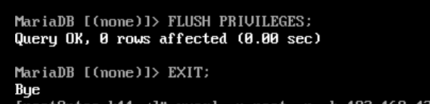

It is too late since I realize that I need to screen cap this… this is what it’s left.

At Server VM



### Task 2.5

