IERG2602 LAB REPORT 2

NAME : Yeung Tang, SID : 1155144676, Email : [1155144676@link.cuhk.edu.hk](mailto:1155144676@link.cuhk.edu.hk)

### Task 3.1

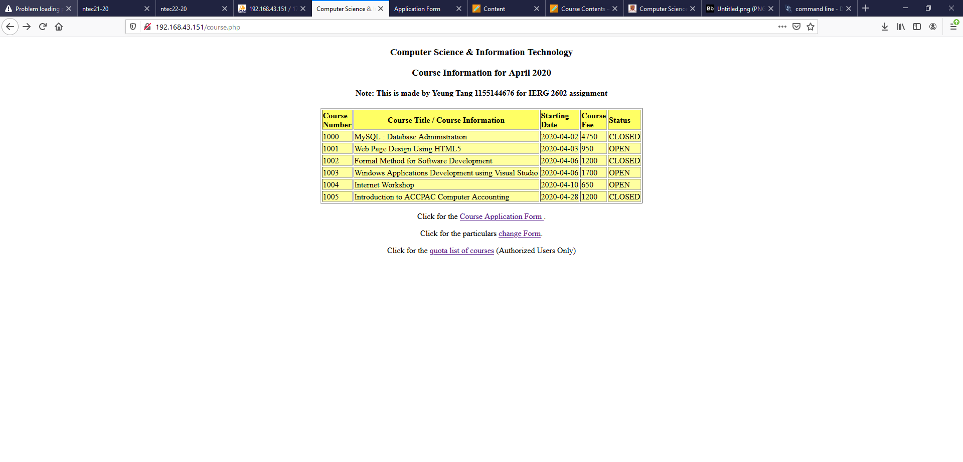

### Task 3.2

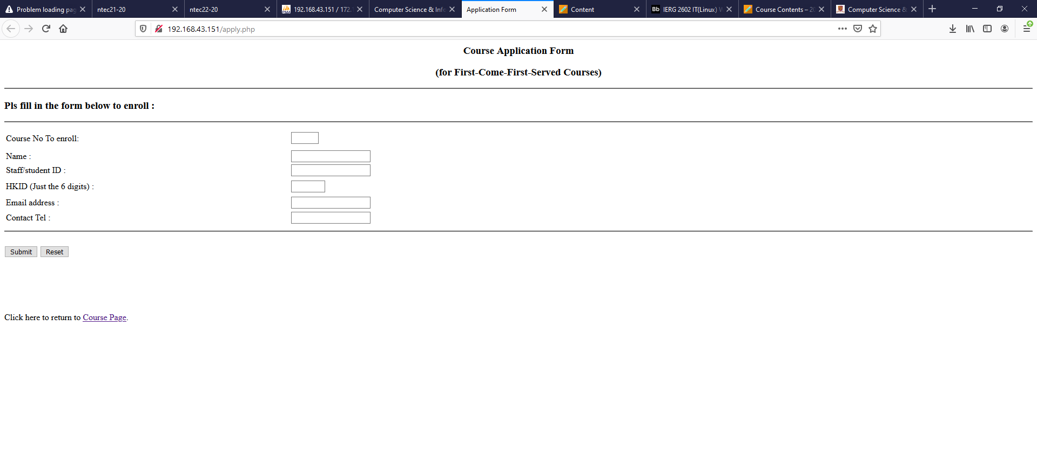

### Task 3.3

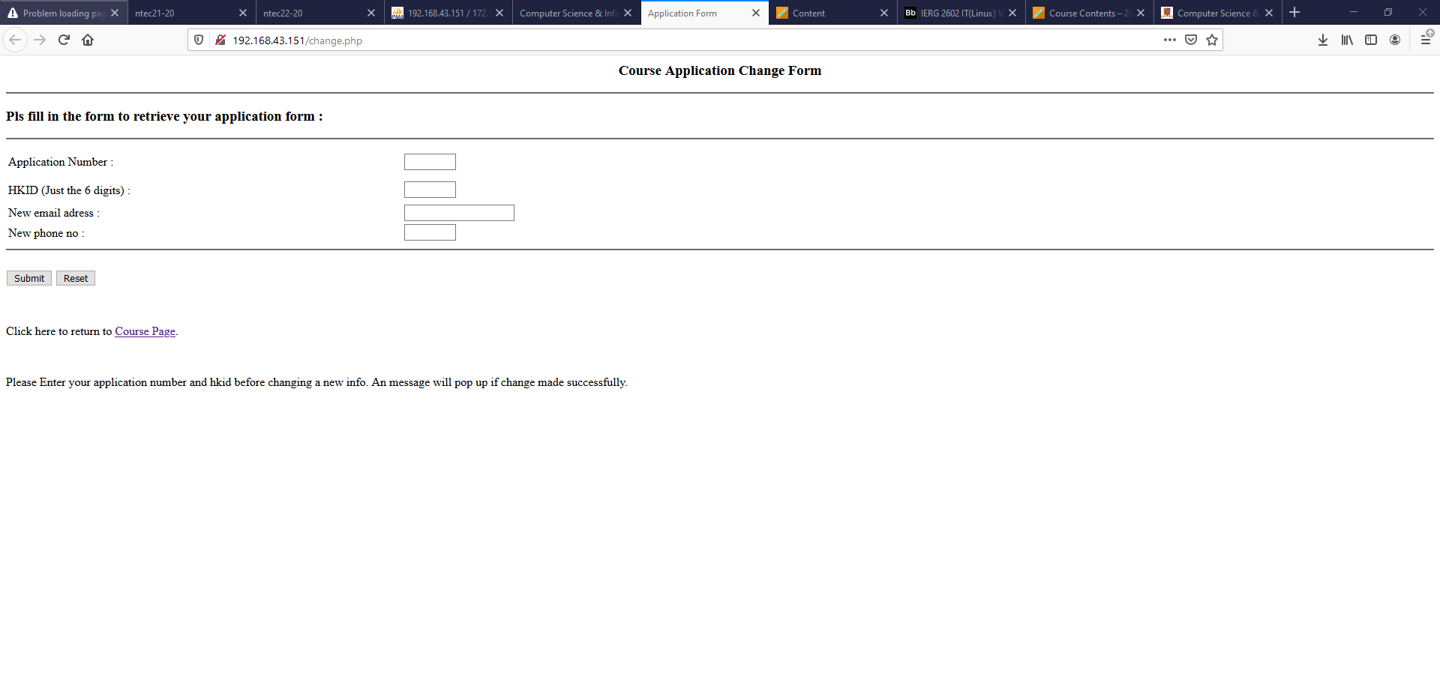

### Task 3.4

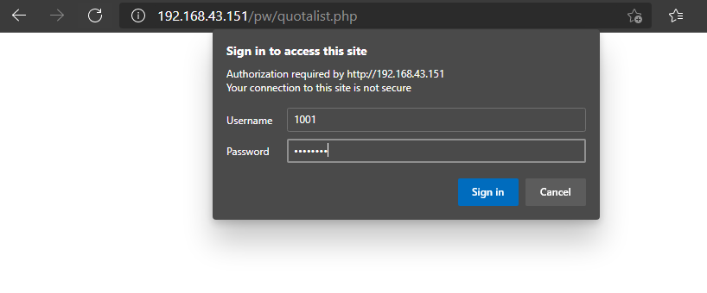

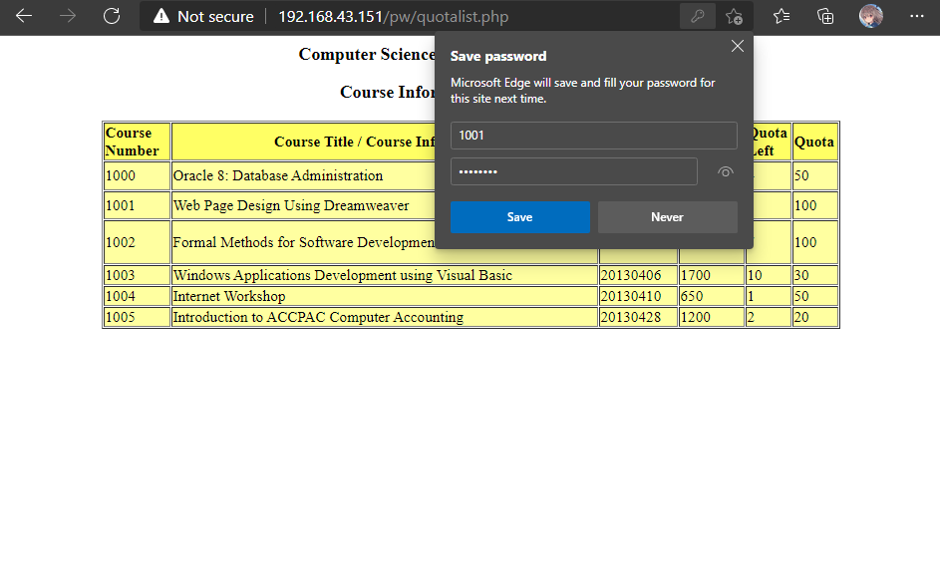

|  |
| --- |
| Put apply.php source code below :  <html>  <head>  <title>Application Form</title>  <meta http-equiv="Content-Type" content="text/html; charset=iso-8859-1">  </head>  <body bgcolor="#FFFFFF">  <h3 align="center">Course Application Form</h3>  <div align="center">  <h3>(for First-Come-First-Served Courses) </h3>  </div>  <hr>  <h3>Pls fill in the form below to enroll :</h3>  <hr>  <form method="post" action="apply.php">  <table width="75%" border="0">  <tr>  <td width="37%" height="39">Course No To enroll:</td>  <td width="63%" height="39">  <input type="text" name="courseno" size="4" maxlength="4">  </td>  </tr>  <tr>  <td width="37%">Name :</td>  <td width="63%">  <input type="text" name="name">  </td>  </tr>  <tr>  <td width="37%">Staff/student ID :</td>  <td width="63%">  <input type="text" name="stid">  </td>  </tr>  <tr>  <td width="37%" height="32">  <p>HKID (Just the 6 digits) :</p>  </td>  <td width="63%" height="32">  <input type="text" name="hkid" size="6" maxlength="6">  </td>  </tr>  <tr>  <td width="37%">Email address : </td>  <td width="63%">  <input type="text" name="email">  </td>  </tr>  <tr>  <td width="37%" height="28">Contact Tel : </td>  <td width="63%" height="28">  <input type="text" name="tel">  </td>  </tr>  </table>  <hr>  <BR>  <input type="submit" name="Submit" value="Submit">  <input type="reset" name="reset" value="Reset">  </form>  <p>&nbsp;</p>  <br>  <?php  define('DBSERVER',"172.16.151.2");  define('DBUSER',"coursedb");  define('DBPASS',"m16_ak47");  define('DATABASE',"coursedb");  if (!$connection = @ mysql_connect(DBSERVER, DBUSER, DBPASS, DATABASE))  { die("Cannot connect");  }  @mysql_select_db(DATABASE) or die( "Unable to select database");  $query="SELECT *FROM applytbl;";  $result = mysql_query($query);  $count = $_POST['courseno'];  $num = mysql_numrows($result);  $count = $count*1000+$num;  $name = $_POST['name'];  $studentid = $_POST['stid'];  $id = $_POST['hkid'];  $email = $_POST['email'];  $phone = $_POST['tel'];  $result = mysql_query($query);  $result= mysql_query($query_check);  $ans = mysql_numrows($result);  $error = false;  if(empty($_POST['courseno'])){  $error = true;  }  if(empty($_POST['name'])){  $error = true;  }  if(empty($_POST['stid'])&&is_int($studentid)!=false){  $error = true;  }  if(empty($_POST['hkid'])&&is_int($id)!=false){  $error = true;  }  if(empty($_POST['email'])){  $error = true;  }  if(empty($_POST['tel'])&&is_int($phone)!=false){  $error = true;  }  if(isset($_POST['Submit'])&&$error==false){  $sql = "INSERT INTO applytbl (applyno ,name ,studentid ,hkid ,email ,tel ) VALUES ('$count', '$name', '$studentid', '$id', '$email', '$phone')";  $result = mysql_query($sql)or die(mysql_error());  mysql_close();  print "your apply no: $count";  }else{  }  ?>  <br><p>Click here to return to <a href="course.php">Course Page</a>.</p>  </body>  </html> |
| Put change.php source code below:  <html>  <head>  <title>Application Form</title>  <meta http-equiv="Content-Type" content="text/html; charset=iso-8859-1">  </head>  <body bgcolor="#FFFFFF">  <h3 align="center">Course Application Change Form</h3>  <div align="center">  <hr>  <h3 align="left">Pls fill in the form to retrieve your application form :</h3>  </div>  <hr>  <form method="post" action="">  <table width="75%" border="0">  <tr>  <td width="37%" height="39">Application Number :</td>  <td width="63%" height="39">  <input type="text" name="applyno" size="7" maxlength="7">  </td>  </tr>  <tr>  <td width="37%" height="32">  <p>HKID (Just the 6 digits) :</p>  </td>  <td width="63%" height="32">  <input type="text" name="hkid" size="7" maxlength="6">  </td>  </tr>  <tr>  <td width="37%" height="25">  <p>New email adress :</p>  </td>  <td width="63%" height="25">  <input type="text" name="email" size="20" maxlength="20">  </td>  </tr>  <tr>  <td width="37%" height="18">  <p>New phone no :</p>  </td>  <td width="63%" height="18">  <input type="text" name="phone" size="7" maxlength="8">  </td>  </tr>    </table>  <hr>  <BR>  <input type="submit" name="Submit" value="Submit">  <input type="reset" name="reset" value="Reset">  </form>  <br><p>Click here to return to <a href="course.php">Course Page</a>.</p>  <p>&nbsp;</p>  <?php  define('DBSERVER',"172.16.151.2");  define('DBUSER',"coursedb");  define('DBPASS',"m16_ak47");  define('DATABASE',"coursedb");  if (!$connection = @ mysql_connect(DBSERVER, DBUSER, DBPASS, DATABASE))  die("Cannot connect");  @mysql_select_db(DATABASE) or die( "Unable to select database");  $query="SELECT *FROM applytbl;";  $result = mysql_query($query);  $count = $_POST['courseno'];  $num = mysql_numrows($result);  $count = $count*1000+$num;  $name = $_POST['name'];  $studentid = $_POST['stid'];  $hkid = $_POST['hkid'];  $email = $_POST['email'];  $phone = $_POST['phone'];  $applyno = $_POST['applyno'];  $query_check ="SELECT *FROM applytbl WHERE applyno ='$applyno' AND hkid = '$hkid';";  $result = mysql_query($query_check);  $ans=mysql_numrows($result);  if($ans!=0){  ;}  if($ans ==0){  echo"Please Enter your application number and hkid before changing a new info. A message will pop up if change made successfully. ";  die();  }  $query ="UPDATE applytbl SET email ='$email', tel ='$phone' WHERE applyno ='$applyno' AND hkid = '$hkid';";  mysql_query($query);  if($ans ==0){  echo"wrong ";  die();  }else{  $sql = "SELECT *FROM applytbl WHERE applyno = '$applyno' AND hkid = '$hkid'";  if(mysql_query($sql)){  $new_email = mysql_result($sql, 0, "email");  $new_tal = mysql_result($sql, 0, "tel");  echo "updated ";  print"app no : $applyno successfully.";  }  }  mysql_close();  ?>  </body>  </html> |