The VI reads the marks of individual students and puts the individual Cgpa along with student names.

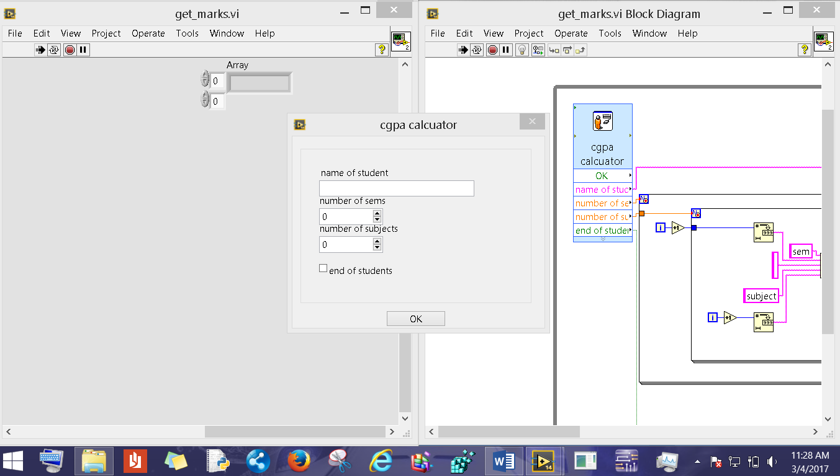

When we run the VI the above window pops and ask for the details like student name, number of sems, and number of subjects.

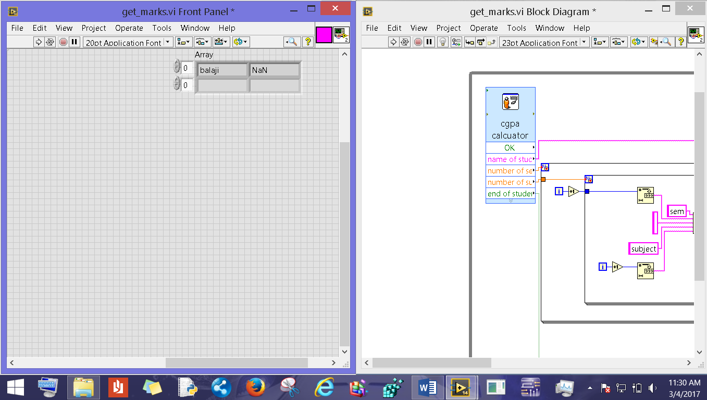

If we input the data and click ok.

The vi opens a blank excel sheet and feeds the data as a table as shown below.

