n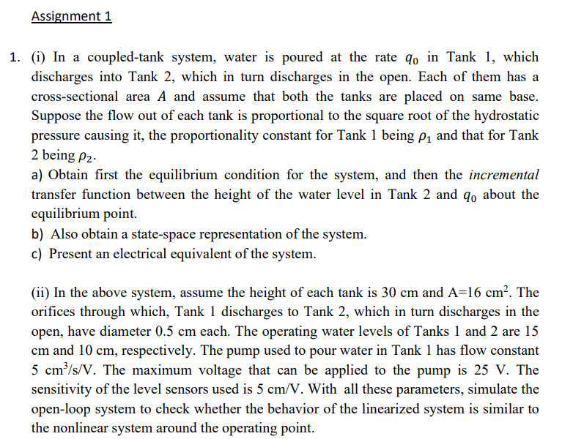

**Solutions:**

**1. System Description and Linearization**

Given:p1=p2=p=Cd*a*√(2*g)

Cd= discharge coefficient (0.6)

a= area of pipe =pi*d2/4

g = acceleration due to gravity

• Tank 1:

Input flow rate: q0

Height: h₁

• Outflow rate: q1 = P1√(h₁-h2)

• Tank 2:

• Height: h2

Outflow rate: q2 = p2√h2

The continuity equation for each tank is:

A * dh1/dt = q - p1√(h₁-h2)

A *dh2/dt = p1√(h₁ -h2) - p2√h2

**B) Find the Equilibrium Point**

At equilibrium, the time derivatives are zero, so:

0 = q - p1√(h₁e-h2e)

0 = p1√(h₁e -h2e) - p2√h2e

q0 = p1 √h₁e

p1√h₁e = p2√h2e

Using these, you can solve for the equilibrium heights h₁e and h2e.

After solving we get: h1e= $\frac{(q0)^2}{(p2)^2}$

h2e= $\frac{2*(q0)^2}{(p2)^2}$

**3. Linearization Around the Equilibrium Point**

Linearize the system around the equilibrium points h₁ = h₁e + Dh₁ and h₂ = h2e + Dh2. The flow rates q₁ and q₂ are also expanded around their equilibrium values:

q1 = p1√(h₁-h2) =p1 √(h1e-h2e) + p1/2√(h1e-h2e) Δh₁ - p1/2√(h1e-h2e) Δh2

q2 = p2√h2 = P2h2e + P2/ 2hze Δh2

Substituting these into the continuity equations gives:

A dΔh1/ dt = - [p1/2√(h1e-h2e) Δh₁ - p1/2√(h1e-h2e) Δh2]+ Δq0

A dΔh2 /dt = [p1/2√(h1e-h2e) Δh₁ - p1/2√(h1e-h2e) Δh2]- p2/2√h2e xΔh2

Substitute the value of h1e and h2e in above equations we get,

Since p1=p2=p

Linearized state space model

dΔh1/ dt= -[(p)^2/2*(A*q0eq )]* Δh1 + [(p)^2/2*(A*q0eq )]* Δh2 + Δq0/A

dΔh2/ dt= [(p)^2/2*(A*q0eq )]* Δh1 -[2*(p)^2/2*(A*q0eq )]* Δh2

apply laplace transform we get

sΔh1= -[(p)^2/2(A*q0eq )]* Δh1 + [(p)^2/2(A*q0eq )]* Δh2 + Δq0/A

sΔh2= [(p)^2/2(A*q0eq )]* Δh1 -[2*(p)^2/289(A*q0eq )]* Δh2

after solving transfer function is

$$\frac{Δh2}{Δq0}=\frac{p^{2}*\frac{q0eq}{2}}{\left[S^{2{\left(A*q0eq\right)}^{2}}+3*A*{\left(p\right)}^{2}*S +p^{4}\right]}$$

State space model

**dh/dt= $\left[\begin{matrix}-\frac{{\left(p\right)}^{2}}{2\left(A*q0eq \right)} & \frac{{\left(p\right)}^{2}}{2\left(A*q0eq \right)} \\ \frac{{\left(p\right)}^{2}}{2\left(A*q0eq \right)} & -\frac{{\left(p\right)}^{2}}{A*q0eq }\end{matrix}\right]h+[$ $\begin{matrix}\frac{1}{A} \\ 0\end{matrix}$]q0**

**h2= [0 1]h + [0] q­­0**

**C)Mapping to Electrical Components**

* For **Tank 1**:
  + C1=A (Capacitance equivalent to the cross-sectional area)
  + R1=1/ρ1​ (Resistance related to the proportionality constant ρ1​)
  + Input current Iin= q0(The current source analogous to the water inflow)
* For **Tank 2**:
  + C2 =A
  + R2=1/ρ2

State space representation

dV1/ dt= $\frac{-1}{R^{2}*C*I0eq }$* ΔV1 + * ΔV2 + ΔI0/C

dΔV2/ dt= $\frac{1}{R^{2}*C*I0eq }$ ΔV1 -[$\frac{2}{R^{2}*C*I0eq }$]* ΔV2

Transfer function

$\frac{ΔV2}{ΔI0}$ = $\frac{R^{2}*I0eq}{2* \left[S2 {\left(CxI0eq\right)}^{2}xR4 +3*C*R^{2}x I0eq +1\right]}$

**ii)**

Block diagram for non linear system

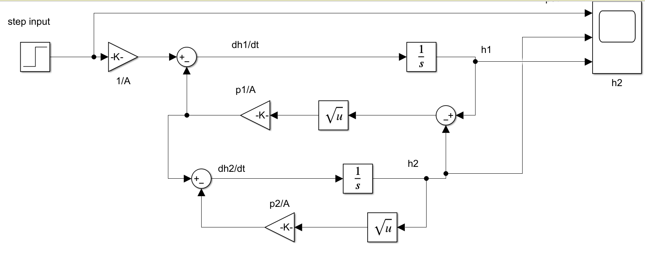

Input parameters

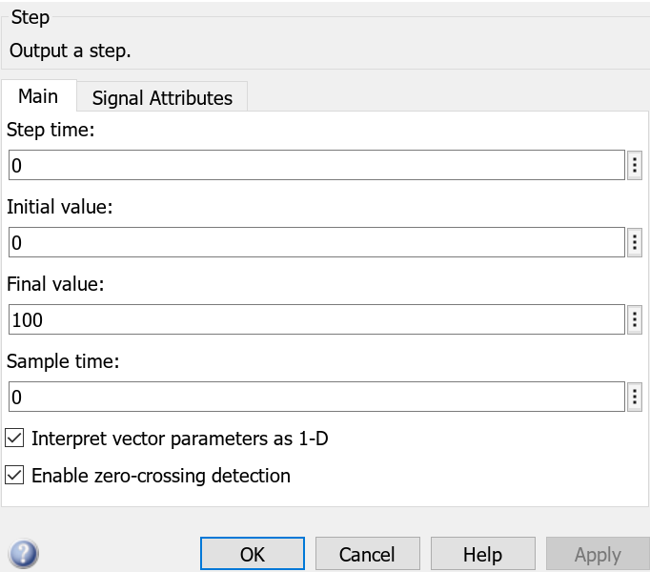

**Graph for height of both tank Vs time** 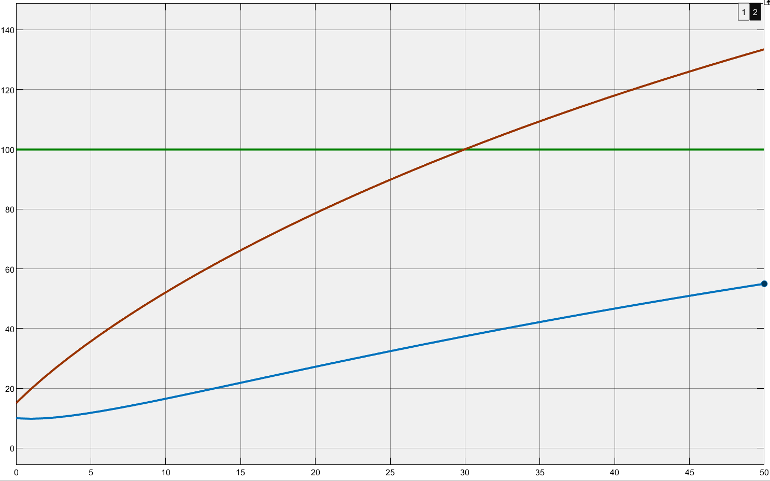

Height in cm

Time in seconds

Input parameters for step input of 250

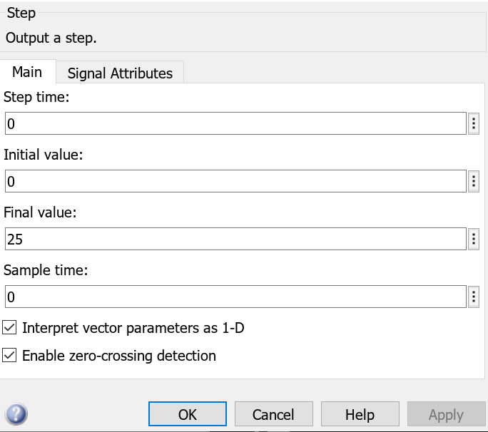

**Graph for height of both tank Vs time**

Height in cm

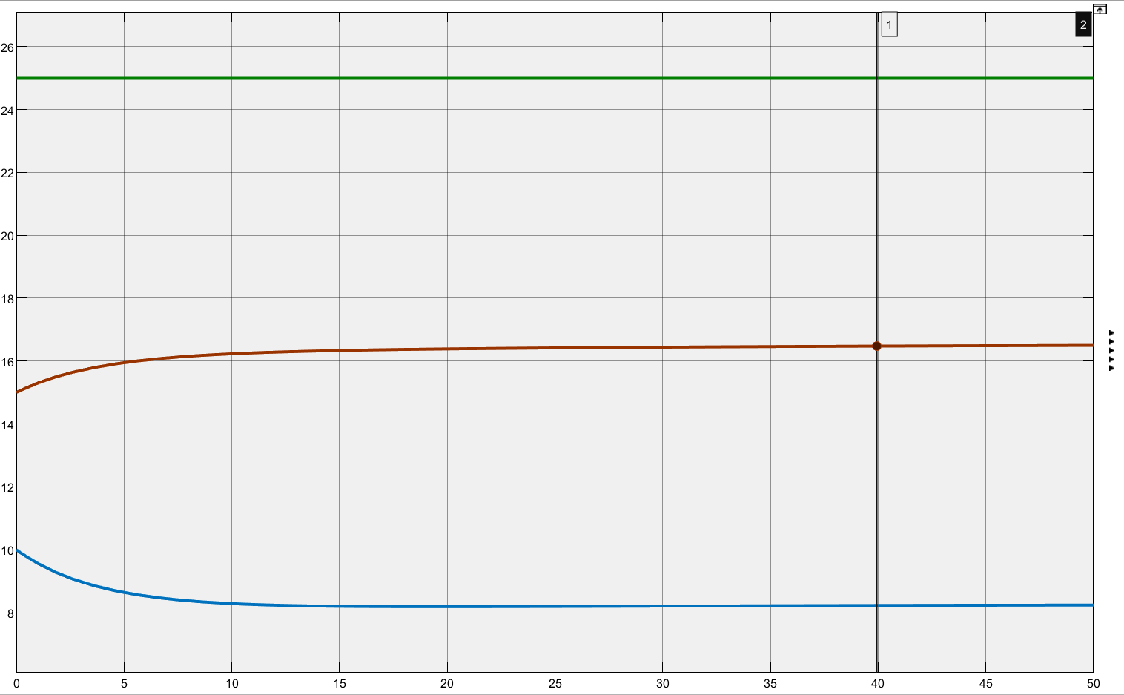

Time in seconds

Height of tank 1 height of tank 2

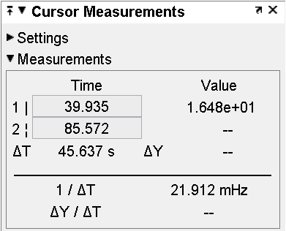 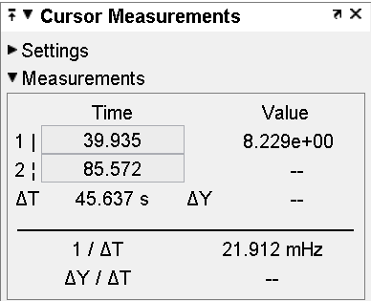

Linearized model for 2 tank system

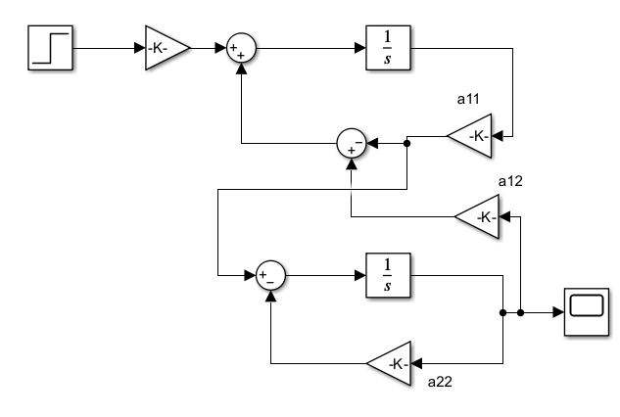

Input parameters for step input of 25



Graph of height of tank 2 Vs time

Height in cm

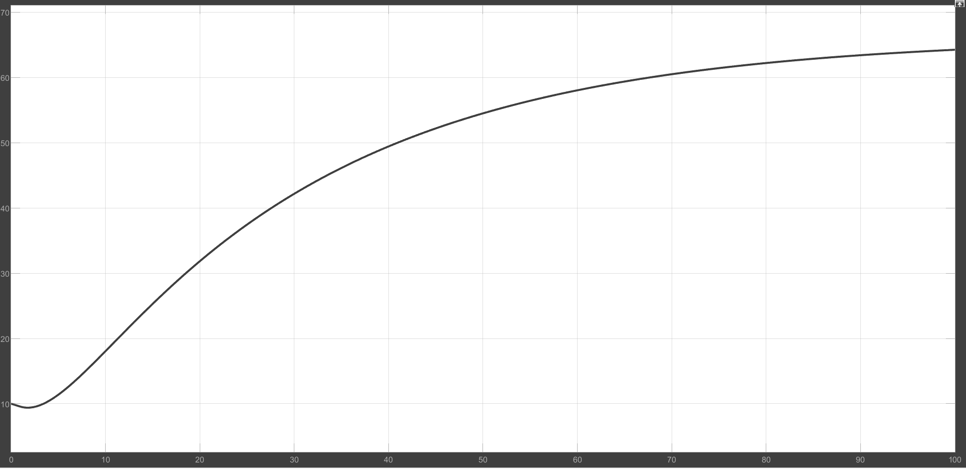

Time in seconds

**Transfer function**

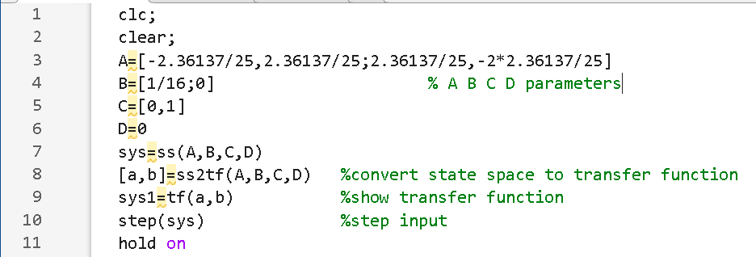

Transfer function of linear model

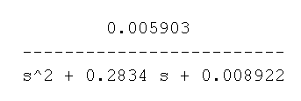

**Conclusion:**

Nonlinear system was modelled and graph of height of both tank was observed. We found out the equilibrium point of the system and linearized it about operating point. And observed the graph of height of tank two of linear system.