# 3D DATA PROCESSING LAB 3

Giuseppe Labate mat.2095665

**Topic:** Iterative Closest Point Cloud Registration

**Goal:** Given a source and a target point cloud roughly aligned, find the fine alignment  
transformation of the source to the target cloud.

## Work description

### Task 1 – **find_closest_point**

For this task, the objective was to find the nearest target_point for each source_point.  
To do so, I used a KD-tree to store the target_ point cloud, which accelerates the process of finding the nearest source_point.  
Next, a source_clone point cloud was created to save the source_for_icp_ point cloud, which is the source point cloud transformed by the current estimation of transformation_.

To find the closest point, the SearchKNN function with K = 1 was exploited.

When a neighbor is found, its square distance is checked. If it’s below a certain arbitrary threshold (0.2 in this case), the source and target indices are saved into two std::vector and the mean square error (MSE) is updated to keep track of the current error.

After the for loop is completed, the root mean square error (RMSE) is calculated by taking the square root of the final MSE.

Finally, a tuple composed of the source_indices, target_indices and RMSE is returned.

### Task 2 – **get_svd_icp_registration**

Here it was requested to apply the singular value decomposition (SVD) to find the transformation from source to target.

To achieve this, the transformed source point cloud, source_for_icp_ was saved to source_clone.  
The source_for_icp_ is the initial source point cloud to which the current estimation of the transformation_ was applied.

Next, the centroids for source and target point clouds were calculated and saved in the source_centroid and target_centroid 3D vectors, respectively.

With the centroids identified, the difference between each point in the point cloud and its centroid was retrieved, following the nearest neighbor (NN) matching indices order, returned by find_closest_point.  
In other words, for each iteration ***i***, the source_clone.points_[source_indices[i]] and target_clone.points_[target_indices[i]] were picked to compute the difference between them and their respective centroids:  
source_point = source_point - source_centroid;   
target_point = target_point - target_centroid;  
applying the following formulas:

Subsequentially, the 3x3 **W** matrix was computed by multiplying the and the transpose of and summing the result for each iteration:

Note that *m* variables represent for target point and *d* variables represent source points.

The **W** matrix is crucial for finding the transformation between two point clouds.  
In fact, the rotation matrix can be written as:

Given:

The U and V matrices were found to derive the rotation matrix.  
This was achieved by applying the singular value decomposition (SVD) to **W** by using Eigen::JacobiSVD<Eigen::MatrixXd> svd(W, Eigen::ComputeFullU | Eigen::ComputeFullV);

The special case in which the was also handled, by computing the rotation matrix as follows:

Note that to check if the determinant was negative, it was needed only to compute and multiply and because

*Figure 1: implementation of SVD*

Next, the translation vector was calculated as the difference between the target_centroid and the rotated source_centroid.

Finally, the rotation matrix and translation vector were concatenated into a 4D transformation matrix, which was then returned.

### Task 3 – PointDistance

In task 3 the objective was to complete the PointDistance struct to include an auto-differentiable cost function.  
This part was similar to the Bundle Adjustment in the previous assignment.  
The main difference here was that the function now had to optimize only the transformation array, which is composed by:

* 3 cells for the rotation (expressed in angle-axis representation)
* 3 cells for the translation (tx, ty, tz)

The operator() function was used for two purposes:

* to transform the source_point first by rotating it with the AngleAxisRotatePoint function and then by translating it by exploiting the last 3 cells of transf array;
* to retrieve the residual by computing the difference between transformed source_point and target_point (Note that the residual is 3 dimensional).

### Task 4 – **get_lm_icp_registration**

In this task, it was requested to use the Levenberg-Marquardt algorithm (LM) to find the best roto-translation matrix.

Similar to task 2, the source_for_icp_ point cloud was stored in source_clone to easily access to the point cloud with the current estimated transformation.

Next, for each point in source_clone, the cost_function was created using the coupled source and target points as parameters. In the same iteration, the residual block was added to the problem, with the cost_function and the transformation_arr (the array containing the roto-translation transformation) as parameters.

After exiting the loop, the ceres::Solve function was executed to obtain the transformation.

*Figure 2: Ceres process to use LM to get the estimated transformation*

Once Ceres solved the problem, the transformation_arr vector was accessed to compute the 4D roto-translation matrix transformation.  
The rotation matrix **R** was obtained from the first three angle-axis cells using the Eigen::AngleAxisd method.   
The translation vector was instead directly extracted from the last three cells.

Finally, the rotation matrix and translation vector were concatenated into a 4D transformation matrix, which was then returned.

### Task 5 – **execute_icp_registration**

Task 5 was the most important one because it was the function from which all the other functions were called.  
A primary for loop iterates up to a maximum of max_iteration (100) times to execute the following steps:

* **Find Closest Points:** Launch find_closest_point to get coupled points (the source and target indices) and current RMSE.
* **Check Convergence:** If the absolute difference between previous and current RMSE is less than relative_rmse (which is equal to 1e-6 in this case), return because the execution converged.
* **Update RMSE:** Update the prev_rmse to current_rmse
* **Perform ICP Registration:** Launch get_lm_icp_registration if mode == “lm” or launch get_svd_icp_registration if mode == “svd”
* **Save Transformation:** Save the returned transformation into new_transformation
* **Update transformation_ and source cloud:** Update the transformation_ 4D matrix and transform source_for_icp_ using new_transformation to avoid recalculating the transformed source cloud each time.

If after max_iteration the algorithm hasn’t converged, a "Diverged: MAX_ITERATION surpassed." message is sent.

## Encountered problems

During the assignment, no major problems were encountered.

## Quantitative results

|  |  |  |
| --- | --- | --- |
|  | SVD RMSE | LM RMSE |
| Bunny | 0.00401621 | 0.00341366 |
| Dragon | 0.00568867 | 0.00564134 |
| Vase | 0.0162243 | 0.0162217 |

|  |  |  |
| --- | --- | --- |
|  | SVD ITERATIONS | LM ITERATIONS |
| Bunny | 23 | 21 |
| Dragon | 13 | 19 |
| Vase | 25 | 29 |

## Qualitative results

### 4.1) Bunny

#### 4.1.1) Bunny SVD 🡪 0.00401621 at iteration 23

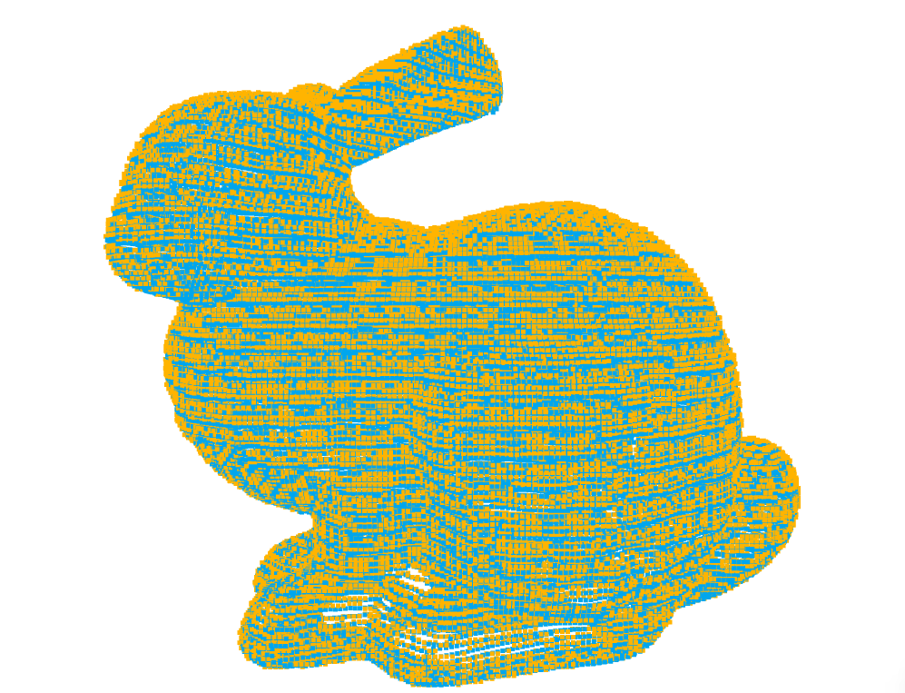

#### 4.1.2) Bunny LM 🡪 0.0341366 at iteration 21

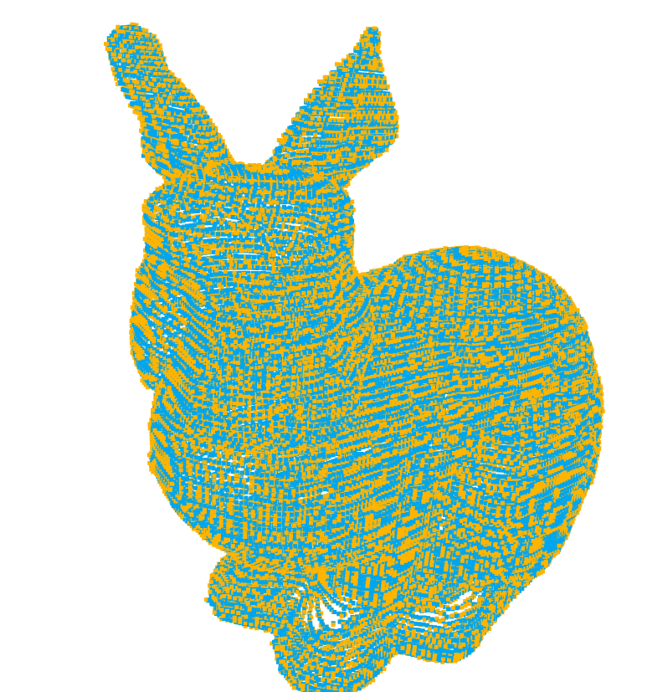 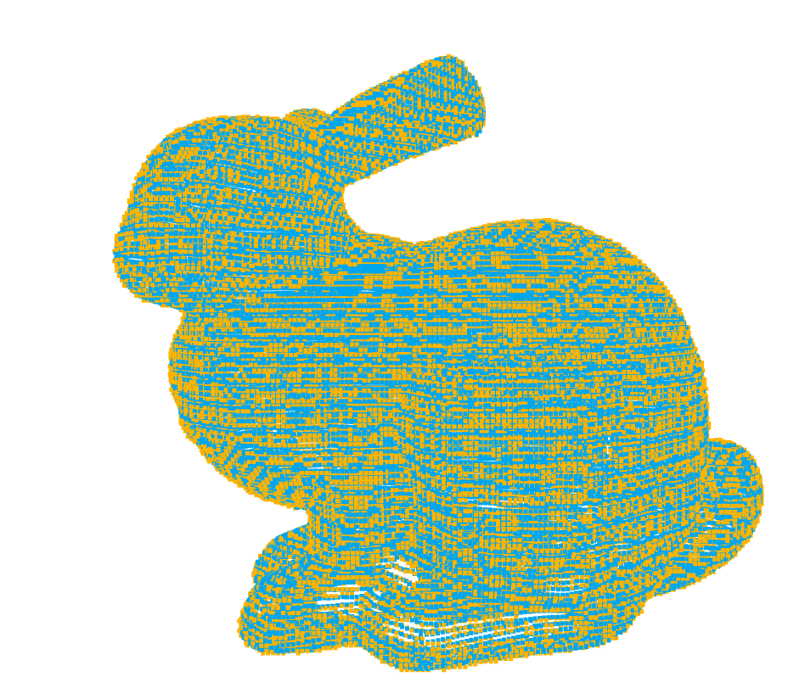

### 4.2) Dragon

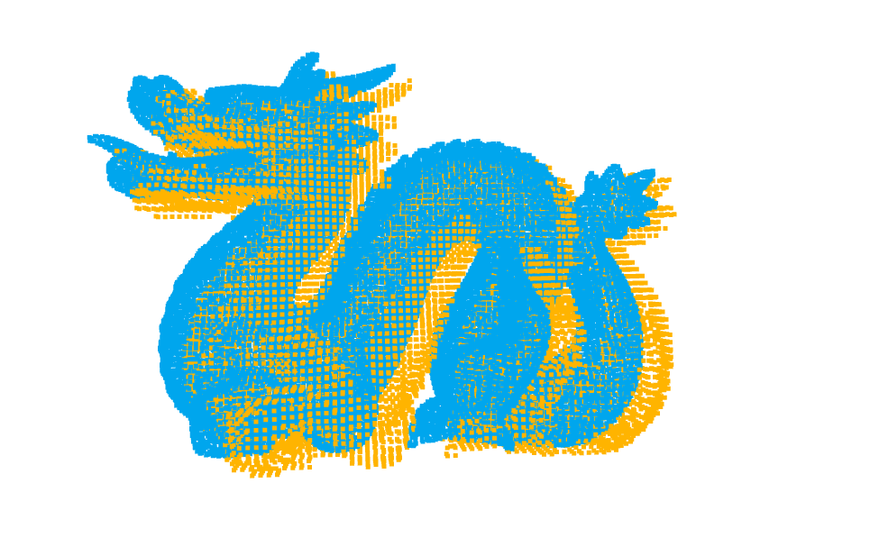

#### 4.2.1) Dragon SVD 🡪 0.00568867 at iteration 13

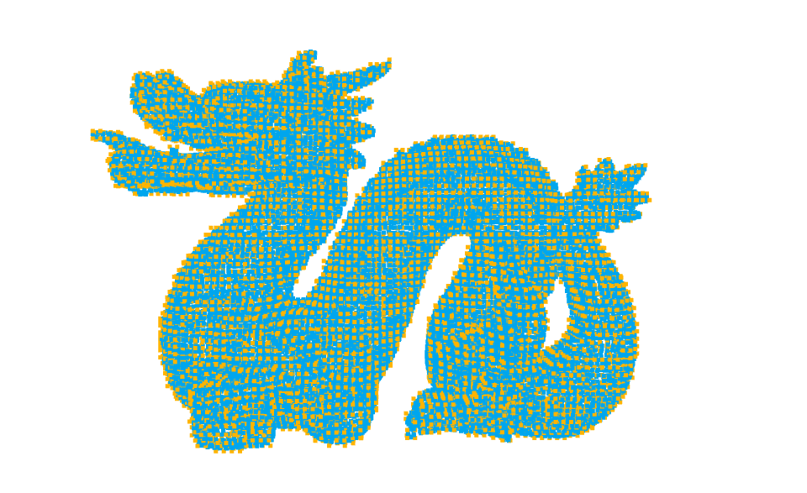 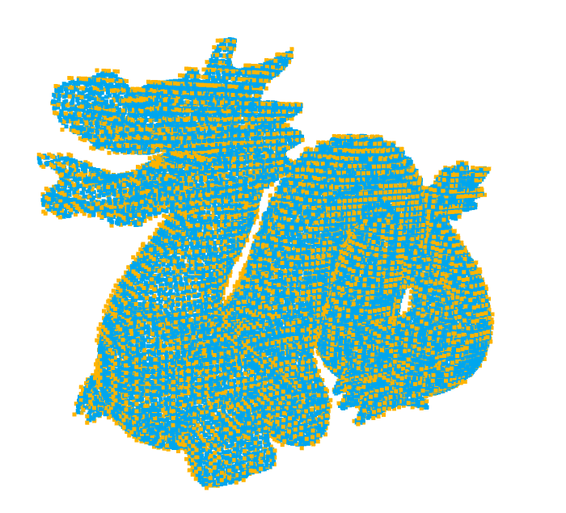

#### 4.2.2) Dragon LM 🡪 0.00564134 at iteration 19

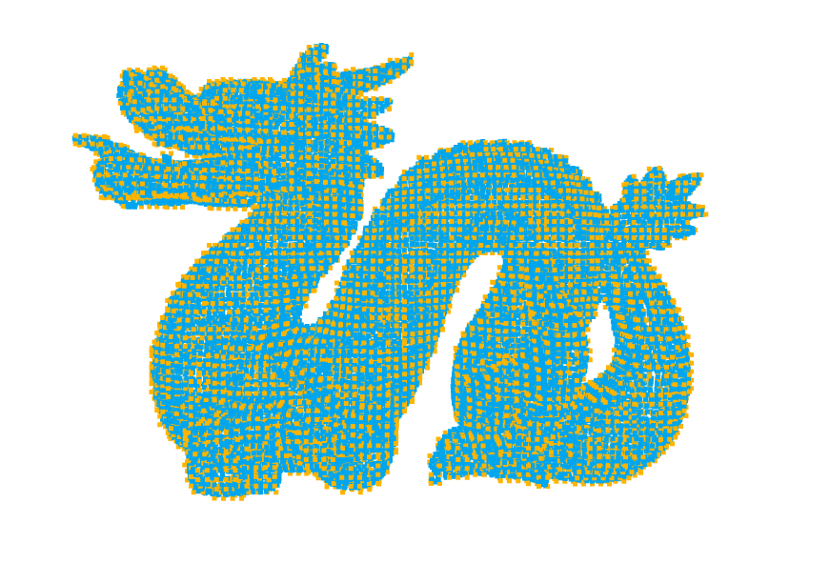 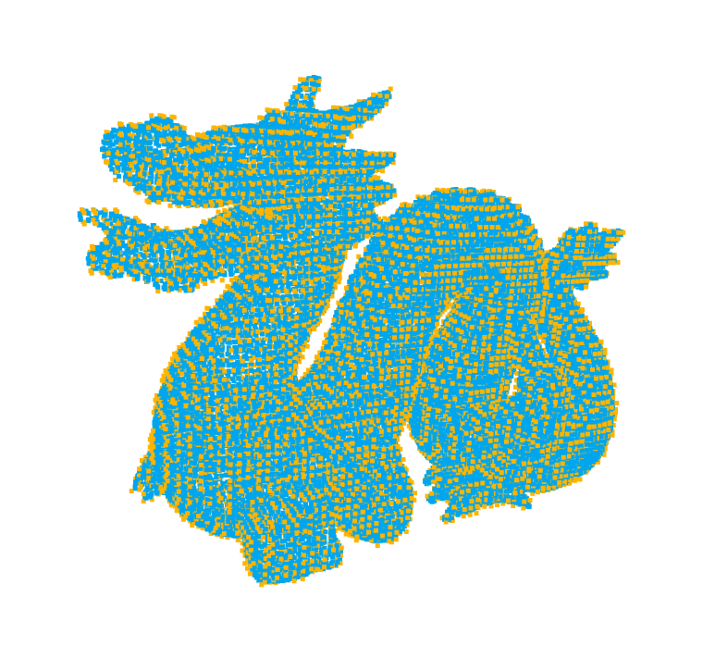

### 4.3) Vase

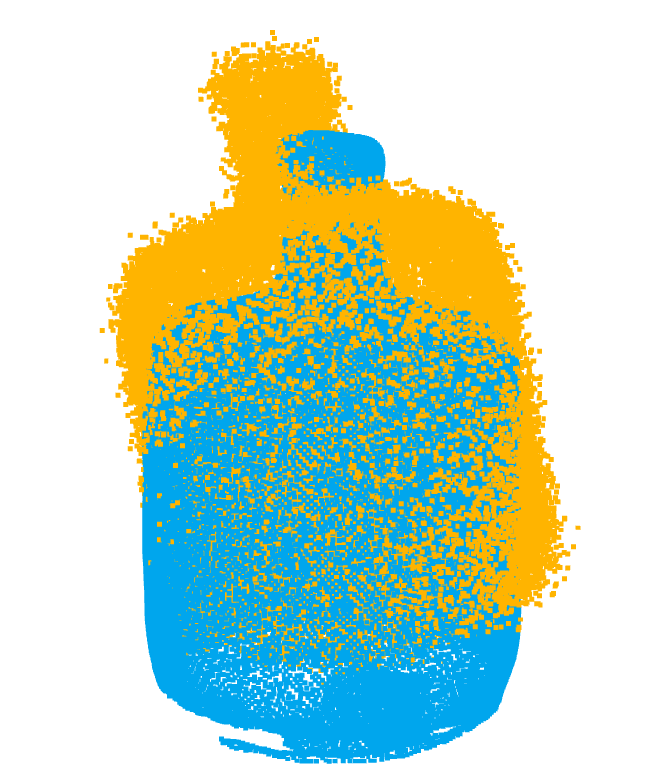

#### 4.3.1) Vase SVD 🡪 0.0162243 at iteration 25

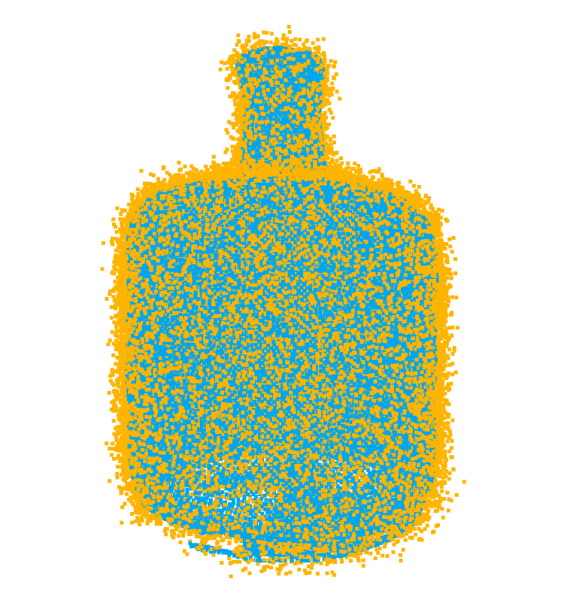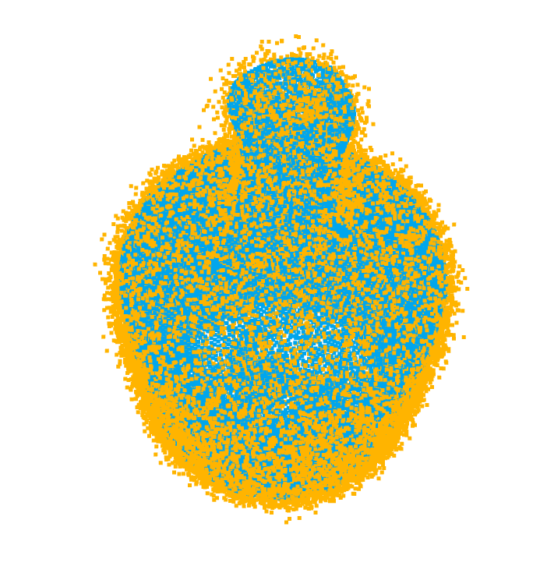

#### 4.3.2) Vase LM 🡪 0.0162217 at iteration 29

