Emodio: AI-Powered Vocal Biomarkers for Teletherapy

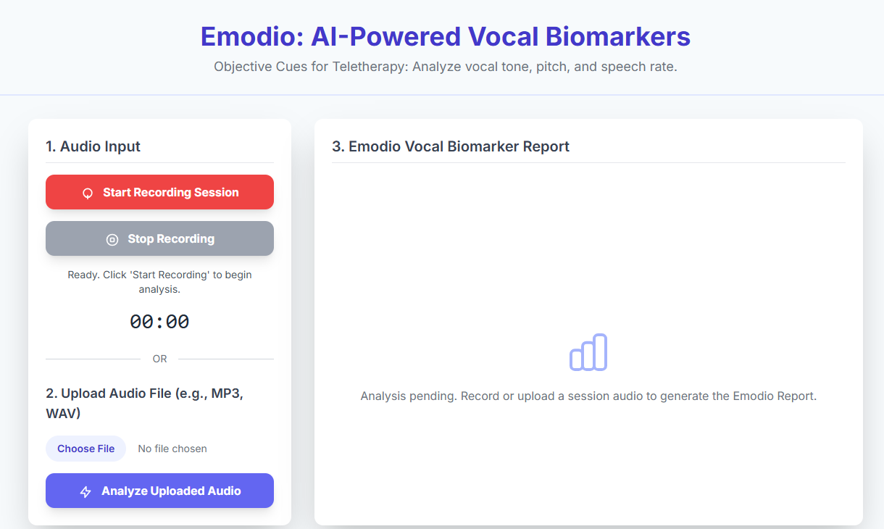
Fig 1.0 (Prototype of the emodio API)
Theme: AI in Healthcare
Problem Statement

Teletherapy (remote mental health services) faces a significant challenge: clinicians lose important non-verbal emotional cues, for example, changes in vocal tone, pitch, and rate of speech, when they move from in-person visits to video calls. This results in subjective assessment, a delayed intervention on the part of the clinician, and less accurate diagnosis, especially with subtle changes indicating conditions such as depression or anxiety.

Goal: To supply therapists and clinicians with objective, real-time data to support human judgment.

Proposed Solution: Emodio (Emotional Monitoring Dashboard)

Emodio is an AI-based intelligent system that analyzes the human emotion in a person's voice using AI and Signal Processing techniques. Emodio is primarily intended to provide therapists with insights about the emotional disposition of their patients that may be lost during remote or online therapy sessions.
Emodio analyzes a user’s voice by either recording it in real-time or analyzing a user-uploaded audio file. The system extracts important audio features (e.g., MFCCs, pitch, energy, and speech rate) using a signal processing library, such as Librosa or OpenSMILE. The extracted audio features are passed as input into a trained AI/ML classification model that can identify the emotional tone of the speaker, including happiness, sadness, anger, fear, or neutrality.
After the data is processed, the data will be available for review on the Emodio Dashboard and therapists will also be able to visualize how the Emotional Intensity Graph shifts over the course of the conversation. The Virtual Dashboard acts as a real-time emotional tracking system. The API also converts the subjective emotional expression into documented data points that support diagnostic and therapy decision-making.

The system has been designed to be a modular API service that can plug into a pre-existing teletherapy or mental health application. The system will have an API back-end developed with either Flask or Fast API. The front-end will be in HTML, JavaScript and Tailwind CSS to create a clean user experience. The API can be hosted on any cloud platform like AWS or Google Cloud to make it scalable and eliminate latency.

Technical Stack

Layer | Component | Technology Used | Purpose
1. Signal Processing | Feature Extraction | Python (Librosa) | Converts raw voice into key audio features like MFCCs and zero-crossing rate for tone and emotion analysis. This is the foundation of our model.
2. AI/ML Core | Emotion Classification | TensorFlow / Scikit-learn | A lightweight model (LSTM) trained on public datasets such as RAVDESS or CREMA-D ensures balanced accuracy and real-time performance.
3. Deployment / API | Backend & Dashboard | Flask / FastAPI, HTML, JS, Tailwind CSS | Builds a REST API with a clean, responsive dashboard for therapists, ensuring smooth visualization and easy integration.

Real-World Impact and Feasibility

Emodio seeks to transform emotional measurement in teletherapy by providing therapists with real-time, data-informed insights during virtual sessions. Emodio interprets vocal signals into measurable emotional patterns to provide clinicians with a more objective and timely assessment of disorders such as depression and anxiety. Emodio even has the potential to increase diagnostic objectivity by 15-20%, enabling earlier interventions for better mental health outcomes.
With regards to the deployment, Emodio is developed with a micro-service based API architecture for ease of integration into existing teletherapy infrastructures. This architecture provides horizontal scalability, as it enables the system to operate across multiple therapy sessions at the same time, as healthcare systems implement and integrate into numerous teletherapy sessions.
The project is definitely possible, especially given the clear linear development path. The main components of the project (speech feature extraction, model training, and API development) will all happen using open-source technologies and publicly available emotional speech datasets. The first developments will be a baseline speech emotion detection model using both AI and signal processing methodologies. After sufficient reliability is achieved, the model will be published as a lightweight API on the web as well as a dashboard for real-time emotion tracking and visualizations during voice-based engagements.
In the future, the goal for Emodio is to ultimately become a multimodal emotional analysis system. The next developmental stage will add Natural Language Processing (NLP) to better assess not only how someone speaks but also what is being said. This multimodal emotion analysis will combine a comprehensive Multimodal Emotion Score (Voice + Text), offering richer contextual emotional assessments and improving the overall accuracy, empathy, and effectiveness of remote therapy sessions.

