**Introduction:** This excercise solves a simulation problem using SAS. A sub branch of a major bank has only one point. An exponential distribution mean of inter-arrival of costumer is 5 min. There is probability 0.7 that costumer is business costumer and 0.3 probability that costumer is private costumer. Service time have exponential distribution mean of 5 min for business costumer and 2 min for private costumer.

**1 Simulating 200 arrivals:** Foe simulating 200 arrivals a code is typed as given below into SAS. Type 1 is for business costumer and type 2 is for private costumer.

**data** queue;

retain arrive **0**;

retain finish **0**;

do i=**1** to **200**;

rand=ranuni(**1**);

type=**1**;

if rand<**0.7** then type=**2**;

between=ranexp(**5**);

arrive=arrive+between;

service=**2**\*ranexp(**5**);

if type=**1** then service=**5**;

if i=**1** then finish=arrive+service;

if i>**1** then finish=max(arrive,finish)+service;

total=finish-arrive;

output;

end;

**proc** **print** data=queue;

**run**;

|  |
| --- |
| The SAS System |

| **Obs** | **arrive** | **finish** | **i** | **rand** | **type** | **between** | **service** | **total** |
| --- | --- | --- | --- | --- | --- | --- | --- | --- |
| **1** | 0.030 | 1.864 | 1 | 0.18496 | 2 | 0.03037 | 1.83346 | 1.833 |
| **2** | 0.112 | 1.926 | 2 | 0.25940 | 2 | 0.08164 | 0.06241 | 1.814 |
| **3** | 0.744 | 7.926 | 3 | 0.54298 | 2 | 0.63169 | 5.99972 | 7.182 |
| **4** | 0.943 | 9.219 | 4 | 0.06657 | 2 | 0.19928 | 1.29302 | 8.276 |
| **5** | 3.643 | 14.219 | 5 | 0.85339 | 1 | 2.70031 | 5.00000 | 10.576 |
| **6** | 4.943 | 14.961 | 6 | 0.29719 | 2 | 1.29971 | 0.74233 | 10.018 |
| **7** | 6.428 | 19.961 | 7 | 0.97676 | 1 | 1.48498 | 5.00000 | 13.533 |
| **8** | 7.010 | 22.456 | 8 | 0.41276 | 2 | 0.58240 | 2.49497 | 15.446 |
| **9** | 7.179 | 23.366 | 9 | 0.47579 | 2 | 0.16843 | 0.90976 | 16.187 |
| **10** | 7.719 | 25.317 | 10 | 0.59036 | 2 | 0.54029 | 1.95095 | 17.598 |
| **11** | 8.399 | 30.317 | 11 | 0.72836 | 1 | 0.68003 | 5.00000 | 21.918 |
| **12** | 8.927 | 35.317 | 12 | 0.92912 | 1 | 0.52821 | 5.00000 | 26.390 |
| **13** | 9.677 | 36.090 | 13 | 0.39104 | 2 | 0.74987 | 0.77272 | 26.413 |
| **14** | 11.470 | 36.366 | 14 | 0.16809 | 2 | 1.79260 | 0.27599 | 24.896 |
| **15** | 11.537 | 36.575 | 15 | 0.29879 | 2 | 0.06759 | 0.20968 | 25.038 |
| **16** | 14.542 | 40.572 | 16 | 0.56878 | 2 | 3.00486 | 3.99626 | 26.029 |
| **17** | 15.379 | 44.045 | 17 | 0.51132 | 2 | 0.83655 | 3.47334 | 28.666 |
| **18** | 16.283 | 48.211 | 18 | 0.66504 | 2 | 0.90432 | 4.16612 | 31.928 |
| **19** | 17.895 | 49.318 | 19 | 0.45349 | 2 | 1.61167 | 1.10734 | 31.424 |
| **20** | 18.716 | 54.318 | 20 | 0.73847 | 1 | 0.82141 | 5.00000 | 35.602 |

In the above table the first costumer arrives after 0.030 minutes and the service takes 1.8336 minutes and the second costumer arrives 0.081 minutes after the first and the service takes 0.064 but it can be seen that when the second costumer arrives the first one is being served because second arrives after 0.081 while the service time for the first costumer is 1.833 this shows the second one has to wait for the service. If the time in between is less than service, then every new costumer will have to wait to get served. Arrive shows arrival time of each costumer by adding the values of between this means arrival time for each costumer after the first costumer.

**2 Calculate the size of queue each costumer finds on arrival:** To solve this problem a list of events is required and in this case they are arrive and finish. Type 1 is arrival and type 2 departure. Two data set are created with arrive in one dataset with type=1 and finish in another dataset with type=2.

**data** arrive;

set queue;

evtype=**1**;

events=arrive;

keep evtype events;

output;

**data** finish;

set queue;

evtype=**2**;

events=finish;

keep evtype events;

output;

**data** events;

set arrive finish;

**proc** **sort** data=events;

by events;

**proc** **print** data=events;

**run**;

|  |
| --- |
| The SAS System |

| **Obs** | **evtype** | **events** |
| --- | --- | --- |
| **1** | 1 | 0.030 |
| **2** | 1 | 0.112 |
| **3** | 1 | 0.744 |
| **4** | 1 | 0.943 |
| **5** | 2 | 1.864 |
| **6** | 2 | 1.926 |
| **7** | 1 | 3.643 |
| **8** | 1 | 4.943 |
| **9** | 1 | 6.428 |
| **10** | 1 | 7.010 |
| **11** | 1 | 7.179 |
| **12** | 1 | 7.719 |
| **13** | 2 | 7.926 |
| **14** | 1 | 8.399 |
| **15** | 1 | 8.927 |
| **16** | 2 | 9.219 |
| **17** | 1 | 9.677 |
| **18** | 1 | 11.470 |
| **19** | 1 | 11.537 |
| **20** | 2 | 14.219 |

**Size of the Queue each costumer finds on arrival:**

To calculate the queue length for each arrival the given code is typed. Here the length is the queue length for each arrival. For calculating length 1 is added for every arrival and 1 is subtracted for every departure.

**data** length;

set events;

retain length -**1**;

if evtype=**2** then length=length-**1**;

else length=length+**1**;

if evtype=**1** then output;

keep length;

**proc** **print** data=length;

**run**;

|  |
| --- |
| The SAS System |

| **Obs** | **length** |
| --- | --- |
| **1** | 0 |
| **2** | 1 |
| **3** | 2 |
| **4** | 3 |
| **5** | 2 |
| **6** | 3 |
| **7** | 4 |
| **8** | 5 |
| **9** | 6 |
| **10** | 7 |
| **11** | 7 |
| **12** | 8 |
| **13** | 8 |
| **14** | 9 |
| **15** | 10 |
| **16** | 10 |
| **17** | 10 |
| **18** | 11 |
| **19** | 12 |
| **20** | 13 |

In the above table it can be seen that the first costumer finds queue length to be 0 and the 2nd costumer finds queue length 1 and the 3rd finds it 2. It is known from the previous table that if costumer is arriving faster than the service time then queue will build.

**Calculate mean maximum and minimum waiting time and mean maximum minimum queue length encountered:**

For this a code is typed into SAS. With the data queue.

**data** queue;

set queue;

merge length;

queue=total-service;

**proc** **means** data=queue mean max min;

var queue length;

**run**;

|  |
| --- |
| The SAS System |

The MEANS Procedure

| **Variable** | **Mean** | **Maximum** | **Minimum** |
| --- | --- | --- | --- |
| |  | | --- | | **queue** | | **length** | | |  | | --- | | 201.4613571 | | 67.8500000 | | |  | | --- | | 379.5000770 | | 131.0000000 | | |  | | --- | | 0 | | 0 | |

So mean waiting time for costumer is 201.46 and the maximum waiting time 379.500 and minimum 0 and for the length encountered by costumer has a mean of 67.85 with 131.00 maximum and 0 minimum.

**Graphs and summary statistics for the waiting time and queue length encountered:**

**This graph shows the arrive time and the finishing time.** It shows the relation between arrival time and finish time to investigate that, are costumers arriving faster than finishing service or vice versa.

**proc** **gplot** data=queue;

symbol1 i=r v=plus;

plot arrive*finish;

**run**;

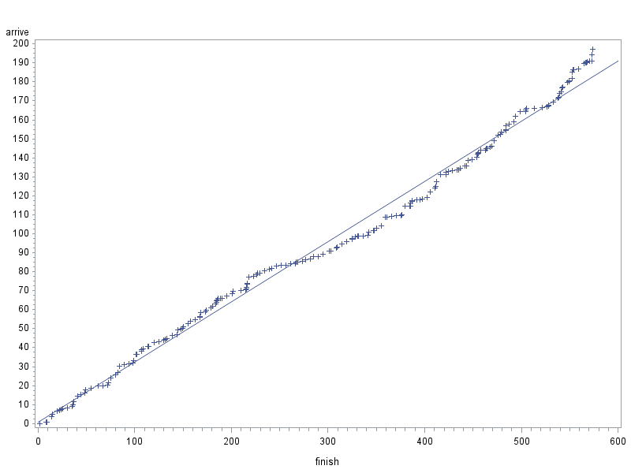

The finishing time is the accumulation of the values of arrive and adding value of service for every arrival and arrive is the value we get by accumulating between values. The service for the new costumer will not begin until previous one is served. so the above graph shows the arrival time is going up and the finishing time also going up but average finishing time is greater than arriving time which means costumer are waiting in the queue for service.

Means of arrive and finish are also required for the investigation.

**proc** **means** data=queue;

var arrive finish;

**run**;

|  |
| --- |
| The SAS System |

The MEANS Procedure

| **Variable** | **N** | **Mean** | **Std Dev** | **Minimum** | **Maximum** |
| --- | --- | --- | --- | --- | --- |
| |  | | --- | | **arrive** | | **finish** | | |  | | --- | | 200 | | 200 | | |  | | --- | | 95.8594863 | | 300.1881453 | | |  | | --- | | 54.8671046 | | 172.2169090 | | |  | | --- | | 0.0303678 | | 1.8638279 | | |  | | --- | | 197.1819363 | | 573.4907674 | |

The average arriving time is 95.8594 and has maximum 197.181 and minimum 0.0303 and finishing time has mean of 300.188 with the maximum of 573.4907 and minimum 1.8638. This show that the finishing time is much higher on average than arrival time which shows that new arrival has to wait for the service when the previous costumer is being served.

**This graph shows the length every new arrival has to face**. So this code it typed to investigate the length each new costumer finds on arrival.

**proc** **gplot** data=queue;

symbol1 i=r v=plus;

plot arrive*length;

**run**;

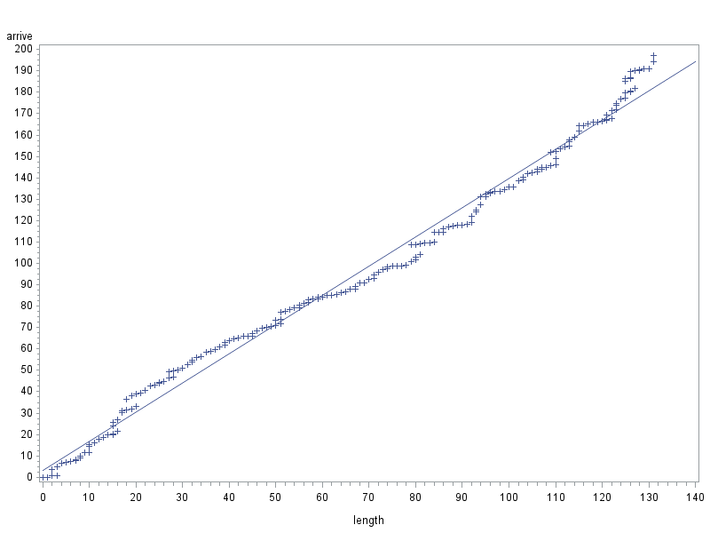

The output table shows that the length is increasing with every new arrival as it can be seen that on average a new arrival find longer queue than previous one. Slow service is causing queue build-up.

**proc** **means** data=queue;

var arrive length;

**run**;

|  |
| --- |
| The SAS System |

The MEANS Procedure

| **Variable** | **N** | **Mean** | **Std Dev** | **Minimum** | **Maximum** |
| --- | --- | --- | --- | --- | --- |
| |  | | --- | | **arrive** | | **length** | | |  | | --- | | 200 | | 200 | | |  | | --- | | 95.8594863 | | 67.8500000 | | |  | | --- | | 54.8671046 | | 40.0401494 | | |  | | --- | | 0.0303678 | | 0 | | |  | | --- | | 197.1819363 | | 131.0000000 | |

The average length found by costumer arriving is 67.85 with maximum length of 131.00 and minimum of 0.

**This Graph shows arrival time and service times.** This investigate relation between arrivals and service and also is service time going up with new arrivals or not.

**proc** **gplot** data=queue;

symbol1 i=r v=plus;

plot arrive*service;

**run**;

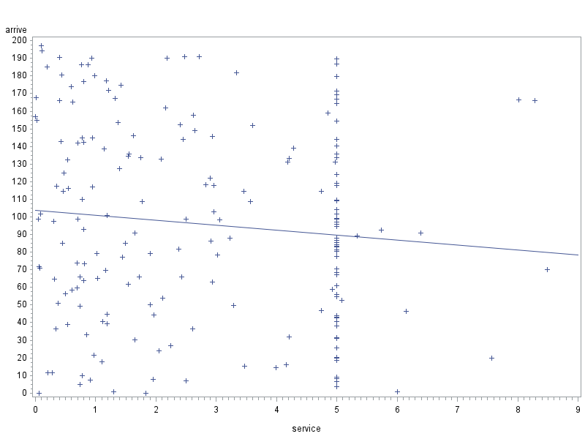

**proc** **means** data=queue;

var arrive service;

**run**;

|  |
| --- |
| The SAS System |

The MEANS Procedure

| **Variable** | **N** | **Mean** | **Std Dev** | **Minimum** | **Maximum** |
| --- | --- | --- | --- | --- | --- |
| |  | | --- | | **arrive** | | **service** | | |  | | --- | | 200 | | 200 | | |  | | --- | | 95.8594863 | | 2.8673020 | | |  | | --- | | 54.8671046 | | 2.0553666 | | |  | | --- | | 0.0303678 | | 0.0025920 | | |  | | --- | | 197.1819363 | | 8.4882286 | |

**This graph shows the time between the new arrival (between) and the service:** Between is the gap of new costumer arriving after first on and if service is still going then he will have to wait. This graph will investigate that.

**proc** **gplot** data=queue;

symbol1 i=r v=plus;

plot between*service;

**run**;

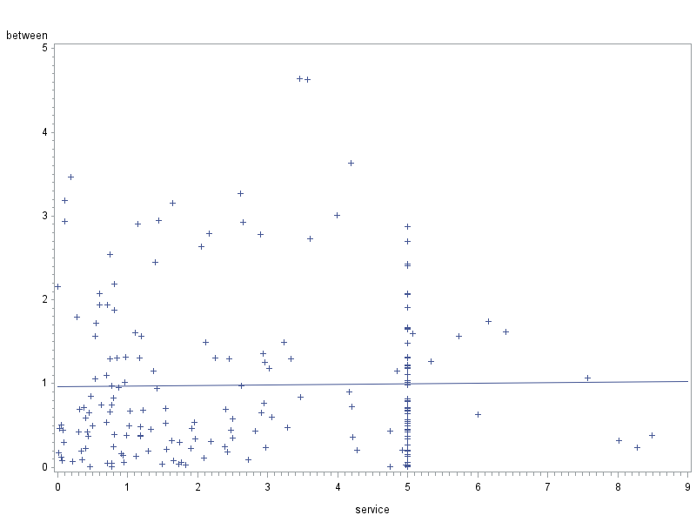

The above graph shows that the time in between every arrival on y axis and service time on x axis. So the average service time showing more increase than between time which is almost same, this shows that queue is building because customers are not being served faster than arrival of every new costumer.

**proc** **means** data=queue;

var between service;

**run**;

|  |
| --- |
| The SAS System |

The MEANS Procedure

| **Variable** | **N** | **Mean** | **Std Dev** | **Minimum** | **Maximum** |
| --- | --- | --- | --- | --- | --- |
| |  | | --- | | **between** | | **service** | | |  | | --- | | 200 | | 200 | | |  | | --- | | 0.9859097 | | 2.8673020 | | |  | | --- | | 0.9189717 | | 2.0553666 | | |  | | --- | | 0.0057919 | | 0.0025920 | | |  | | --- | | 4.6423726 | | 8.4882286 | |

The mean between time is also less than the service time so it is clear that a queue is building because of that. The means time between every new arrival is 0.985 min while service takes more time with average 2.867 minutes.

**This graph show service time and length:**

**proc** **gplot** data=queue;

symbol1 i=r v=plus;

plot service*length;

**run**;

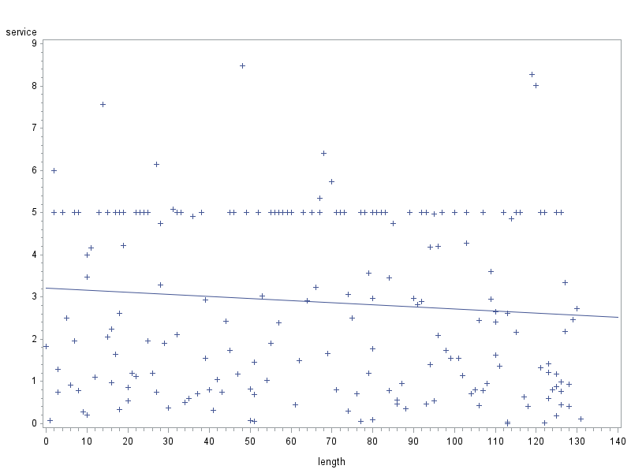

This graph shows that the average service time is going down as the length is increasing.

**proc** **means** data=queue;

var service length;

**run**;

|  |
| --- |
| The SAS System |

The MEANS Procedure

| **Variable** | **N** | **Mean** | **Std Dev** | **Minimum** | **Maximum** |
| --- | --- | --- | --- | --- | --- |
| |  | | --- | | **service** | | **length** | | |  | | --- | | 200 | | 200 | | |  | | --- | | 2.8673020 | | 67.8500000 | | |  | | --- | | 2.0553666 | | 40.0401494 | | |  | | --- | | 0.0025920 | | 0 | | |  | | --- | | 8.4882286 | | 131.0000000 | |

**Conclusion from Graphs and summary statistics:**

The above graphs and summary statistics shows that a queue is building up because costumer are not being served with a required service speed and the new arriving costumer has to wait to get served. The arrive and finish graph shows that the finishing time is greater then arriving time, a new costumer will not get served until previous one is served and also the arrive and length graph shows that average length is increasing with the new arrivals. Between and service graph shows that time between new arrival is less than service time which indicate service time is the reason of queue build up.

The analysis of graphs show that service providers are not providing service with required speed causing costumer to wait. So many option can be considered but one option is to open a new service point for business customers.

For that a new code is typed with data queue and again 200 arrivals are stimulated.

**If a new service point for business costumer is opened:**

**data** queue;

retain arrive **0**;

retain finish **0**;

do i=**1** to **200**;

rand=ranuni(**1**);

type=**1**;

if rand<**0.7** then type=**2**;

between=ranexp(**5**);

arrive=arrive+between;

service=**2**\*ranexp(**5**);

if type=**1** then service=**5**;

if type=**1** then service=**0**;

if i=**1** then finish=arrive+service;

if i>**1** then finish=max(arrive,finish)+service;

total=finish-arrive;

if type=**2** then output;

end;

**data** queue;

set queue;

merge length;

queue=total-service;

**proc** **means** data=queue mean max min;

var queue length;

**run**;

Below is the mean, maximum and minimum for queue and length after opening a new service point for the business customers.

|  |
| --- |
| The SAS System |

The MEANS Procedure

| **Variable** | **Mean** | **Maximum** | **Minimum** |
| --- | --- | --- | --- |
| |  | | --- | | **queue** | | **length** | | |  | | --- | | 48.0591338 | | 48.0000000 | | |  | | --- | | 95.2275751 | | 97.0000000 | | |  | | --- | | 0 | | 0 | |

Here it can be seen that by opening a new service point for business customers mean queue time has been reduced from 201.5 to 48.05 and the maximum queue time has been reduced from 379.50 to 95.23 while the minimum is the same 0. Maximum queue length time has been reduced to 48.00 from 67.85 and maximum queue length has been reduced to 97.00 from 131.00 while the minimum is the same 0. So it is clear that opening a new counter for the business costumer can reduced waiting time and length of the queue.