**frame_0019**

yolov11 >>> showing car where there is no car

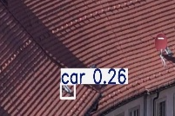

yolov11 >>> showing traffic light in place of bike rider

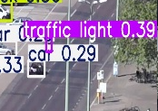

yolov11 >>> detecting person in very difficult spot | not detected by yolov12

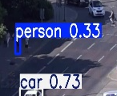

yolov11 >>> detecting less car than yolov12 | car detecting is mainly focused on central region

**frame_0024**

Yolov11 >>> Detected truck in place of car | yolov12 detected correctly

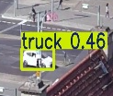

Yolov11 >>> failed to detected many car | detected by yolov12

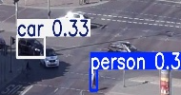 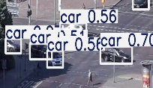

**frame_0036**

both yolov11 and yolov12 wrongly detected traffic light

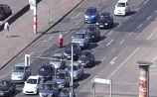 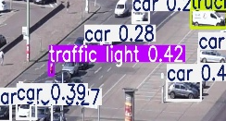 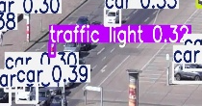

**frame_0042**

yolov12 correctly detected motocycle early | later detected by yolov11

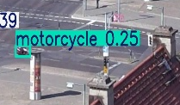

**frame_0072**

yolov12 detected motorcycle | not by yolov11 in any frame

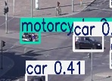

**Frame_0077**

Yolov12 detected traffic light correctly | not detected by yolov11

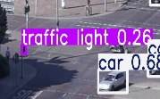

**Frame_0148**

Yolov12 correctly detected majority of car in central region | not by yolov11

