HTML - Lists

[Previous Page](https://www.tutorialspoint.com/html/html_tables.htm)

[Next Page](https://www.tutorialspoint.com/html/html_text_links.htm)

HTML offers web authors three ways for specifying lists of information. All lists must contain one or more list elements. Lists may contain −

* **<ul>** − An unordered list. This will list items using plain bullets.
* **<ol>** − An ordered list. This will use different schemes of numbers to list your items.
* **<dl>** − A definition list. This arranges your items in the same way as they are arranged in a dictionary.

HTML Unordered Lists

An unordered list is a collection of related items that have no special order or sequence. This list is created by using HTML **<ul>** tag. Each item in the list is marked with a bullet.

Example

[Live Demo](http://tpcg.io/QvdUjX)

<!DOCTYPE html>

<html>

<head>

<title>HTML Unordered List</title>

</head>

<body>

<ul>

<li>Beetroot</li>

<li>Ginger</li>

<li>Potato</li>

<li>Radish</li>

</ul>

</body>

</html>

This will produce the following result –

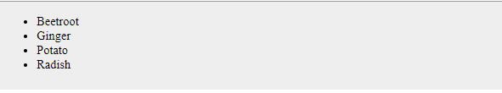

The type Attribute

You can use **type** attribute for <ul> tag to specify the type of bullet you like. By default, it is a disc. Following are the possible options −

<ul type = "square">

<ul type = "disc">

<ul type = "circle">

Example

Following is an example where we used <ul type = "square">

[Live Demo](http://tpcg.io/AGkGec)

<!DOCTYPE html>

<html>

<head>

<title>HTML Unordered List</title>

</head>

<body>

<ul type = "square">

<li>Beetroot</li>

<li>Ginger</li>

<li>Potato</li>

<li>Radish</li>

</ul>

</body>

</html>

This will produce the following result –

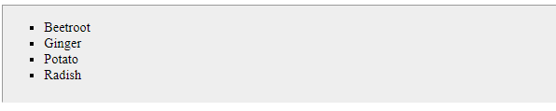

Example

Following is an example where we used <ul type = "disc"> −

[Live Demo](http://tpcg.io/CxW0Mz)

<!DOCTYPE html>

<html>

<head>

<title>HTML Unordered List</title>

</head>

<body>

<ul type = "disc">

<li>Beetroot</li>

<li>Ginger</li>

<li>Potato</li>

<li>Radish</li>

</ul>

</body>

</html>

This will produce the following result –

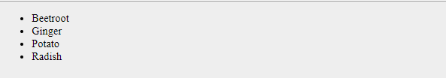

Example

Following is an example where we used <ul type = "circle"> −

[Live Demo](http://tpcg.io/iUFmCG)

<!DOCTYPE html>

<html>

<head>

<title>HTML Unordered List</title>

</head>

<body>

<ul type = "circle">

<li>Beetroot</li>

<li>Ginger</li>

<li>Potato</li>

<li>Radish</li>

</ul>

</body>

</html>

This will produce the following result –

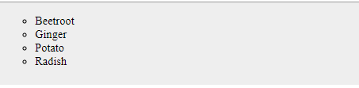

HTML Ordered Lists

If you are required to put your items in a numbered list instead of bulleted, then HTML ordered list will be used. This list is created by using **<ol>** tag. The numbering starts at one and is incremented by one for each successive ordered list element tagged with <li>.

Example

[Live Demo](http://tpcg.io/7bxlJW)

<!DOCTYPE html>

<html>

<head>

<title>HTML Ordered List</title>

</head>

<body>

<ol>

<li>Beetroot</li>

<li>Ginger</li>

<li>Potato</li>

<li>Radish</li>

</ol>

</body>

</html>

This will produce the following result –

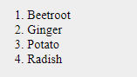

The type Attribute

You can use **type** attribute for <ol> tag to specify the type of numbering you like. By default, it is a number. Following are the possible options −

<ol type = "1"> - Default-Case Numerals.

<ol type = "I"> - Upper-Case Numerals.

<ol type = "i"> - Lower-Case Numerals.

<ol type = "A"> - Upper-Case Letters.

<ol type = "a"> - Lower-Case Letters.

Example

Following is an example where we used <ol type = "1">

[Live Demo](http://tpcg.io/1IgyrU)

<!DOCTYPE html>

<html>

<head>

<title>HTML Ordered List</title>

</head>

<body>

<ol type = "1">

<li>Beetroot</li>

<li>Ginger</li>

<li>Potato</li>

<li>Radish</li>

</ol>

</body>

</html>

This will produce the following result –

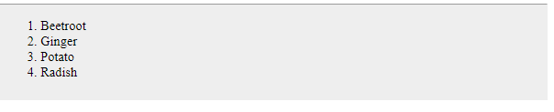

Example

Following is an example where we used <ol type = "I">

[Live Demo](http://tpcg.io/LlRUhH)

<!DOCTYPE html>

<html>

<head>

<title>HTML Ordered List</title>

</head>

<body>

<ol type = "I">

<li>Beetroot</li>

<li>Ginger</li>

<li>Potato</li>

<li>Radish</li>

</ol>

</body>

</html>

This will produce the following result –

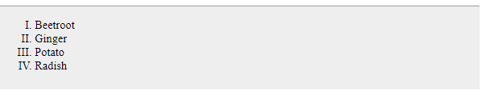

Example

Following is an example where we used <ol type = "i">

[Live Demo](http://tpcg.io/VJqDVU)

<!DOCTYPE html>

<html>

<head>

<title>HTML Ordered List</title>

</head>

<body>

<ol type = "i">

<li>Beetroot</li>

<li>Ginger</li>

<li>Potato</li>

<li>Radish</li>

</ol>

</body>

</html>

This will produce the following result –

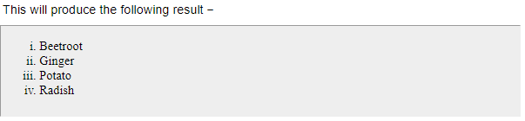

Example

Following is an example where we used <ol type = "A" >

[Live Demo](http://tpcg.io/NN69sS)

<!DOCTYPE html>

<html>

<head>

<title>HTML Ordered List</title>

</head>

<body>

<ol type = "A">

<li>Beetroot</li>

<li>Ginger</li>

<li>Potato</li>

<li>Radish</li>

</ol>

</body>

</html>

This will produce the following result –

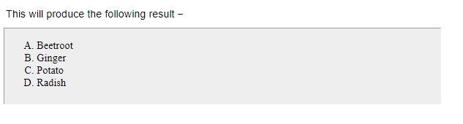

Example

Following is an example where we used <ol type = "a">

[Live Demo](http://tpcg.io/kCZI20)

<!DOCTYPE html>

<html>

<head>

<title>HTML Ordered List</title>

</head>

<body>

<ol type = "a">

<li>Beetroot</li>

<li>Ginger</li>

<li>Potato</li>

<li>Radish</li>

</ol>

</body>

</html>

This will produce the following result –

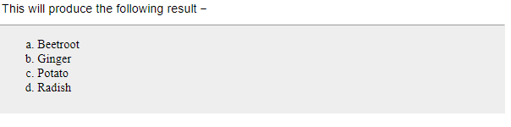

The start Attribute

You can use **start** attribute for <ol> tag to specify the starting point of numbering you need. Following are the possible options −

<ol type = "1" start = "4"> - Numerals starts with 4.

<ol type = "I" start = "4"> - Numerals starts with IV.

<ol type = "i" start = "4"> - Numerals starts with iv.

<ol type = "a" start = "4"> - Letters starts with d.

<ol type = "A" start = "4"> - Letters starts with D.

Example

Following is an example where we used <ol type = "i" start = "4" >

[Live Demo](http://tpcg.io/89i1AU)

<!DOCTYPE html>

<html>

<head>

<title>HTML Ordered List</title>

</head>

<body>

<ol type = "i" start = "4">

<li>Beetroot</li>

<li>Ginger</li>

<li>Potato</li>

<li>Radish</li>

</ol>

</body>

</html>

This will produce the following result –

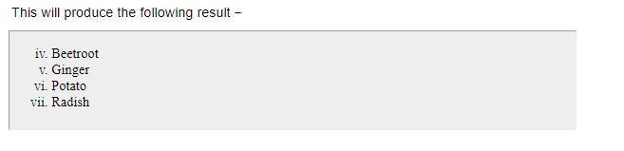

HTML Definition Lists

HTML and XHTML supports a list style which is called **definition lists** where entries are listed like in a dictionary or encyclopedia. The definition list is the ideal way to present a glossary, list of terms, or other name/value list.

Definition List makes use of following three tags.

* <dl> − Defines the start of the list
* <dt> − A term
* <dd> − Term definition
* </dl> − Defines the end of the list

Example

[Live Demo](http://tpcg.io/yw2HxB)

<!DOCTYPE html>

<html>

<head>

<title>HTML Definition List</title>

</head>

<body>

<dl>

<dt><b>HTML</b></dt>

<dd>This stands for Hyper Text Markup Language</dd>

<dt><b>HTTP</b></dt>

<dd>This stands for Hyper Text Transfer Protocol</dd>

</dl>

</body>

</html>

This will produce the following result −

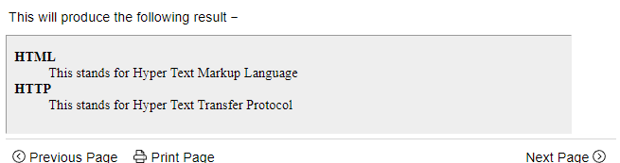

The rest images are here too:

https://www.tutorialspoint.com/html/html_lists.htm