For to start excel, we must know the file icon for excel file while is indicated by

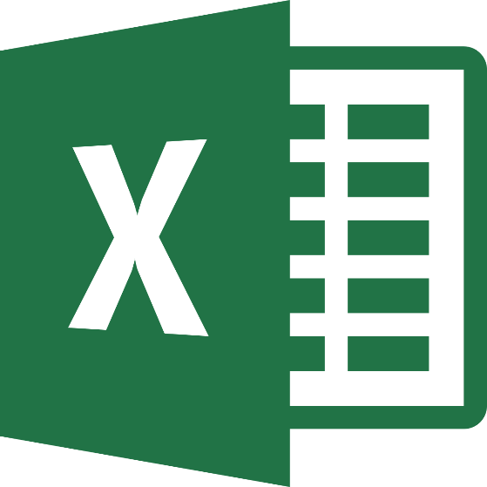

When we open the excel, it will show many templates from there but we must choose the first one or ‘blank workbook’ template.

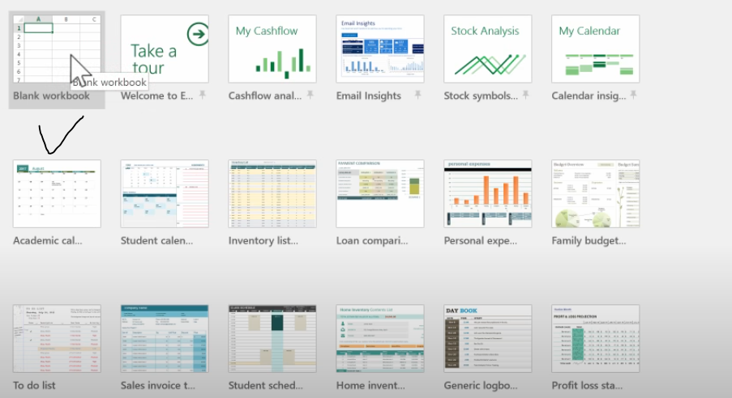

This is a welcome to excel tour and it is a good way to learn the basics of excel. In this template there are ‘Welcome to Email’, Cashflow analysis and many more. 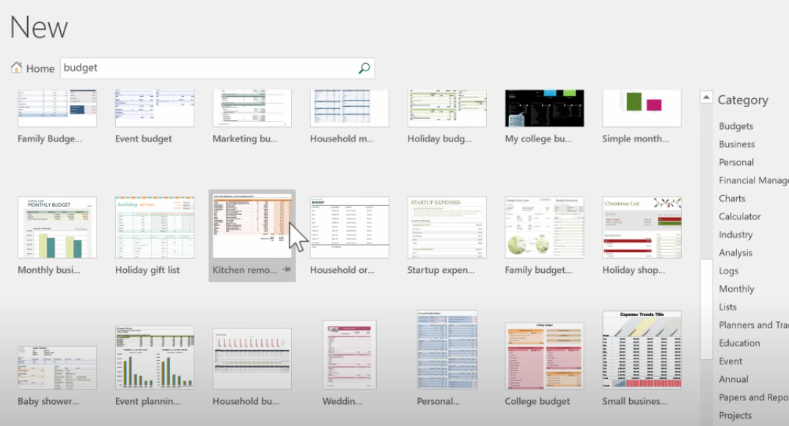  
There is also a search option and for example I want to search **‘budget’** and it comes many kinds of template if you search this word. For example I choose, business trip budget, so just click and it make a copy of that as a spreadsheet, you can open this file and use this in spreadsheet.

Let’s start with blank notebook, and we should double click on that.

From the top we have tabs, 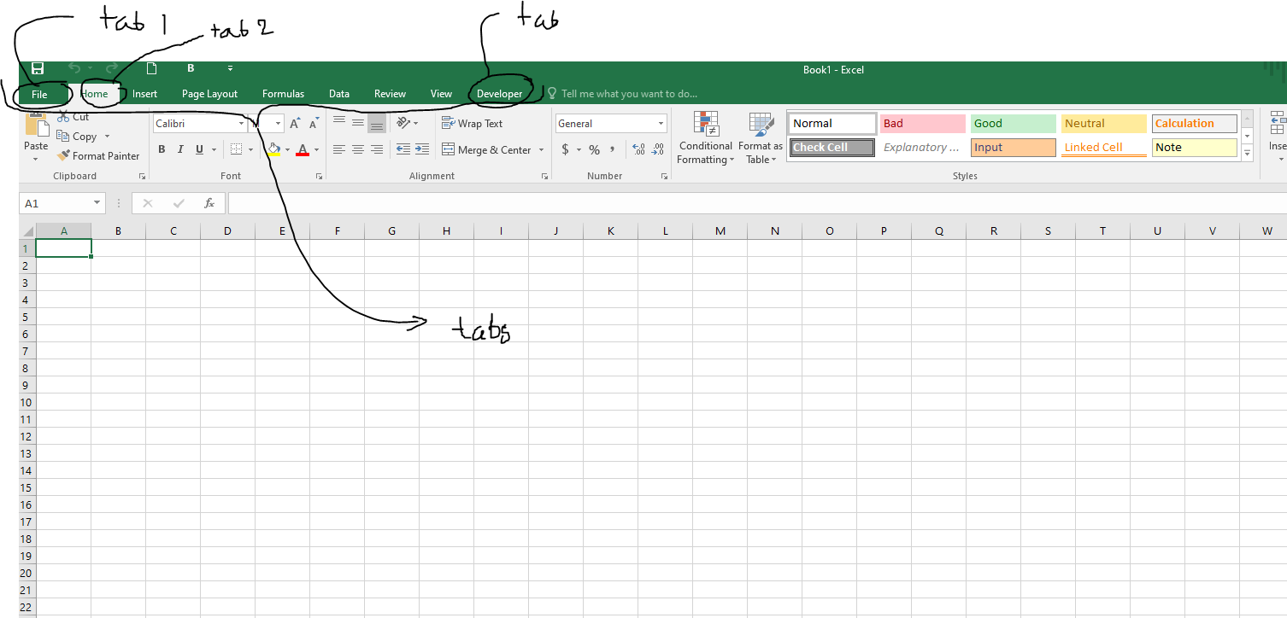

We have home tab, file tab, Insert tab and many tabs. Each of these tabs is important.

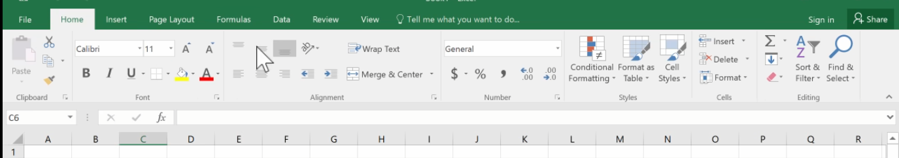

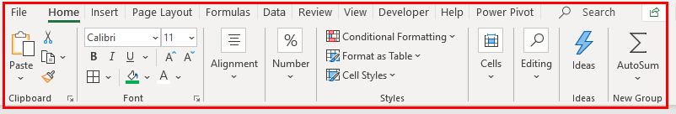

The ribbon is basically an element of the UI (User Interface) at the top of Excel. In simple words, the ribbon can be called as a strip that consists of buttons or tabs which is seen at top of the excel sheet. The ribbon was first introduced in Microsoft Excel 2007.

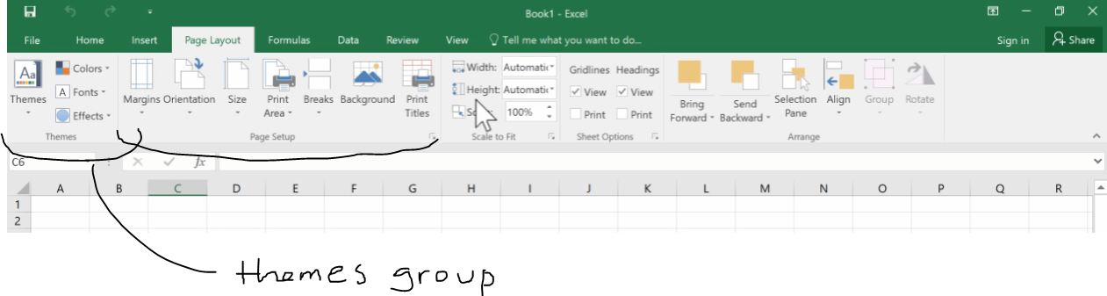

Those are Groups in those Ribbon tab.

In the corner of these Ribbon groups you will see a corner, and this is called **‘Launch Button’**

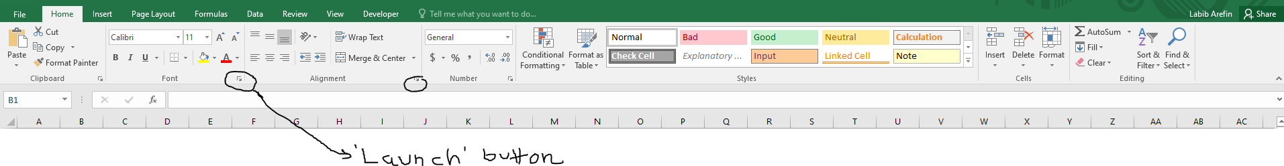

If you click this button, it will show more options.

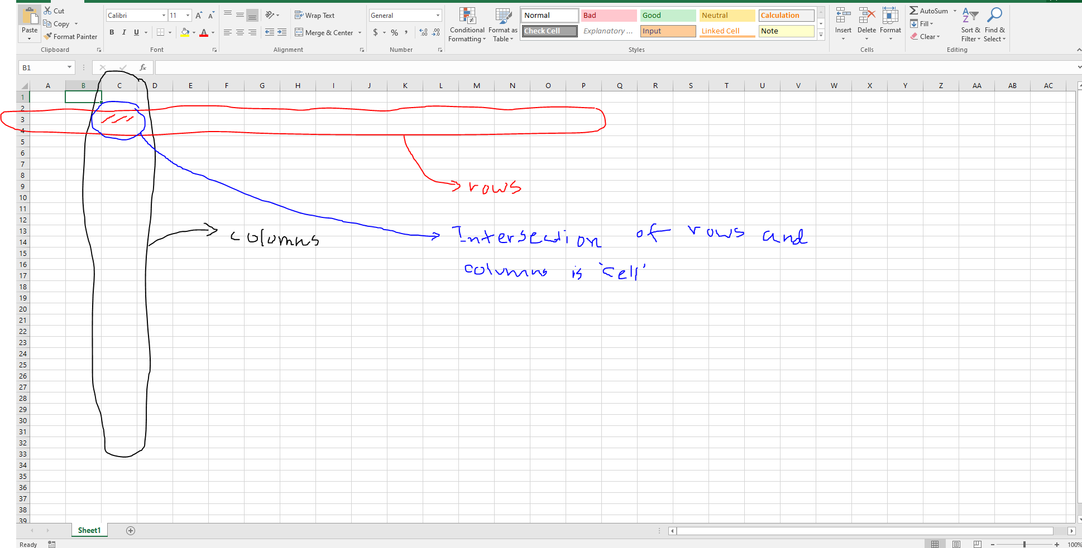

There are rows and columns in the spreadsheet. The intersection of rows and columns in ‘cell’. There are many columns like column A, B upto Z.

Every cell in excel has a name.

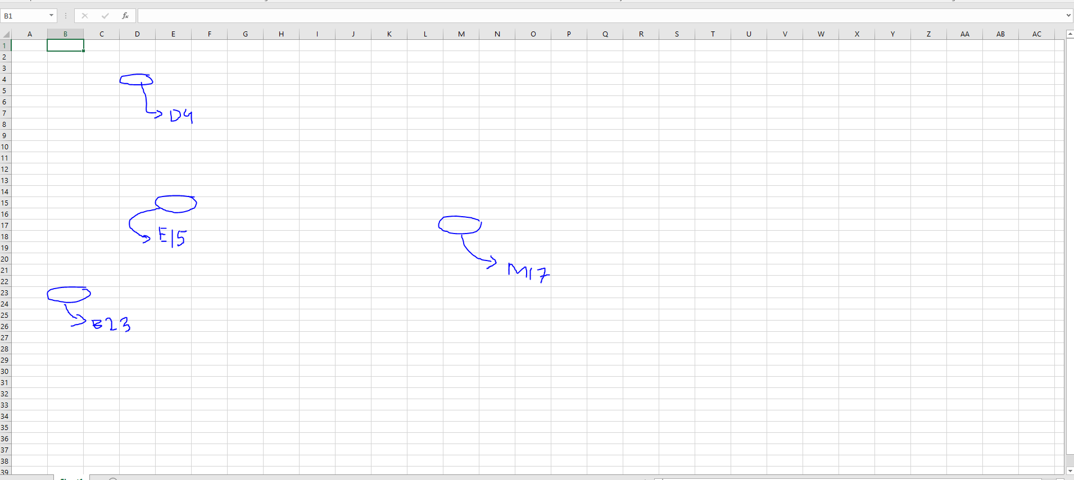

There is also **range**, it is a group of cells that are together.

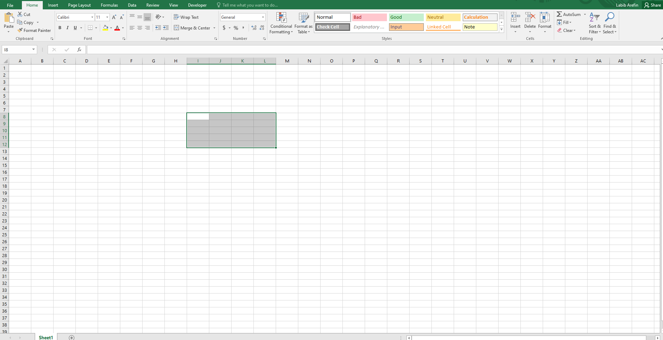

We named the range as I8 to L12 (I8:L12).

On the downside, we have **worksheet** or **sheet.** As we add more sheets, it creates a workbook.

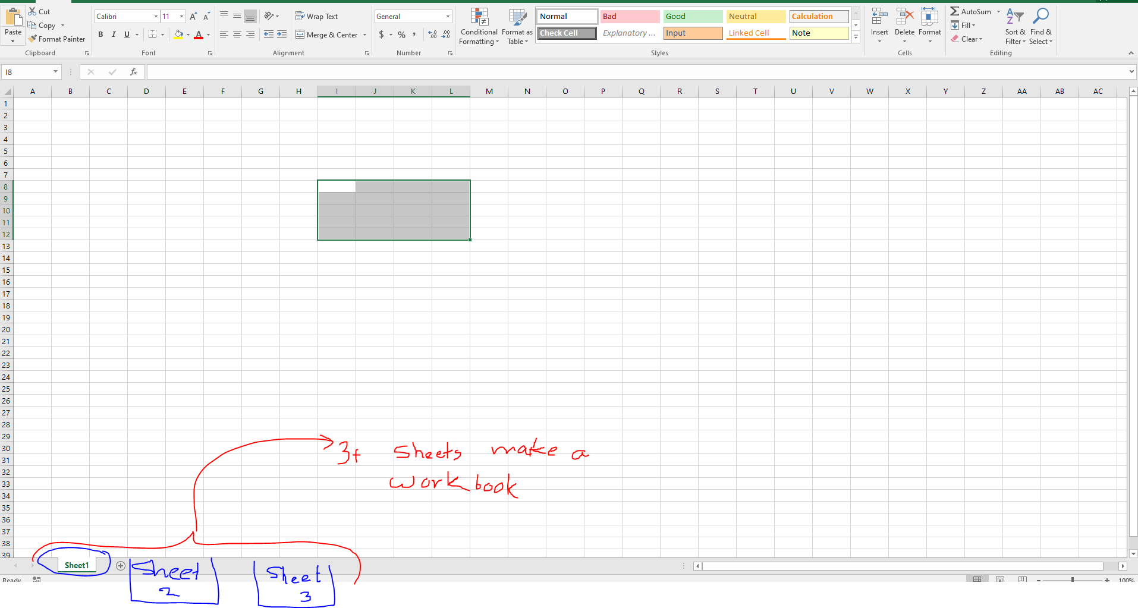  
I can create an inventory, to store movies collection.

Suppose I have written a text in A1, if we hit enter we go to another cell.

You can increase the size of row like this. 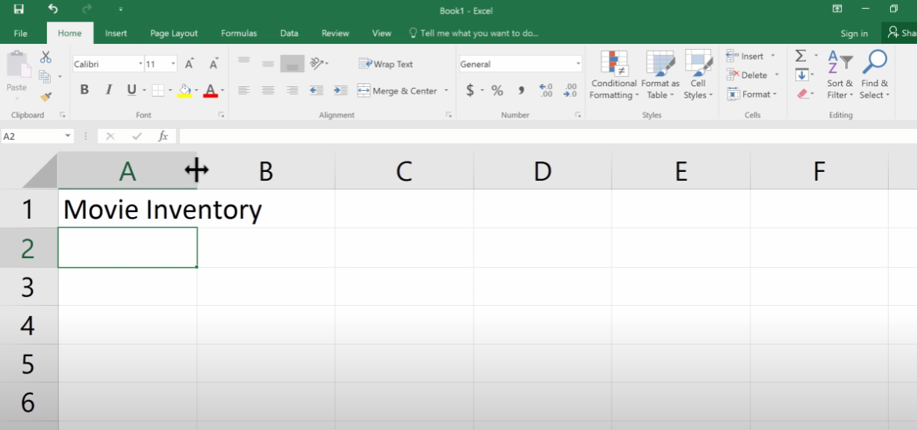

If you hit enter or down key, it will go down.

If you hit shift+enter or up key, it will go up.

To move right from A1 to B1, just tap ‘tab’ button or right key.

To move left like B1 to A1, just tap ‘shift + tab’ or left key.

To edit a cell just tap on the cell and double click it which allow you to edit.

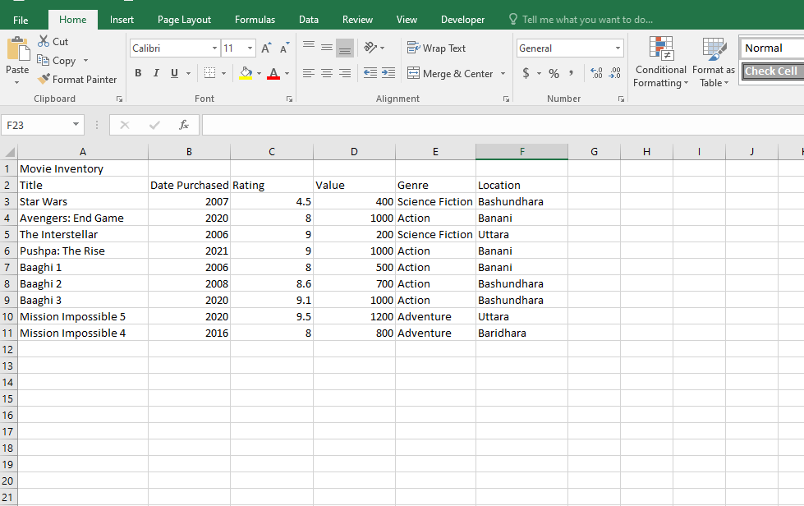

So these are my data on spreadsheet.

As you can see that it’s off-side, so I will choose the cell.

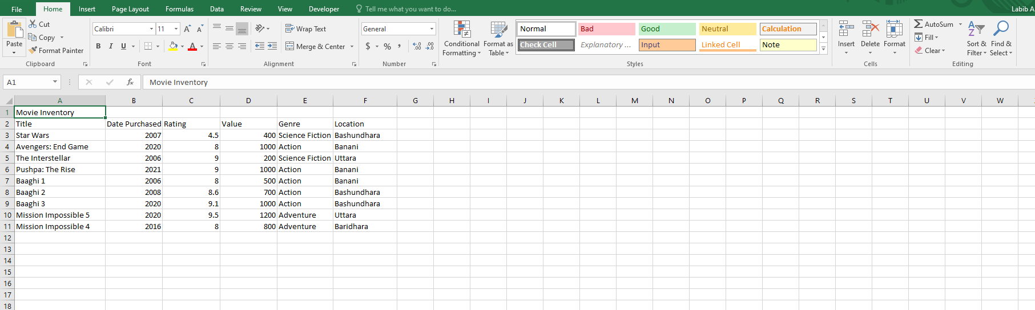

And I should choose bold tool, then yellow color for the background color using bucket tool in the cell.

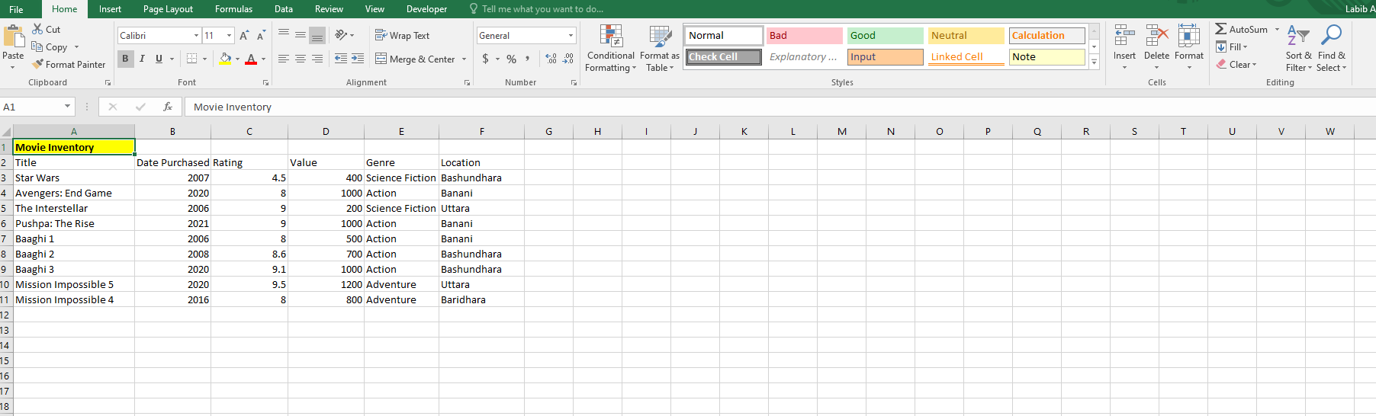

Here the output I have shown. To make the text center for text in A1. We have to tap the button ‘merge & center’ and select those cells. This put the text in center.

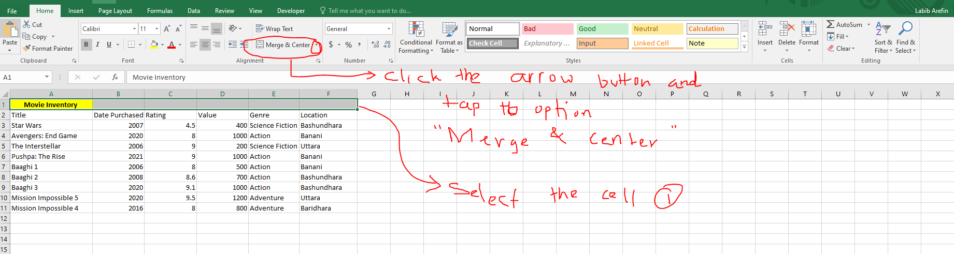

To fit those cells just select those cells

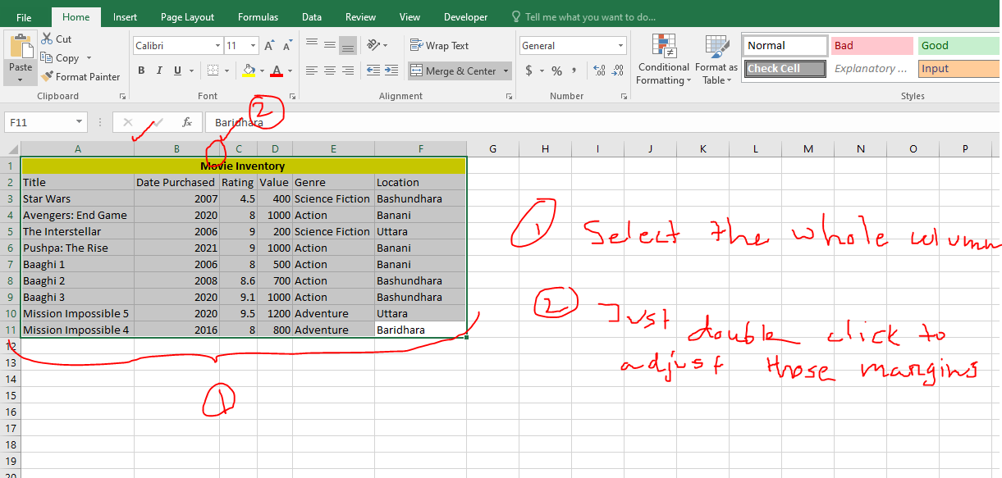

1. Select the whole column

2. Just double click to adjust those margins.

Here is the most updated of my table.

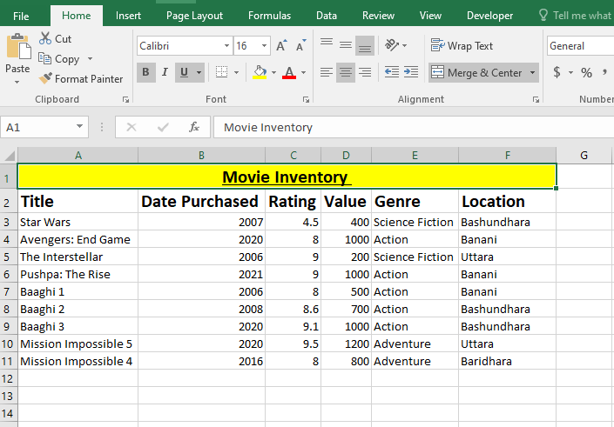

So that’s the part 1 of Excel, and don’t forget to follow my page for more tutorials and notes. Please do like and share my notes :3