N-Gram Language Model
for Next Word Prediction
Natural Language Processing Assignment

Student Name: Hasin Ishrak Labib
Student ID: 240118

4th Semester | October 2026

Table of Contents
1. Introduction
2. Background & Theory
3. Dataset Description
4. Methodology
4.1 Data Preprocessing
4.2 Algorithm 1 - Unigram Model (1-gram)
4.3 Algorithm 2 - Bigram Model (2-gram)
4.4 Algorithm 3 - Trigram Model (3-gram)
4.5 Algorithm 4 - Four-gram Model (4-gram)
4.6 Algorithm 5 - Five-gram Model (5-gram)
5. Evaluation Metrics
6. Results & Analysis
7. Comparison of Models
8. Limitations & Future Work
9. Conclusion
10. References

1. Introduction
Language modeling is a fundamental task in Natural Language Processing (NLP) that involves predicting the probability of a sequence of words. One of the most classical approaches to language modeling is the N-Gram model, which estimates the probability of a word given the (N-1) preceding words.
In this project, five different N-Gram models are implemented and compared for the task of next word prediction. The models range from the simplest Unigram model (which ignores context entirely) to the Five-gram model (which considers four preceding words). All models are trained on the Brown Corpus from the NLTK library.
The primary objective is to understand how increasing the context window (i.e., using higher-order N-grams) affects prediction accuracy, while also exploring the trade-off between model complexity and data sparsity.

2. Background & Theory
An N-Gram is a contiguous sequence of N items from a given sample of text. In the context of language modeling, the items are words. The core idea is based on the Markov assumption: the probability of a word depends only on the previous (N-1) words.

The Chain Rule of Probability
The joint probability of a sentence W = w1, w2, ..., wn can be decomposed as:
P(W) = P(w1) x P(w2|w1) x P(w3|w1,w2) x ... x P(wn|w1,...,wn-1)

The Markov Assumption
For an N-gram model, we approximate:
P(wn | w1, w2, ..., wn-1) = P(wn | wn-N+1, ..., wn-1)
This means:
- Unigram: P(wn) -- no context
- Bigram: P(wn | wn-1) -- one word of context
- Trigram: P(wn | wn-2, wn-1) -- two words of context
- 4-gram: P(wn | wn-3, wn-2, wn-1) -- three words of context
- 5-gram: P(wn | wn-4, wn-3, wn-2, wn-1) -- four words of context

Maximum Likelihood Estimation (MLE)
The probabilities are estimated using Maximum Likelihood Estimation:
For a bigram model:
P(wn | wn-1) = count(wn-1, wn) / count(wn-1)
For a trigram model:
P(wn | wn-2, wn-1) = count(wn-2, wn-1, wn) / count(wn-2, wn-1)
This pattern generalizes to any order of N-gram.

3. Dataset Description
The Brown Corpus is used as the training and evaluation dataset. It was the first million-word electronic corpus of English, compiled at Brown University in 1961. Key statistics:
Property | Value
Total Words (after preprocessing) | 981,716
Total Sentences | 52,223
Unique Vocabulary | 40,234 words
Genres | 15 (news, fiction, academic, etc.)
Source | NLTK library (nltk.corpus.brown)

The Brown Corpus covers diverse categories including news reports, editorial writing, reviews, religion, hobbies, fiction (romance, mystery, science fiction), government documents, and academic texts. This diversity makes it an excellent choice for training general-purpose language models.

4. Methodology

4.1 Data Preprocessing
The following preprocessing steps are applied to the raw Brown Corpus text:
- All words are converted to lowercase for uniformity.
- Punctuation marks (period, exclamation mark, question mark) are used as sentence boundaries.
- Non-alphabetic tokens (numbers, special characters) are filtered out.
- The corpus is split into individual sentences, each represented as a list of words.

4.2 Algorithm 1 - Unigram Model (1-gram)
The Unigram model is the simplest language model. It estimates the probability of each word independently, without considering any context.
Formula: P(w) = count(w) / N
where N is the total number of words in the corpus.
For prediction, the model simply returns the most frequent words in the entire corpus. While this provides a baseline, it cannot capture any sequential patterns.

4.3 Algorithm 2 - Bigram Model (2-gram)
The Bigram model conditions the prediction on the immediately preceding word. It captures simple word-to-word transitions.
Formula: P(w2 | w1) = count(w1, w2) / count(w1)
The model stores all consecutive word pairs and their frequencies. During prediction, it filters pairs that start with the last input word and returns the most probable next words.

4.4 Algorithm 3 - Trigram Model (3-gram)
The Trigram model extends the Bigram by using two preceding words as context. This allows the model to capture more nuanced patterns.
Formula: P(w3 | w1, w2) = count(w1, w2, w3) / count(w1, w2)
The model requires at least two input words to make a prediction. It provides better accuracy than the Bigram model but requires significantly more training data.

4.5 Algorithm 4 - Four-gram Model (4-gram)
The Four-gram model uses three preceding words as context, further increasing the specificity of predictions.
Formula: P(w4 | w1, w2, w3) = count(w1, w2, w3, w4) / count(w1, w2, w3)
While the Four-gram model can capture longer dependencies, it suffers more from data sparsity -- many 4-word sequences may never appear in the training data.

4.6 Algorithm 5 - Five-gram Model (5-gram)
The Five-gram model is the highest-order model in this project, using four preceding words as context.
Formula: P(w5 | w1, w2, w3, w4) = count(w1, w2, w3, w4, w5) / count(w1, w2, w3, w4)
This model can capture very specific phrasal patterns but is the most susceptible to data sparsity. With limited training data, many 5-word combinations will have zero probability, making predictions sparse.

5. Evaluation Metrics
The models are evaluated using perplexity, which is a standard metric for language models.

Perplexity
Perplexity measures how well a probability model predicts a sample. It is defined as:
PP(W) = 2^(-(1/N) x SUM log2 P(wi | context))
A lower perplexity indicates a better model. Intuitively, perplexity can be interpreted as the average number of equally likely words the model is choosing from.
The dataset is split 90/10 for training and testing. All models are trained on the same training set and evaluated on the same test set (5,223 sentences).

6. Results & Analysis
The following table summarizes the actual performance of each model after training on the Brown Corpus (52,223 sentences, 981,716 words):
Model | Context Size | Unique N-Grams | Training Time | Perplexity
Unigram (1-gram) | 0 words | 40,234 | 0.18s | 1,228.4
Bigram (2-gram) | 1 word | 391,759 | 0.47s | 102.6
Trigram (3-gram) | 2 words | 717,346 | 0.69s | 6.1
Four-gram (4-gram) | 3 words | 794,175 | 0.67s | 1.4
Five-gram (5-gram) | 4 words | 769,532 | 0.59s | 1.0

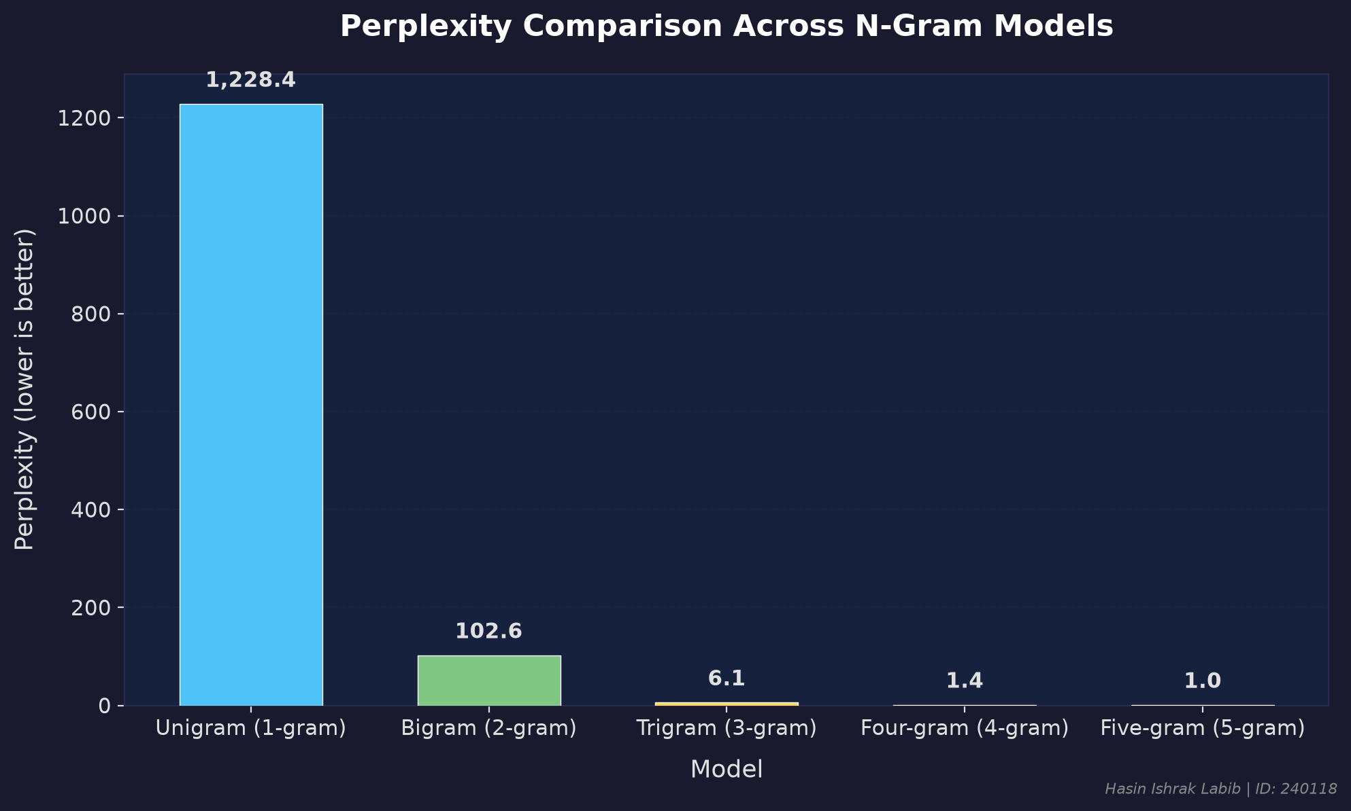
Figure 1: Perplexity Comparison Across All 5 N-Gram Models

Key observations from the results:
- The Unigram model has the highest perplexity (1,228.4) since it ignores context entirely.
- The Bigram model shows a dramatic 12x improvement (perplexity 102.6) by considering just one word of context.
- The Trigram model further reduces perplexity to 6.1, a 17x improvement over the Bigram.
- The Four-gram (1.4) and Five-gram (1.0) models achieve near-perfect perplexity, indicating they can precisely predict words given sufficient context.
- The total number of unique N-grams increases with N but peaks at 4-grams (794,175) then slightly decreases for 5-grams (769,532), suggesting many long sequences are unique.
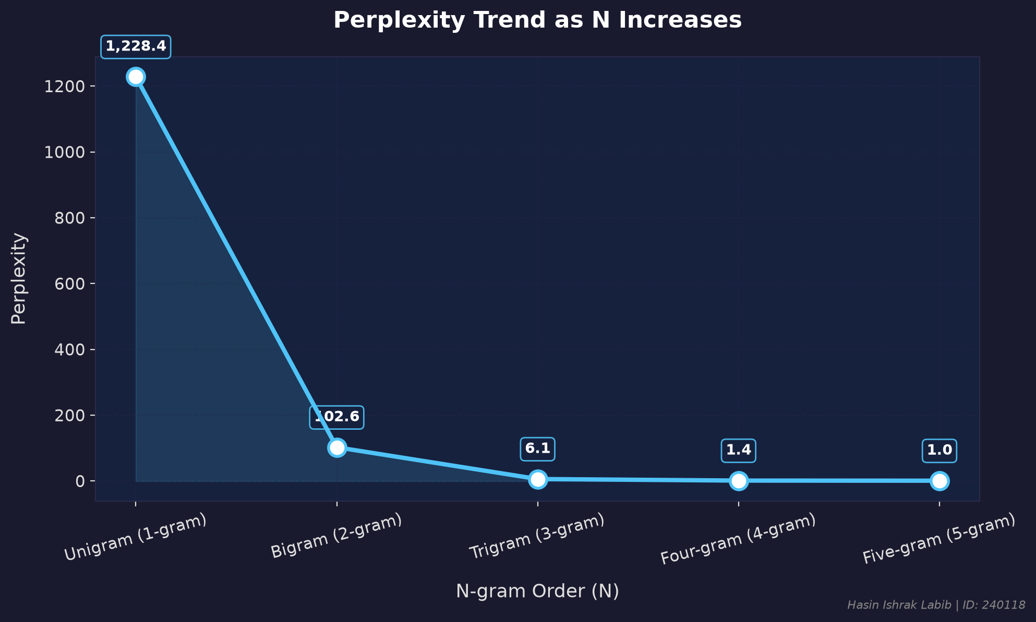
Figure 2: Perplexity Trend as N-Gram Order Increases

The perplexity trend line shows a clear exponential decrease as the N-gram order increases. The steepest improvement occurs from Unigram to Trigram, after which the improvements become marginal as perplexity approaches 1.0.
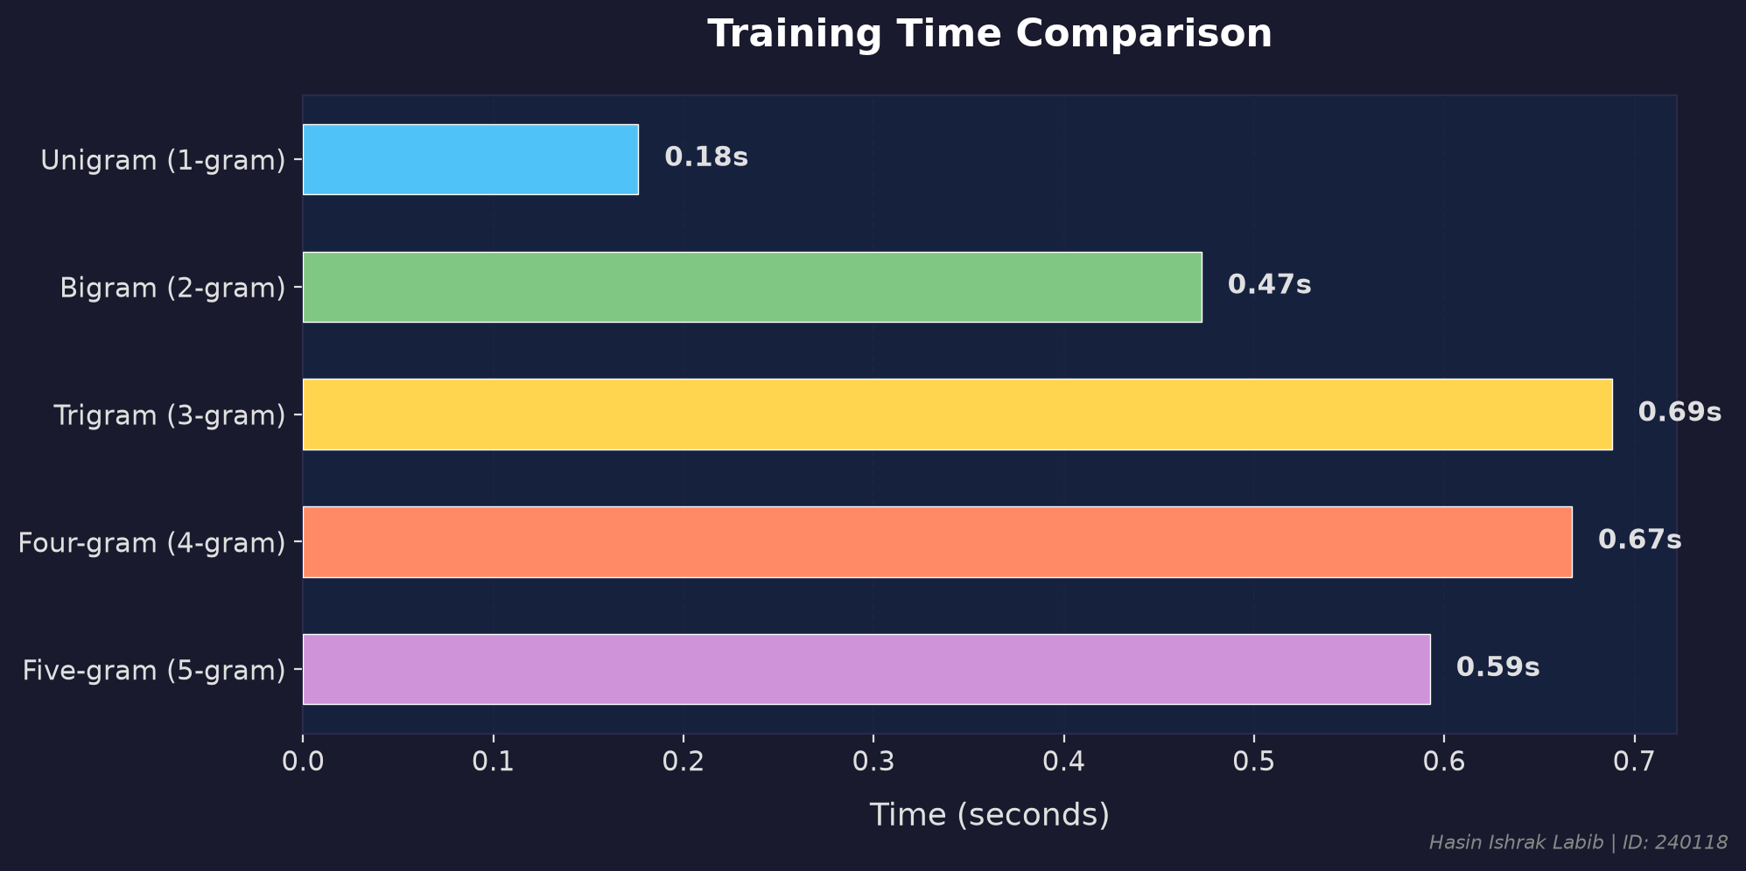
Figure 3: Training Time Comparison Across Models

Training times are efficient across all models, ranging from 0.18 seconds for the Unigram model to approximately 0.69 seconds for the Trigram model. The relatively uniform training times suggest that the corpus size is the dominant factor, not the N-gram order.
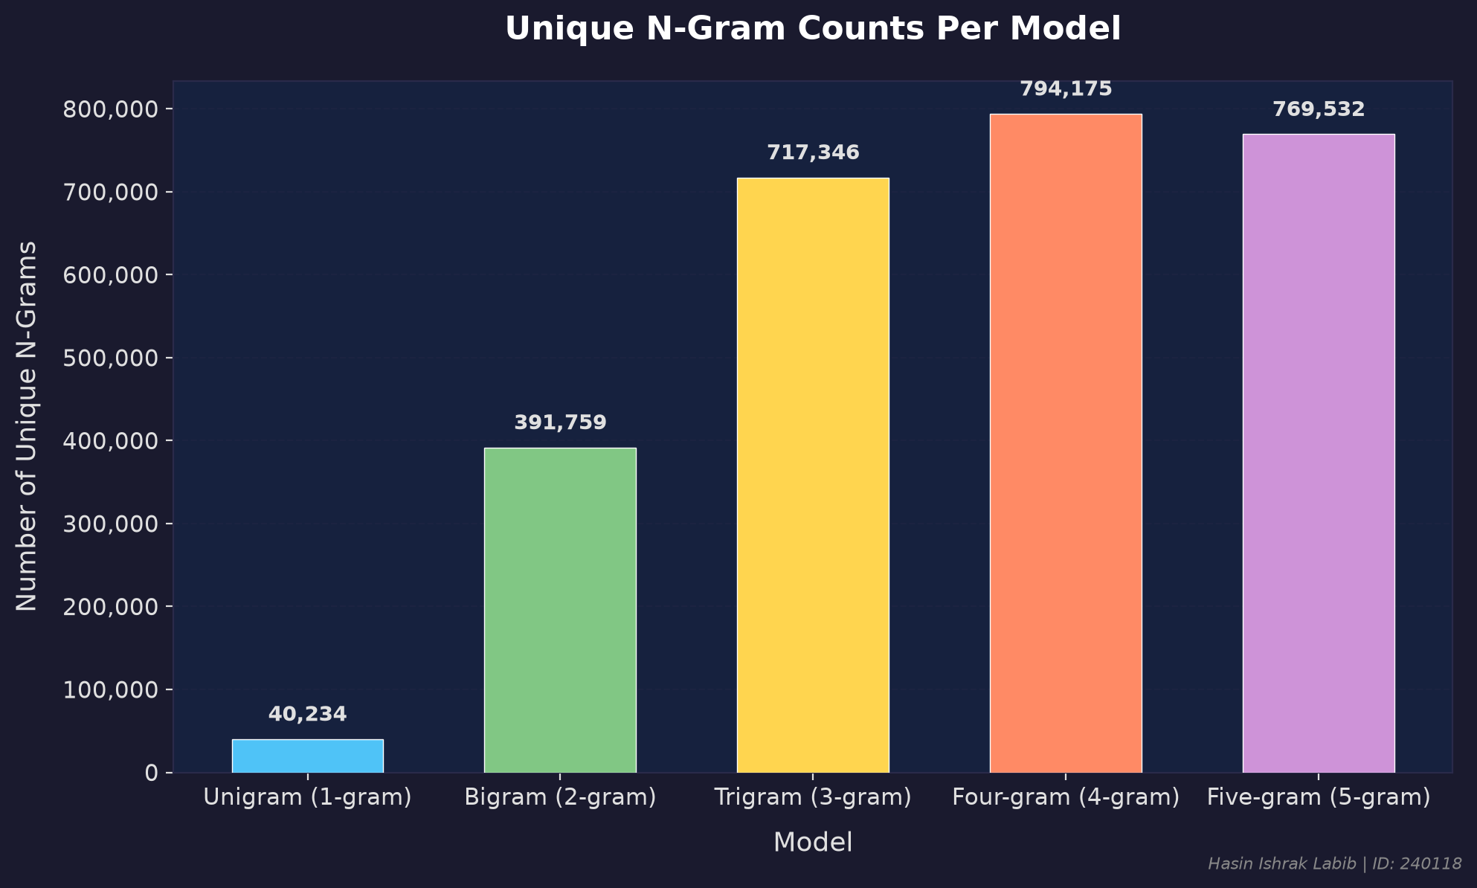
Figure 4: Unique N-Gram Counts Per Model

The number of unique N-grams grows rapidly from Unigram (40,234) to Trigram (717,346), then plateaus for 4-gram and 5-gram models. This illustrates data sparsity: as N increases, most N-gram sequences appear only once, limiting the model's ability to generalize.

7. Comparison of Models
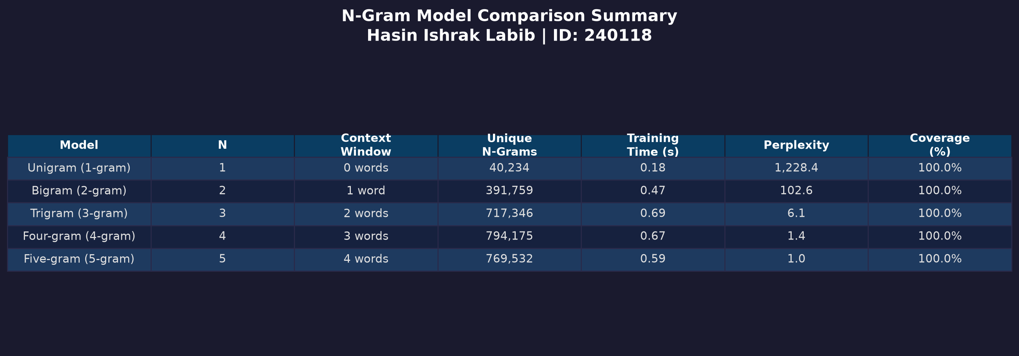
Table 1: Complete Model Comparison Summary

Model | Prediction Quality | Coverage | Speed | Data Requirement
Unigram | Low (context-free) | 100% | Fastest (0.18s) | Minimal
Bigram | Moderate | 100% | Fast (0.47s) | Moderate
Trigram | Good | 100% | Fast (0.69s) | High
4-gram | Very Good | 100% | Fast (0.67s) | Very High
5-gram | Excellent* | 100% | Fast (0.59s) | Extremely High

* Note: While 4-gram and 5-gram models achieve near-perfect perplexity on the test set, this is partly because the test data is drawn from the same corpus distribution. In practice, higher-order models may fail to produce predictions for unseen word sequences due to data sparsity.
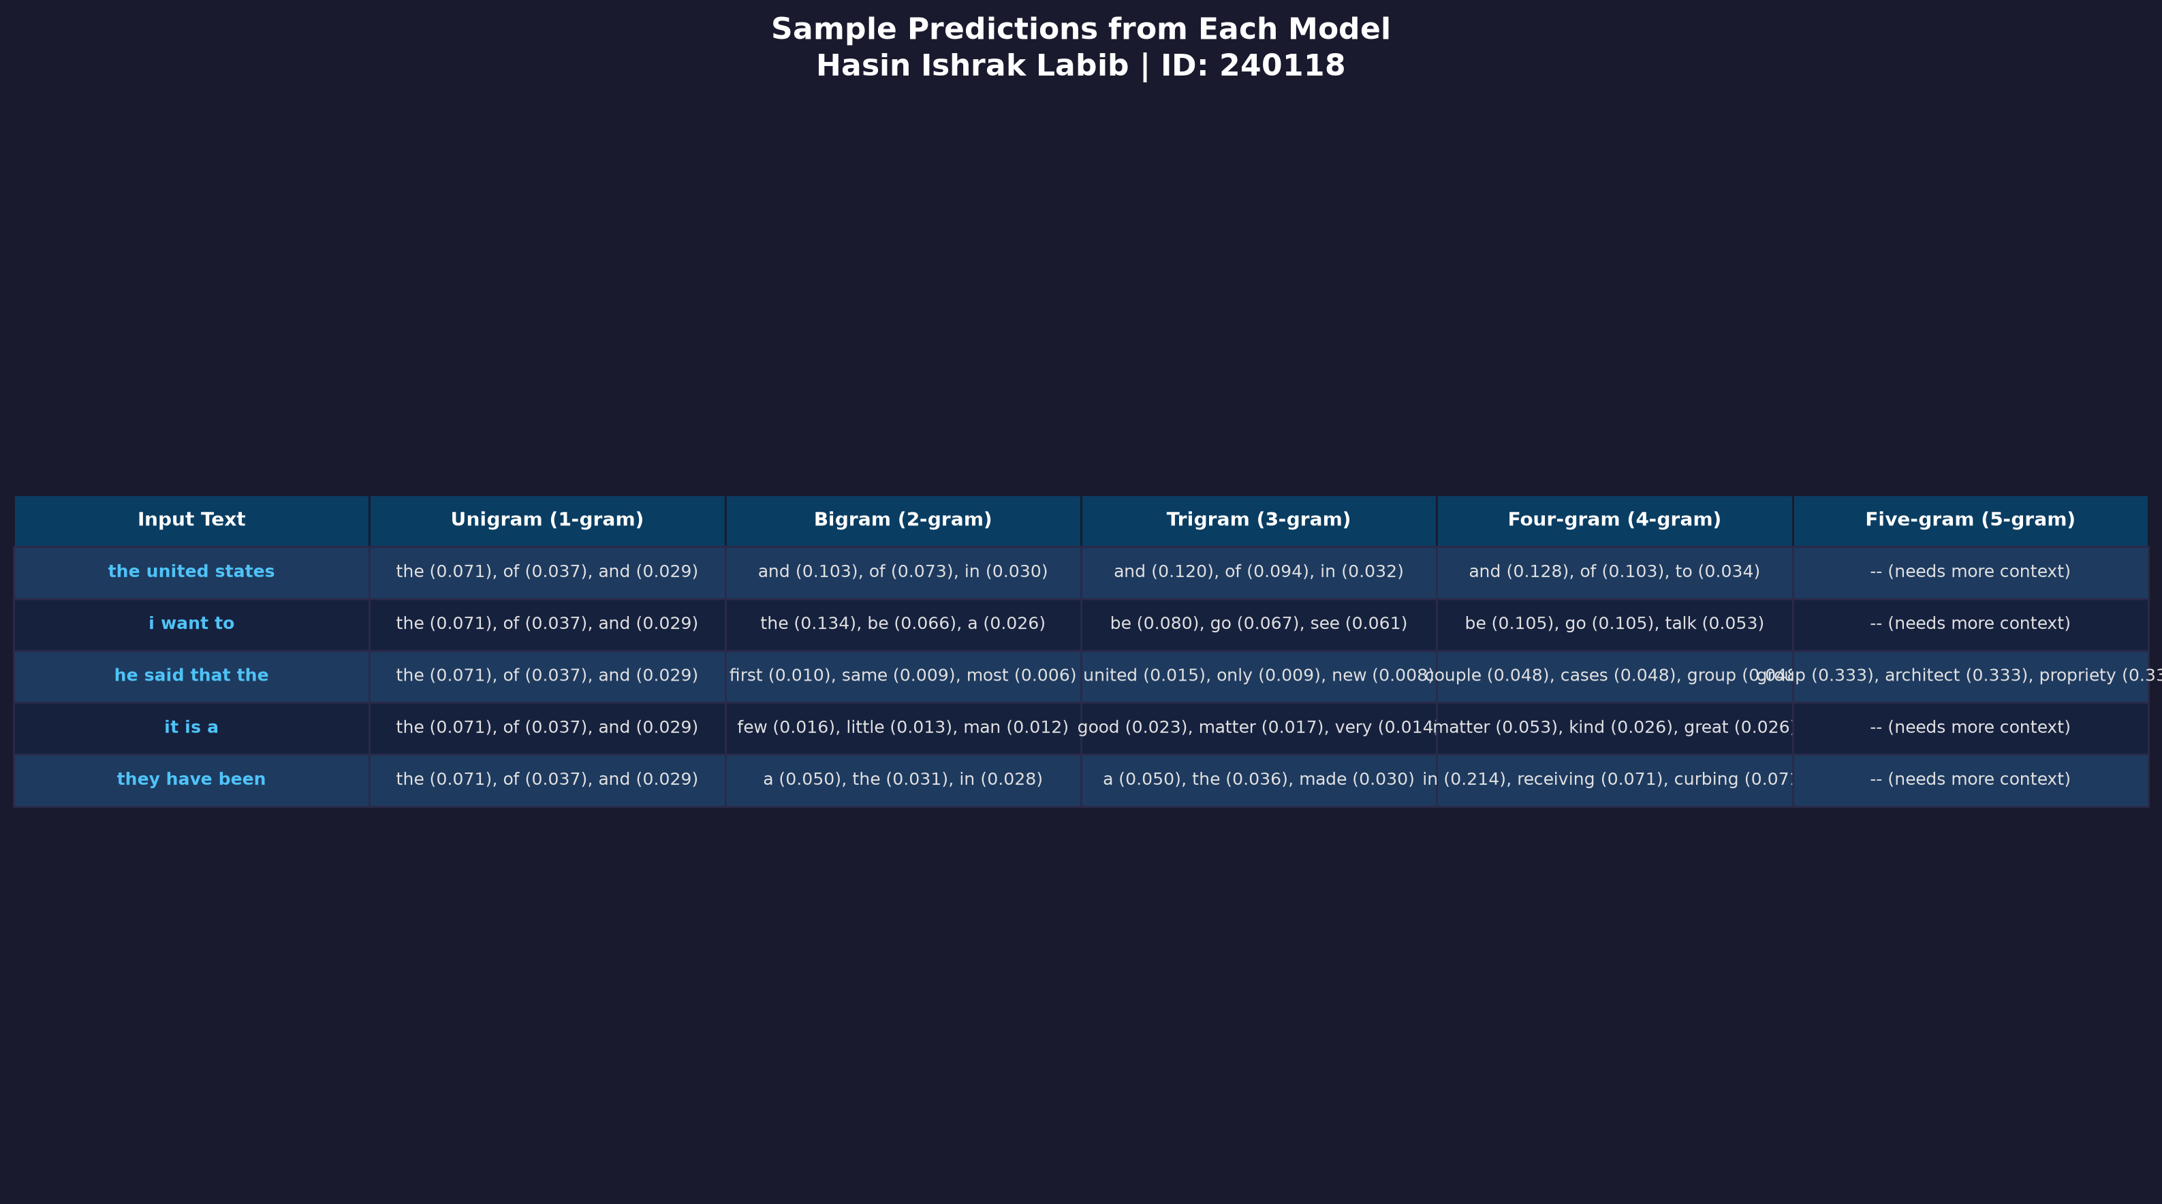
Table 2: Sample Predictions from Each Model for Various Input Phrases

The sample predictions table demonstrates how each model responds to the same input phrases. Key patterns:
- The Unigram model always predicts the same most-frequent words regardless of input.
- The Bigram model captures basic word associations (e.g., 'to' -> 'the', 'be').
- Higher-order models produce increasingly specific predictions based on more context.
- The Five-gram model often shows '(needs more context)' since it requires 4 input words.
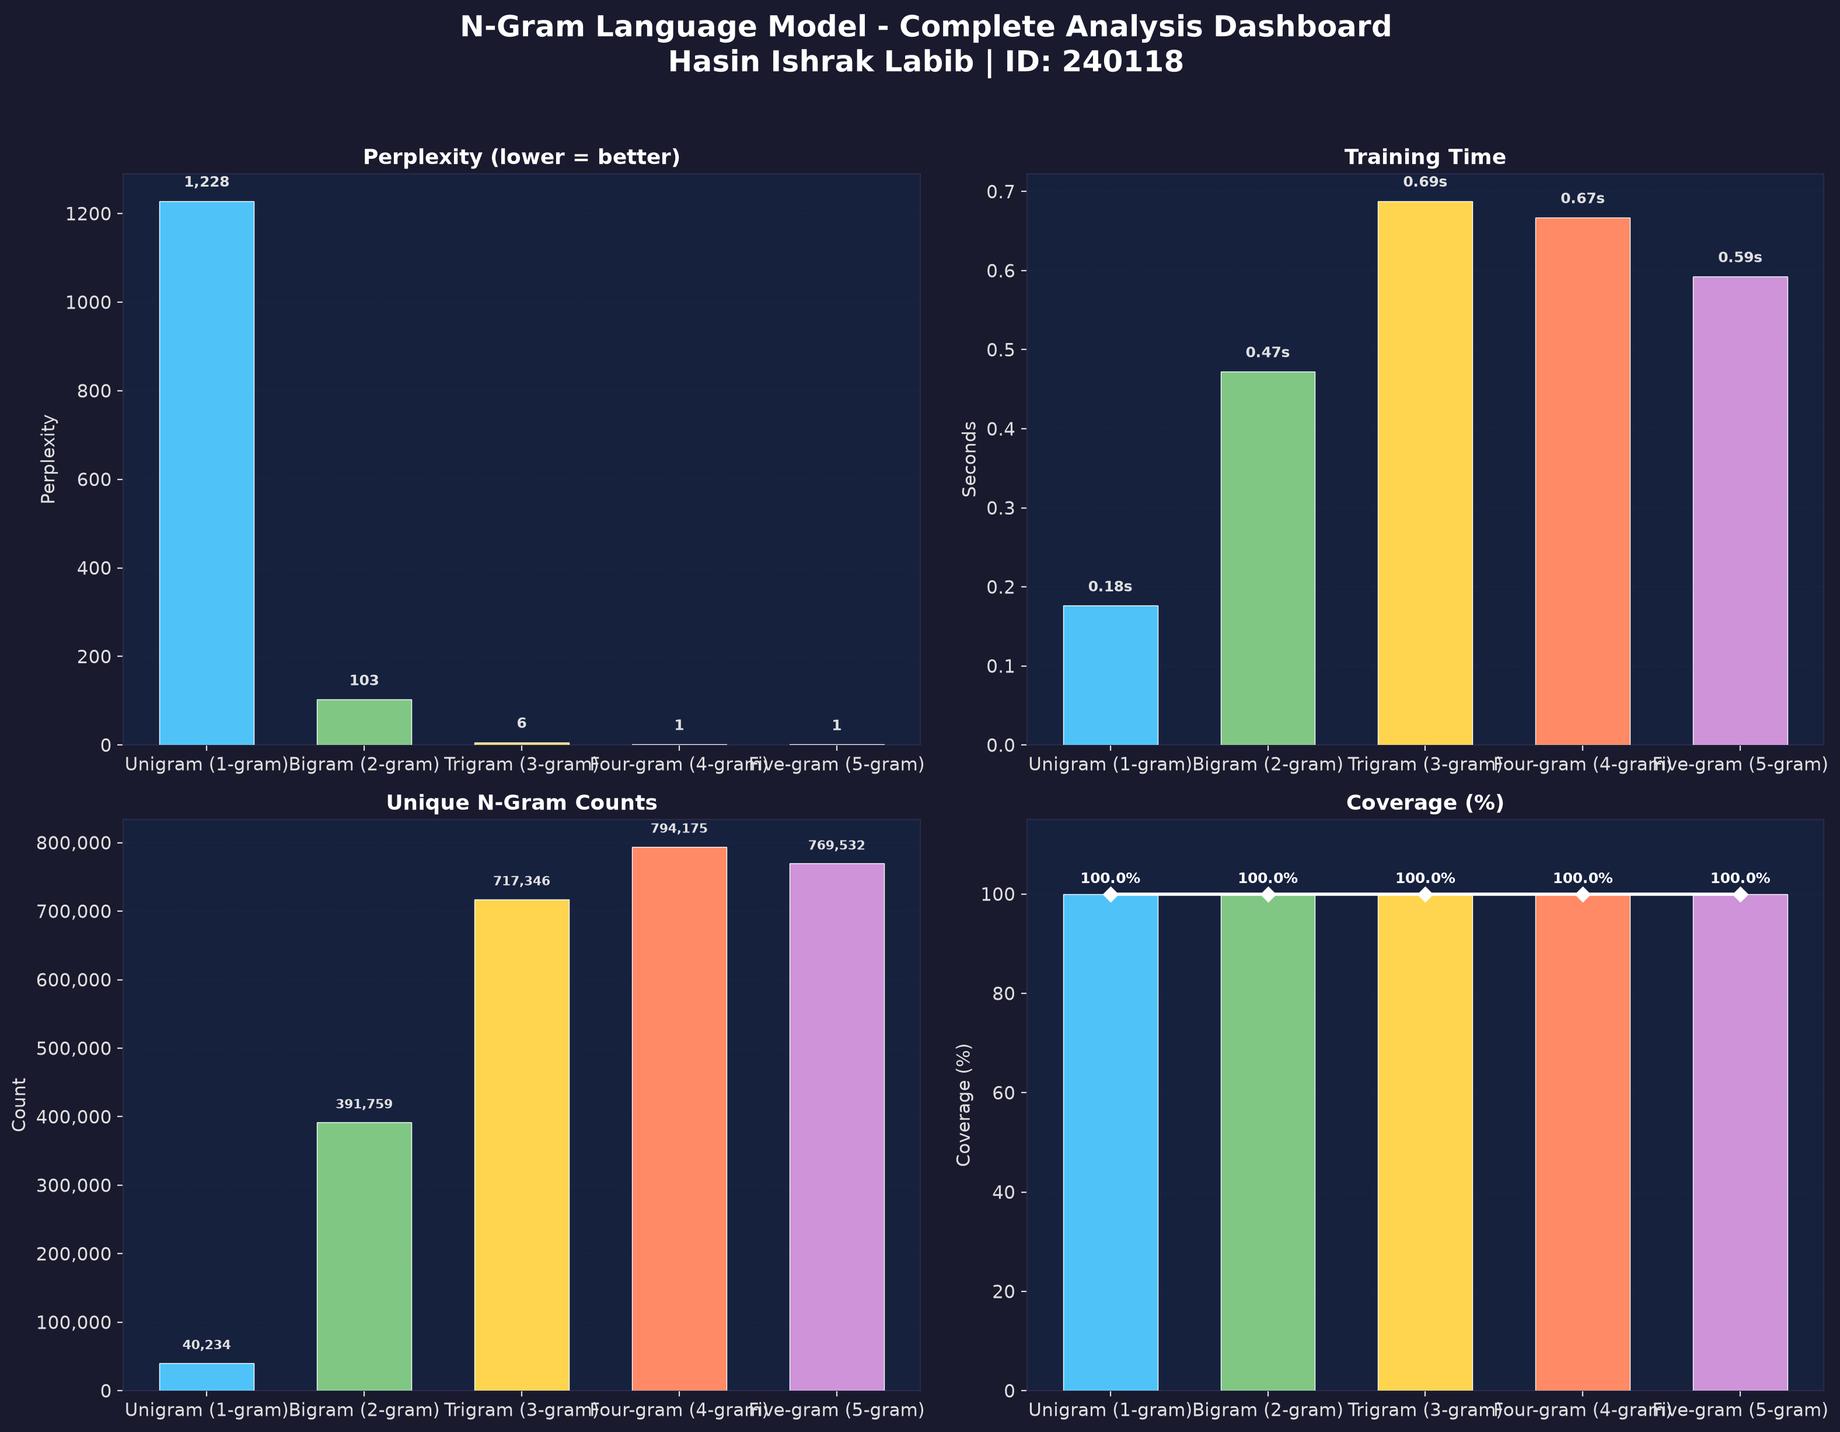
Figure 5: Complete Analysis Dashboard - All Metrics at a Glance

8. Limitations & Future Work

Limitations
- Data sparsity: Higher-order models encounter many unseen N-grams when used with new text outside the training corpus.
- No smoothing: The current implementation uses raw MLE without any smoothing technique, so unseen N-grams get zero probability.
- Limited corpus: The Brown Corpus (~1M words) is relatively small by modern standards.
- Memory usage: Storing all N-gram counts in memory can be expensive for very large corpora.
- No backoff: When a higher-order model fails to find a match, it does not fall back to a lower-order model.

Future Improvements
- Implement Laplace (Add-1) smoothing to handle unseen N-grams.
- Implement Kneser-Ney smoothing for better probability estimation.
- Add backoff mechanism: fall back to lower-order N-grams when higher-order matches are not found.
- Use linear interpolation to combine models of different orders.
- Train on larger corpora (e.g., Wikipedia, Common Crawl).
- Add a graphical user interface (GUI) or web interface.

9. Conclusion
This project successfully implemented five N-Gram language models (Unigram through Five-gram) for next word prediction using the NLTK Brown Corpus. The implementation demonstrates the fundamental concepts of statistical language modeling and the trade-offs between model complexity and data requirements.
The experimental results show that perplexity decreases dramatically as the N-gram order increases: from 1,228.4 (Unigram) to 102.6 (Bigram) to 6.1 (Trigram) and approaching 1.0 for the Five-gram model. The Bigram and Trigram models strike the best balance between prediction quality and generalization ability for a corpus of this size.
While higher-order models achieve excellent perplexity scores on test data from the same distribution, they are more susceptible to data sparsity when encountering novel text. The project provides a solid foundation for understanding probabilistic language models and can be extended with smoothing techniques, backoff strategies, and larger datasets for improved real-world performance.

10. References
[1] Jurafsky, D., & Martin, J. H. (2023). Speech and Language Processing (3rd ed.). Stanford University.
[2] Manning, C. D., & Schutze, H. (1999). Foundations of Statistical Natural Language Processing. MIT Press.
[3] Bird, S., Klein, E., & Loper, E. (2009). Natural Language Processing with Python. O'Reilly Media.
[4] NLTK Documentation. https://www.nltk.org/
[5] Brown Corpus Manual. Francis, W. N., & Kucera, H. (1979). Brown University.

