**PRIMEASIA UNIVERSITY**

**DEPARTMENT OF CSE**



**PROJECT PROPOSAL**

**Computer Interfacing (LAB)**

**(CSE-402)**

**SUBMITTED BY**

**TANVIR ANJUM LABIR**

**191039042**

**MANZURUL ISLAM**

**191005042**

**SANTOSH MRIDHA**

**181048042**

**Atia Sikder**

**172024042**

**SUBMITTED TO**

**SALEHUZZAMAN EBON**

**LECTURER**

**DEPARTMENT OF CSE**

**DATE: December 21, 2021**

**Fingerprint Door Lock System using Arduino**

Biometric systems have overtime served as robust security mechanisms in various domains. Fingerprints are the oldest and most widely used form of biometric identification. The use of fingerprint for identification has been employed in law enforcement for about a century. A much broader application of fingerprint is for personal authentication, for instance to access a computer, a network, an ATM machine, a car or a home.

Electronic lock using fingerprint recognition system is a process of verifying the fingerprint image to open the electronic lock. This project highlights the development of fingerprint verification. Verification is completed by comparing the data of authorized fingerprint image with incoming fingerprint image. Then the information of incoming fingerprint image will undergo the comparison process to compare with authorized fingerprint image.

Fingerprint door lock incorporates the proven technology. Fingerprint reader scanning is the most mature and tested type of biometric technology. Recent studies on biometrics have shown that compared to the hand method, fingerprint is more accurate and cost-effective. The duplication of biometric fingerprint technology is virtually impossible, only one in one billionth of a chance. Biometric security guarantees a positive method of user identification with something that cannot be lost, replicated or stolen.

**ARDUINO**

Arduino is an open-source electronic platform based on easy-to-use hardware and software. Arduino boards are able to read inputs – light on sensor, a finger on a button, or a Twitter message – and turn it into an output – activating a motor, turning on an LED, publishing some thing online. You can tell your board what to do by sending a set of instructions to the microcontroller on the board. To do so you use the Arduino programming language (based on writing), and the arduino software (IDE), based on processing.

Over the years Arduino has been the brain of thousands of projects, from everyday objects to complex scientific instruments. A worldwide community of makers students, hobbyists, artists, programmers, and professionals – has gathered around this open source platform, their contributions have added up to an incredible amount of accessible knowledge that can be of great help to novices and experts alike.

Arduino was born at the ivrea interaction design institute as an easy tool for fast prototyping, aimed at students without a background in electronics and programming. As soon as it reached a wider community, the Arduino board started changing to adapt to new needs and challenges, differentiating its offer from simple 8-bit boards to products for IOT applications, wearable, 3D printing, and embedded environments. All Arduino boards are completely open-source, empowering users to build them independently and eventually adapt them to their particular needs. The software, too, is open –source, and it is growing through the contributions of users worldwide.

Equipments:

Here we are using Arduino Uno, Fingerprint scanner sensor, MOSFET transistor, solenoidal door lock , breadboard, wires, wifi connector charger for power supply.

Circuit Diagram:

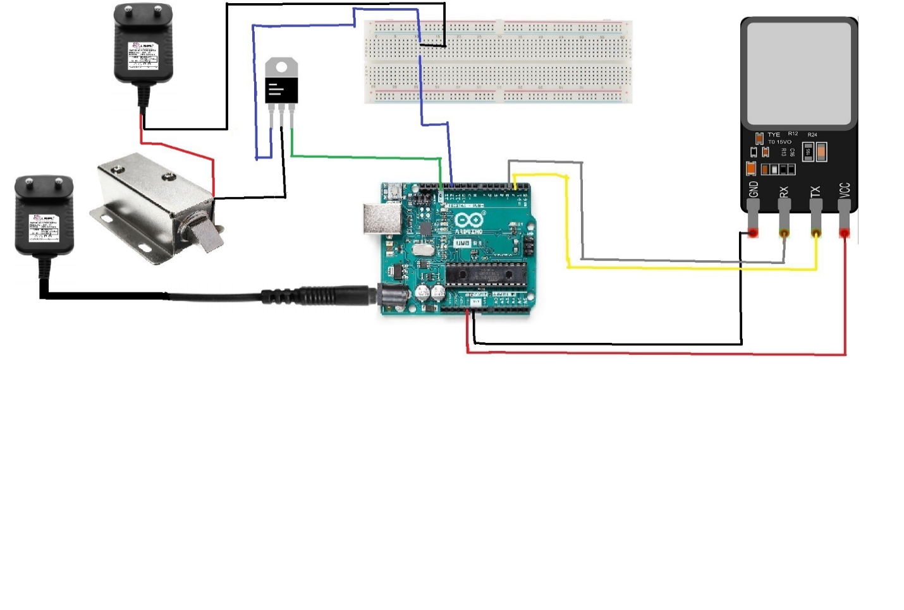

Conclusion:

This project is a revolutionary project in security system. Which gives unique security system for every each person. We all should use this project in our home as a security system.