BantayDagat: SMS-Based Information Dissemination
and Incident Reporting System

A Capstone Project Presented to
Information Technology Department
Cebu Technological University - Bantayan Extension Campus

In Partial Fulfillment of the Requirements
For the degree Bachelor of Science in Information Technology

By:
Cueva, Joshwel Keith G
Marandi, Justine C.
Entrada, Emilyn C.
Reyes, Lovely A.

Alyssa Marie B. Gigantana
Adviser

October 2026

APPROVAL SHEET

AKNOWLEGDEMENT

ABSTRACT

TABLE OF CONTENTS

LIST OF FIGURES

LIST OF TABLES

CHAPTER 1

‎THE PROBLEM AND ITS SCOPE‎

INTRODUCTION

Rationale of the Project

The municipality of Bantayan is a busy coastal town in the Visayan Sea, where daily life is closely connected to the ocean. Fishing is not just a tradition; it is the main source of income for most of the population. Because of this, it is highly important to establish strong support systems to protect marine resources and ensure the welfare of the fisherfolks. However, despite its importance, the local fishing industry still faces major challenges. This is primarily due to a lack of fast, accurate, and organized information needed for both their day-to-day operations and long-term planning.
Currently, marine resources are protected by the joint efforts of the local Bantay Dagat and the Municipal Agriculture Office (MAO/Fisheries Department). Their work is crucial in enforcing maritime laws and safeguarding the ocean from destructive practices. However, coordination between these authorities and the fisherfolks is limited by poor communication channels. For instance, fisherfolks are usually the first to witness illegal fishing, but they do not have a fast and reliable way to report these incidents. At the same time, authorities struggle to send important information to a community that is spread out across different areas. The information authorities need to share covers a broad and changing range of topics—including new local policies, safety warnings, community meetings, and general fisheries updates. This lack of proper communication makes it difficult for authorities to manage the area, and leaves fisherfolks struggling to follow rules without proper official guidance.
A major challenge to using modern technology to solve this problem in Bantayan is the lack of internet access. While cities have fast internet and advanced mobile apps, many of Bantayan's coastal communities have unstable or zero internet connection. A large share of the fishing population still uses basic keypad phones that can only send text messages and make calls. Because of this, standard web platforms or smartphone apps are simply not practical or accessible for them. To solve this problem, this project aims to build a two-way, SMS-based Information Dissemination and Incident Reporting System. By relying on basic text messaging, this project bridges the technology gap and ensures that crucial information reaches every fisherfolk, no matter what kind of phone they own.
That is why the development of this SMS-based system is essential. Its primary purpose is to build a more knowledgeable, organized, and resilient fishing community by serving as a direct and reliable communication channel. It ensures that fisherfolks promptly receive a wide variety of important announcements, ranging from daily operational updates and safety alerts to long-term regulatory changes. More significantly, the system empowers fisherfolks to actively protect their marine resources by allowing them to instantly text the Bantay Dagat if they witness illegal fishing or other violations. Ultimately, by upgrading slow and informal communication into an organized, instant exchange, this system will greatly reduce the daily struggles of both the fisherfolks and the local authorities.
There is importance of establishing strong support systems for the sustainable use of marine resources and the welfare of fisherfolk. But the industry, while of critical importance, is still hampered by systemic problems, primarily due to the lack of timely, accurate and well-organized information required for both long-term planning and day-to-day operations.
The management of marine resources and the enforcement of regulations are at present being done by the joint efforts of the local Bantay Dagat, the Municipal Agriculture Office (MAO/Fisheries Department). These are important for the enforcement of maritime laws, seasonal fishing bans, no-fishing zones and safeguarding the marine environment from destructive practices. However, the interaction between these authorities and the fisherfolk is often hampered by the absence of effective communication channels. Fisherfolk, who are often the first to observe illegal fishing or environmental violations, lack an immediate and reliable means of reporting such incidents. On the other hand, the Bantay Dagat and the Fisheries Department are challenged in bringing important information to a geographically dispersed community whose members are largely isolated in their work locations. Such information includes updates on ordinances, no fishing zones, seasonal fishing advisories, meeting schedules, and emergency safety notices. This lack of communication hampers not only effective enforcement and resource management but also places an unfair burden on fisherfolk who must navigate complex regulations and environmental change with little official guidance.
A significant challenge to the deployment of modern information solutions in Bantayan is the digital divide. While urban centers enjoy high-speed internet and sophisticated smartphone applications, many of the island’s remote coastal communities experience sporadic or no internet at all. A large share of the fishing population still relies on traditional keypad phones with limited SMS and voice call capabilities. Consequently, advanced web-based platforms or mobile applications, while useful in other contexts, are not practical or reachable for the majority of the fisherfolk in Bantayan. In view of this technological limitation, this project aims to build a two-way SMS-based information dissemination and incident reporting system. This system is designed with a focus on utilizing the ubiquity of SMS technology to reduce the digital divide and to ensure that crucial information is delivered to all fisherfolk, irrespective of the capacity of their device.
The deployment of SMS-based is essential to building a fishing community that is more knowledgeable, organized, and resilient. It will act as a direct channel for fishermen to receive important announcements about fisheries-related subjects, such as updates on seasonal fishing conditions, such as times of high or low fish catch, and changes to regulations. More significantly, the system will enable fishermen to take an active role in protecting marine resources by giving them the ability to instantly notify the Bantay Dagat when they witness illicit fishing or other infractions. This system will reduce the operational burden on both fishermen by converting informal, frequently delayed communication into an organized, instantaneous exchange.

Review of Related Systems (RRS)
The advancement of information systems has enabled the development of solutions that improve environmental monitoring, disaster preparedness, and fisheries management. However, many coastal communities and fisherfolk continue to experience problems such as delayed incident reporting, weak monitoring of illegal fishing activities, and limited access to seasonal fishing updates. In the Philippines, illegal, unreported, and unregulated (IUU) fishing accounts for approximately 27%–40% of fish caught annually, resulting in an estimated ₱62 billion loss every year. Additionally, around 30% of municipal fishing vessels remain unregistered, making monitoring and enforcement more difficult (name, 2024)
These problems significantly affect fisheries sustainability, coastal resource management, and fisherfolk livelihoods. Reports also show that capture fisheries production in the Philippines declined from 2.6 million metric tons in 2010 to around 1.9 million metric tons in 2023 due to overfishing, illegal fishing, and weak law enforcement.
To address these issues, the proposed system aims to develop an information system that facilitates incident reporting, provides seasonal fishing condition updates, and enables community feedback. These features are essential in helping fisherfolk make informed decisions while improving transparency, communication, and fisheries management.

Local Studies
Carpio et al. (2022) developed a flood monitoring system using Arduino and GSM modules to address the problem of delayed dissemination of environmental alerts in communities with limited internet connectivity. The researchers found that many remote areas struggle to receive timely warnings because of inadequate communication infrastructure. Their study demonstrated that SMS-based systems are effective in delivering real-time notifications and improving accessibility for users in geographically isolated communities. This supports the proposed system’s use of accessible communication technologies for disseminating fishing alerts and seasonal updates.
Terry and Donato (2024) examined efforts to combat illegal, unreported, and unregulated (IUU) fishing activities along Manila Bay. Their study identified problems related to weak monitoring systems, delayed reporting of fishing violations, and insufficient enforcement mechanisms. These issues negatively affect fisheries management and marine resource sustainability. Studies further show that illegal fishing remains a major concern in the Philippines, where monitoring limitations continue to weaken law enforcement efforts.
The researchers emphasized the importance of reporting systems and monitoring platforms in improving fisheries enforcement and transparency (Terry & Donato, 2024). These findings support the proposed system’s incident reporting feature, which allows fisherfolk and community members to report illegal fishing activities and coastal concerns more efficiently.
The reviewed local studies demonstrate that accessible technologies and reporting mechanisms are important in improving safety, monitoring, and communication in coastal communities. However, many existing systems focus only on one function, such as alerts or monitoring, and lack integration of seasonal updates and community feedback systems.

Foreign Studies
Kim et al. (2025) emphasized the importance of user-centered design in addressing problems related to poor usability and low user engagement in information systems. Their study found that systems developed with active user involvement are more effective in improving accessibility, efficiency, and adoption among users. This supports the proposed system’s objective of developing a user-friendly platform tailored to fisherfolk and coastal communities.
Lim and Jung (2025) proposed an intelligent electronic monitoring and reporting system for fisheries to address problems involving inaccurate reporting, lack of transparency, and difficulties in detecting illegal fishing activities. Their study highlighted that integrated monitoring systems improve data accuracy, strengthen fisheries governance, and support sustainable resource management (Lim & Jung, 2025).
Research also indicates that monitoring fisheries is challenging because illegal fishing activities often occur in remote marine areas where law enforcement resources are limited. Advanced monitoring systems using data analytics and tracking technologies can significantly improve detection and reporting efficiency.
Another study indexed in ScienceDirect (2024) highlighted the role of real-time data systems in improving decision-making in dynamic environments such as weather forecasting and fisheries management. The study emphasized that data-driven systems improve adaptability and responsiveness, which are essential in providing seasonal fishing updates and environmental information to fisherfolk. Additionally, studies show that approximately 3.6 million people in the Philippines rely on small-scale fisheries for food and income, emphasizing the importance of effective fisheries management systems and timely information dissemination.
The reviewed studies show that both local and foreign systems contribute significantly to improving environmental monitoring, fisheries management, and community safety. Local studies emphasize accessible technologies and practical communication methods, such as SMS-based alerts and community-centered reporting systems, which are suitable for coastal communities with limited technological resources. Meanwhile, foreign studies focus on integrated monitoring systems, data analytics, and user-centered design to improve efficiency, transparency, and decision-making.
Despite these advancements, several problems remain unresolved. Illegal fishing continues to cause significant economic and environmental losses in the Philippines, with reports estimating annual losses of about ₱62 billion and declining fish production due to overfishing and weak enforcement systems. Many existing systems also focus only on single functionalities such as monitoring or alerts, without integrating reporting, seasonal updates, and community feedback into one platform.
The proposed system addresses these gaps by integrating incident reporting, seasonal fishing updates, and community feedback into a single accessible and user-friendly platform. By combining these features, the system improves communication, enhances transparency, supports informed decision-making, and contributes to sustainable fisheries management for fisherfolk and coastal communities.

Theoretical Background
This study is grounded in several theoretical frameworks that explain how information is communicated, adopted, and utilized within communities, particularly in environments with limited access to digital infrastructure. These theories provide the foundation for the development of a centralized information system designed to support fisherfolk in Bantayan.
One of the primary theories underpinning this study is Information Dissemination Theory, which explains how information is transmitted from a source to intended recipients through appropriate channels (Rogers, 2003). In coastal communities, the timely dissemination of information such as illegal fishing incidents, seasonal variations in fish availability, and community concerns is essential for effective decision-making. However, as identified in the study’s rationale, reliance on informal communication channels often leads to delays, inaccuracies, and fragmented information flow. Applying this theory, the proposed system introduces a structured and centralized platform that ensures information is delivered efficiently, accurately, and in an organized manner.
The study also adopts the Shannon-Weaver Model of Communication, which highlights the process of transmitting messages from sender to receiver while considering possible interference or “noise” that may distort the message (Shannon & Weaver, 1949). In the current setting of fisherfolk communities, communication barriers such as lack of coordination, inconsistent reporting methods, and limited access to reliable communication tools contribute to misunderstandings and delayed responses. By implementing a unified system for reporting and feedback, the proposed solution minimizes communication noise and enhances clarity, ensuring that critical information reaches both fisherfolk and local authorities effectively.
Another important framework supporting this study is the Technology Acceptance Model (TAM), which explains how users come to accept and utilize new technologies based on perceived usefulness and perceived ease of use (Davis, 1989). Given that many fisherfolk may have limited exposure to advanced digital systems or inconsistent internet access, the adoption of the proposed system depends on its simplicity, accessibility, and practical benefits. The system is therefore designed to be user-friendly and adaptable to the community’s context, increasing the likelihood of acceptance and sustained use.
The study is supported by Disaster Risk Reduction and Management (DRRM) Theory, which emphasizes the importance of preparedness, early warning systems, and risk awareness in minimizing the impact of hazards (UNDRR, 2015). Although the primary focus of the system is not limited to disaster response, the inclusion of timely updates on environmental conditions and incident reporting contributes to improved situational awareness. This enables fisherfolk to make safer and more informed decisions, particularly in response to potential risks such as unsafe fishing conditions or illegal activities.
These theories are interconnected in supporting the overall objective of the study. Effective information dissemination relies on clear communication processes, while the success of the system depends on user acceptance and its ability to enhance community preparedness. Collectively, these frameworks justify the development of a centralized, accessible, and efficient information system that improves communication, strengthens coordination, and supports sustainable fishing practices among fisherfolk in Bantayan.

THE PROBLEM

Statement of the Problem

The fisherfolk community in the Municipality of Bantayan relies heavily on effective communication to support their daily livelihoods, ensure safety at sea, and protect marine resources. However, existing methods of information dissemination and incident reporting are often informal and highly limited by the lack of reliable internet connectivity in coastal areas. These limitations result in severe delays, poor coordination between the fisherfolks and local authorities, and difficulties in broadcasting urgent announcements or reporting illicit activities.
To address these critical communication gaps, this study aims to design and develop an SMS-Based Information Dissemination and Incident Reporting System. The proposed system seeks to provide a highly accessible and reliable platform to bridge the digital divide, allowing authorities to seamlessly broadcast announcements and empowering fisherfolks to instantly report incidents using basic mobile phones.
Specifically, this study seeks to answer the following questions:
- What is the current process of the fisherfolks and local authorities in Bantayan in disseminating information and reporting maritime incidents?
- What are the problems encountered by the fisherfolks and local authorities in using the current process of communication and incident reporting?
- How can the implementation of the SMS-Based Information Dissemination and Incident Reporting System help in addressing the problems of the current communication process?
- How will the SMS-Based Information Dissemination and Incident Reporting System be developed in terms of:
4.1. Dimensions of Quality as to:
  - Performance
  - Features
  - Enhanced Security
  - Perceived Quality
- What is the system acceptability of the SMS-Based Information Dissemination and Incident Reporting System for the fisherfolks and local authorities in terms of:
5.1. Perceived ease of use
5.2. Perceived usefulness
- What is the perception of the Municipality of Bantayan (fisherfolks and authorities) towards implementing the SMS-Based Information Dissemination and Incident Reporting System?

Objectives of the Study

A. General Objective

To develop an information system that improves communication and reporting among fisherfolk in Bantayan.

B. Specific Objectives

• To design an SMS-based reporting module that allows fisherfolks to easily submit reports on illegal fishing activities, emergency/rescue (SOS) requests, and general community complaints.
• To develop a Web-Based Admin Dashboard that enables Bantay Dagat personnel and the Fisheries Department to centrally monitor, filter, and manage these incoming reports in real-time.
• To integrate a Smart Categorization and Grouping algorithm that automatically extracts incident locations, identifies priority levels from text messages, and groups related reports for efficient bulk resolution.
• To implement an Automated Blotter Generation feature that instantly converts SMS incident reports into standardized, printable official blotter documents, replacing manual logbooks.
• To enable a comprehensive Two-Way SMS Communication system directly from the dashboard, allowing admins to send direct replies, block prank senders, and broadcast regulatory announcements (ordinances/resolutions) and community events.
• To centralize all fisheries-related data securely in a database for accurate monitoring, transparent tracking, and long-term record-keeping.

Scope and Limitation of the Study

This study focuses on the design, development, and evaluation of a two-way SMS-based information system intended for fisherfolk communities. The following enumerates the scope of the study and its limitations.

Scope

1. The scope of the proposed system encompasses a web-based administrative dashboard and a two-way SMS gateway. The system is designed to handle the following core functions:
- Incident Reporting & Routing: Receiving incoming SMS reports from fisherfolks regarding illegal fishing activities and emergencies (SOS), with automatic or manual routing of these messages to Bantay Dagat responders.
- Dashboard Management & Blotter Generation: A dedicated admin dashboard featuring real-time monitoring of incoming reports, filtering capabilities, and an automated blotter generation tool to digitize official incident records.
- Smart Categorization & Grouping: An algorithm that automatically determines priority levels, extracts incident locations from text messages, and groups related or duplicate reports to enhance response efficiency.
- Two-Way SMS & Broadcasting: The ability for admins to reply directly to fisherfolks, block unregistered or malicious prank numbers, and broadcast regulatory announcements (ordinances/resolutions) and community events.
2. The administrative dashboard is strictly accessible only to authorized Bantay Dagat Staff and MAO-Fisheries Office Staff. The client-side users of the system are the Registered Fisherfolks (individuals or small fishing boat operators) within the municipality.
3. The study focuses on coastal communities and fishing grounds within the municipal waters (specifically up to 15 kilometers from the shoreline). The system targets specific barangays where mobile cellular network signal is available but internet connectivity is unreliable or entirely absent.
For the fisherfolks, the system utilizes a strict SMS-only interface, requiring no smartphone applications or internet connectivity—it is fully operable using basic feature phones. On the server side, the system relies on a dedicated GSM Modem (SIM900 Module) connected to the central system to handle the bulk sending and receiving of text messages.

Limitations

The study acknowledges the following constraints:
- No real-time GPS tracking: While fisherfolks can text their location descriptively (e.g., "near Lipayran"), the system cannot automatically pinpoint their coordinates unless they manually provide them or the phone supports location sharing via SMS.
- Network dependency: The system requires at least a weak mobile signal. It will not work in dead zones or far seas beyond cell tower range.
- No multimedia support: Images or video evidence of illegal fishing cannot be transmitted via SMS.
- Potential delays: SMS delivery may be delayed during network congestion, peak hours, or natural disasters affecting cell towers.
- Literacy constraints: Fisherfolks with very low reading/writing ability may struggle to compose detailed incident reports or understand complex announcements, despite SMS being text-based.
- Phone ownership: Not every fisherfolk may have a personal phone; shared phones could lead to missed or delayed messages.
- Cost of SMS: If fisherfolks bear the cost of sending reports, usage may be limited (unless free or subsidized via telco partnerships).
- Bantay-Dagat capacity: The effectiveness of illegal fishing reporting depends entirely on whether Bantay-Dagat has the resources (fuel, boats, personnel) to respond.
- After-hours coverage: Reports sent late at night or during holidays may receive delayed responses if Bantay-Dagat Admin are not monitoring the system 24/7.
- Fake or hoax reports: The system cannot automatically verify the truthfulness of incoming messages, potentially leading to wasted response efforts.
- Short pilot duration: The study may only run for a limited time (e.g., 3–6 months), which may not capture illegal fishing or rescue needs.
- Limited sample size: Only a few coastal barangays or a specific number of fisherfolk participants may be included due to logistical constraints.
- No control group: Without a comparable community not using the system, causal claims about reduced illegal fishing may be weak.
- Self-reported data: Perceived improvements in safety or enforcement depend on fisherfolk surveys, which are subjective.
- Telco reliability: The study cannot control network outages, changes in SMS pricing, or spam filtering by mobile carriers.
- Weather and sea conditions: Severe typhoons may prevent any rescue even if a request is successfully sent.
- Political or regulatory changes: Sudden changes in fishing policies or local leadership could disrupt system adoption or support.

Significance of the Study

The Bantay-Dagat is a two-way SMS-based information system designed to bridge the communication gap between fisherfolks, local authorities, and fisheries management bodies. The successful implementation of this system holds profound significance for multiple stakeholders, as outlined below.
- To the Fisherfolks
This system directly enhances their safety, livelihood, and participation in governance. By receiving real-time SMS notifications on the opening and closing of seasonal fishing, no-fishing zone notices, ordinances and regulatory updates, and announcements for meetings and events, they can plan their trips effectively, avoid penalties, and maximize catch without depleting marine resources. Most critically, the system provides a lifeline at sea: the ability to submit SOS/rescue requests during unexpected emergencies (e.g., engine failure, or medical crises) can save lives. Furthermore, the two-way SMS function empowers them to report illegal fishing activities (e.g., dynamite fishing, encroaching commercial vessels) and submit complaints directly to Bantay-Dagat and the Municipal Fisheries Office, transforming them from passive information recipients into active coastal stewards who participate in monitoring and protecting their marine environment.

- To the Bantay-Dagat
The system is a force multiplier for law enforcement. Fisherfolks will provide Bantay-Dagat with timely incident reports containing location descriptions so that they can respond quickly and specifically to ongoing illegal fishing activities rather than relying on infrequent patrols and delayed manual reports. This will increase the rates of apprehension, deter offenders and maximize the use of limited patrol resources.” The system also includes various types of report data such as incident reports, SOS/rescue requests, and complaints, providing a full picture of maritime issues in real time. When fisherfolk directly send out rescue requests, coordination with the coast guard or emergency services is easier and law enforcement is more proactive and responsive. The centralized database also allows for trend analysis and identification of hot spots, allowing for more strategic patrol planning and evidence-based decisions for enforcement. They will also benefit from the automated blotter generation and smart grouping features, which will drastically reduce their paperwork and improve their response times to critical incidents.

- To the Fisheries MAO Office
The system provides a low-cost, high-reach communication platform for municipality fisheries officers that does not require a smartphone or internet connection. The fisheries department can deliver regulatory updates (e.g., closed seasons, mesh size restrictions) instantly and verifiably. Anonymized and aggregated data from fisherfolk reports on illegal fishing hotspots, incident frequency, and rescue patterns can inform evidence-based policy and marine protected area management.

- To the Fishing Community and Resource Sustainability
The system enhances community-based resource management through enabling structured communication and real-time reporting of illegal fishing, environmental issues, and emergencies. Fisherfolk are given what they need to know when they receive timely regulatory updates—ordinances, no-fishing zone notices, and seasonal fishing announcements. Their incident reports and complaints will be acted upon by Bantay-Dagat and the Fisheries Office, which enhances their compliance with seasonal closures and fishing restrictions. This two-way feedback loop of explicit rules in and tangible reports out tackles overfishing, protects breeding grounds, and ensures the long-term recovery of fish stocks. As the system matures, it builds a sense of collective accountability among the fisherfolks who become educated players and co-managers of the marine environment, rather than the traditional role of resource extraction, thus ensuring the long-term sustainability and resilience of the fishing grounds of Bantayan for generations to come.

- To Future Researchers and System Designers
This study contributes a documented case of a low-tech, high-impact information system for marginalized, low-literacy, or remote populations. Future researchers can analyze its usability, adoption rates, and impact on illegal fishing incidence. System designers in other domains (e.g., farming, forestry) can replicate the two-way SMS architecture as a template for participatory information systems in resource-dependent communities.

Technical Background

The proposed SMS-Based Information Dissemination and Incident Reporting System is a web application designed to help the Bantay Dagat, the Municipal Fisheries Office, and local fisherfolk communicate better. While most modern systems require a constant internet connection, this project allows administrators to manage records on a central web platform, while fisherfolk can send and receive information using standard text messages. This setup ensures that even users without smartphones or data plans can still connect with local authorities.
For the system's development, the front-end interface will be built using HTML, CSS, and JavaScript to make sure it is responsive and easy to navigate. The back-end will run on the ASP.NET MVC framework, which will handle the core logic and connect the web interface to the database. To manage the data, the proponents will use SQL Server Express LocalDB to store fisherfolk details, incident reports, and message logs. To make the SMS feature work, a SIM900L GSM module, paired with an Arduino microcontroller, will be connected to the server. The Arduino will act as a serial bridge to facilitate communication between the web application and the GSM hardware, which is directly responsible for sending and receiving the actual text messages.
Visual Studio 2022 will be used as the main Integrated Development Environment (IDE) for coding and testing the application. The developers will use a standard laptop or desktop with an internet connection during the development phase. System testing will involve checking the web pages on common browsers like Google Chrome to ensure the layouts load correctly, as well as sending actual text messages through the GSM module and Arduino setup to verify that the hardware works properly. The main features of the system include managing fisherfolk profiles, sending group text announcements, receiving incident reports, and viewing SMS logs. It will also have role-based access control so that only authorized users, like Bantay Dagat staff, can access sensitive data. This allows administrators to organize incoming reports, view past messages, and generate printed records of daily operations.
For deployment, the system will run on a local computer or server that stays connected to the GSM module and Arduino to keep the SMS service active. By combining a web dashboard with offline text messaging, the project provides a more reliable way to share information. It removes the delays of manual reporting, adapts to the lack of internet in coastal areas, and helps the local government manage marine resources faster and with better documentation.

METHODOLOGY

This study, titled "BantayDagat: An SMS-Based Information Dissemination and Incident Reporting System for Fisherfolk in Bantayan," employs the Waterfall Model under the System Development Life Cycle (SDLC). The Waterfall Model is a linear and sequential approach to system development in which each phase must be completed before proceeding to the next. It was chosen because it provides a structured framework for planning, designing, developing, testing, and implementing the system in an organized manner.
The following phases were observed in the development of the system:
• Planning Phase: The researchers identified the objectives, scope, and requirements of the proposed system through interviews, observations, and consultations with fisherfolk, community leaders, and Local Government Unit (LGU) representatives.
• Requirements Analysis Phase: The researchers analyzed the gathered data to determine the functional and non-functional requirements of the system. Features such as SMS-based incident reporting, information dissemination, user management, and database monitoring were specified during this phase.
• Design Phase: The system architecture, database structure, SMS integration, and user interface were designed based on the identified requirements. The design aimed to provide a user-friendly and efficient platform accessible to fisherfolk using basic mobile phones.
• Development Phase: The system was developed according to the approved design specifications. Modules such as incident reporting, announcement dissemination, administrative dashboard, and database management were coded and integrated.
• Testing Phase: The developed system underwent unit testing, integration testing, and system testing to identify and correct errors. This phase ensured that all system components functioned properly and met the specified requirements.
• Implementation Phase: After successful testing, the completed system was deployed and introduced to the target users. Necessary orientation and demonstrations were conducted to familiarize users with the system's functionalities.
• Maintenance Phase: The system was monitored and maintained to ensure continuous operation. Necessary updates, corrections, and improvements were performed to address issues encountered during actual system usage.
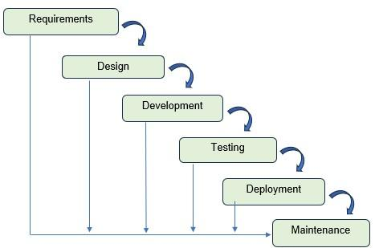

‎

Fig. 1 Waterfall Model

Environment

Locale
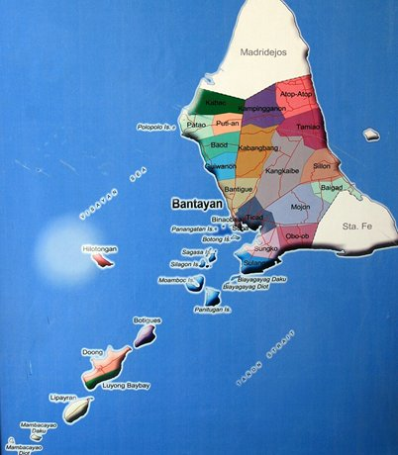

Fig. 2 Location Map of the Study
Municipality of Bantayan

Population of the Study

The target population of this study consists of the one hundred fifty (150) registered fisherfolk residing in Patao, Guiwanon, and Sulangan in the Municipality of Bantayan, who will serve as the system's main users during this pilot implementation.
From this population, the respondents of this study will comprise a sample size of 30 fisherfolks. To ensure equal representation, quota sampling will be applied, selecting 10 respondents from each of the three barangays. Furthermore, purposive sampling will be utilized to establish two strict inclusion criteria: first, the selected fisherfolks must own a functional mobile phone (either keypad or smartphone); and second, they must lack consistent access to the internet.
It is imperative to target individuals without internet connectivity to highlight the core necessity of utilizing SMS technology over standard web-based alternatives. By focusing specifically on this demographic, the study aims to solve a critical communication problem for a marginalized, unconnected sector of the community. Because the proposed solution is an offline, SMS-based information and incident reporting system, surveying these specific fisherfolks ensures that the researchers are gathering data and feedback from the exact end-users the system was designed to empower and protect.

Organizational Chart/Profile

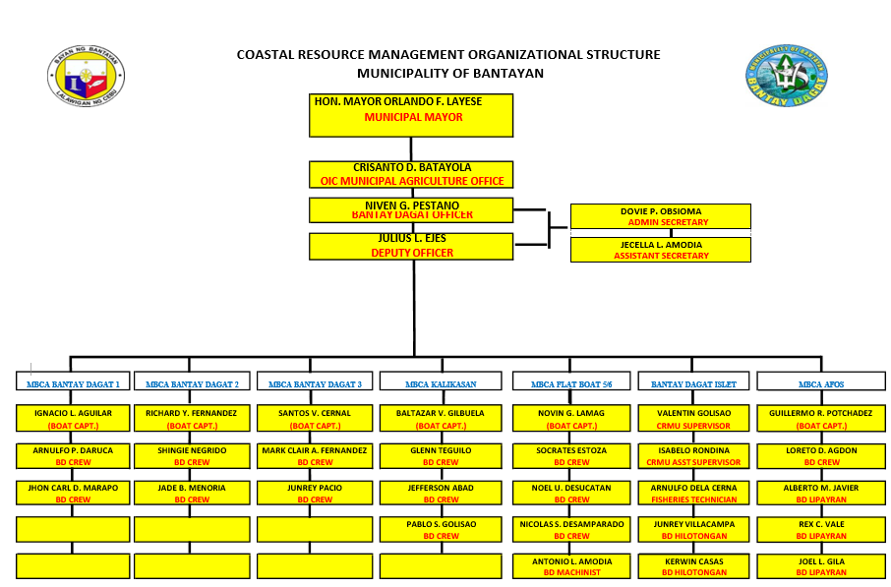

Fig. 3 Bantay Dagat Organizational Chart

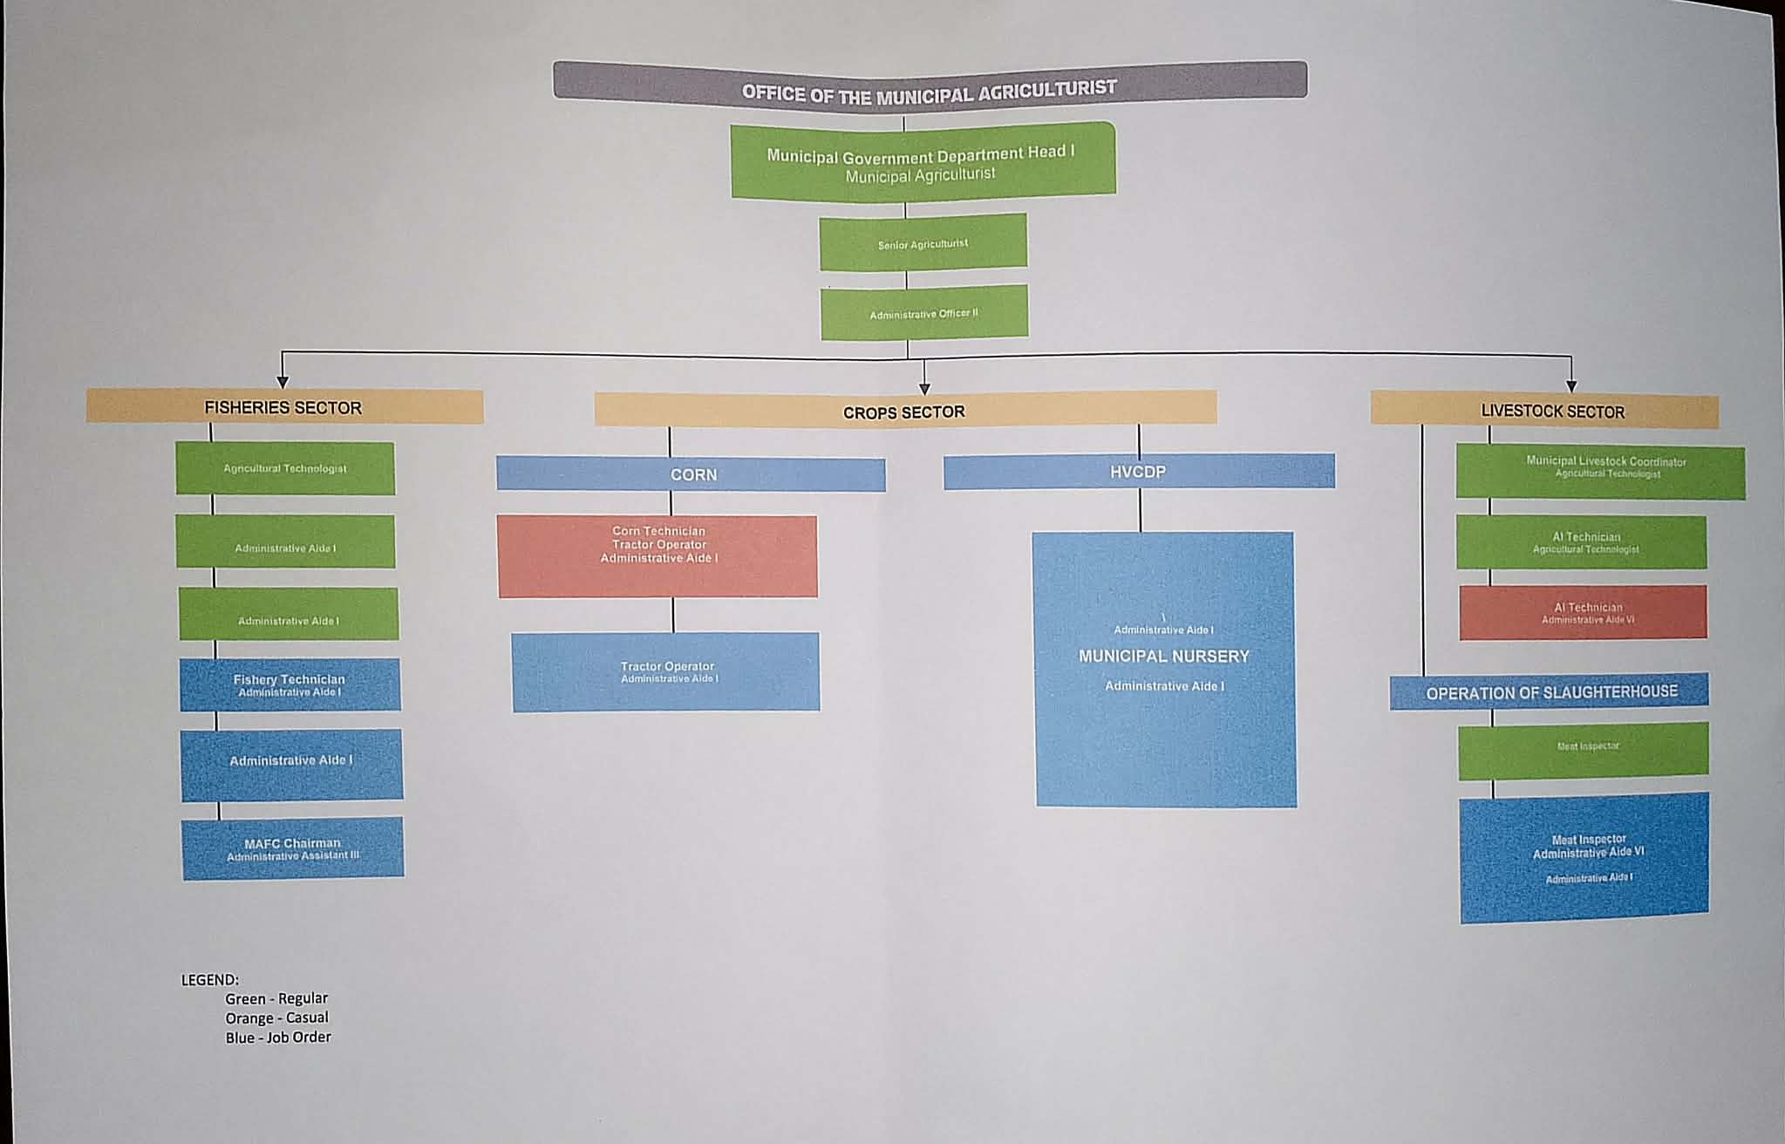

Fig. 4 Fisheries Organizational Chart

Requirements Specification

Operational Feasibility

To determine whether the proposed system can work within the Municipality of Bantayan's existing communication and reporting processes among the Municipal Agriculture Office, Bantay Dagat personnel, and fisherfolk. Currently, announcements are spread through meetings, barangay officials, social media, or word-of-mouth, while incident reports are submitted manually via personal reporting or calls, often causing delayed communication, incomplete information, and poor monitoring. The proposed BantayDagat Information System addresses these issues through a centralised SMS platform that lets personnel broadcast announcements instantly to all fisherfolk while allowing fisherfolk to report illegal fishing, emergencies, and damaged equipment via SMS, with all reports automatically stored in a database for easy verification, monitoring, and reporting—ultimately improving communication speed, reducing response time, and strengthening coordination among stakeholders.

Fishbone Diagram
Fig. 5 shows the fishbone diagram of the current process used in the [system name]. A fishbone diagram, also known as an Ishikawa diagram or a cause-and-effect diagram, is a visual tool used to identify and organize possible causes of a problem or issue. Potential causes of the said problem are categorized into 6: material, measurement, machine, method, environment, and people. In this study, the causes are listed in the body, while the problem or the effect is located at the head of the fish. Here, the problem is the lack of a centralized and accessible communication system for fisherfolk. This current setup is largely dependent on manual, delayed, and unstructured reporting methods, compounded by limited awareness among fisherfolk and their continued reliance on verbal communication. Due to restricted access to smartphones and stable internet connectivity, as well as the absence of organized documentation and reporting tools, problems such as poor coordination and inaccurate information dissemination are expected. The remote and coastal conditions in which fisherfolk operate further hinder effective communication, while the absence of a reliable system for monitoring and tracking incidents and fishing conditions makes the situation worse. This will lead to delayed reporting, weak coordination among stakeholders, and limited capability to respond to incidents in a timely and accurate manner.

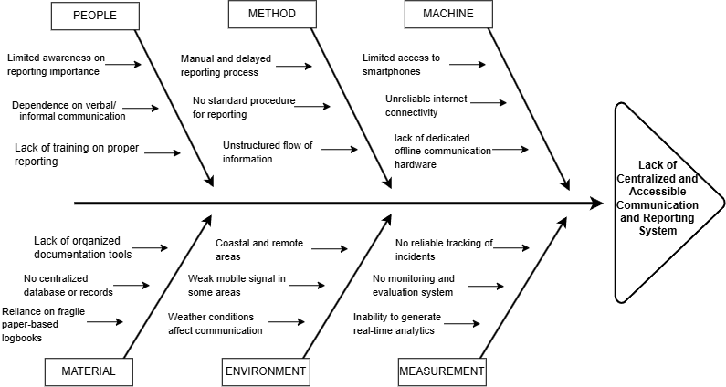
Fig. 5 Fishbone Diagram

Functional Decomposition Diagram

Figure 6 shows the Functional Decomposition Diagram (FDD) of the proposed BantayDagat: SMS-Based Information Dissemination and Incident Reporting System, depicting the major functional components and their interrelationships within the system. The figure below helps illustrate the overall structure of the system by breaking it down into its primary modules, namely User Management, Fisherfolks Information, Announcement Management, Incident Management, and Reports and Monitoring, together with their corresponding sub-functions. This provides a clear representation of how the system is organized and how its different functional components work together to support information dissemination and incident reporting for fisherfolk.
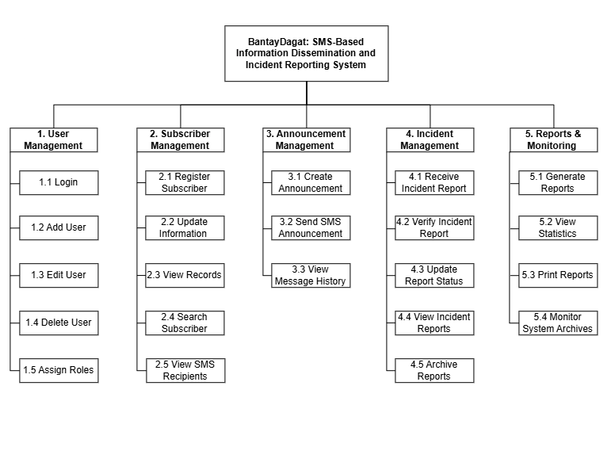

Fig. 6 Functional Decomposition Diagram

Technical Feasibility

Technical feasibility evaluates the technical resources and requirements needed to develop and implement the proposed system successfully.
The researchers assessed the availability of hardware, software, and communication technologies necessary for the operation of the SMS-based system.
2.1 Hardware Requirements
Table # 1
Hardware Requirements (Development and Deployment)
Hardware | Specification
Computer/Desktop | Intel Core i3 or higher
Mobile Phone | SMS-capable device
Memory (RAM) | At least 4GB
Storage | 128GB or higher
Internet Modem/Network | For SMS gateway and system administration

2.2 Software Requirements
Operating System: Windows 10 or Windows 11
Web Browser: Google Chrome, Microsoft Edge, or Mozilla Firefox
Frontend Technologies: HTML5, CSS3, Vanilla JavaScript
Backend Framework: ASP.NET MVC (.NET)
Programming Language: C#
Database Management System: SQL Server Express LocalDB
Integrated Development Environment (IDE): Visual Studio 2022

Schedule Feasibility

Schedule feasibility determines whether the project can be completed within the proposed timeframe.

Gantt Chart

The researchers used the Gantt Chart as a guide to monitor weekly tasks and ensure everything stayed on track. The figures below illustrate the weekly distribution of tasks from January 2026 to August 2026, beginning with the assignment of group members and continuing through the development of Chapter 2, following the manuscript format

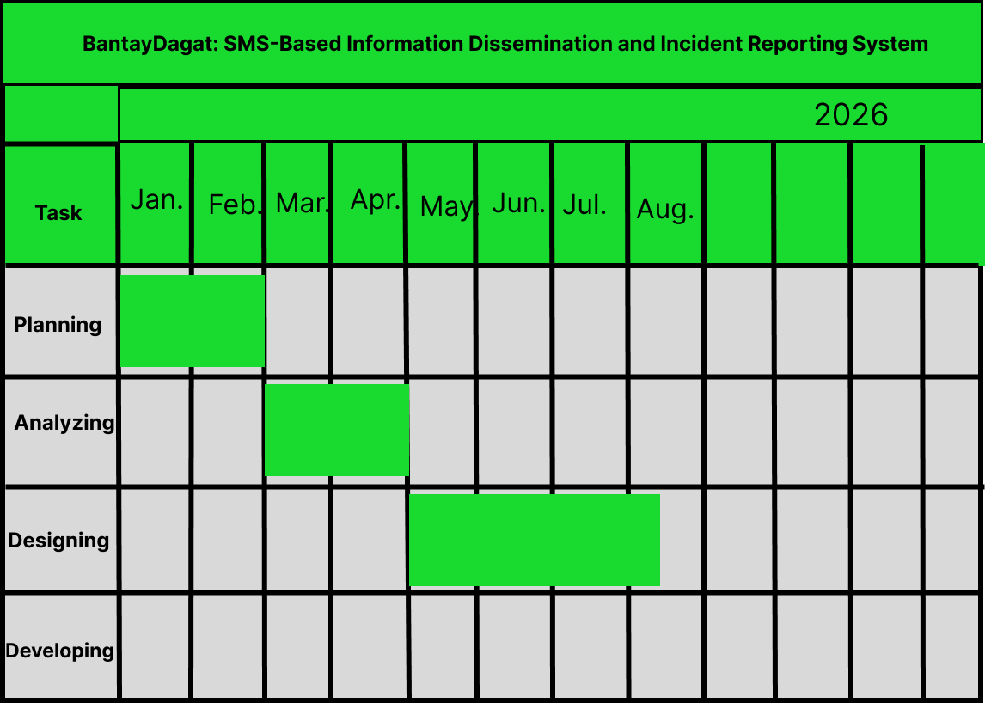

Fig. 7 Gantt Chart

Work Breakdown Structure

3.1.1 Planning
Table 2 shows the schedule of tasks done by the researchers during the planning phase which mostly involved gathering ideas on what system to implement.

Table #2
Requirements Phase (Planning)
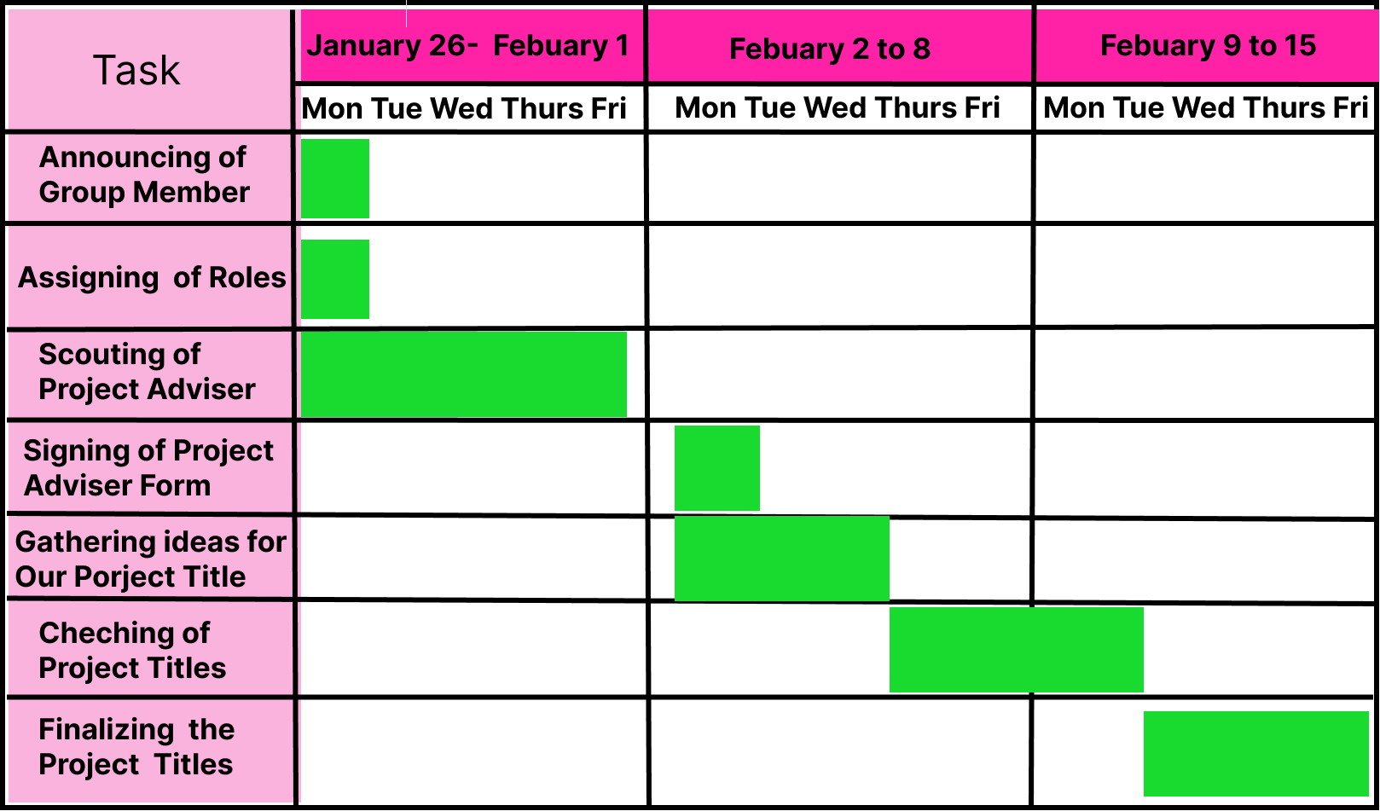

3.1.2 Analysis
Table 3 shows the Analysis part where the researchers gathered information on the generated project titles.
Table #3
Requirements Phase (Analysis)
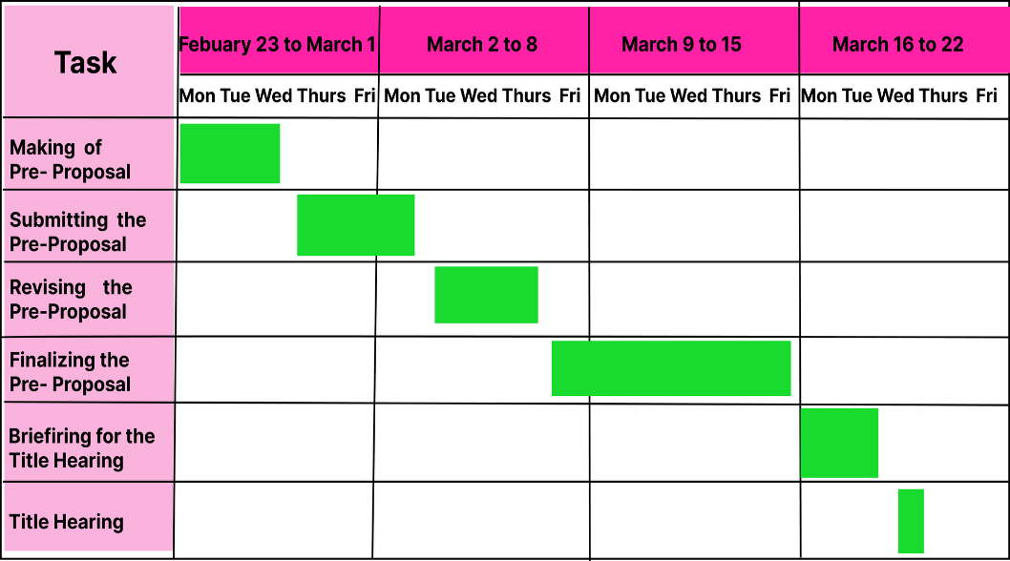

3.1.3 Conceptual
Table 4 shows the summary of the conceptual phase which involves formulating the clinical problem, reviewing the literature, and determining the research purpose.
Table #4
Requirements Phase (Conceptual)
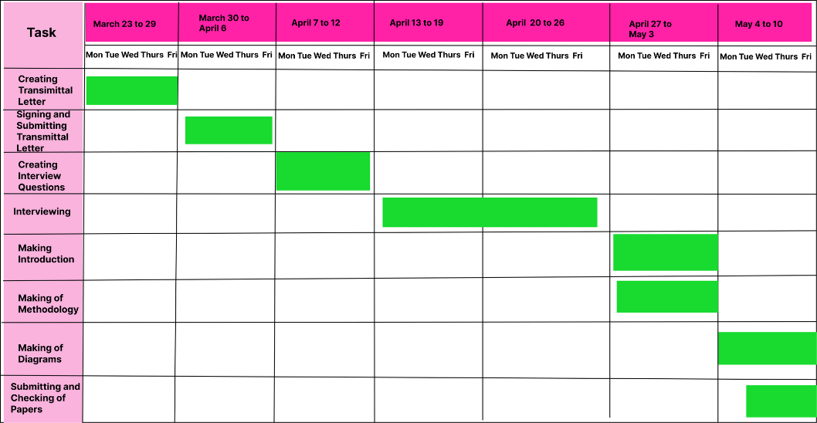

3.1.4 Design and Deployment
Table 5 shows the schedule of tasks done by the researchers during the design and development phase which mostly involved creating a detailed design document that outlines the software architecture, user interface, and system components it also involves coding the software based on the design specifications.

Table #5
Design and Deployment Phase
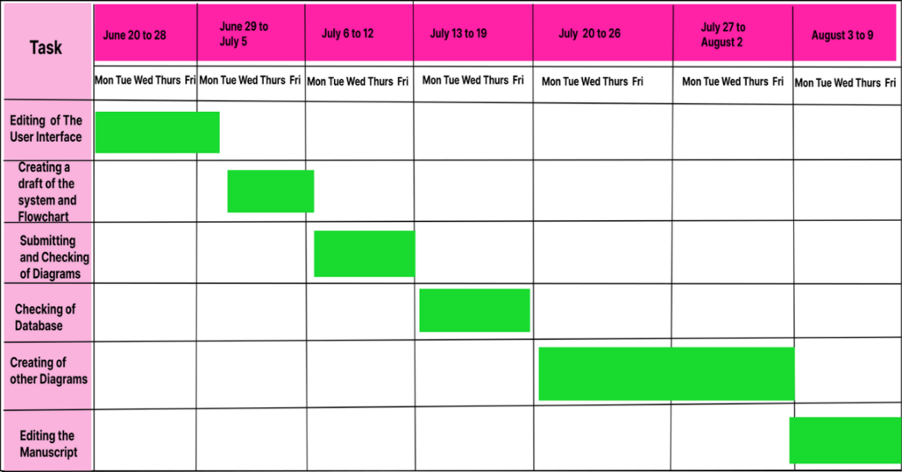

Requirements Modelling

Input-Process-Output (IPO) Diagram
The figure below illustrates the Input-Process-Output (IPO) model of the proposed BantayDagat system, showing the data entered into the system, the processes performed, and the outputs generated to support information dissemination, incident reporting, and communication between fisherfolk and authorized personnel.
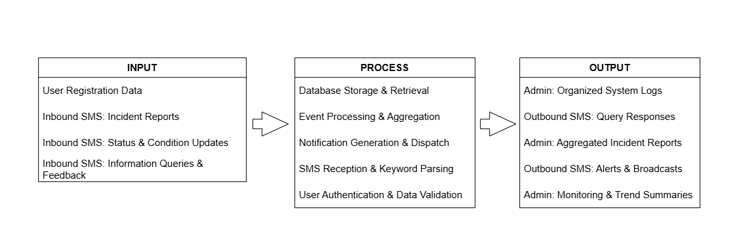

Fig. 8 IPO

Process
The proposed BantayDagat system begins when users register and send SMS messages containing incident reports, status and condition updates, information queries, or feedback. The system receives incoming messages, identifies relevant keywords, validates the submitted information, and stores the data in the database for future retrieval and monitoring. It processes and organizes incident-related information and generates appropriate SMS responses, alerts, and announcements. Authorized administrators can access organized system logs, aggregated incident reports, and monitoring summaries to support fisheries management and improve communication with fisherfolk in the Municipality of Bantayan.

Control
The proposed system includes the following control measures to maintain data accuracy, system reliability, and information security:
- User authentication and access control
- Role-based access permissions for authorized personnel
- Validation of user registration data and incoming SMS messages
- Proper storage and management of incident reports and system logs
- Monitoring and verification of submitted information
- Controlled dissemination of SMS alerts, announcements, and responses

Data and Process Modeling

Context Diagram

Fig. 9 shows the context diagram of the proposed BantayDagat: An SMS-Based Information Dissemination and Incident Reporting System for Fisherfolk in Bantayan. It illustrates the interaction between the system and its external entities through the exchange of data. The diagram depicts the information that each entity provides to and receives from the system, showing the overall flow of communication and defining the system boundary.
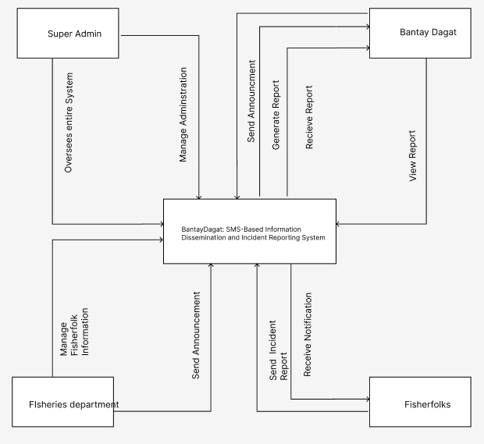

Fig. 9 Context Diagram of BantayDagat

Data Flow Diagram

Fig. 10 shows the Data Flow Diagram (DFD) of the proposed BantayDagat: An SMS-Based Information Dissemination and Incident Reporting System for Fisherfolk in Bantayan. It illustrates the flow of data between the system processes, external entities, and data stores. The diagram depicts how user management, login, fisherfolk information management, announcement dissemination, SMS notifications, incident reporting, and report generation are interconnected to facilitate information exchange, incident monitoring, and efficient fisheries management.

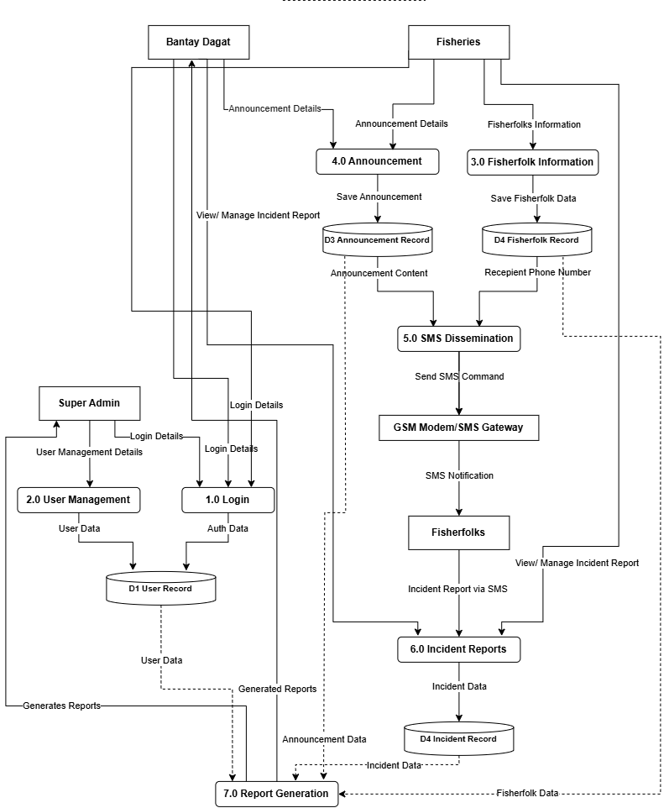

Fig. 10 Data Flow Diagram of BantayDagat

System Flowchart

A program flowchart illustrates how decisions influence the sequence of events within a system. It uses standard flowchart symbols such as start/end terminals, process blocks, decision diamonds, and directional arrows to represent the logical flow of program execution and the movement of data throughout the system.
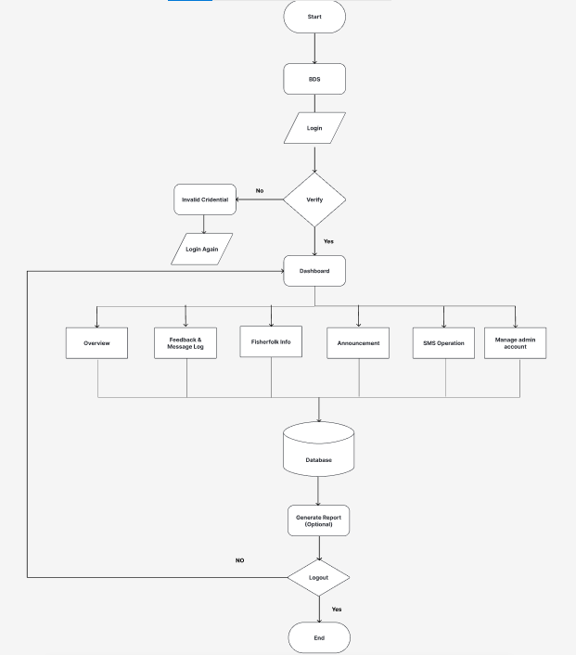
3.1 Super Admin System Flowchart

Fig. 10 Super Admin System Flowchart
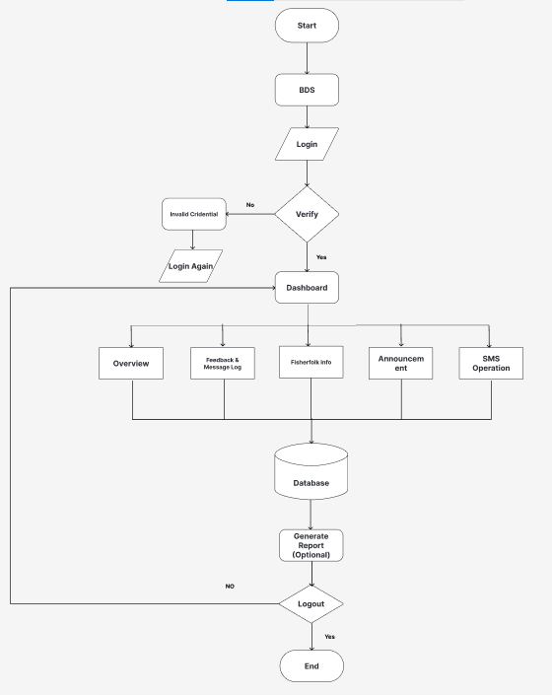
3.2 Bantay Dagat System Flowchart

Fig. 11 Bantay Dagat System Flowchart

3.3 Fisheries Department System Flowchart
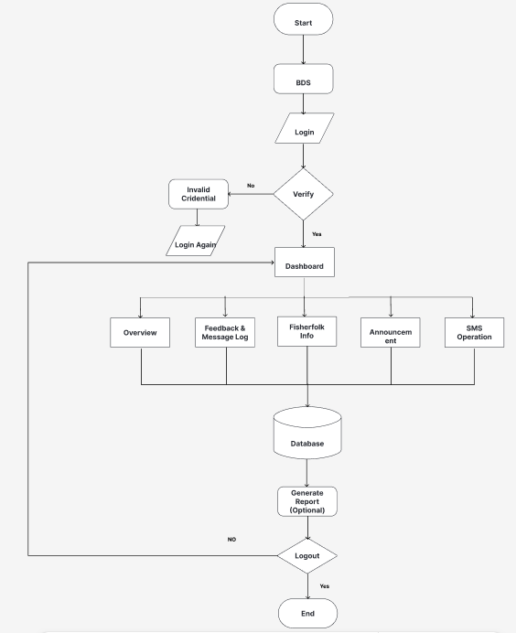

Fig. 12 Fisheries Department System Flowchart

Program Flowchart
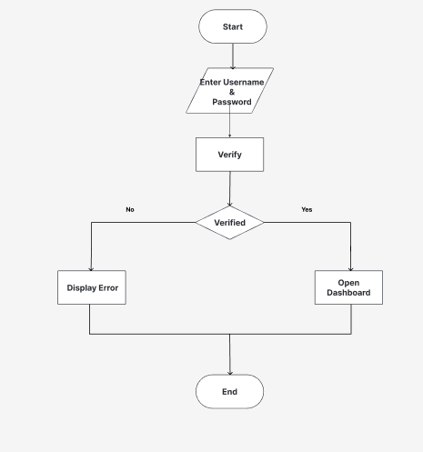

Fig. 13 Login Admin Flowchart

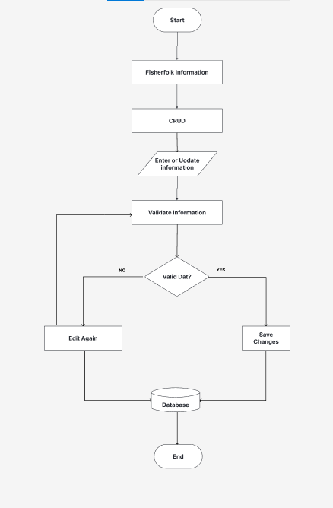

Fig. 14 Fisherfolks Information Flowchart

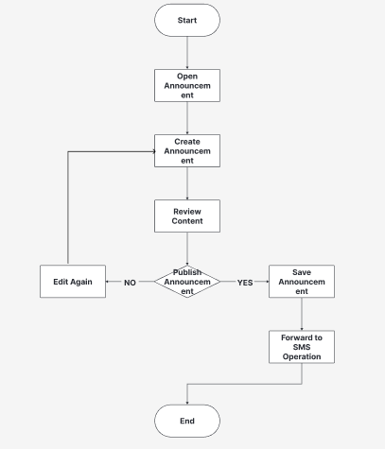

Fig. 15 Announcement Flowchart

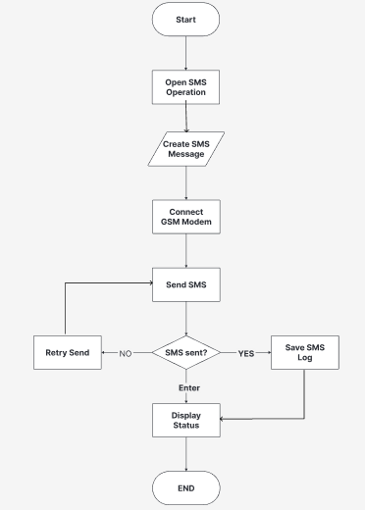

Fig. 16 SMS Operation Flowchart

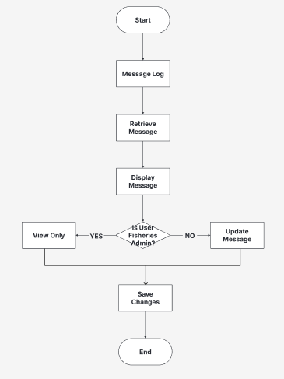

Fig. 17 Feedback and Message Log Flowchart

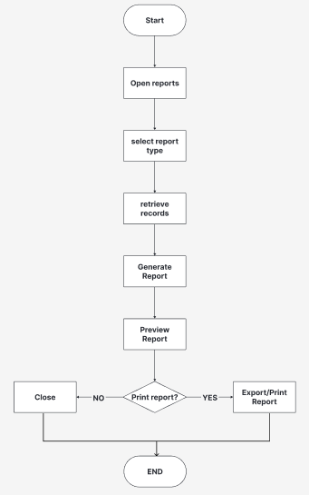

Fig. 18 Report Program Flowchart

Object Modeling

Use Case Diagram

Fig. 19 shows the use case diagram of the proposed BantayDagat: SMS-Based Information Dissemination and Incident Reporting System. It illustrates the different functions that each user can access within the system. The diagram depicts the interactions between the Super Admin, Fisheries, Bantay Dagat, and Fisherfolk with the system, showing the specific tasks and responsibilities assigned to each user. It also presents the relationships among the use cases through include and extend functions, providing a clear overview of the system's functionality and the level of accessibility of each user.

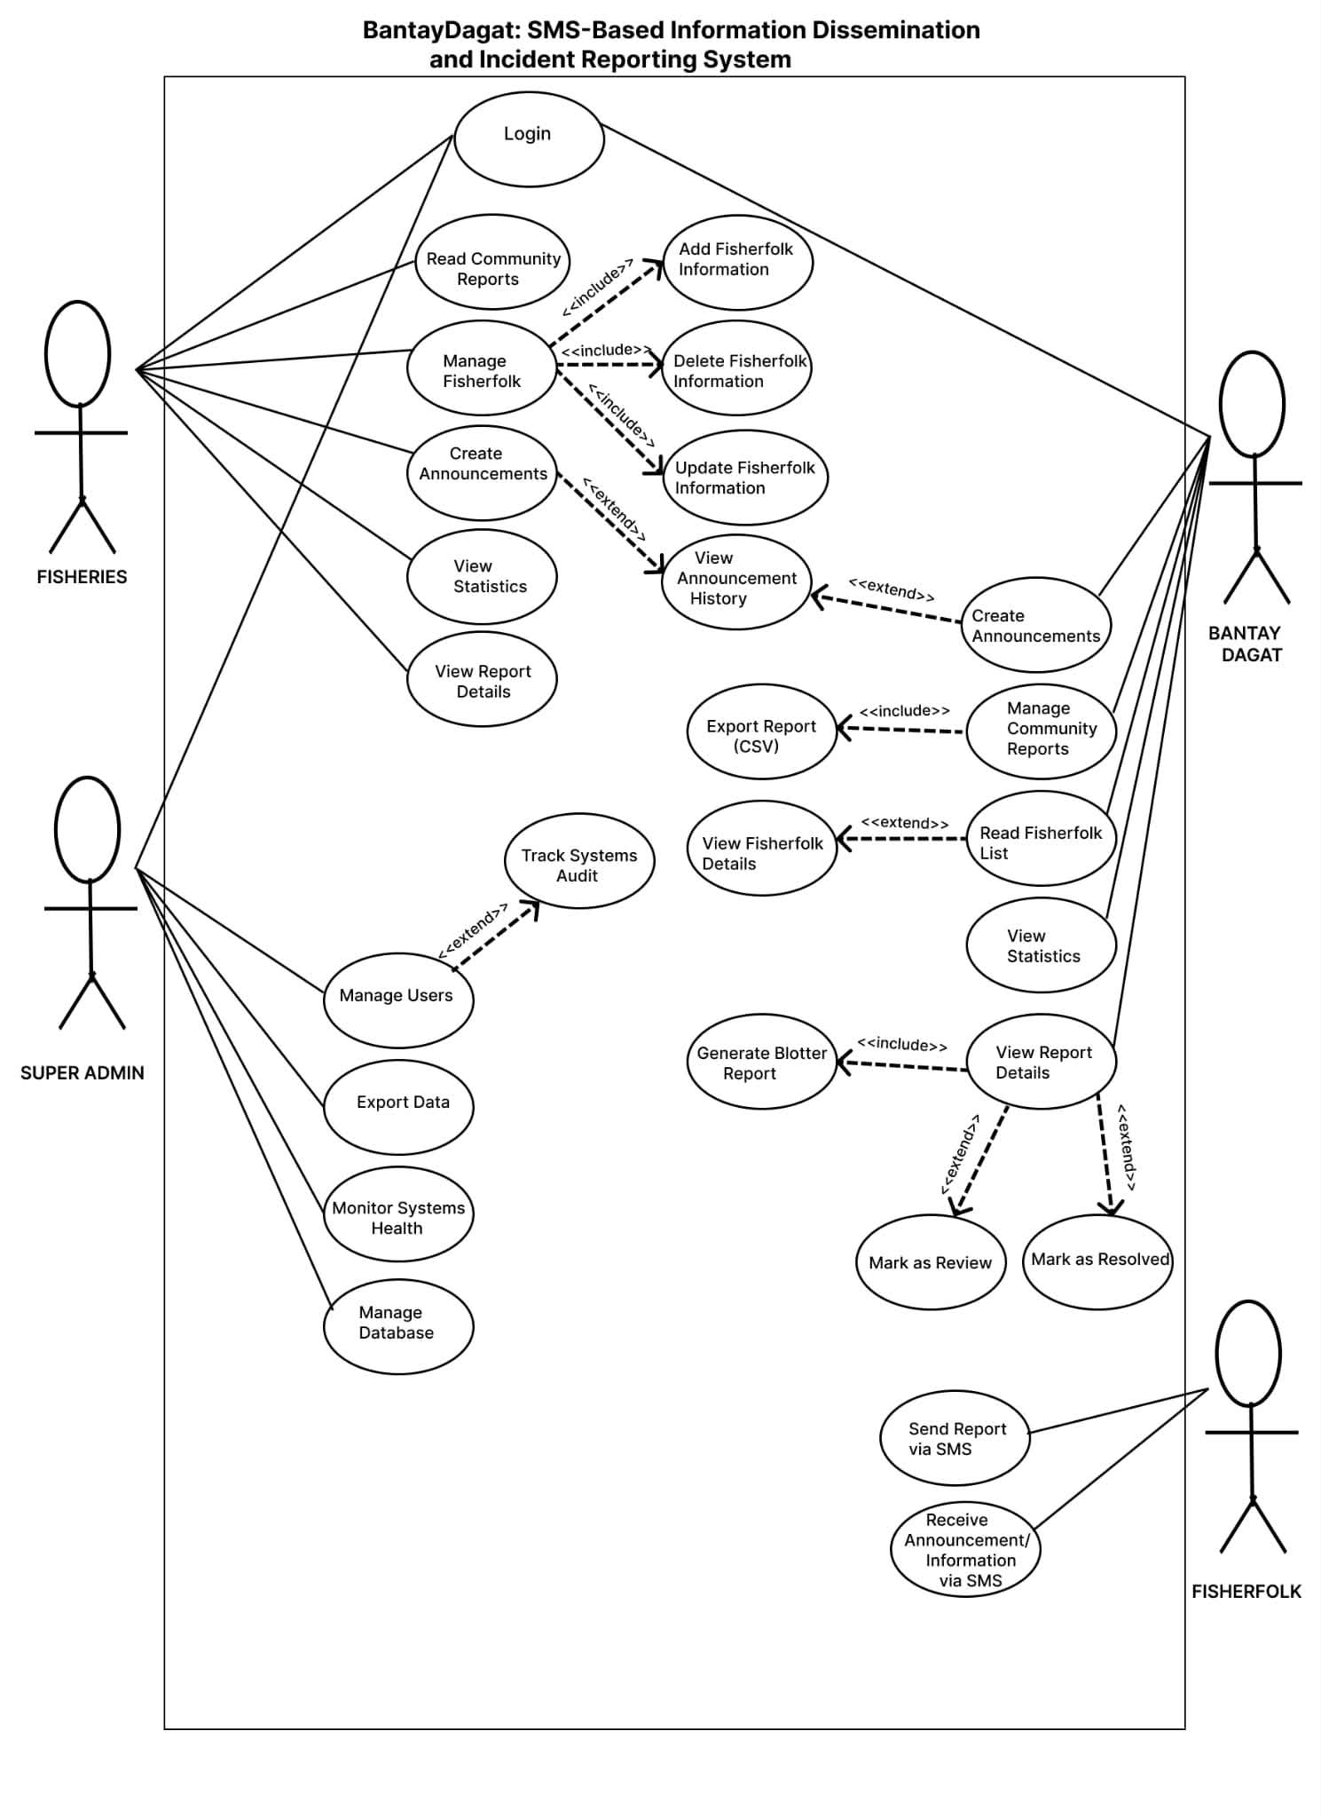

Fig. 19 Use Case Diagram

Class Diagram

Fig. 11 shows the class diagram of the proposed BantayDagat: An SMS-Based Information Dissemination and Incident Reporting System for Fisherfolk in Bantayan. It illustrates the system's structure by presenting the different classes, their attributes, and the relationships among them. The diagram depicts how user accounts, fisherfolk registries, announcements, SMS logs, feedback messages, survey responses, incident reports, blotter reports, administrator messages, attachments, and chat archives are organized and interconnected to support the system's functionality. It also provides an overview of how data is stored, managed, and exchanged to facilitate information dissemination, incident reporting, communication, and record management within the system.

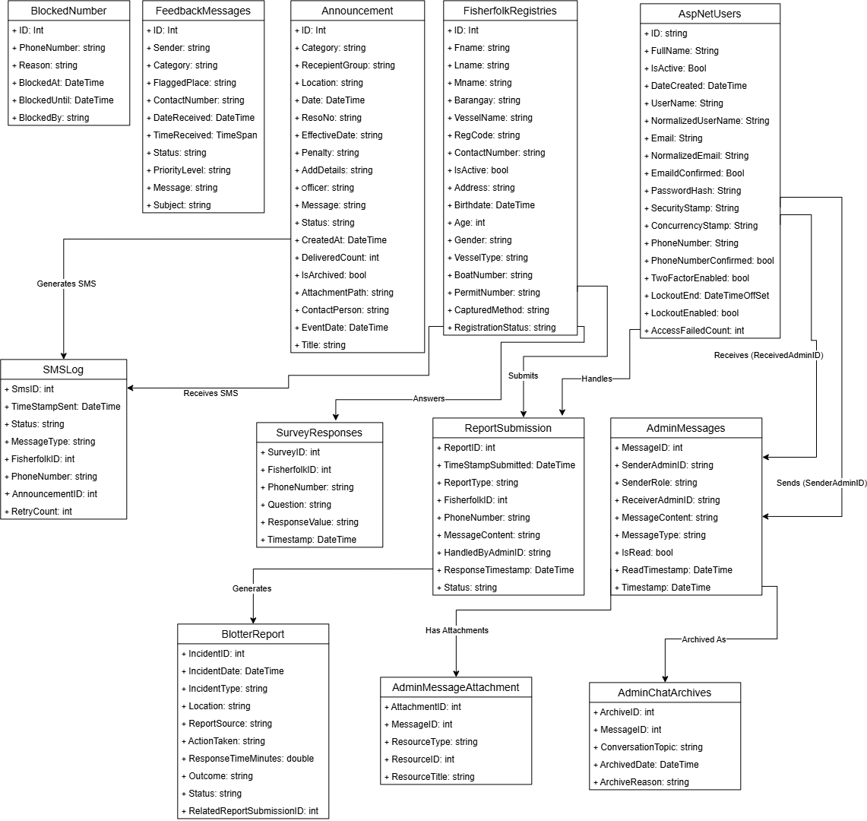

Fig. 20 Class Diagram of BantayDagat

Sequence Diagram

This illustrates the interaction and the sequence of messages exchanged between different actors and the system. In the context of the proposed BantayDagat: SMS-Based Information Dissemination and Incident Reporting System, the sequence diagram shows how the Super Admin, Fisheries, Bantay Dagat, and Fisherfolk interact with the system to perform various operations, such as logging in, managing fisherfolk information, disseminating announcements through SMS, submitting incident reports, viewing reports, and generating reports.
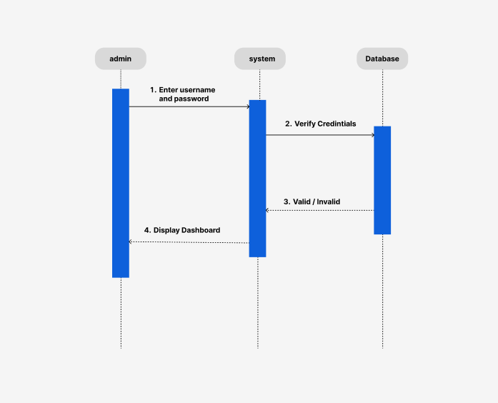

Fig. 21 Login Sequence Diagram

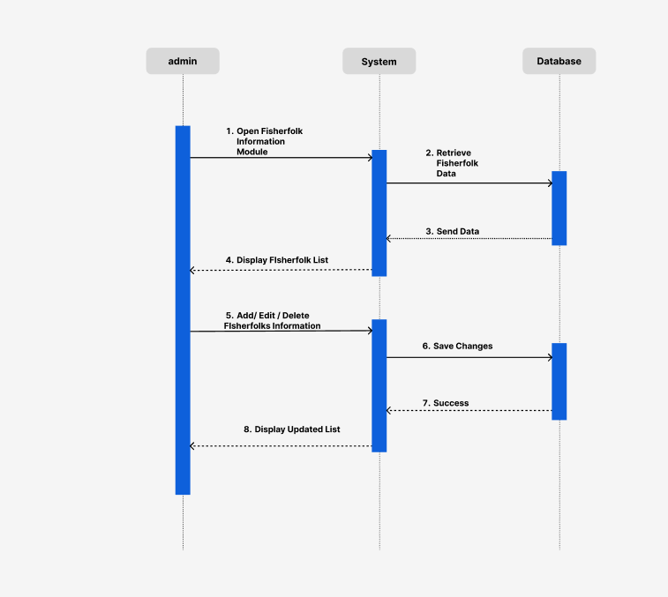

Fig. 22 Fisherfolk Information Sequence Diagram

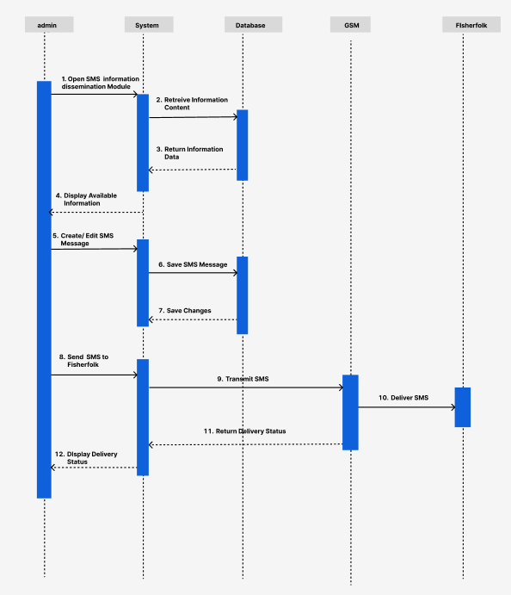

Fig. 23 SMS Dissemination Information Sequence Diagram

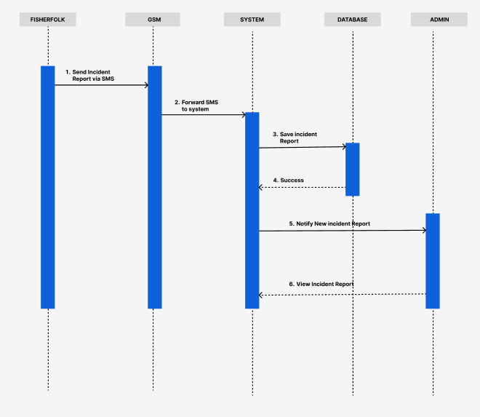

Fig. 24 Incident Reporting Sequence Diagram

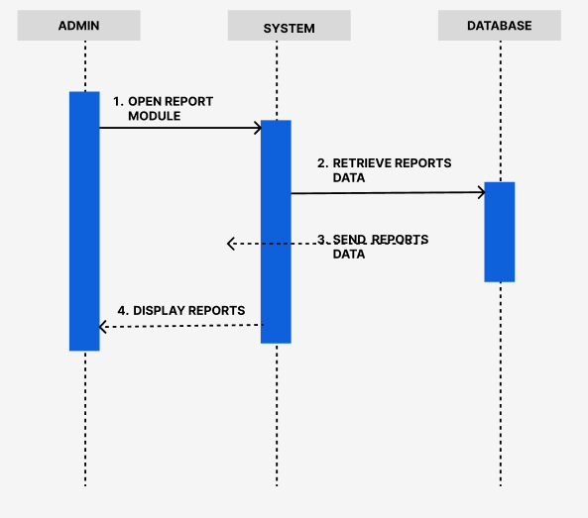

Fig. 25 View Report Sequence Diagram

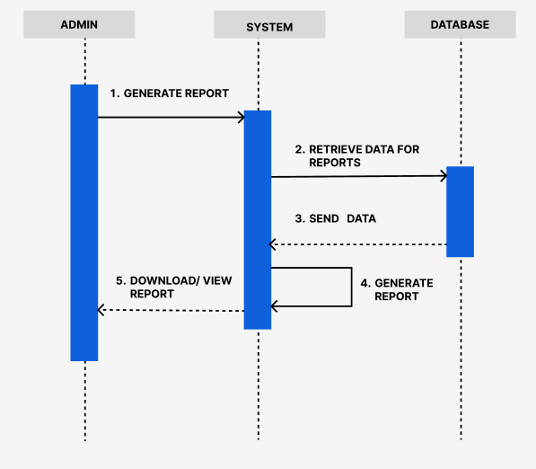

Fig. 26 Generate Report Sequence Diagram

Activity Diagram
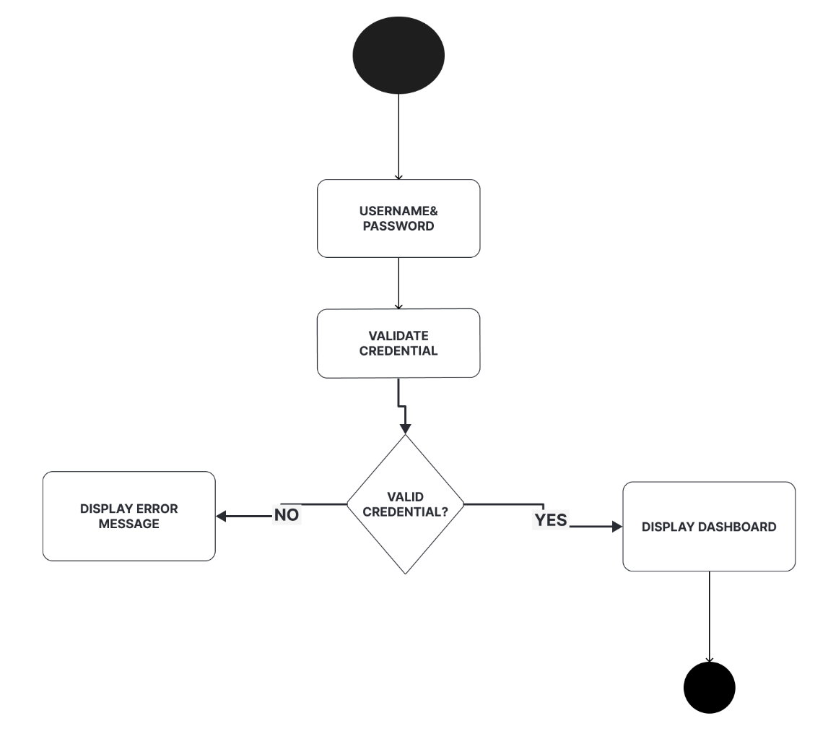

Fig. 27 Login Activity Diagram

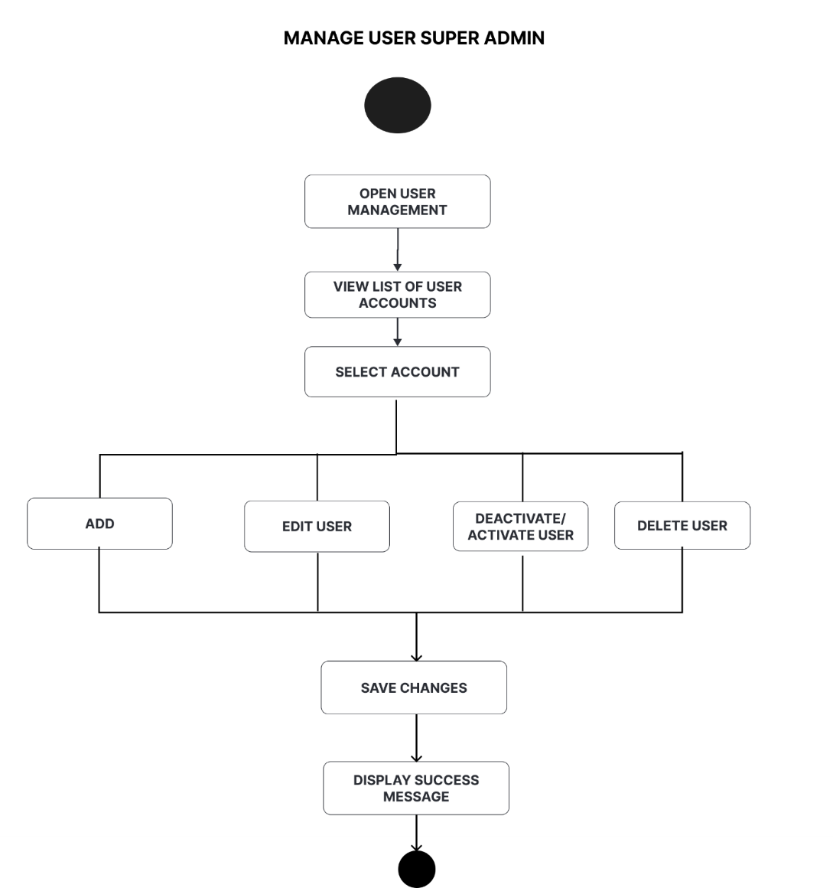

Fig. 28 Manage User Super Admin Activity Diagram

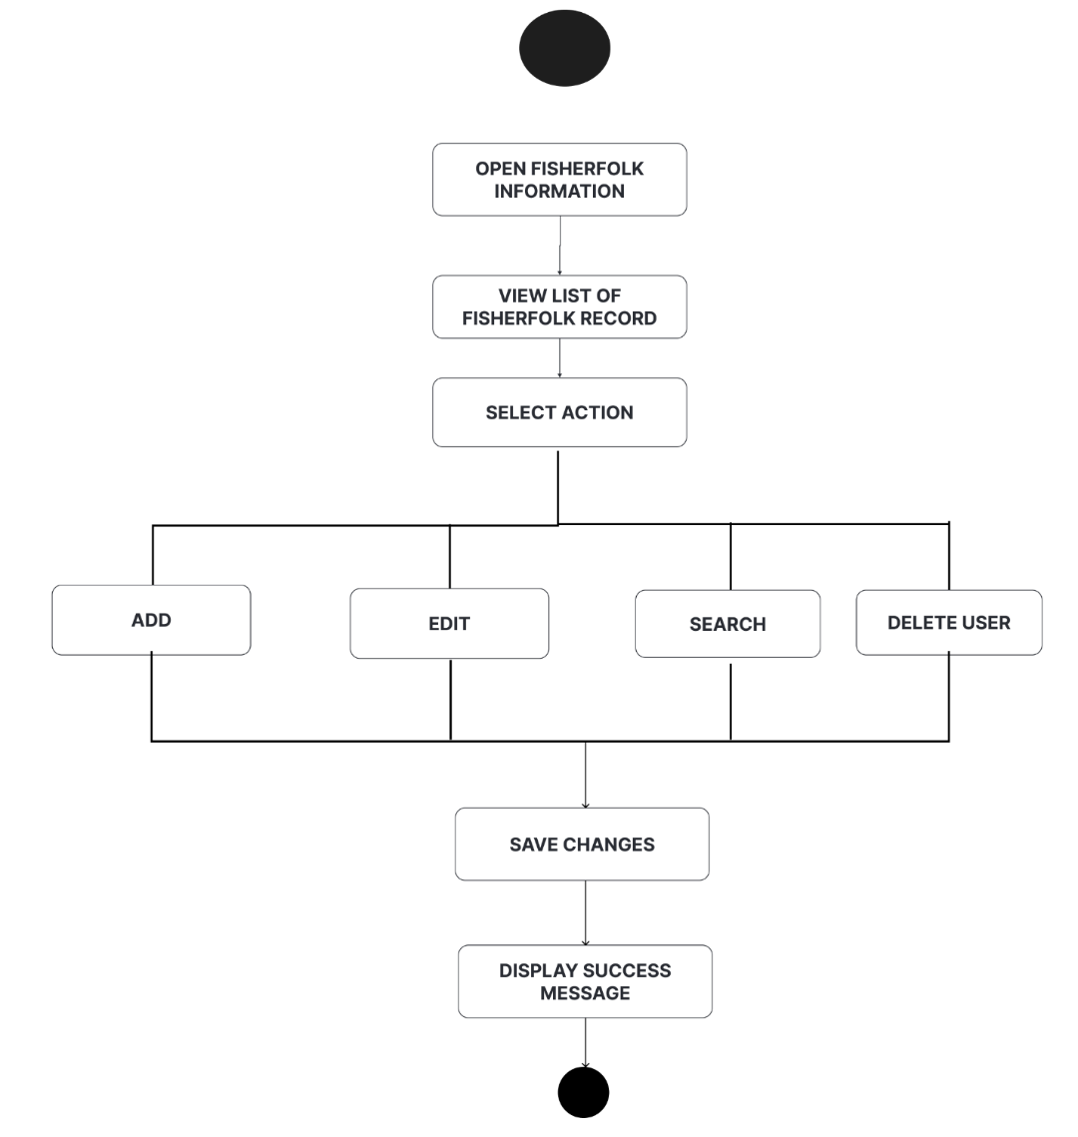

Fig. 29 Manage Fisherfolk Information Admin Activity Diagram

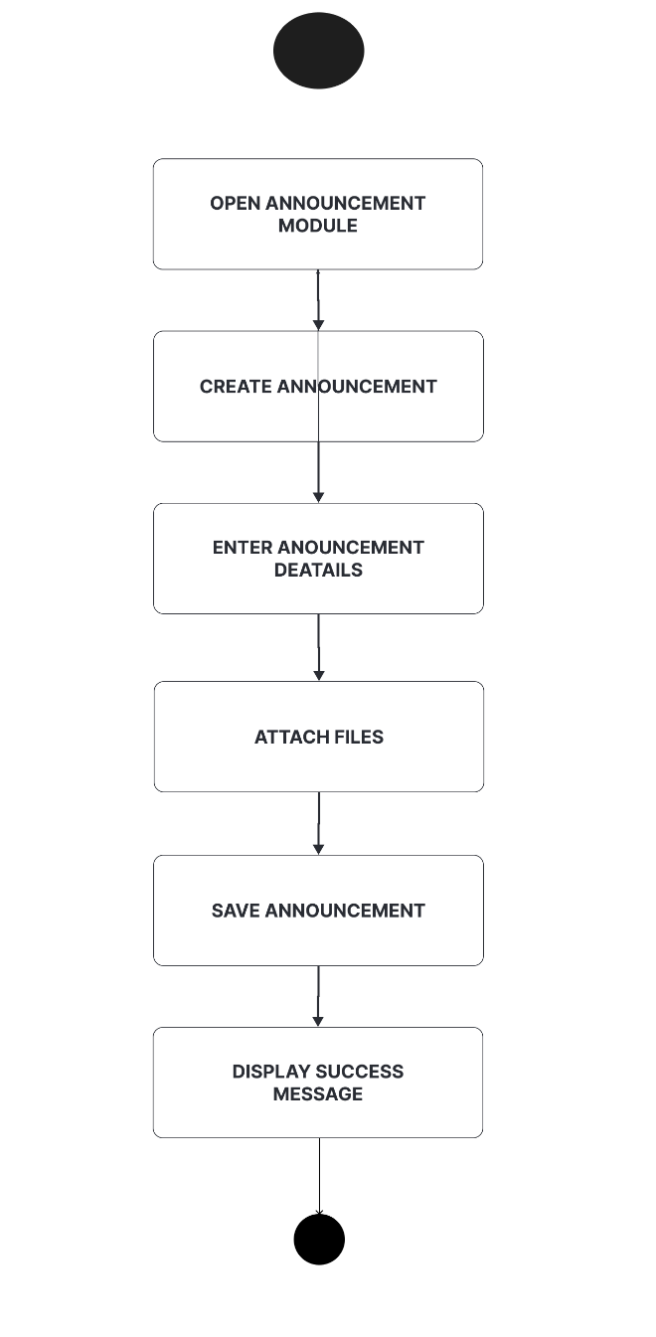

Fig. 30 Announcement Activity Diagram

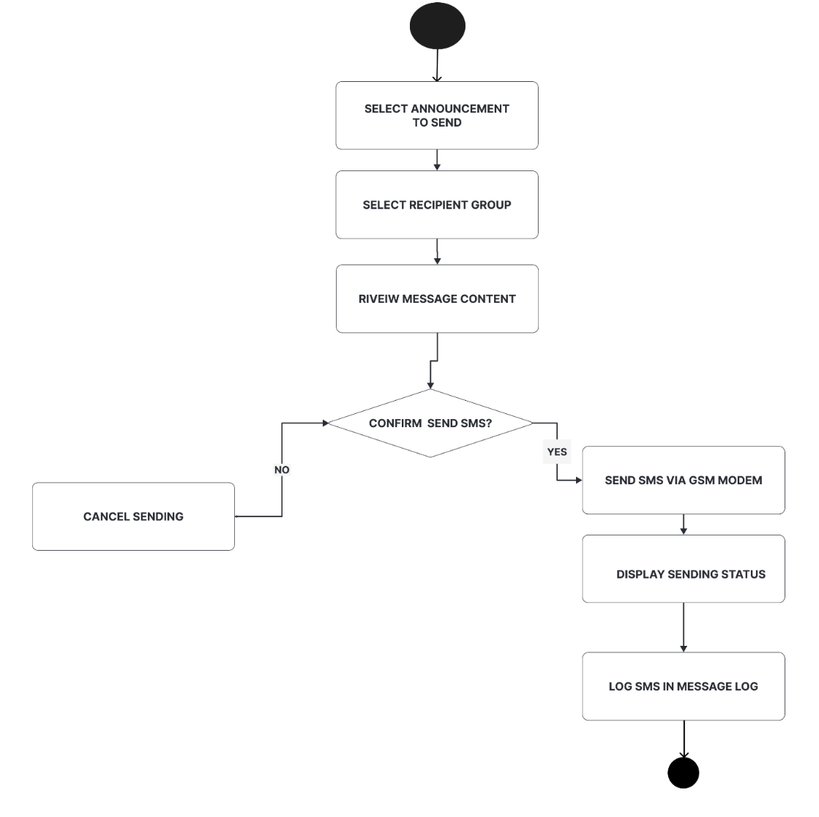

Fig. 31 Information Dissemination Activity Diagram

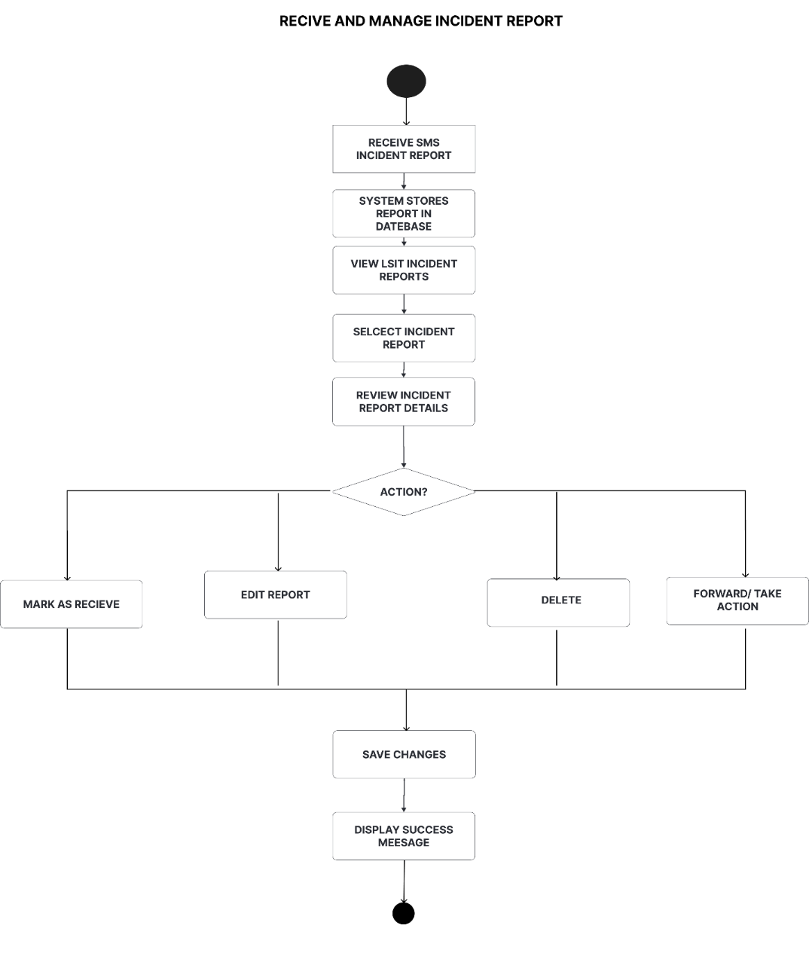

Fig. 32 Receive and Manage Incident Report Activity Diagram

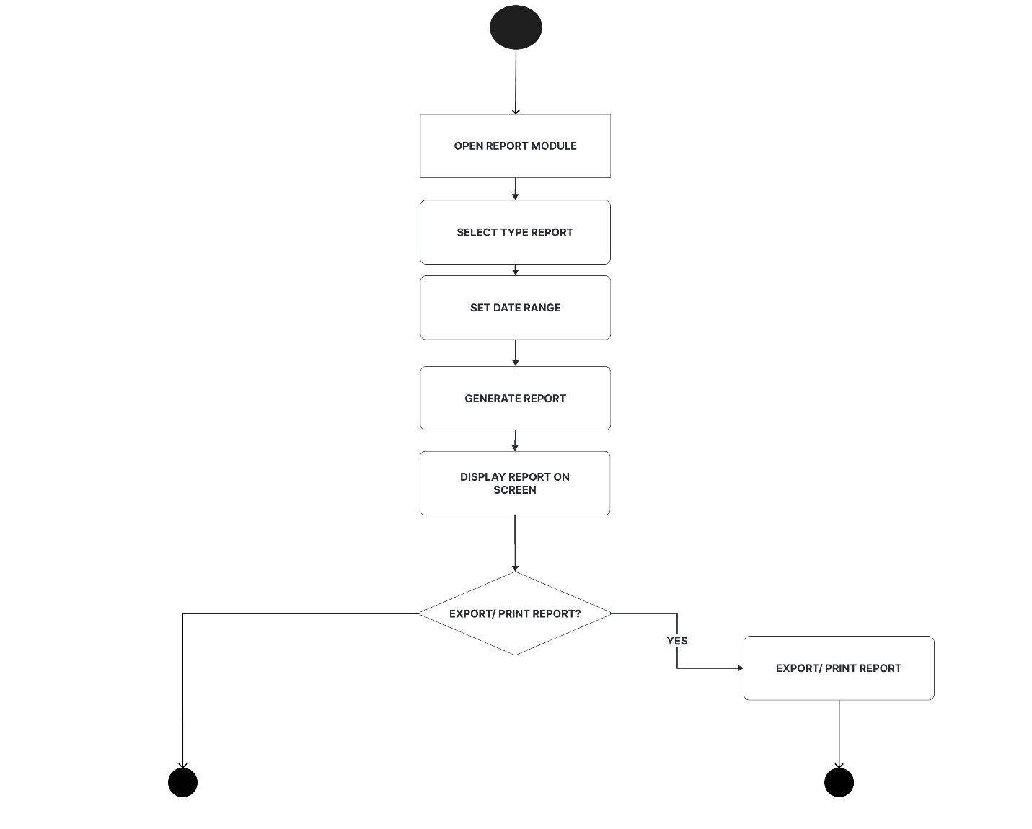

Fig. 33 Generate Report Activity Diagram

Analysis

Cost and Benefit Analysis

This analysis aims to provide an estimate of the expenses involved in developing, implementing, and maintaining the system. It considers various aspects such as primary hardware, software development, and ongoing operational costs.
For the primary hardware, a computer set or laptop with an internet connection is required to host the system, which costs approximately ₱35,000.00. For the communication hardware, a GSM module (SIM900) costing ₱800.00 and an Arduino Uno microcontroller costing ₱400.00 are needed to bridge the SMS capabilities to the computer. For software development, the necessary tools and frameworks cost around ₱2,000.00. Finally, ongoing operational costs—specifically the monthly SMS credits required for sending announcements and receiving fisherfolk reports—are estimated at up to ₱5,000.00, alongside occasional hardware maintenance.
Estimated Cost Breakdown:
- Computer Set / Laptop: ₱35,000.00
- Software Tools & Frameworks: ₱2,000.00
- GSM Module (SIM900): ₱800.00
- Arduino Uno: ₱400.00
- Initial Operational Cost (Monthly SMS Credits): ₱5,000.00
- Total Estimated Cost: ₱43,200.00

Benefit Analysis: Given its significant benefits—including improved fisherfolk safety, real-time reporting of illegal fishing activities, and a high-reach communication channel that functions entirely without internet access—the system is highly cost-effective. While it requires an initial investment of ₱43,200.00, it is expected to yield a massive return on investment in terms of public service value. The system will significantly reduce the operational delays of manual reporting and contribute directly to the successful monitoring and protection of the marine resources and fisherfolk community in Bantayan.

Risk Assessment/Analysis:

This analysis is crucial for identifying potential risks and vulnerabilities the Bantay-Dagat: An SMS-based Information Dissemination and Incident Reporting System for Fisherfolk in Bantayan may encounter throughout its lifecycle. The system may experience technical issues such as network downtime, signal dead zones, and SMS delivery delays, as well as operational risks such as delayed rescue response due to limited fuel, boats, or personnel. Implementing delivery confirmation receipts, retry logic on the gateway, and securing a dedicated budget for patrol response can mitigate these technical and operational risks.

Design

A. Output and User-Interface Design

Forms

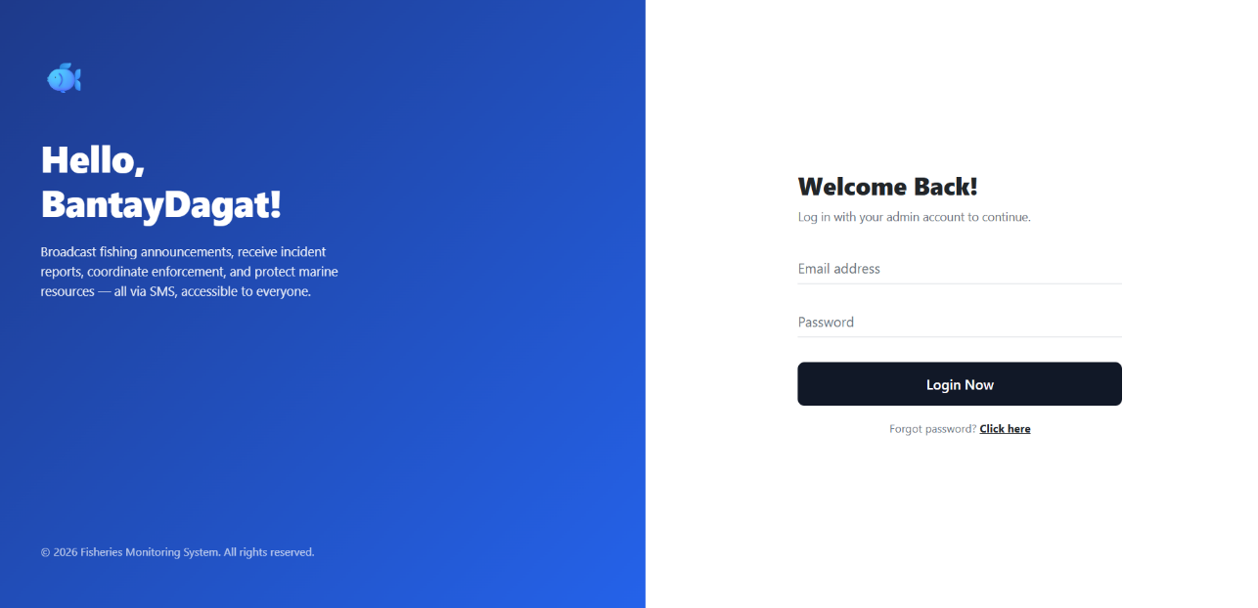
BantayDagat Admin

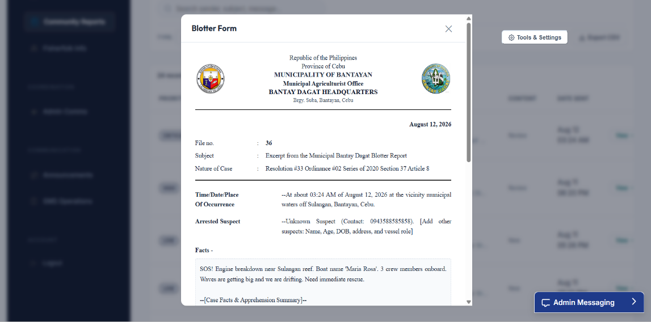
Fig. 8 Landing Page

Fig. 9 Generate Blotter

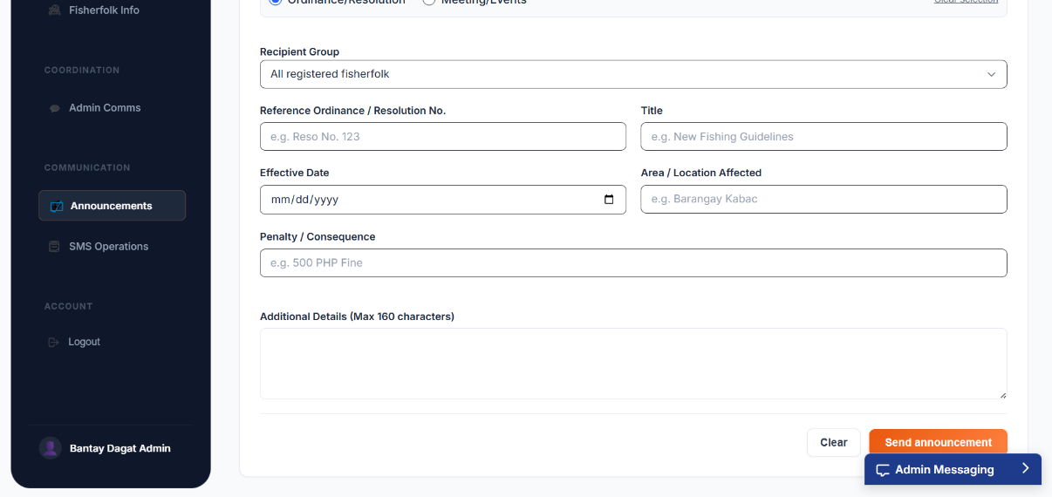

Fig. 10 Announcement

Fisheries Municipal Agriculture Office (MAO) Admin
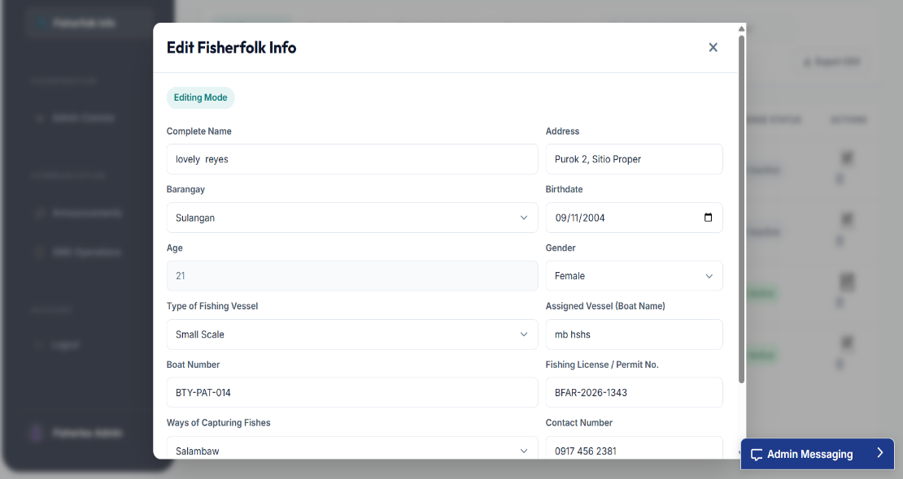

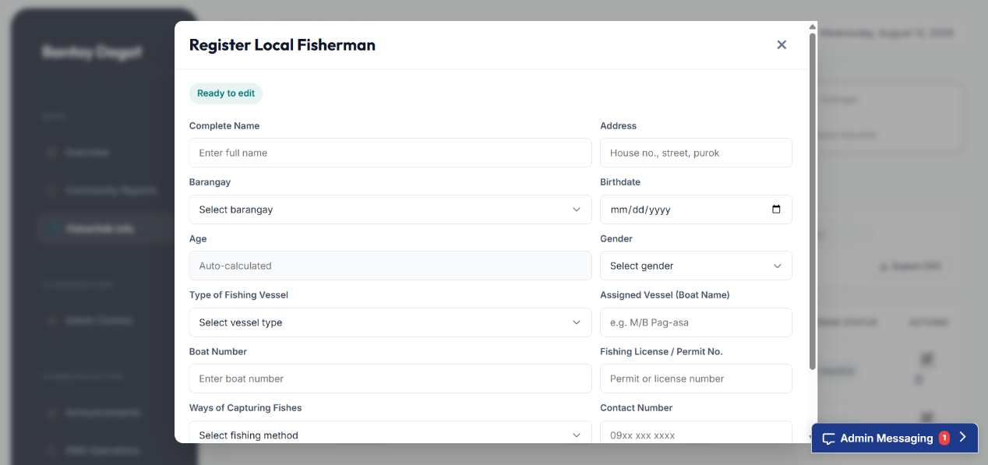
Fig. 11 Edit Fisherfolk Information

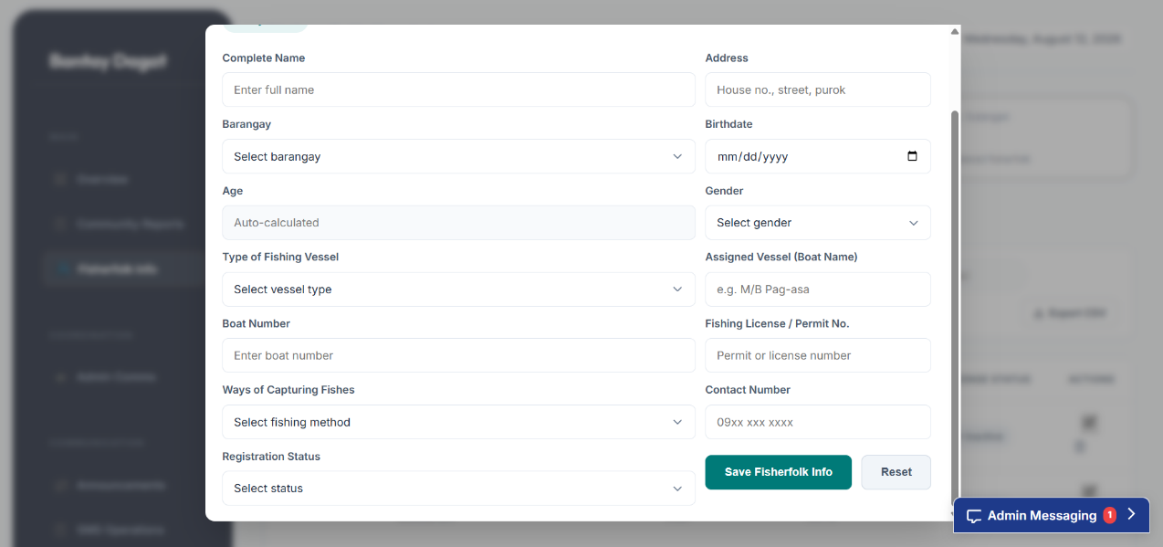

Fig. 12 Register Local Fisherfolk

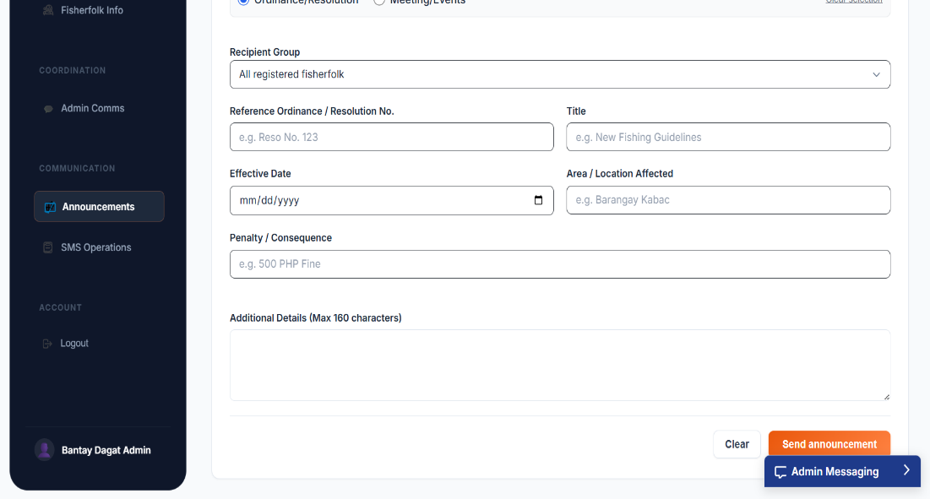

Fig. 13 Announcement
Super Admin
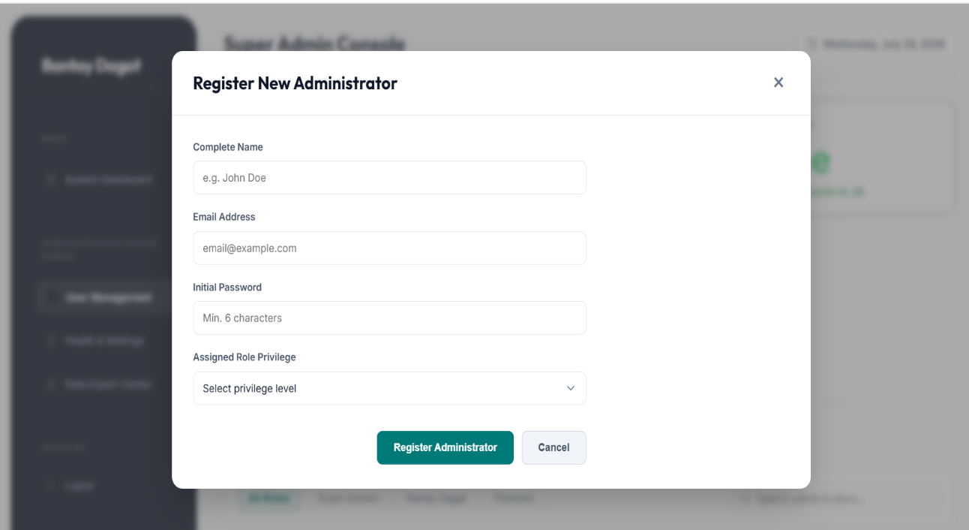

Fig. 14 Register New Administrator

Reports

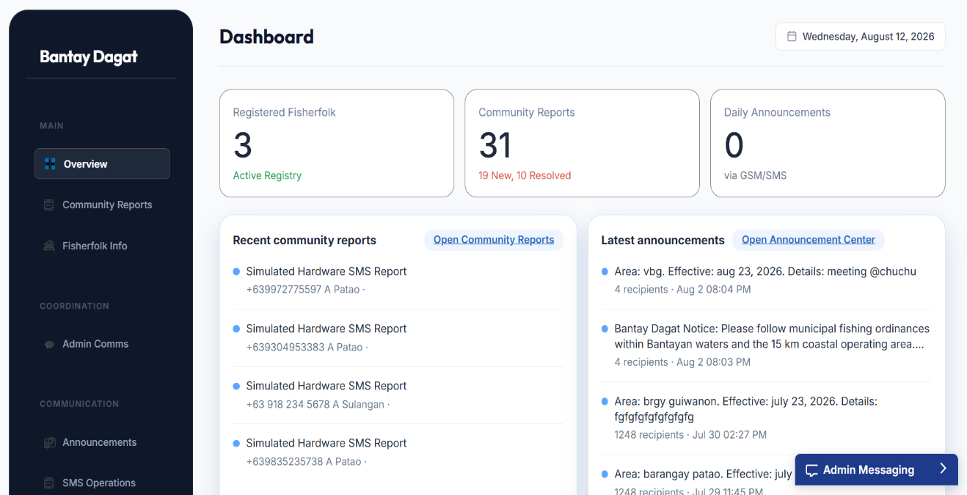
Bantay Dagat Admin

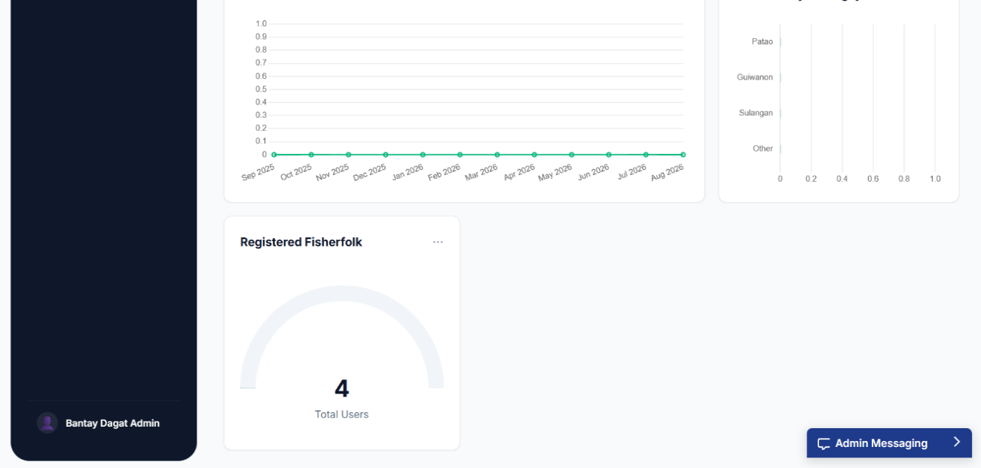

Fig. 15 Overview

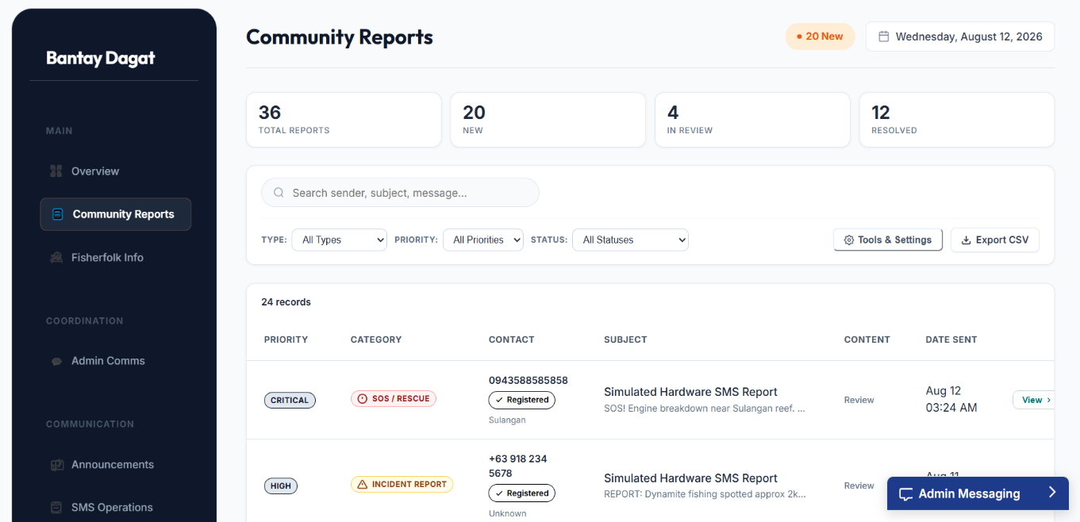

Fig. 16 Community Report

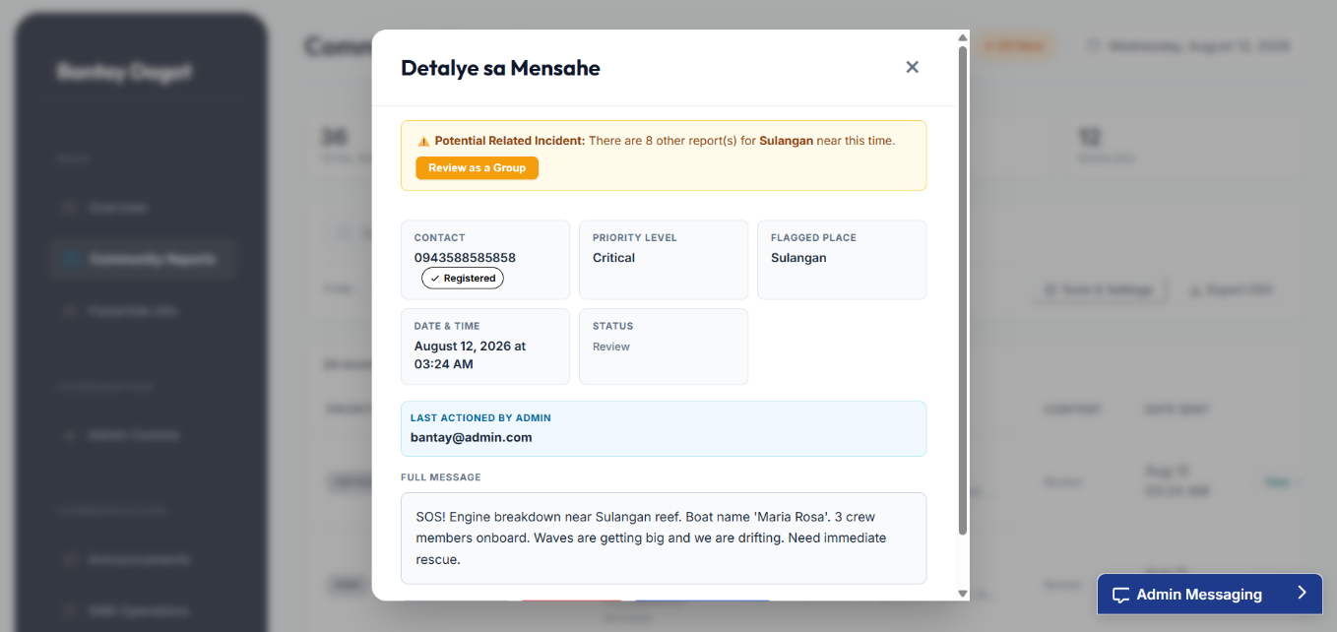

Fig. 17 Message Details

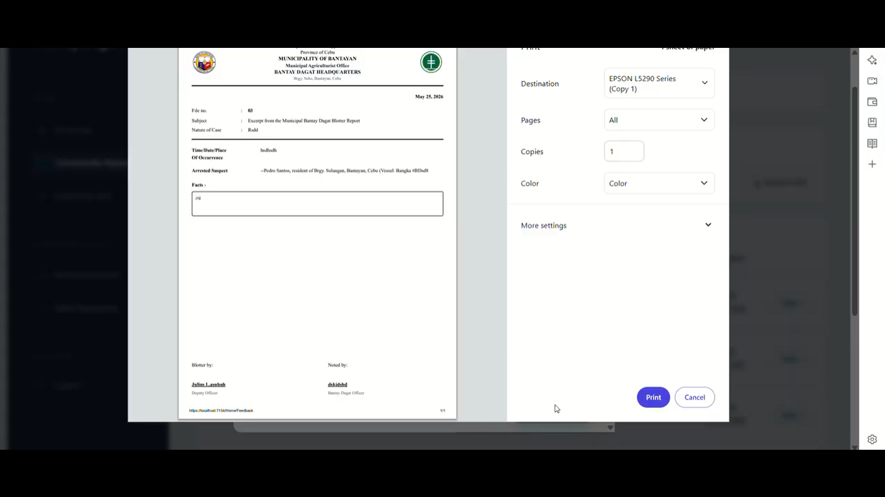

Fig. 18 Print Blotter
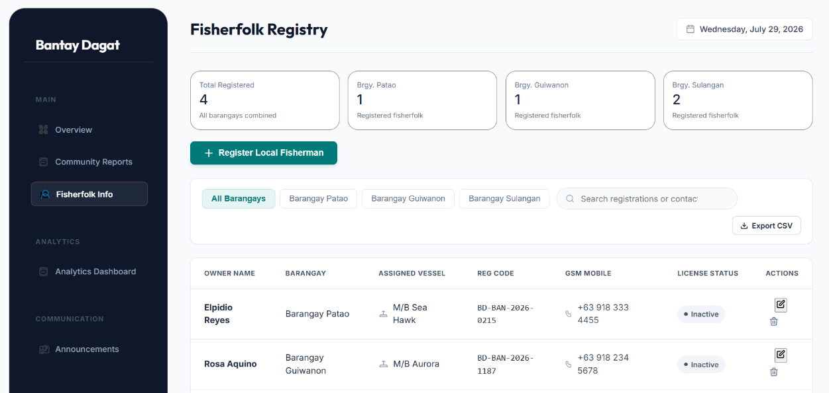

Fig. 19 Fisherfolk Information

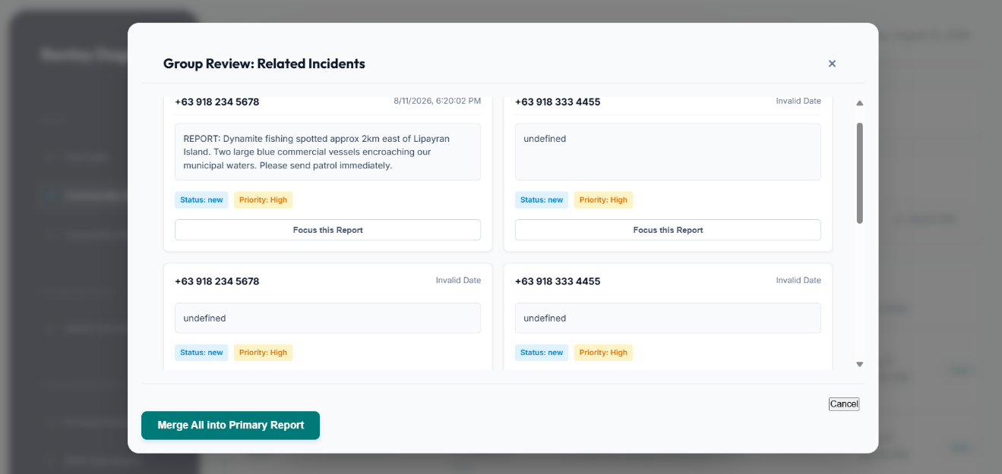

Fig. 20 Group Review

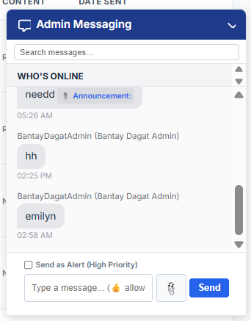

Fig. 21 Admin Communication

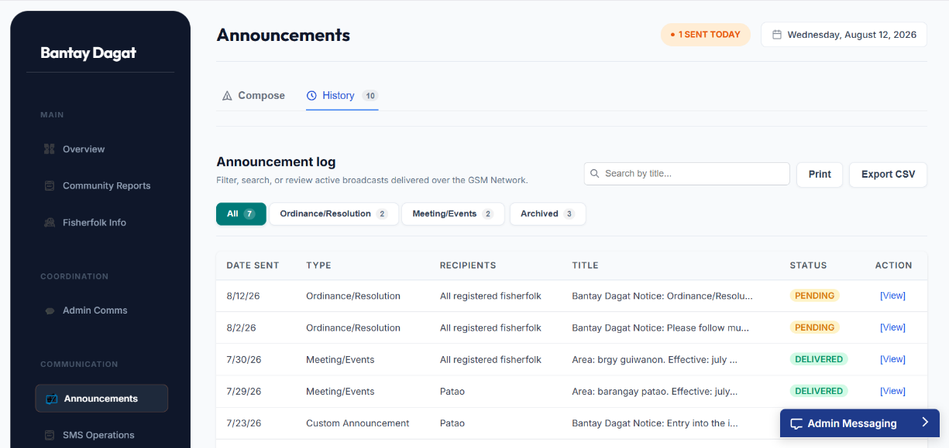

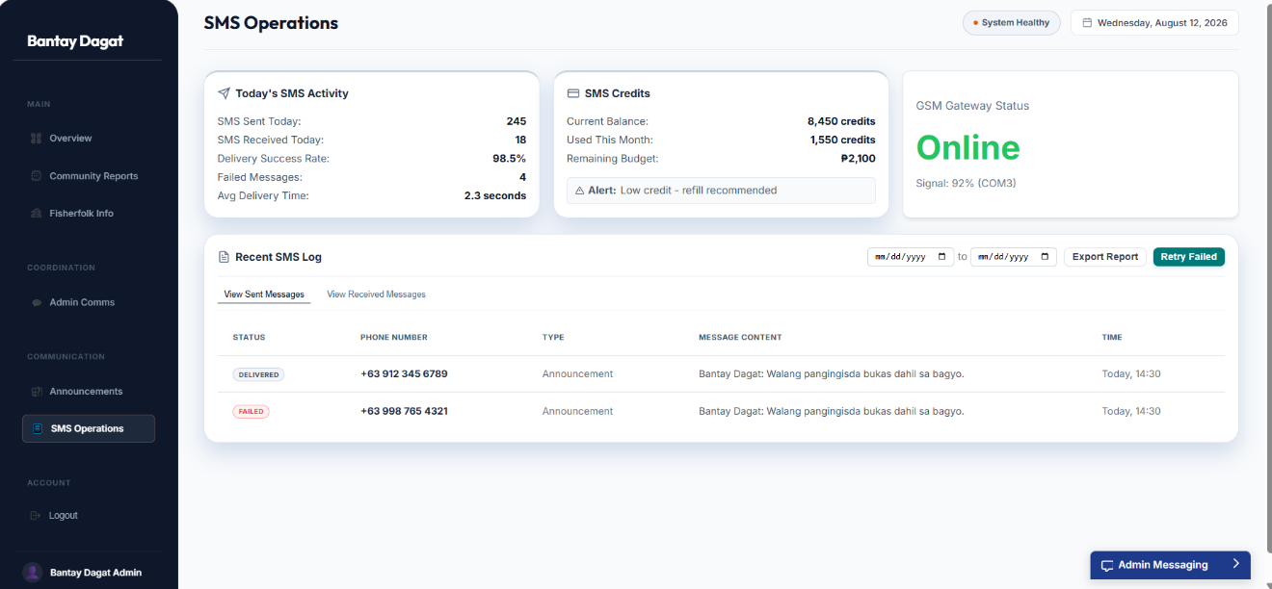
Fig. 22 Announcement History

Fig. 23 SMS Operation

Fisheries-MAO Admin
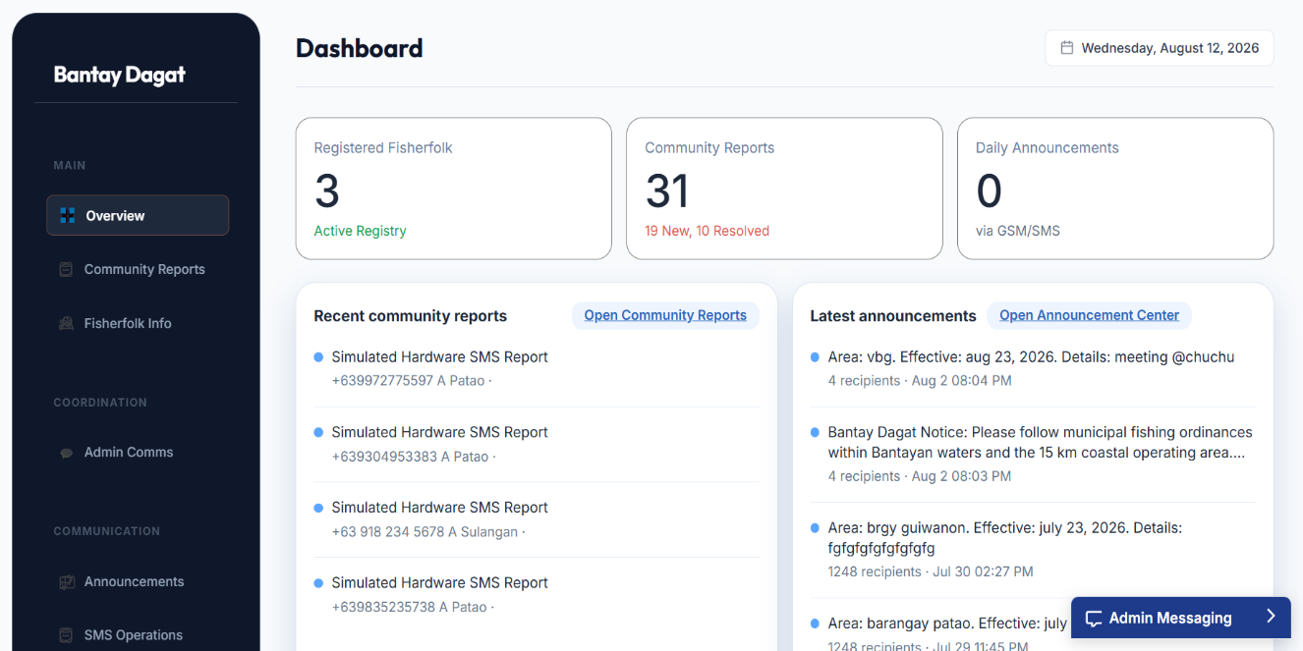

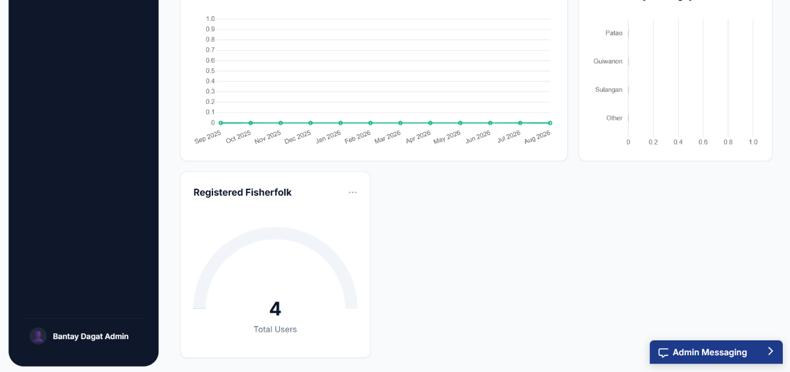
Fig. 24 Overview

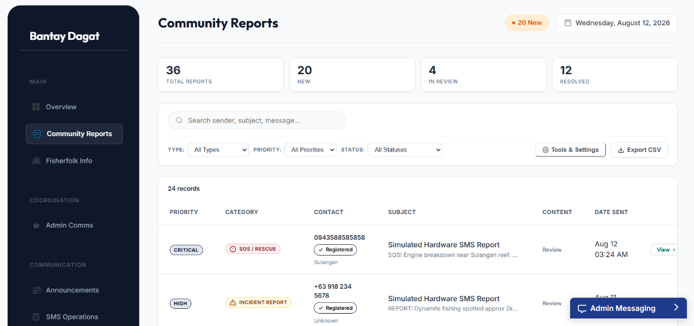

Fig. 25 Community Reports
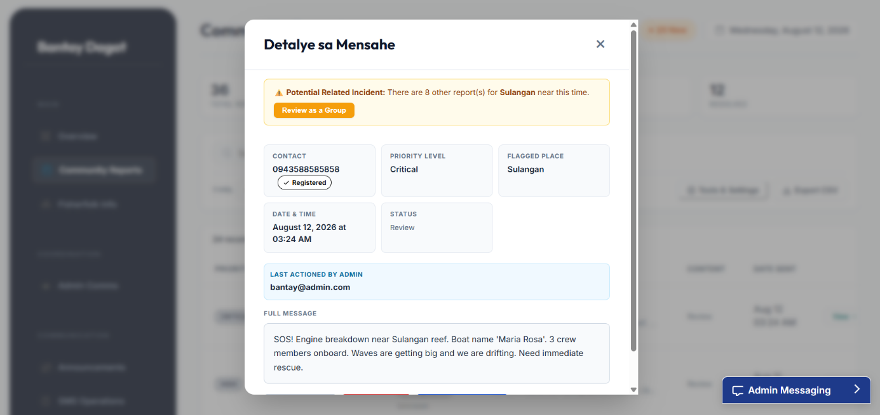

Fig. 26 Message Details

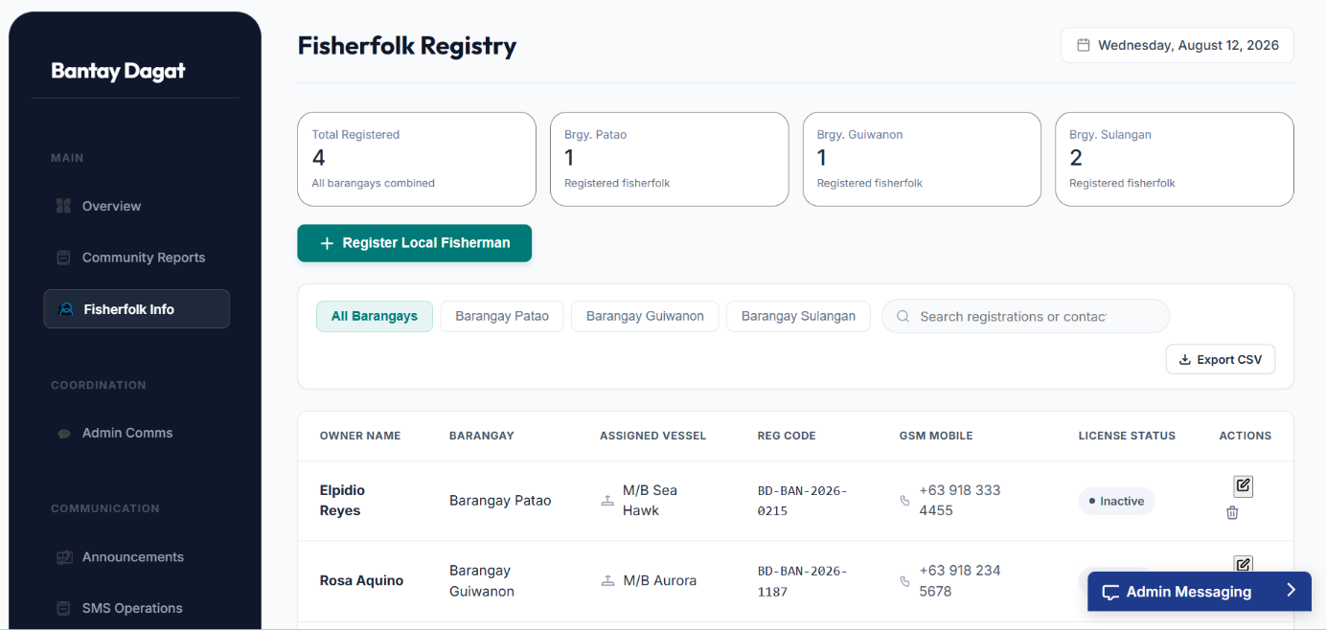

Fig. 27 Fisherfolk Information

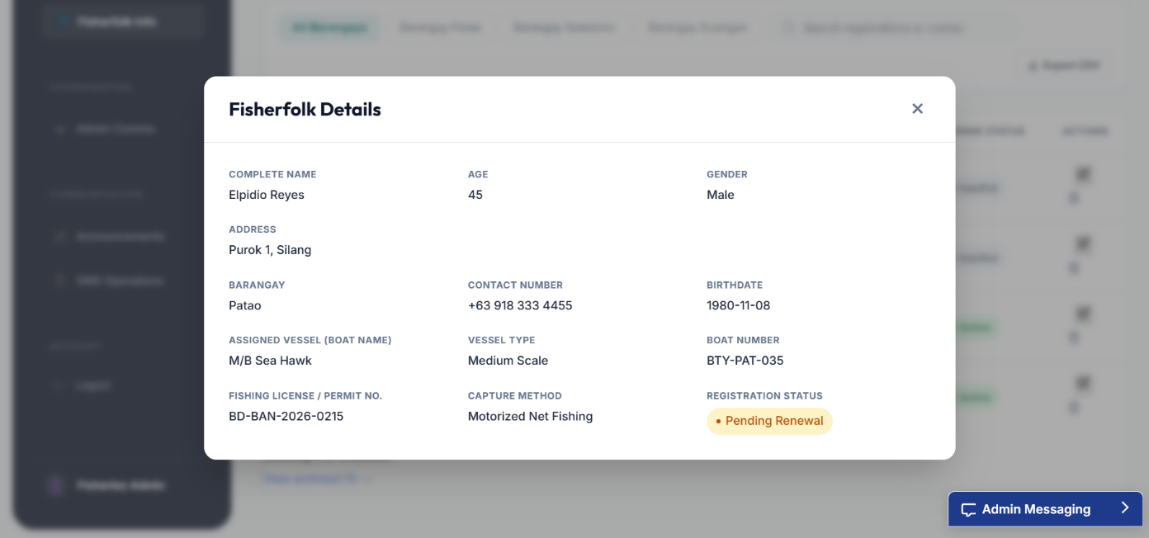

Fig. 28 View Fisherfolk Details

Fig. 29 Group Review

Fig. 30 Admin Communication

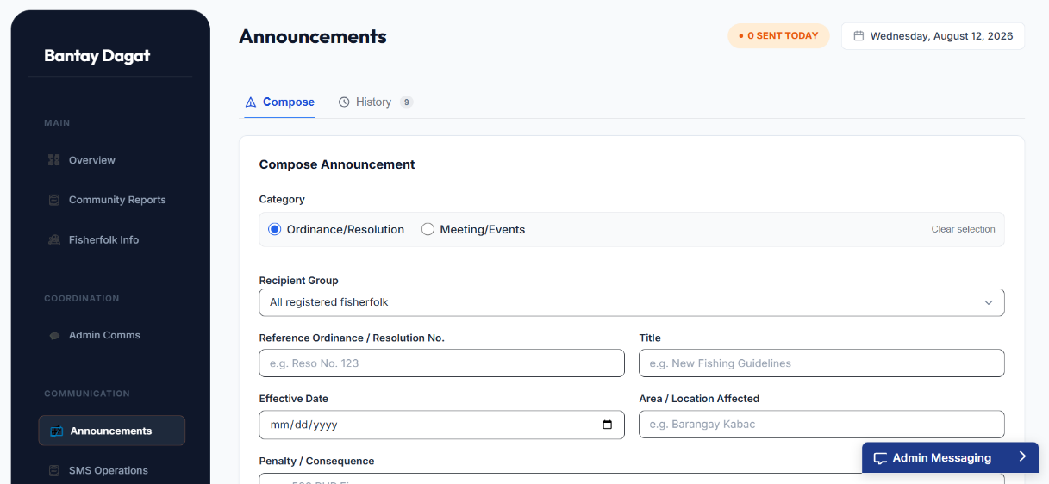

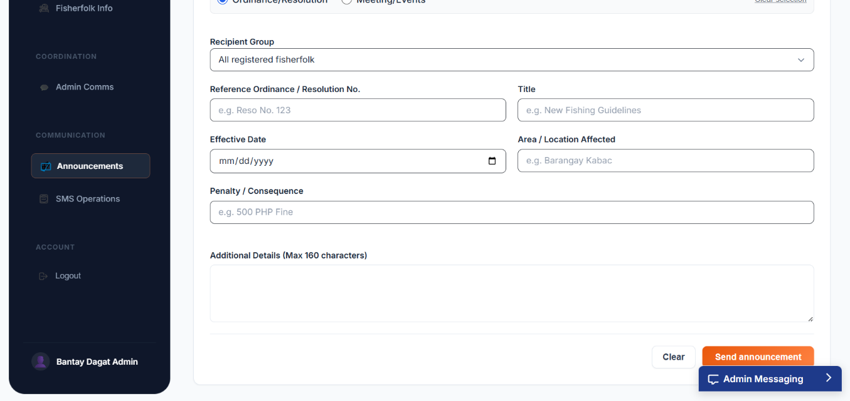

Fig. 31 Announcement

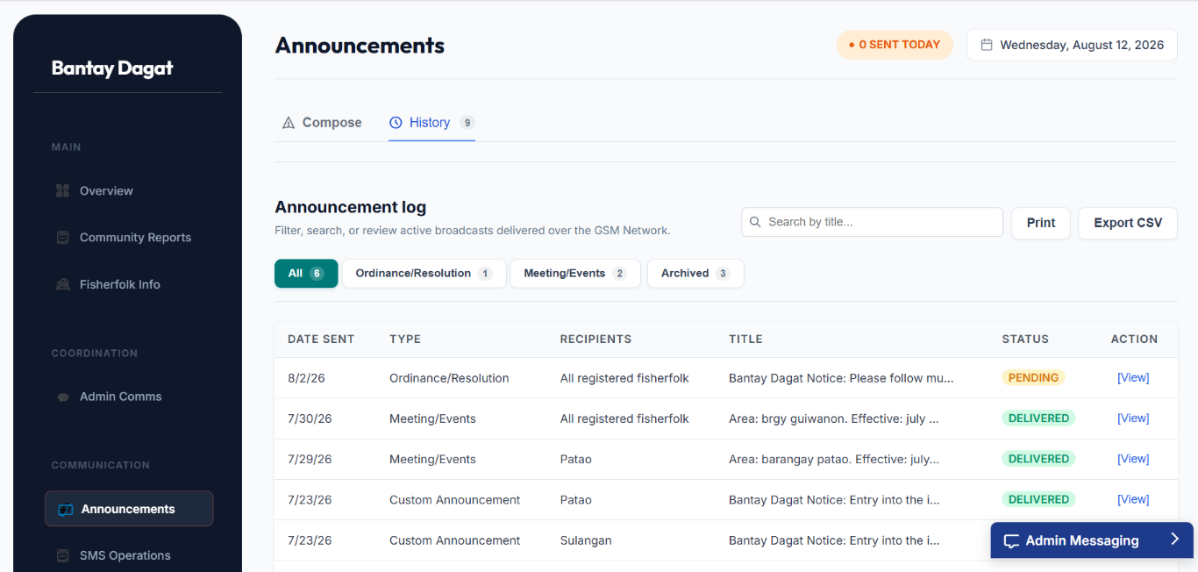

Fig. 32 Announcement History

Super Admin

Fig. 33 SMS Operation

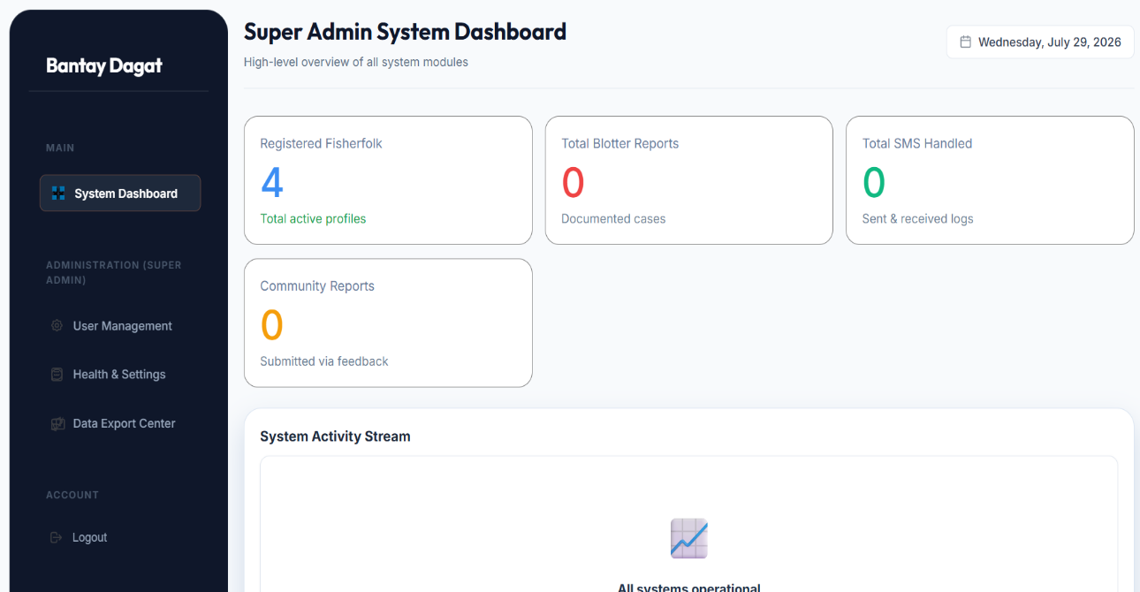

Fig. 34 System Dashboard

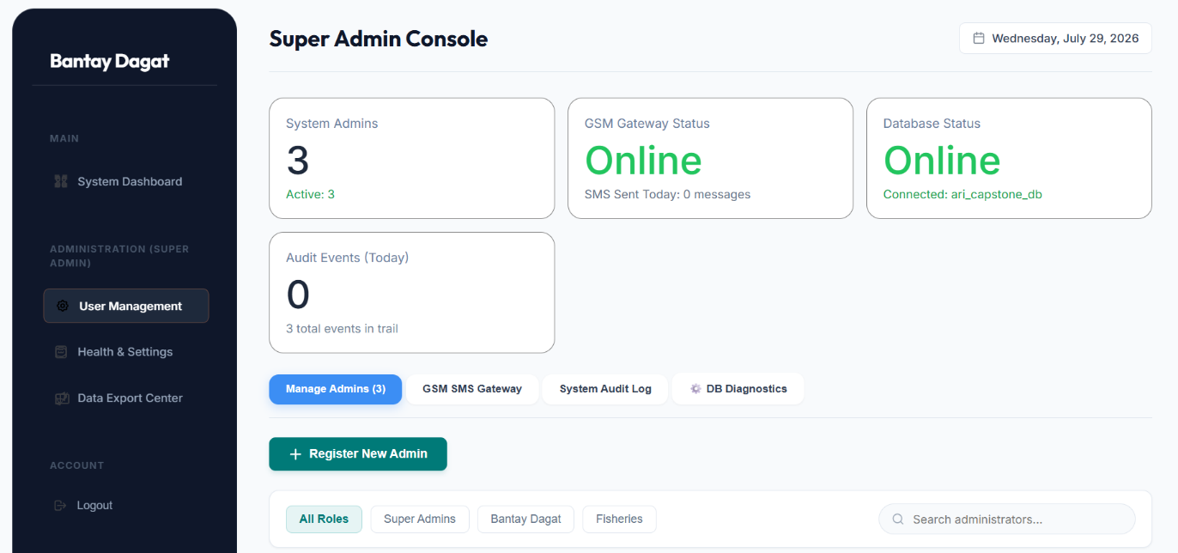

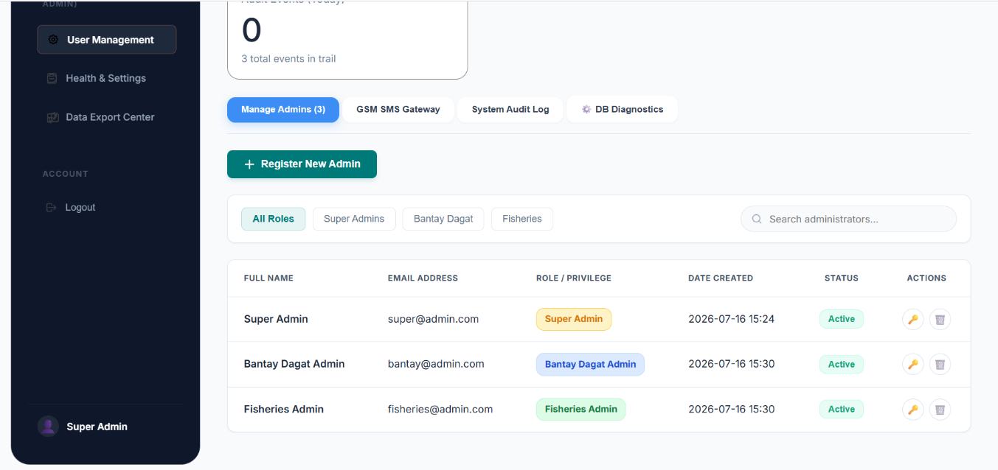

Fig. 35 User Management

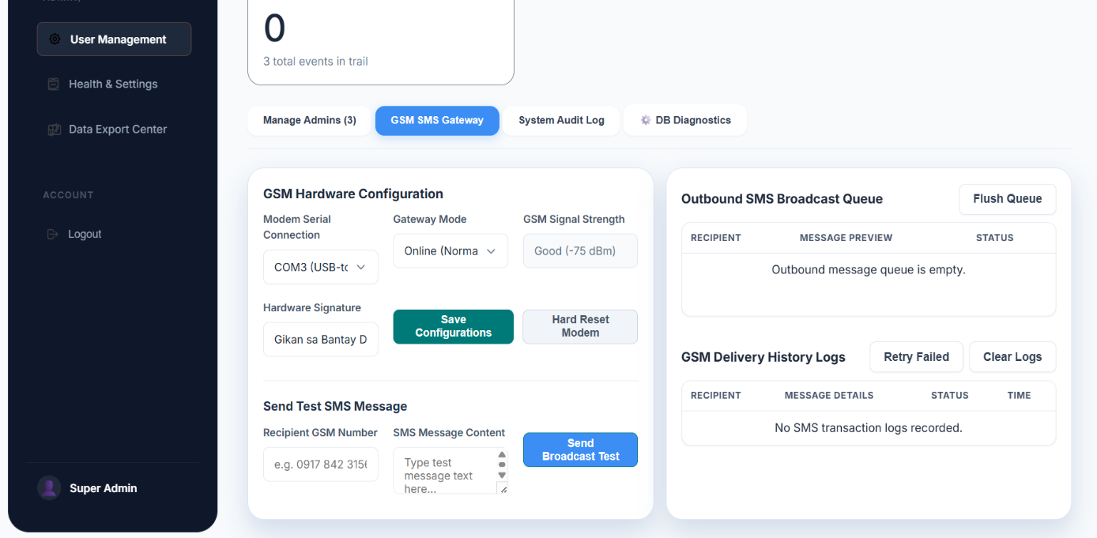

Fig. 36 SMS Gateway

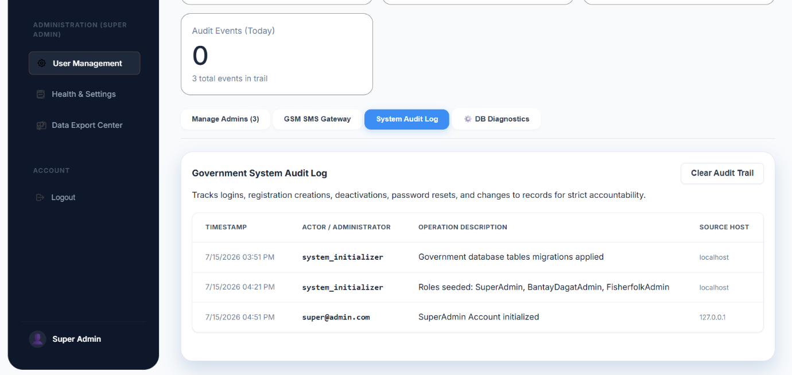

Fig. 37 System Audit Log

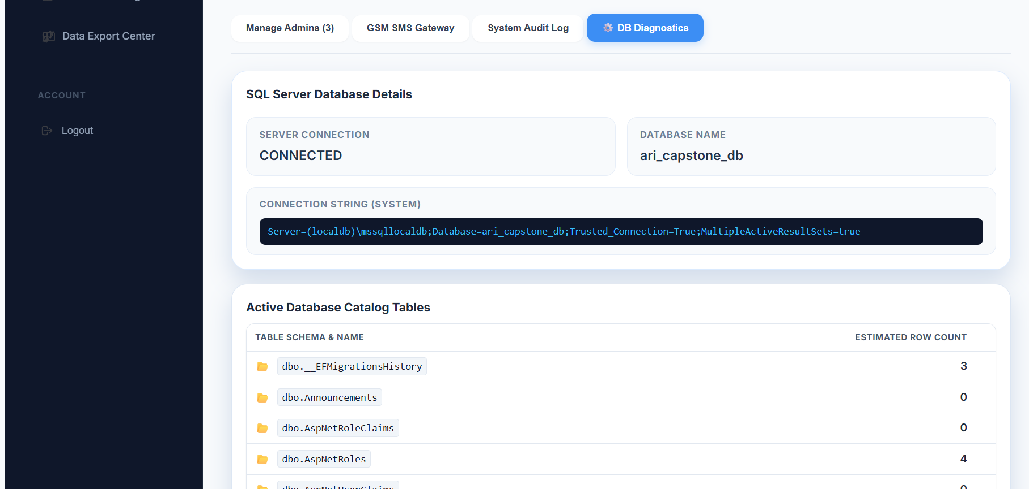

Fig. 38 Database Diagnostics
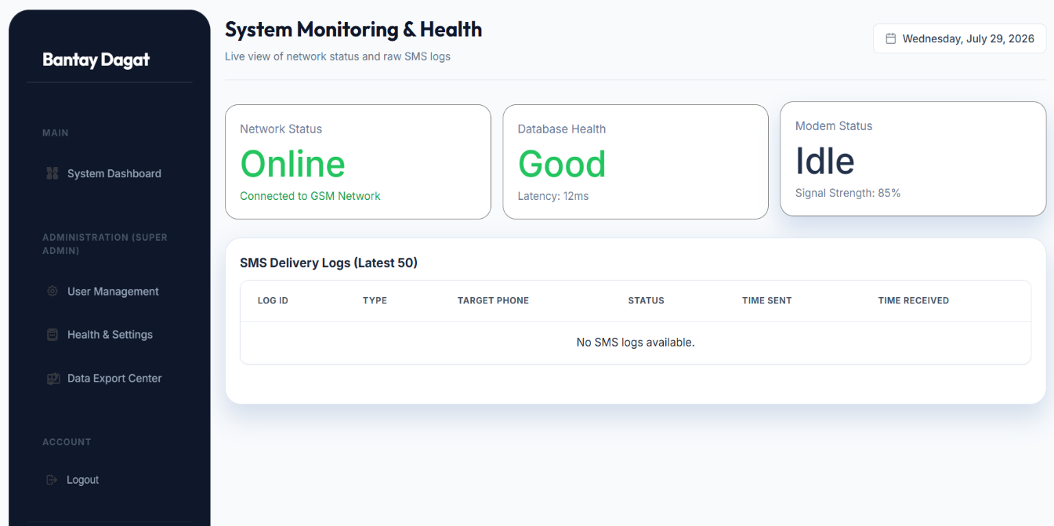

Fig. 39 Health and Settings

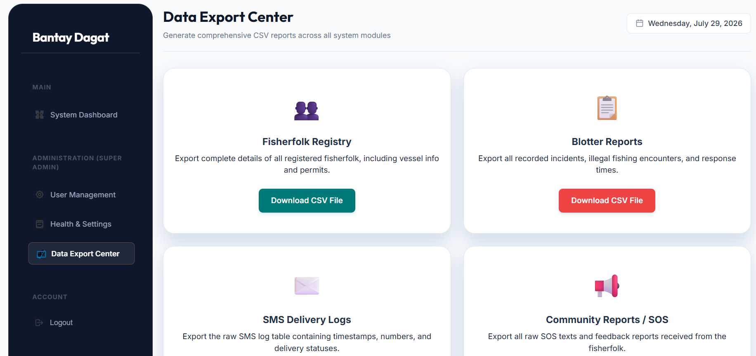

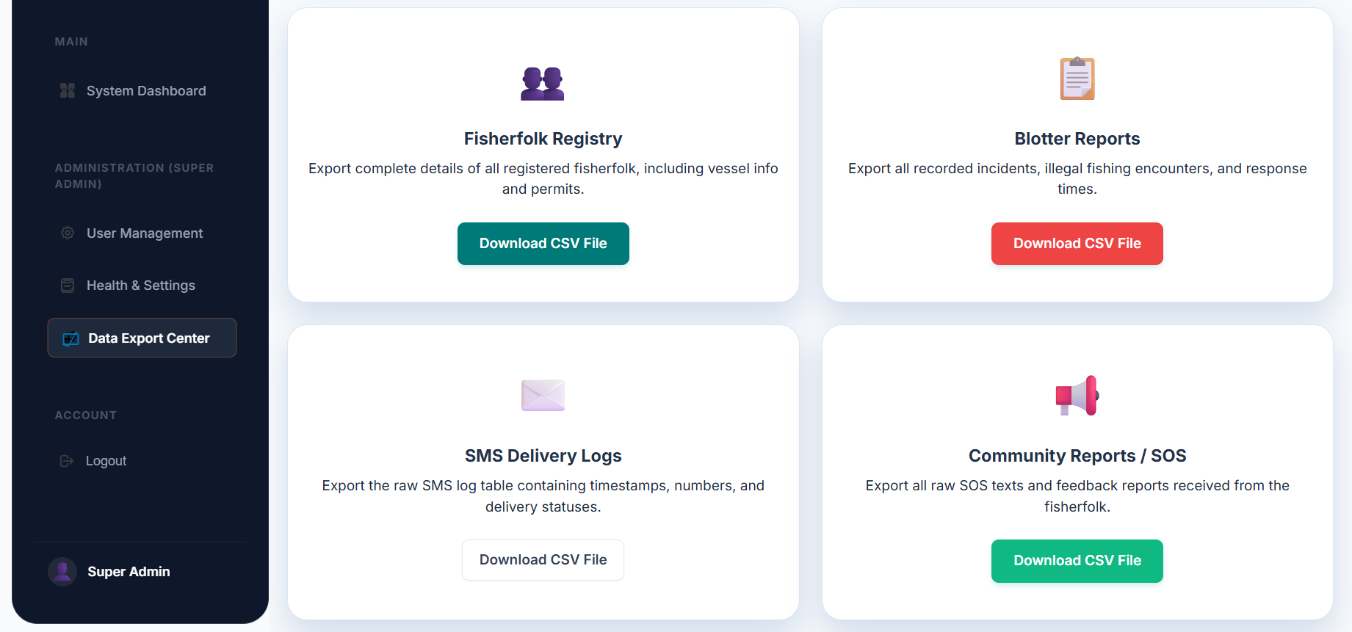

Fig.40 Data Export Center

B. Data Design

Entity Relationship Diagram
This portion of the chapter presents the database structure of the proposed BantayDagat system, consisting of the entities, attributes, primary and foreign keys, and relationships among the tables required to support information dissemination, SMS communication, incident reporting, and record management.

Fig.41 Entity Relationship Diagram

Data Dictionary

C. System Architecture

Network Model

Figure 73 presents the connectivity and communication flow among the users, the system, the database, and the SMS communication components of the proposed BantayDagat: An SMS-Based Information Dissemination and Incident Reporting System for Fisherfolk in Bantayan. It illustrates how the Bantay Dagat Admin, Fisheries Admin, and Super Admin interact with the system, while fisherfolk communicate through the mobile network and GSM modem to send and receive SMS messages. It also shows how the system exchanges data with the database to support announcement dissemination, incident reporting, user management, and report generation.

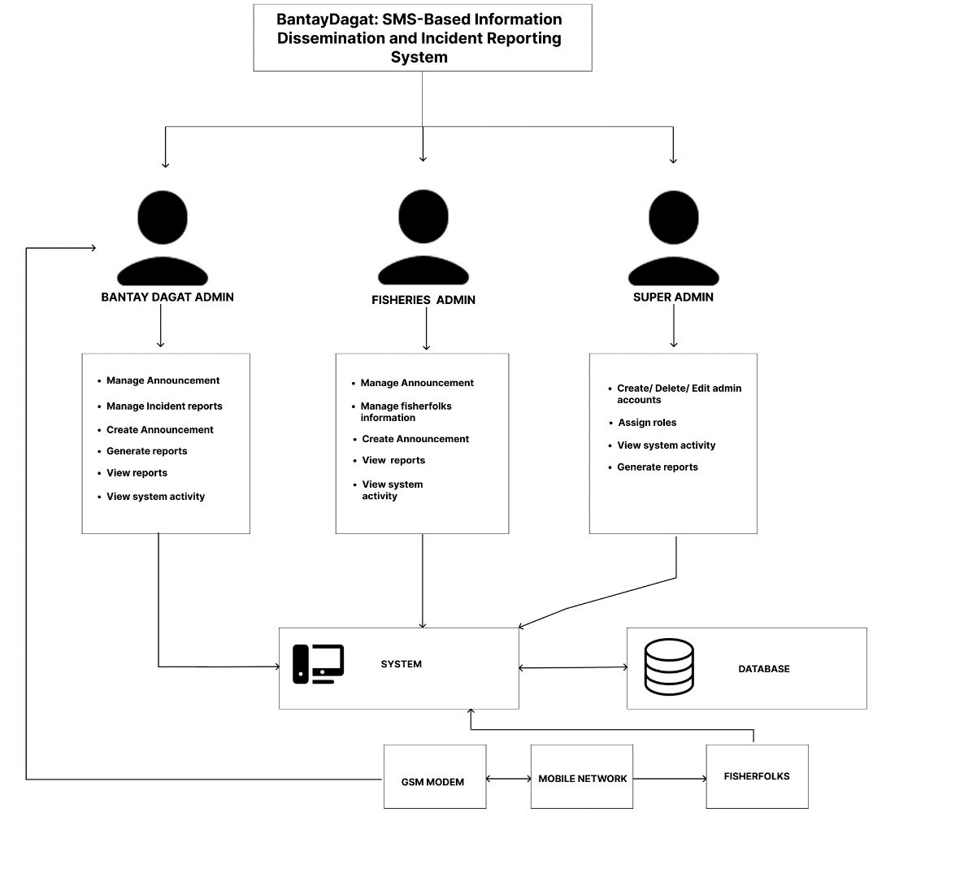

Figure 73 Network Model

Network Topology

Figure 74 presents the network topology of the proposed BantayDagat: An SMS-Based Information Dissemination and Incident Reporting System for Fisherfolk in Bantayan. It illustrates the connections among the Bantay Dagat Admin, Fisheries Admin, Super Admin, system, database, printer, GSM module, mobile network, and fisherfolk. The diagram shows how administrators access the system, how data is stored and retrieved from the database, and how the GSM module communicates with the mobile network to send and receive SMS messages between the system and fisherfolk. It also demonstrates how the system supports report printing and facilitates information dissemination and incident reporting through SMS communication.

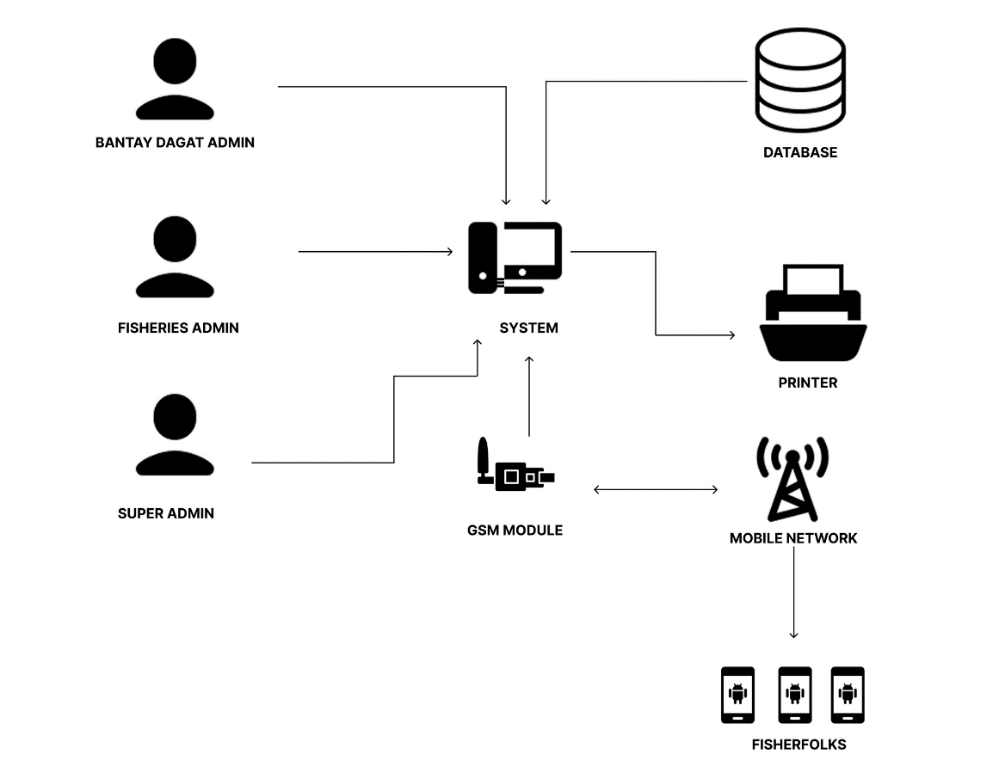

Figure 74 Network Topology

Security

Development

Hardware Specification
  Acer Aspire Lite 15 | Laptop | The laptop was used for system analysis, coding, database management, SMS integration, documentation, and system testing to ensure that the application functions properly and efficiently.
 | Hardware | Description
 | Processor
  Intel Core i5 Processor
 | System Type | 64-bit Operating System, x64-based Processor
 | RAM/ROM | 8 GB RAM / 512 GB SSD
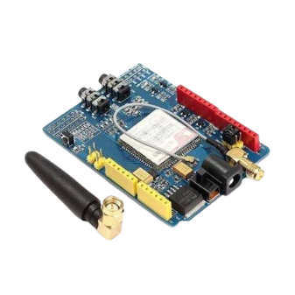 | GSM Modem | SIM900

 | HTML | HTML (HyperText Markup Language) was used to create and structure the web pages and interface of the proposed system.
 | CSS | CSS (Cascading Style Sheets) was utilized to design and improve the appearance, layout, and responsiveness of the system interface.
 | JavaScript | JavaScript was used to provide interactive functions and dynamic features within the system.
 | Operating System | Windows 10/11
 |  | Windows 10 and Windows 11 are operating systems developed by Microsoft. These operating systems were used by the researchers in developing, testing, and running the proposed system. They provide compatibility with ASP.NET, database management systems, and other software tools necessary for the development of the study.
 | Version | Windows 10 22H2 / Windows 11 23H2
 | Edition | Windows Home Single Language

Software Specification

Program Specification

ASP.Net | ASP.NET is a web application framework developed by Microsoft used for creating dynamic web applications and system functionalities such as SMS notifications, incident reporting, and data management.

Programming Environment

The programming environment combines different software and hardware components necessary for developing, testing, and implementing the proposed system. It provides an organized and efficient platform for creating system functionalities, managing databases, and handling SMS communication processes.
The researchers used an Acer laptop operating on Windows 10/11 as the primary development platform. The proposed system was developed using the ASP.NET Framework 4.8 together with HTML for designing and creating the web-based user interface and system functionalities. For database management, SQL Server Express LocalDB was utilized to store, organize, and retrieve fisherfolk records, incident reports, and SMS data securely and efficiently. In addition, a GSM Modem was integrated into the system to support SMS-based information dissemination and incident reporting functionalities.
The programming environment consists of both the front end and back end of the system. The front end is responsible for the user interface and interaction of users with the system, while the back end manages the database, system processing, and SMS communication operations.

Front End

- HTML
- CSS
- JAVASCRIPT

Back End

- ASP.NET Core MVC
- C#
- Entity Framework Core
- SQL Server Express LocalDB

Deployment Diagram
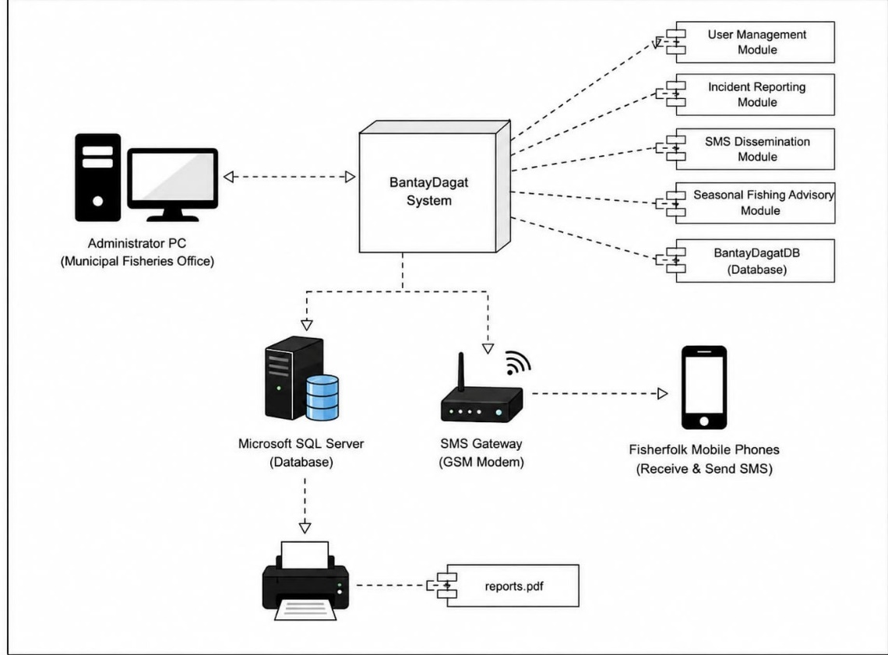

Fig. 41 Deployment Diagram

Test Plan

This test plan outlines the approach and scope of testing for the Bantay-Dagat: An SMS-based Information Dissemination and Incident Reporting System for Fisherfolk in Bantayan. The system is a web application that monitors the incident reporting or request rescue announcement. The testing will focus on ensuring the system's functionality, usability, security, and performance.

Testing

The testing and debugging process was conducted to ensure the functionality, reliability, and efficiency of the proposed system entitled “BantayDagat: SMS-Based Information Dissemination and Incident Reporting System for Fisherfolk in Bantayan.” During this phase, the researchers identified system errors, corrected technical issues, and improved the overall performance of the system. Repeated testing and debugging were performed to ensure that all system features functioned properly according to the objectives of the study. This process also helped maintain data accuracy, secure communication, and system reliability.

Unit Testing

Evaluated each module individually. The login and user management modules were tested to ensure secure access and proper account handling by administrators. This included testing the account lockout mechanism by intentionally simulating failed login attempts, as well as verifying that passwords are securely hashed (PBKDF2) in the database. The SMS dissemination modules were tested to confirm that announcements, alerts, and schedule updates were correctly sent to registered fisherfolk. The incident reporting, report management, notification, and archiving modules were also tested to ensure that reports were properly received, recorded, monitored, responded to, and stored for future reference.

Integration Testing

Ensured that all modules worked together seamlessly. The SMS gateway, database, and system interface were tested to confirm that information was properly processed, stored, and displayed. The integration of the reporting, dissemination, seasonal updates, and notification modules was also examined to ensure smooth data flow and reliable message delivery across the system.

System/Alpha Testing

Involved Bantay Dagat personnel, fisherfolk, and barangay officials who evaluated the system's functionality, usability, and reliability. The system successfully sent SMS alerts and updates, recorded incident reports, and managed fisherfolk data. Evaluators found it effective for improving communication and incident monitoring, and their feedback was used to further refine the system.

DEFINITION OF TERMS/GLOSSARY

After-hour coverage – The system's ability to receive and process reports 24/7, including nights, weekends, and holidays.
Arduino Uno – The specific open-source microcontroller board utilized in the project to act as the hardware bridge between the web server and the GSM module.
ASP.NET – The primary coding framework used to build the project's web-based interface and handle server-side logic.
Bantay Dagat- Refer to persons who have undergone training programs on coastal and fisheries law enforcement conducted by any accredited government or non-government organization and who voluntarily work as deputized fishery law enforcers.
Centralized Database – The secure digital repository hosted by the ASP.NET system where all fisherfolk profiles, incident reports, and system logs are stored, replacing scattered, paper-based records.
Community-based – A system designed specifically for use within a single barangay, municipality, or defined neighborhood.
Data analytics – The system's feature that processes incoming SMS reports to generate statistical trends, charts, and summary tables for administrators.
Dead zones – Locations within the coverage area where SMS messages cannot be sent or received due to network limitations.
Fisherfolk – The primary end-users of the system; individuals engaged in fishing or coastal activities within the target deployment area who receive alerts and send incident reports via SMS.
GSM modem – The physical component connected to the server that acts as the system's bridge for all incoming and outgoing text messages.
Hoax reports – Incoming SMS messages that fail the system's verification filters (e.g., duplicate content, unverified sender IDs) and are flagged for admin review before dissemination.
IDE (Integrated Development Environment) – The specific software (e.g., Visual Studio) used by the developers to write, compile, and debug the project's source code.
Information dissemination – The system's primary function of automatically broadcasting alert SMS messages to all registered subscribers within a specific affected area.
Self-reported – SMS reports sent by community members describing local incidents which the system then validates and forwards.
SMS-based – A system where all user interactions—reporting incidents, receiving alerts, and confirming subscriptions - happen exclusively via text messages on mobile phones.

CHAPTER II

PRESENTATION, ANALYSIS, AND INTERPRETATION OF DATA

The data gathered in this study were collected through surveys and interviews regarding the current information dissemination and incident reporting practices among coastal communities at the selected municipality. The surveys were administered among registered fisherfolks, while the interviews were conducted with the head of BantayDagat and the head of the Fisheries Department, revealing that the existing manual and radio-based processes for disseminating regular updates and reporting maritime incidents were slow, unreliable, and lacked proper documentation. During the survey, it was noted that most fisherfolks relied on word-of-mouth and traditional radio broadcasts for critical information, which often led to delayed warnings and miscommunication. Additionally, incident reports were logged manually in logbooks or communicated verbally, which resulted in inefficient response times, unrecorded incidents, and difficulty in tracking repeat offenses. Furthermore, the security and integrity of records were compromised as they were susceptible to loss, fading legibility, or unauthorized access. These findings highlighted the need for an SMS-based Information Dissemination and Incident Reporting System (BantayDagat) to modernize the communication flow. The proposed system aims to automate the delivery of marine alerts via text messaging, provide a structured SMS-based reporting channel for fisherfolks, and store all incident data securely in a centralized database, thus improving efficiency, accuracy, timeliness, and transparency in coastal resource management and maritime law enforcement.

Data Gathering

The data for this study were collected through interviews and survey questionnaire. The head of BantayDagat and the fisheries department were interviewed to gather information about the current system for dissemination of information and how they take incident reports. The interviews aimed to gain insights into their experiences with the existing process.
These methods provided valuable qualitative and quantitative data, highlighting the strengths and weaknesses of the current manual system.

Interviewing

In this method, the researchers approached the head of both the BantayDagat and the fisheries department of Bantayan. Interviews were conducted with the BantayDagat head and also the fisheries department head to learn about their current processes for taking incident reports, rescues, and how they disseminate informations to each and every barangay where a registered fisherfolk is located.

Survey

In this method, the researchers administered a structured survey questionnaire to registered fisherfolks across the pilot barangays of Bantayan. The questionnaire was designed to gather firsthand data on the fisherfolks’ awareness of existing incident reporting procedures, their experiences with rescue operations, and how they currently receive information from the BantayDagat and the fisheries department. Items included closed-ended questions on response times, communication channels used, and frequency of updates received, alongside open-ended questions that allowed respondents to describe specific challenges or gaps they have encountered. This approach shifted the data collection from institutional perspectives to the direct beneficiaries’ lived experiences, enabling the researchers to capture ground-level realities, perceived effectiveness of current systems, and practical suggestions for improving information dissemination and emergency response among the fishing community - some are questions ask to the registered fisherfolks:
- Name?
- Age?
- How many years as a registered fisherfolk?
- Type/s of the fishing vessel?
- Types of fish captured?
- Type of fishing?
- Did you experience firsthand or heard from someone that there's an illegal fishing activity in your barangay?
- How will you report the said activity?
- Do you have a phone?
- Does your phone have a cellular connection?
- Did you experience an accident while out fishing (e.g. Engine failure)?
- If yes, how will you ask for help?
- Are you aware about seasonal fishing?
- Where did you get your information about seasonal fishing?
- If there's a scarcity of a specific fish, will you avoid catching it?
- How many km from the shoreline will you go to go fishing?
- If you see someone doing an illegal fishing in what way will you report it? Fb, SMS, call, etc?
- If there's an announcement from the BantayDagat and the MAO, how will they disseminate informations?
- If thru the barangay, how will the barangay disseminate the information?
- Is it ok with you if the information will come straight from the BantayDagat?
- If you experience an accident or see someone doing an illegal fishing activity, who will you contact firsthand?
- Are you a registered fisherfolk and/or your fishing vessel is registered?

Analysis

Cost and Benefit Analysis

The development and implementation of the BantayDagat: SMS-Based Information Dissemination and Incident Reporting System for Fisherfolk in Bantayan require an estimated total cost of ₱43,200.00. This includes approximately ₱35,000.00 for the computer/laptop and internet connection, ₱1,200.00 for the GSM modem and supporting hardware, ₱2,000.00 for software and development tools, and ₱5,000.00 for SMS credits and other operational expenses. These costs cover the essential resources needed to develop, operate, and maintain the proposed system.
Despite the initial investment, the proposed system provides significant benefits to fisherfolk and local authorities. It enables faster dissemination of announcements and provides fisherfolk with an accessible SMS-based channel for submitting incident reports and emergency requests without requiring internet access. It also helps the Bantay-Dagat and Fisheries-MAO Office organize, monitor, verify, and retrieve incident records more efficiently. Therefore, the expected benefits of improved communication, faster reporting, centralized record management, and better coordination outweigh the estimated costs of implementing the system.

Risk Assessment/Analysis

The proposed BantayDagat system may encounter several risks that could affect its operation and effectiveness. These include weak or unavailable mobile network signals, delayed SMS delivery, incomplete or inaccurate incident information, fake reports, limited phone accessibility, SMS costs, and delayed responses due to limited personnel or resources. Since the system relies on SMS communication and the availability of Bantay-Dagat personnel, these risks may affect the timely delivery of announcements and response to reported incidents. To minimize these risks, the system may implement SMS delivery confirmation and retry mechanisms, report validation, user authentication, regular database backups, and clearly defined response procedures. Proper monitoring and maintenance of the system can also help ensure reliable operation and reduce potential disruptions.

Testing

The testing and debugging process was conducted to ensure the functionality, reliability, and efficiency of the proposed system entitled “BantayDagat: SMS-Based Information Dissemination and Incident Reporting System for Fisherfolk in Bantayan.” During this phase, the researchers identified system errors, corrected technical issues, and improved the overall performance of the system. Repeated testing and debugging were performed to ensure that all system features functioned properly according to the objectives of the study. This process also helped maintain data accuracy, secure communication, and system reliability.

Unit Testing

Evaluated each module individually. The login and user management modules were tested to ensure secure access and proper account handling by administrators. The SMS dissemination and seasonal fishing modules were tested to confirm that announcements, alerts, and fishing schedule updates were correctly sent to registered fisherfolk. The incident reporting, report management, notification, and archiving modules were also tested to ensure that reports were properly received, recorded, monitored, responded to, and stored for future reference.

Integration Testing

Ensured that all modules worked together seamlessly. The SMS gateway, database, and system interface were tested to confirm that information was properly processed, stored, and displayed. The integration of the reporting, dissemination, seasonal updates, and notification modules was also examined to ensure smooth data flow and reliable message delivery across the system.

System/Alpha Testing

Involved Bantay Dagat personnel, fisherfolk, and barangay officials who evaluated the system's functionality, usability, and reliability. The system successfully sent SMS alerts and updates, recorded incident reports, and managed fisherfolk data. Evaluators found it effective for improving communication and incident monitoring, and their feedback was used to further refine the system.

CHAPTER III

SUMMARY OF FINDINGS, CONCLUSION AND RECOMMENDATIONS

Summary of Findings

Analysis

Cost and Benefit Analysis

This portion shows the cost and benefit analysis breakdown stated from the Chapter two cost and benefit analysis.

Cost Breakdown:
Laptop: ₱35,000.00
Software Tools & Frameworks: ₱2,000.00
GSM Module (SIM900): ₱800.00
Arduino Uno: ₱400.00
Initial Operational Cost (Monthly SMS Credits): ₱5,000.00
Total Estimated Cost: ₱43,200.00

Therefore: the cost breakdown for the proposed system can be considered as a sustainable project.

Benefit Analysis
The system will significantly reduce the operational delays of manual reporting and contribute directly to the successful monitoring and protection of the marine resources and fisherfolk community in Bantayan.

Risk Assessment

The risk assessment, helps identify potential risks and vulnerabilities the Bantay-Dagat: An SMS-based Information Dissemination and Incident Reporting System for Fisherfolk in Bantayan may encounter throughout its lifecycle. The system may experience technical issues such as network downtime, signal dead zones, and SMS delivery delays, as well as operational risks such as delayed rescue response due to limited fuel, boats, or personnel. Implementing delivery confirmation receipts, retry logic on the gateway, and securing a dedicated budget for patrol response can mitigate these technical and operational risks.

Testing

Unit Testing

Integration Testing

System/Alpha Testing

CONCLUSION

The BantayDagat: An SMS-Based Information Dissemination and Incident Reporting System for Fisherfolk in Bantayan is a system developed to improve the communication, reporting, and monitoring of incidents among fisherfolk and local authorities in the Municipality of Bantayan. The proposed system is designed to improve the efficiency, accessibility, and organization of information dissemination and incident reporting by providing features such as SMS announcement dissemination, incident reporting, report management, notifications, fisherfolk management, SMS record monitoring, and blotter report generation. These features allow registered fisherfolk to receive important information and submit reports through SMS, while authorized Bantay Dagat and Fisheries-MAO personnel can manage, monitor, and document reports through the web-based dashboard.
The proposed system helps address communication gaps and delays in the existing information dissemination and incident reporting process by providing an accessible SMS-based communication channel that does not require internet access. It also improves the organization of incident records and supports authorized personnel in monitoring reports and generating blotter reports. The system was developed using HTML, CSS, and JavaScript for the front end, ASP.NET for the back end, and Microsoft SQL Server Express LocalDB for database management, with a SIM900 GSM modem used for SMS communication. The system follows the Agile Model, allowing the researchers to develop, test, gather user feedback, and improve the system throughout the development process.

RECOMMENDATIONS

Based on the findings and development of the study, the following recommendations are proposed:
- Pilot Implementation.
The BantayDagat system may be implemented on a pilot basis in selected coastal barangays to evaluate its actual use and effectiveness in information dissemination and incident reporting.
- User Orientation and Training.
Proper orientation and training should be provided to fisherfolk, Bantay Dagat personnel, and Fisheries-MAO personnel to ensure that they understand how to use the SMS reporting process and web-based dashboard.
- Regular System Monitoring.
The system should be regularly monitored to ensure that SMS messages, incident reports, notifications, and records are processed properly and efficiently.
- Report Validation.
Proper validation procedures should be maintained to reduce inaccurate, incomplete, or false incident reports submitted through SMS.
- Continuous Improvement.
Since the system follows the Agile Model, feedback from fisherfolk and authorized personnel should be regularly collected and used to improve existing features and address identified issues.

- System Maintenance and Security.
Regular maintenance, database backups, and security checks should be conducted to protect the system and its stored information from data loss or unauthorized access.
- Adequate SMS Resources.
Sufficient SMS credits and reliable cellular network access should be maintained to support continuous communication between the system and its users.
- Future Enhancements.
Future researchers may enhance the system by adding features such as improved incident tracking, location support, additional notification options, and other functions that may further support the needs of fisherfolk and local authorities.

IMPLEMENTATION PLAN

The implementation plan of the BantayDagat: An SMS-Based Information Dissemination and Incident Reporting System for Fisherfolk in Bantayan presents the phases and activities involved in preparing, deploying, and implementing the proposed system for fisherfolk and local authorities in the Municipality of Bantayan. It provides a structured approach to guide the transition from system development and testing to actual implementation, while allowing continuous feedback and improvements based on the Agile Model.
Table #
Planning Phase
Phase | Activities | Time Frame | Responsible
Planning | Define the project scope, objectives, and expected deliverables | Week 1 | Researchers
Planning | Gather and analyze the requirements of fisherfolk, Bantay Dagat, and Fisheries-MAO personnel | Week 3 | Researchers
Planning | Develop the proposal manuscript and supporting documents | Week 11 | Researchers
Planning | Review and validate the system requirements based on user feedback | Week 26 | Researchers

Phase | Activities | Time Frame | Responsible
Development | Design the user interface prototype | Week 7 | Researchers
Development | Develop the web based administrative dashboard | Week 10 | Development Team
Development | Develop the SMS-based information dissemination and incident reporting features | Week 17 | Researchers
Development | Integrate the database, SMS gateway, and complete system functionality | Week 22 | Developer

Table #29
Development Phase

 | Review and improve developed features based on user feedback | Ongoing during development | Development Team

Table #
Testing Phase
Phase | Activities | Time Frame | Responsible
Testing | Prepare the system test plan and testing procedures | Week 23 | Researchers
Testing | Conduct unit and integration testing of system features | Week 25 | Development Team
Testing | Test SMS dissemination and incident reporting functions | Week 25 | Development Team
Testing | Perform database testing and validate stored records | Week 26 | Development Team
Testing | Resolve identified issues and improve system features based on testing and user feedback | As needed | Development Team

Table #
Deployment Phase
Phase | Activities | Time Frame | Responsible
Deployment | Install and configure the system in the designated environment | After testing | Developer
Deployment | Conduct user orientation and training for fisherfolk and authorized personnel | Before full operation | Researchers
Deployment | Deploy the system for pilot use in selected coastal communities | After user training | Researchers and Authorized Personnel
 | Gather user feedback during the initial implementation | During pilot implementation | Researchers

Table #
Maintenance
Phase | Activities | Time Frame | Responsible
Maintenance | Monitor the overall performance of the deployed system | Ongoing | Developer
Maintenance | Correct reported system errors and software bugs | As needed | Development Team
Maintenance | Implement system improvements based on user feedback and system evaluation | As Needed | Developer
Maintenance | Perform regular database backups and security checks | Ongoing | Developer
 | Provide technical support to authorized users and maintain system availability | Ongoing | Developer

BIBLIOGRAPHY

REFERENCES

Agyekum, T. P., Vidda, S., Odoom, M. A., Darko, E., Opoku, F. J., Donkoh, L. B., Opoku-Yeboah, A. D., Issah, I., Osae-Nyarko, L., Boadu, E. A., Boateng, D., & Boateng, K. S. (2025). Occupational accidents among fisherfolks in the Western Region of Ghana: A cross-sectional study. BMC Public Health, 25, Article 3175. https://doi.org/10.1186/s12889-025-24168-z [1]
Carpio, C. O., Asnaul, M. U., Said, A. H., & Amerin, B. Y. (2022). Isabela City flood
monitoring system using Arduino and GSM module. International Journal of Multidisciplinary Research and Publications, 5(7).
Lim, A. (2026, February 11). Oceana criticises ineffective fisheries enforcement in
Philippines as industry losses mount. AgTech Navigator. agnavigator.com
Lim, S.-S., & Jung, B.-K. (2025). Conceptual design of the intelligent electronic
monitoring and reporting model for combating global illegal, unreported, and
unregulated fishing. Fishes, 10(9), Article 435. https://doi.org/10.3390/fishes10090435
Macusi, E. D., Liguez, A. K., Macusi, E. D., & Digal, L. N. (2021). Factors influencing catch and support for the implementation of the closed fishing season in Davao Gulf, Philippines. Marine Policy, 130, Article 104578. doi.org
Miraflor, M. B. (2021, March 10). 40% of fish caught in PH comes from illegal fishing –USAID. Manila Bulletin. https://mb.com.ph/2021/03/10/40-of-fish- caught-in-ph-comes-from-illegal-fishing-usaid [1]
Smith, S. L., Zuercher, R., Armada, N. B., Castro, J. L., Guiñares, R., Oracion, E. G.,Uychiaoco, A. J., Torell, E., & Kotowicz, D. (2026). Community interventions drive support for fisheries regulations and influence compliance: Lessons from the Philippines. Ocean & Coastal Management, 274, Article 108076. doi.org
Terry, M. D., & Donato, L. M. (2022). Combating of illegal, unreported, and unregulated fishing activities along Manila Bay. Asia Pacific Journal of Advanced Education and Technology. https://doi.org/10.54476/apjaet/22879 [1]
Villamiel, V. A. E. (2026, February 2). PHL fish catch declining 45,000 MT a year due to overfishing, lax regulation — report. BusinessWorld. https://www.bworldonline.com/economy/2026/02/02/728053/phl-fish- catch-declining-45000-mt-a-year-due-to-overfishing-lax-regulation-report
Woodill, A. J., Kavanaugh, M., Harte, M., & Watson, J. R. (2020). Predicting illegal
fishing on the Patagonia shelf from oceanographic seascapes. arXiv. doi.org

APPENDICES

Relevant Source Code

Evaluation Tool

Sample Input/Output/Report

Forms

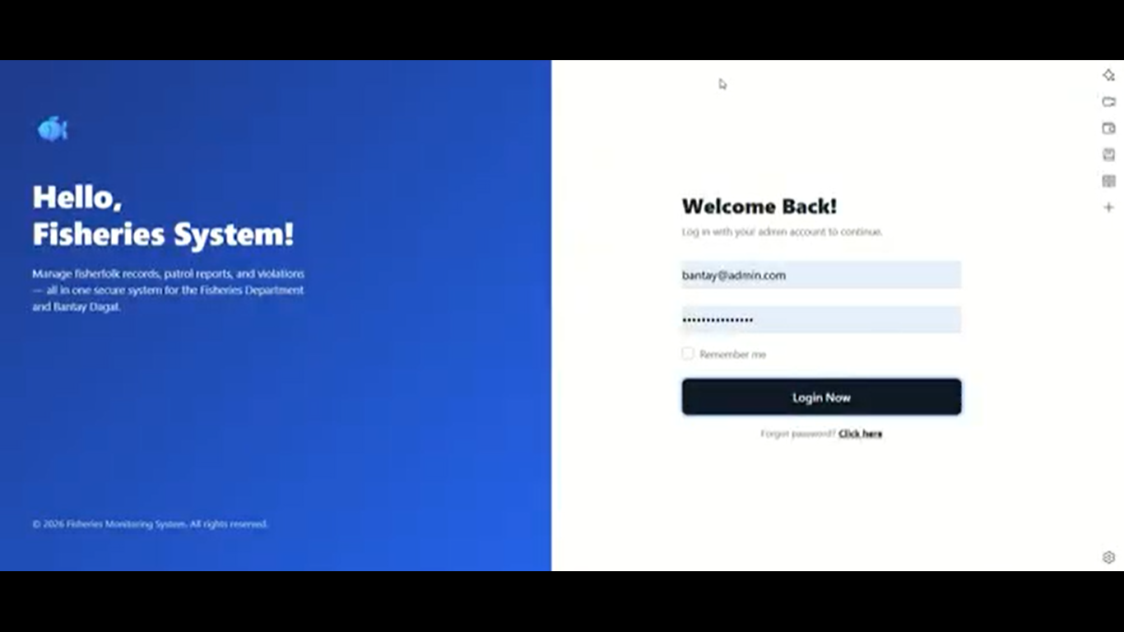
BantayDagat Admin

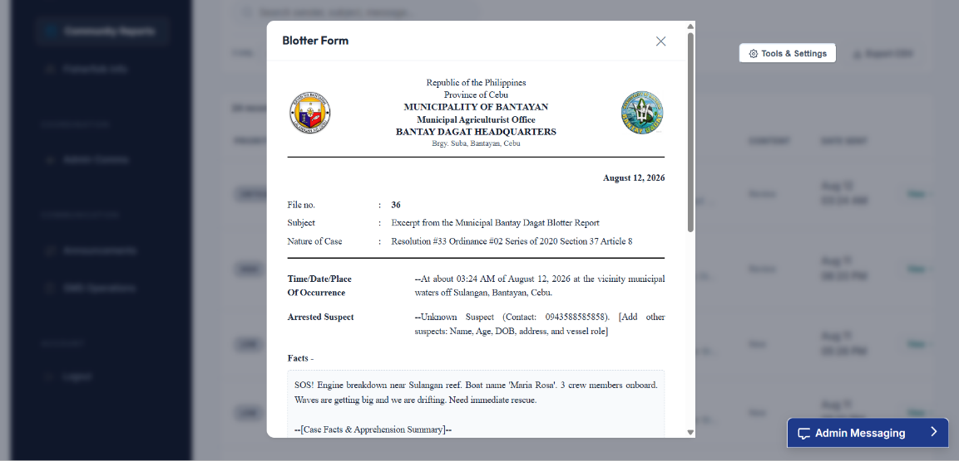
Fig. 42 Landing Page

Fig. 43 Generate Blotter

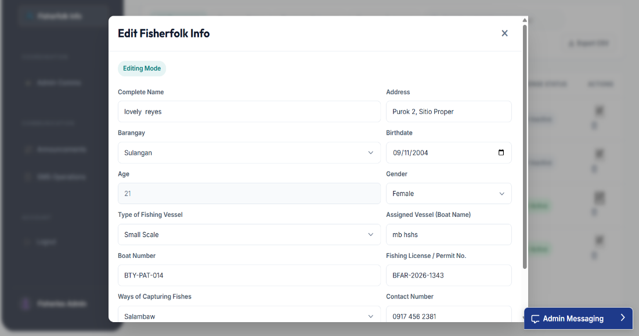
Fisheries MAO Admin

Fig. 44 Edit Fisherfolk Information

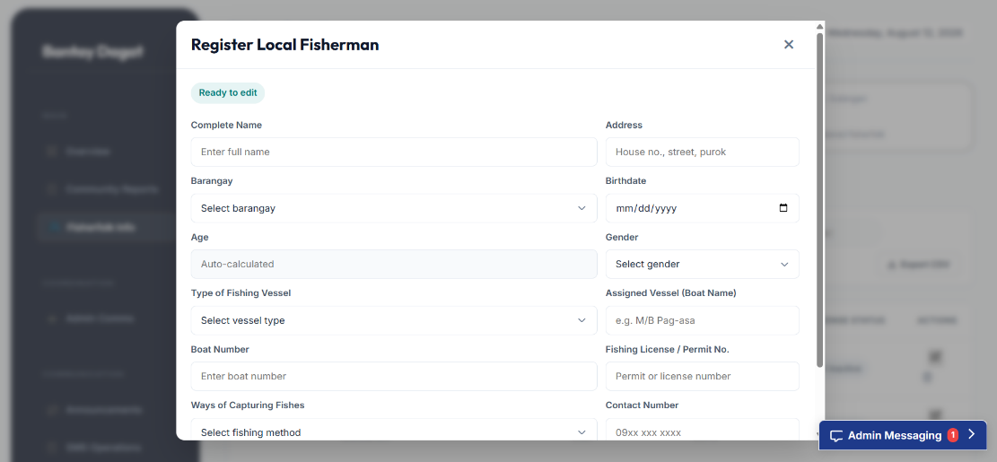

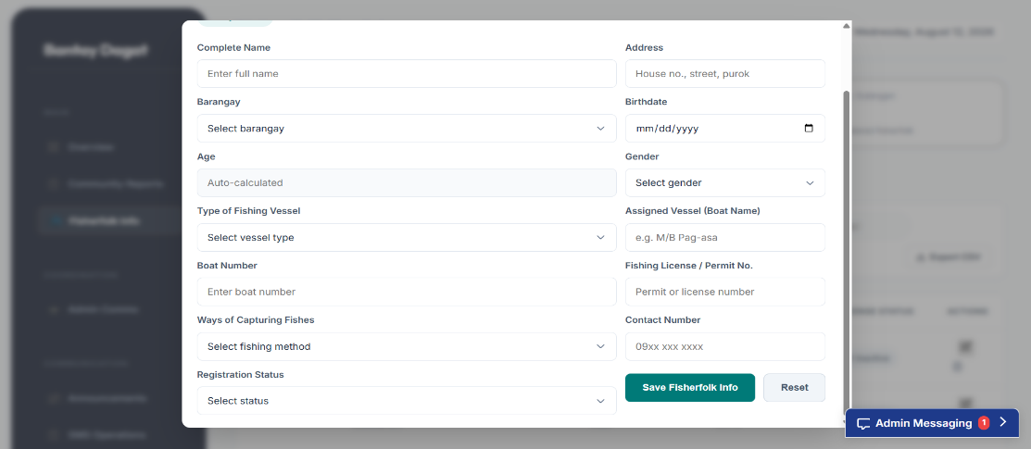

Fig. 45 Register Local Fisherman

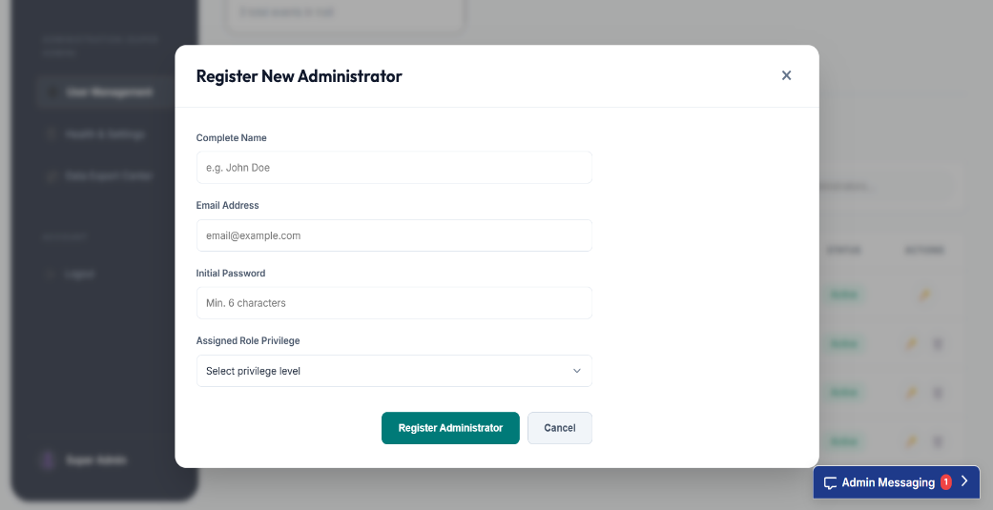
Super Admin

Fig. 46 Register New Administrator

Reports

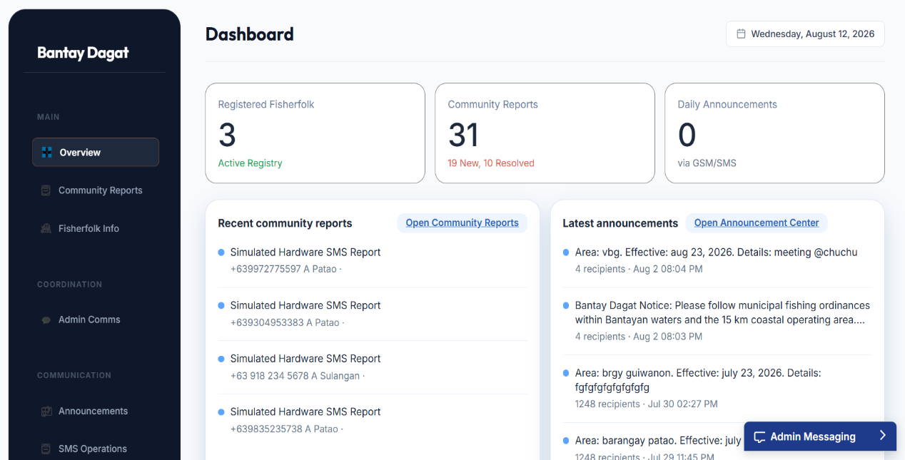
Bantay Dagat Admin

Fig. 47 Overview

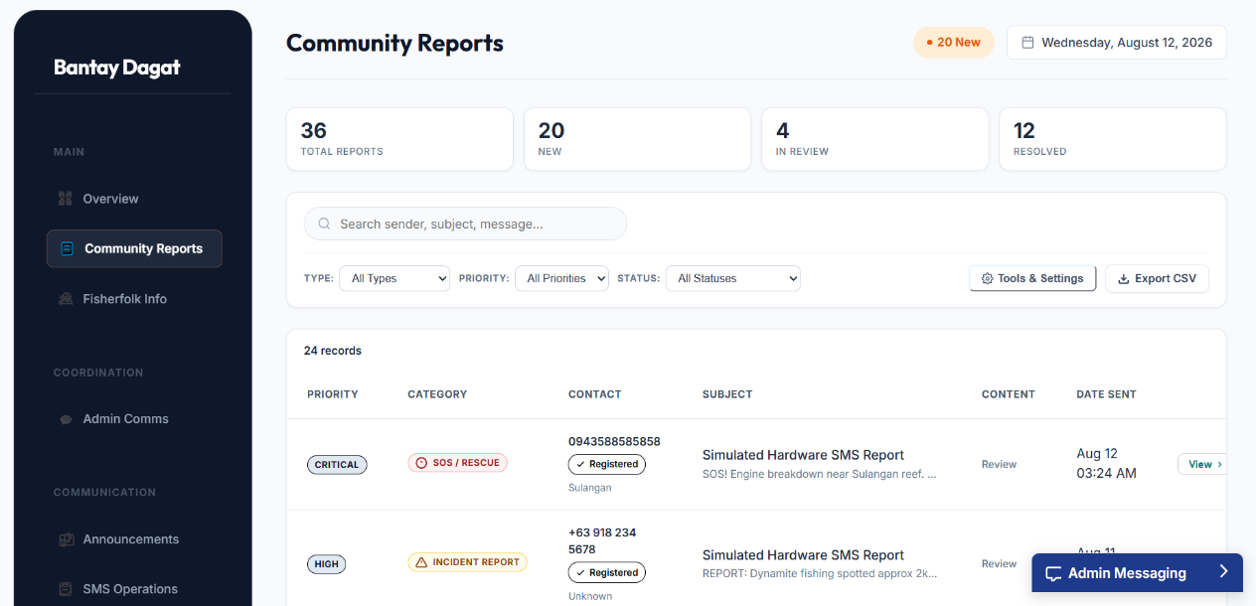

Fig. 48 Community Report

- Other Relevant Document

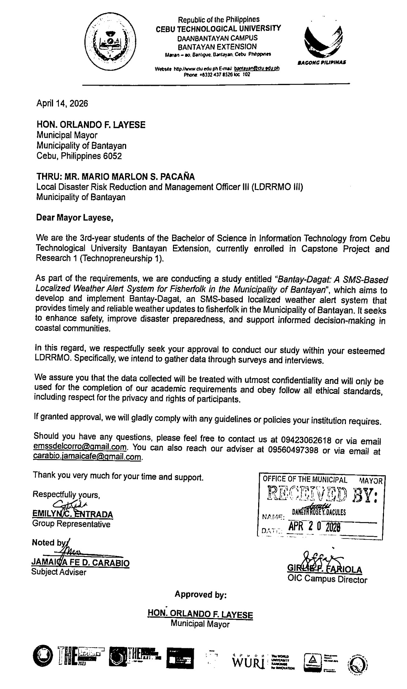
1. Signed Transmittal Letter

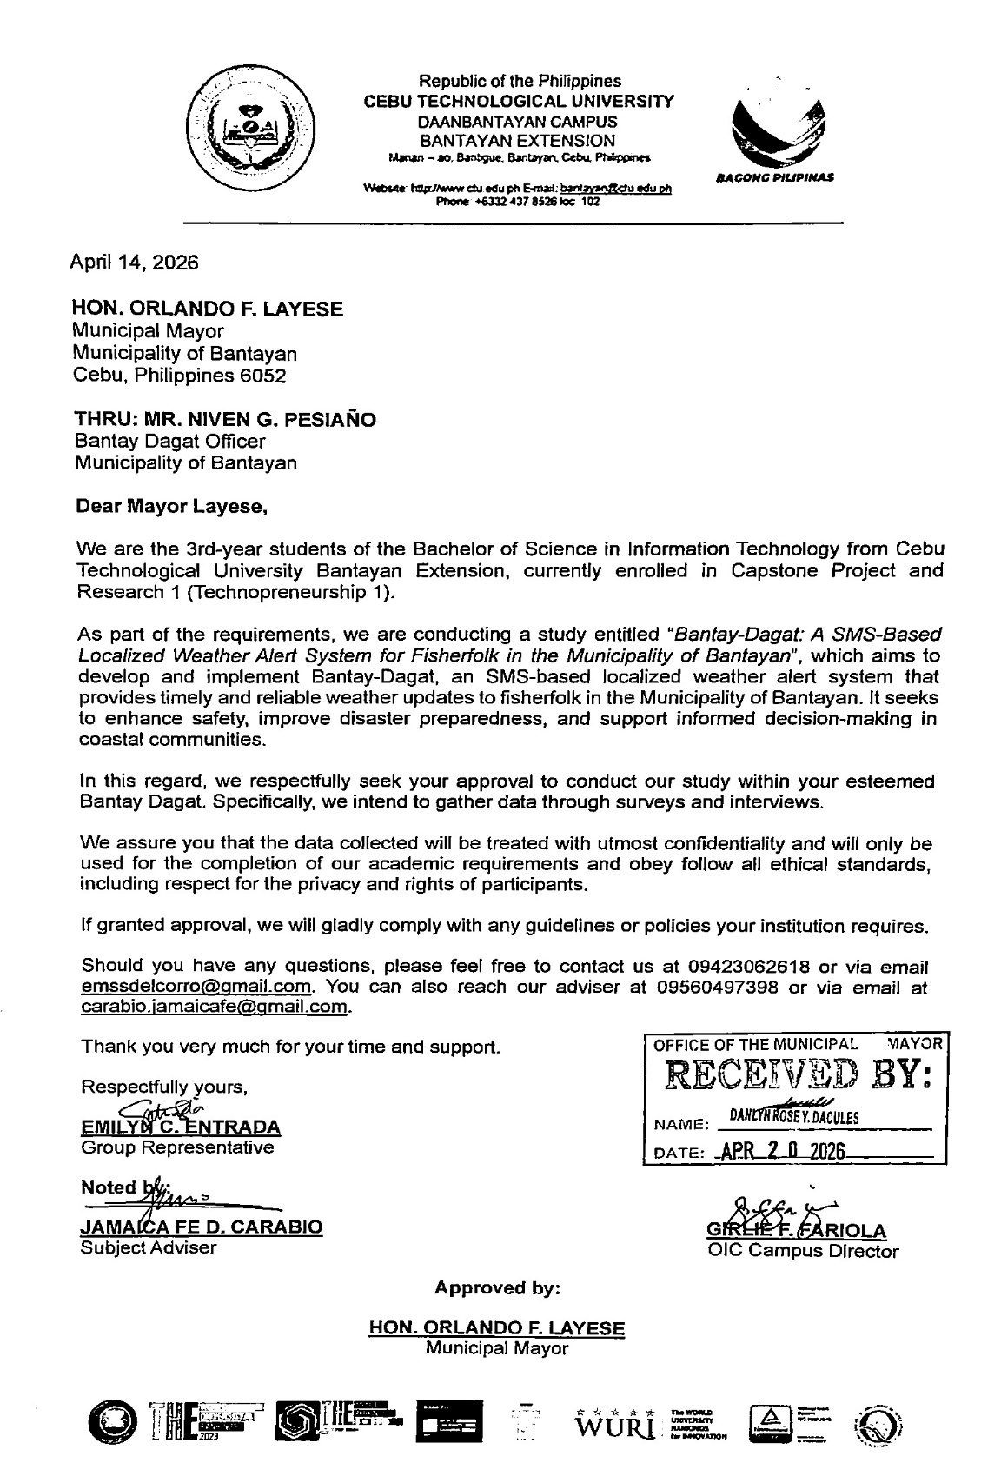

2. Project Adviser Appointment Form
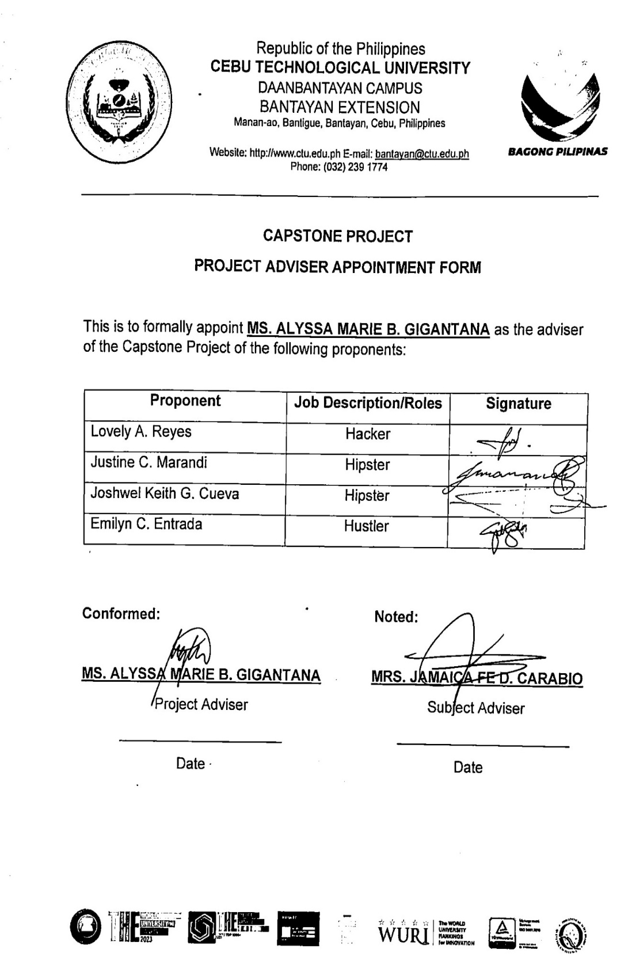

3. Pre-proposal Statement
Project Title: | BantayDagat: An SMS-Based Information Dissemination and Incident Reporting System for Fisherfolk in Bantayan
Proponents: | 1. Cueva, Joshwel Kieth G.  2. Entrada, Emilyn C.  3. Marandi, Justine C.  4. Reyes, Lovely A.
Project Adviser: | Ms. Alyssa Marie B. Gigantana
Statement of the Problem: | Existing methods of communication and information dissemination are often limited, resulting in delays, lack of coordination, and difficulties in reaching all members of the community. These challenges may affect the timely delivery of important announcements, updates, and other relevant information needed by fisherfolk.  The study aims to design and develop BantayDagat, an information dissemination system that facilitates communication, information dissemination, and community engagement among fisherfolk in Bantayan. The proposed system seeks to provide a more efficient, accessible, and reliable platform for delivering announcements, receiving feedback, and improving communication between fisherfolk and local authorities.
Scope of the Study: | RESEARCH OBJECTIVES:  The study focuses on the creation and deployment of Bantay-Dagat, an SMS-Based information dissemination and reporting system created especially for the fishermen of the Municipality of Bantayan. The system disseminates information and receive rescue request via SMS messaging, making it accessible even in places with spotty or nonexistent internet service.  RESEARCH QUESTIONS:  1.How does the SMS-based delivery mechanism ensure reliable weather alert transmission to fisherfolk in areas with limited internet connectivity?  2. How accurate is the localized weather data in predicting severe weather conditions specific to Bantayan Island?  3. How do the fisherfolk perceive the usability and reliability of the Bantay-Dagat system?  GEOGRAPHICAL SCOPE:  • The study is restricted to the Municipality of Bantayan and concentrates on barangays where fishermen live and work.  TIME SCOPE:  • Overall Duration: The research timeline encompasses the academic year 2025–2026 through the first semester of the academic year 2026–2027.  • Proposal Phase (Second Semester, 2025–2026): This initial phase shall focus on the development of the research proposal, manuscript preparation, proposal hearing, and the preliminary oral defense.  • Development Phase (First Semester, 2026–2027): The subsequent phase will entail the system design, software implementation, rigorous testing, maintenance protocols, and the final oral defense of the completed application.  POPULATION SCOPE:  • The one hundred fifty (150) registered fishermen who live in Patao, Guiwanon, and Sulangan in the Municipality of Bantayan are the system's main users and will receive the announcement.  VARIABLES SCOPE:  • This research seeks to provide a validated SMS-based localized weather alert and warning system for the Fisherfolk of Bantayan Island through the implementation of independent variables including SMS Gateway integration, weather API data, and localized alert triggers. The research measures dependent outcomes like delivery success rate, timeliness, and usability, while explicitly excluding internet dependency for end-users and non-weather emergency alerts.  METHODOLOGY SCOPE:  • Primary data will be collected through surveys and interviews with the fisherfolks, Bantay-Dagat staff, and Fisheries-MAO staff.
Limitation of the Study: | • The system is strictly limited to the Municipality of Bantayan, Cebu. Information dissemination and incident reporting are not applicable to the other Municipalities.  • Although users are not required to have internet access, the system relies on the power of the cellular network. In areas with low cellphone coverage, message delivery may be delayed or failed.  • Alerts are exclusively sent via text message (SMS). The system does not support multimedia content (pictures, videos, or voice messages), which could provide additional context during severe weather.
Project Design/  Development Plan: | Project Specification:  • The web-based admin dashboard will be constructed using ASP.NET to provide a fluid and dynamic user interface for Bantay-Dagat and fisheries-MAO officers to disseminate information and receive feedback from fisherfolks.  • The backend logic will be written in ASP.NET Core to handle real-time weather data processing and SMS trigger methods.  • Microsoft SQL Server shall be used as the primary database to securely store user profiles, location data, and weather history records.  • The SMS Gateway integration will be used to send informations to registered mobile numbers without the user's internet connection.  • The system will also integrate SignalR for realtime communication between admins  Software Specification:  Functional Requirements  •The system shall categorize community reports by severity (e.g., Low, Medium, High, Critical) and broadcast accordingly.  • The system shall send text messages to registered mobile numbers when there’s a meeting/events.  Non-functional requirements  • SMS delivery shall occur within 5 minutes of alert generation to ensure timeliness.  • The admin interface shall be intuitive enough for Bantay-Dagat and Fisheries-MAO officers with minimal technical training to operate.  • The system shall support standard mobile phones capable of receiving SMS (2G/3G/4G networks).  Hardware Specification:  DEVELOPMENT:  1. Laptop: Used for developing the system (Minimum: Intel Core i5 Processor, 8GB RAM, 512GB SSD, Windows 10/11 or macOS).  2. GSM Module: Used for sending and receiving messages (Specifically: SIM900)  DEPLOYMENT:  1. Standard Mobile Phones (Android, iOS, or Feature Phones) with active SIM cards and cellular signal coverage.  2. Used for Admin System access and monitoring (Minimum: Intel Core i3 Processor, 4GB RAM, 256GB SSD).


4. Curriculum Vitae
Justine C. Marandi
justinemarandi@gmail.com
09073526297
POSITION: HIPSTER
The hipster is the one that makes sure all
the necessary documents are organized. _____________________________________________________________
PERSONAL DATA
: Guiwanon, Bantayan, Cebu
: May 10, 2005
: Guiwanon, Bantayan, Cebu
: Single
: Filipino
: Male
: 168cm
: 70kg
: Roberto A. Marandi Jr.
: Melanie C. Marandi

Address
Date of Birth
Birth of Place
Civil Status
Citizenship
Sex
Height
Weight
Father's Name
Mother's Name __________________________________________________________ EDUCATIONAL BACKGROUND
Elementary: Guiwanon Elementary School
S. Y. 2016 - 2017
Secondary: Bantayan National High School - Senior High School S. Y. 2022 - 2023
Tertiary: Cebu Technological University Daanbantayan Campus - Bantayan Extension
I hereby declare that all of the above-mentioned information is true to the best of my knowledge and belief
Justine C. Marandi
Researcher


Joshwel Keith G. Cueva
joshwelcuev9@gmail.com
09631988913
POSITION: HIPSTER
The hipster is the one that who organized
papers or documents.
_________________________________________________________
PERSONAL DATA
: Kampingganon, Bantayan, Cebu
: March 25, 2003
: Bantayan District Hospital
: Single
: Filipino
: Male
: 164cm
: 75kg
: Eduardo Cueva
: Babylyn Cueva

Address
Date of Birth
Birth of Place
Civil Status
Citizenship
Sex
Height
Weight
Father's Name
Mother's Name
_____________________________________________________________
EDUCATIONAL BACKGROUND
Elementary: Balintawak Elementary School
S. Y. 2016 - 2017
Secondary: Bantayan National High School - Senior High School S. Y. 2022 - 2023
Tertiary: Cebu Technological University Daanbantayan Campus - Bantayan Extension
I hereby declare that all of the above-mentioned information is true to the best of my knowledge and belief.
Joshwel Kieth G. Cueva
Researcher

Emilyn C. Entrada
emssdelcorro@gmail.com
09423062618
POSITION: HUSTLER
The hustler is the one that makes sure all
the necessary documents are organized. ______________________________________________________________
PERSONAL DATA
: Hilantagan, Santa Fe, Cebu
: August 5, 2005
: Metro Manila
: Single
: Filipino
: Female
: 162
: 47
: Ramil D. Entrada
: Evelyn C. Entrada

Address
Date of Birth
Birth of Place
Civil Status
Citizenship
Sex
Height
Weight
Father's Name
Mother's Name
_____________________________________________________________
EDUCATIONAL BACKGROUND
Elementary: Hilantagaan Elementary School
S. Y. 2016 - 2017
Secondary: Hilantagaan National High School - Ext
S. Y. 2022 - 2023
Tertiary: Cebu Technological University Daanbantayan Campus - Bantayan Extension
I hereby declare that all of the above-mentioned information is true to the best of my knowledge and belief.
Emilyn C. Entrada
Researcher

Lovely A. Reyes
lovelyreyes460@gmail.com
09073526297
POSITION: HACKER
The hacker is the one that make sure the system is running and functional ______________________________________________________________
PERSONAL DATA
: Kangkaibe, Bantayan, Cebu
: September 11, 2004
: Cagayan De Oro City
: Single
: Filipino
: Female
: 154cm
: 46kg
: Rolando R. Reyes
: Almira A. Reyes

Address
Date of Birth
Birth of Place
Civil Status
Citizenship
Sex
Height
Weight
Father's Name
Mother's Name
______________________________________________________________
EDUCATIONAL BACKGROUND
Elementary: Vito Elementary School
S. Y. 2016 - 2017
Secondary: Bantayan National High School - Senior High School S. Y. 2022 - 2023
Tertiary: Cebu Technological University Daanbantayan Campus - Bantayan Extension
I hereby declare that all of the above-mentioned information is true to the best of my knowledge and belief.
Lovely A. Reyes
Researcher

GLOSSARY
After-hour coverage – The system's ability to receive and process reports 24/7, including nights, weekends, and holidays.
Arduino Uno – The specific open-source microcontroller board utilized in the project to act as the hardware bridge between the web server and the GSM module.
ASP.NET – The primary coding framework used to build the project's web-based interface and handle server-side logic.
Bantay Dagat- Refer to persons who have undergone training programs on coastal and fisheries law enforcement conducted by any accredited government or non-government organization and who voluntarily work as deputized fishery law enforcers.
Centralized Database – The secure digital repository hosted by the ASP.NET system where all fisherfolk profiles, incident reports, and system logs are stored, replacing scattered, paper-based records.
Community-based – A system designed specifically for use within a single barangay, municipality, or defined neighborhood.
Data analytics – The system's feature that processes incoming SMS reports to generate statistical trends, charts, and summary tables for administrators.
Dead zones – Locations within the coverage area where SMS messages cannot be sent or received due to network limitations.
Fisherfolk – The primary end-users of the system; individuals engaged in fishing or coastal activities within the target deployment area who receive alerts and send incident reports via SMS.
GSM modem – The physical component connected to the server that acts as the system's bridge for all incoming and outgoing text messages.
Hoax reports – Incoming SMS messages that fail the system's verification filters (e.g., duplicate content, unverified sender IDs) and are flagged for admin review before dissemination.
IDE (Integrated Development Environment) – The specific software (e.g., Visual Studio) used by the developers to write, compile, and debug the project's source code.
Information dissemination – The system's primary function of automatically broadcasting alert SMS messages to all registered subscribers within a specific affected area.
Self-reported – SMS reports sent by community members describing local incidents which the system then validates and forwards.
SMS-based – A system where all user interactions—reporting incidents, receiving alerts, and confirming subscriptions - happen exclusively via text messages on mobile phones.

