Step by step : building a simple level.

Create a wall texture image.
It's an image containing several tiles. These tiles will be applied on wall, during rendering phase.
By default each tile must be 64 x 96 pixels.
The following image contains 5 tiles so its size is 320 x 96 pixels.

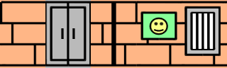

Create a flat texture image.
This image contains tiles which will be applied to floor and ceiling. Each tile is a square of 64 x 64 pixels.
The following image size is 128 x 64 so it contains 2 tiles. (one for the floor, one for the ceiling) .


Both images will be stored in the resources/textures folder.

Create an index.html.
This file will be used to launch the game. It must provide references to :
- the library files
- the configuration and game program files
- the stylesheets...
The file must also contain a canvas tag to render the game into.
Create this file at the root path of the project.
Because of the big amount of library files, I usually use a PHP script to load all files at once.

Example of index.html content

