LFR GSE: System clock simulator
Version 1.0
Solar Orbiter Mission
RPW INVESTIGATION
MEB (Main Electronic Box) Instrument
LFR (Low Frequency Receiver) Sub-Instrument

Purpose of the document
This document presents the Spacecraft time generator that will be used at LFR level to perform testing at LPP. This generator has the following abilities:
- generation of TC_LFR_UPDATE_TIME packets upon reception of valid SpaceWire time codes
- generation of a pulse at a given date. This pulse can be used as an external trigger to start a waveform generator (Tektronix AFG 3022B, Digilent Analog Discovery...)

Presentation of the system
The system is based on a MINI-LFR board. The VHDL bitstream to use is the following:
MINI_LFR-WFP_MS-0.1.25.pdb
This bitstream is based on the 0.1.24 design, slightly modified:
- GPIOS are connected on the header of the board,
- The SpaceWire signal, swno.tickout emitted by the GRSPW SpaceWire module each time a valid time code is received is connected to pin 2
- A signal at 0.5 Hz, synchronized on the SpaceWire time code reception is connected to pin 3.
The timegen executable must be uploaded on the MINI-LFR board. The executable is based on the RTEMS realtime executive. It is able to process two telecommands compliant with the LFR software ICD:
- TC_LFR_UPDATE_TIME (used to set the local coarse time counter to an arbitray value)
- TC_LFR_ENTER_MODE (used to generate pulses at arbitray dates)
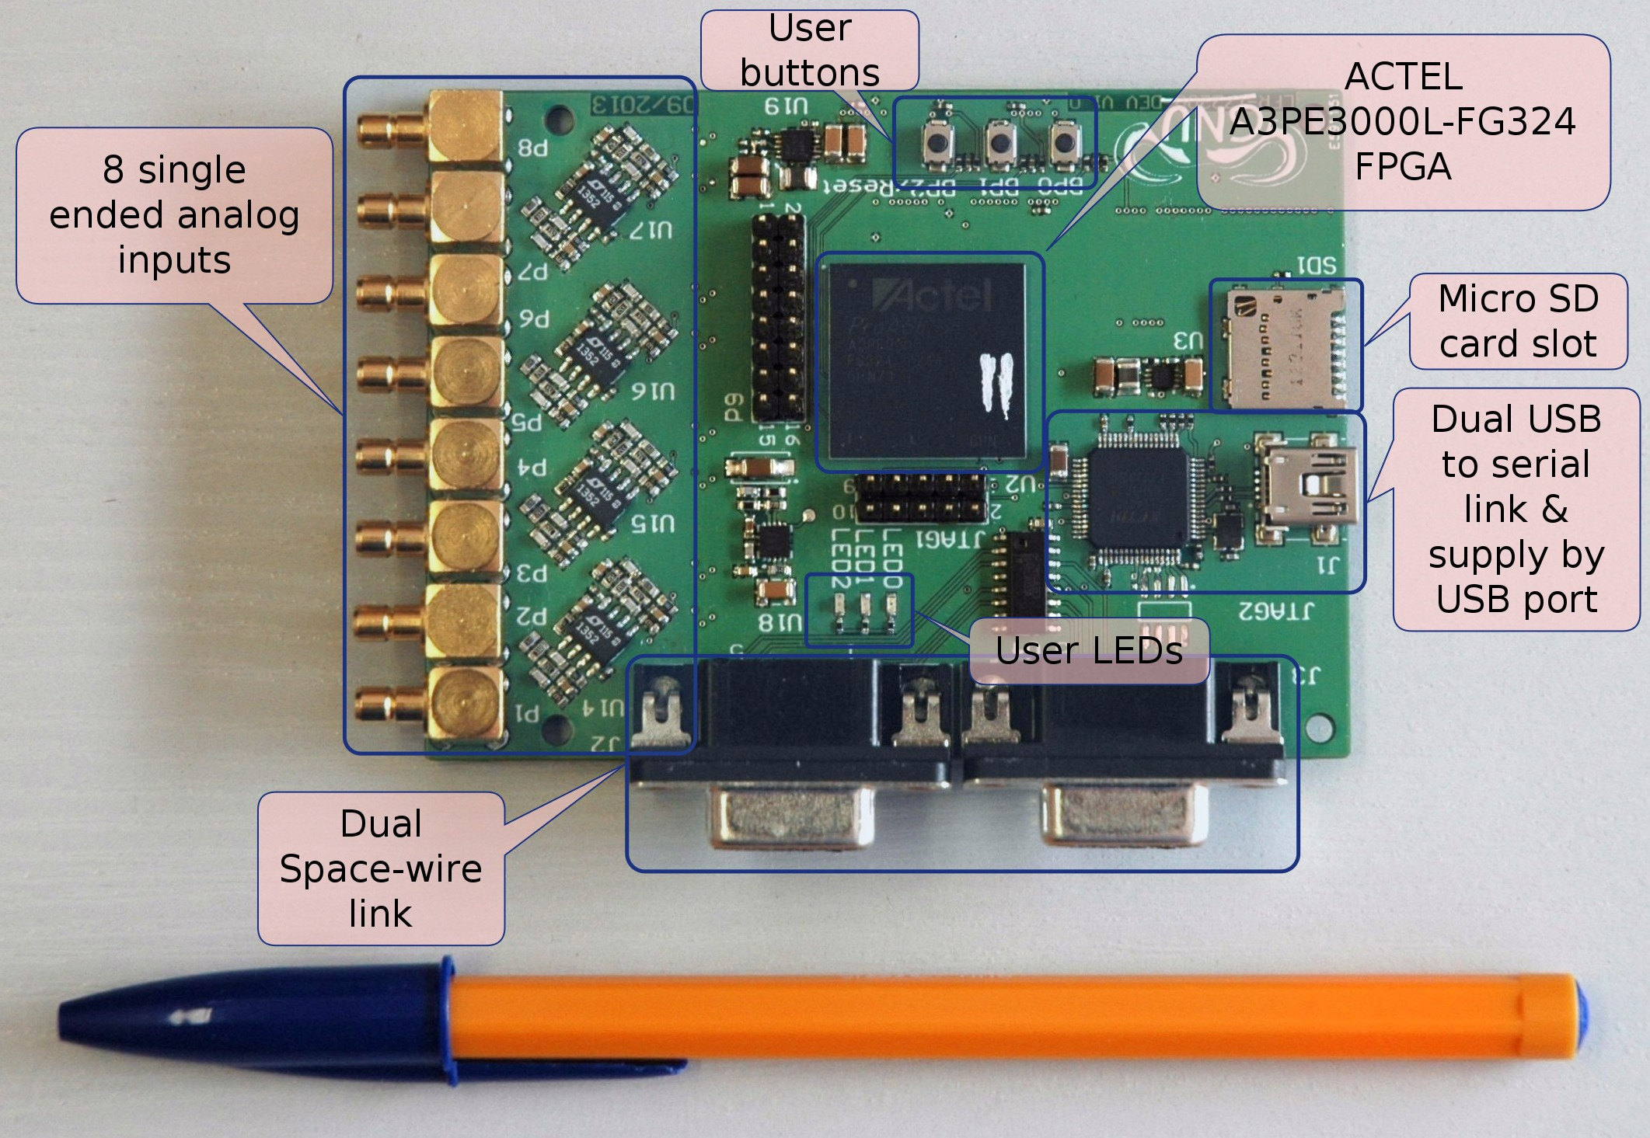
GND | 1 | 2
swno.tickout | 3 | 4 | 0.5 Hz
trigger / GPIO 2 | 5 | 6 | GPIO 3
GPIO 4 | 7 | 8 | GPIO 5
GPIO 6 | 9 | 10 | GPIO 7
 | 11 | 12
 | 13 | 14
GND | 15 | 16

TC_LFR_UPDATE_TIME generation
Each time a valid SpaceWire time code is received by the timegen executive:
- it increments its internal variable localCoarseTime
- 700 ms after it sends a TC_LFR_UPDATE_TIME with a destination address set to 0xfe (the LFR address)
The localCoarseTime value can be changed using a TC_LFR_UPDATE_TIME telecommand. In this case, localCoarseTime is set to the value contained in the telecommand.

Trigger generation
Upon reception of a TC_LFR_ENTER_MODE telecommand, timegen set the value of its local variable incomingTransitionCoarseTime to the value of the time contained in the telecommand. Upon the reception of a valid SpaceWire time code, if the following condition is met:
localCoarseTime = incomingTransitionCoarseTime
A pulse is generated . This pulse is equal to '1' during 1 second.

Example of usage
Connect the MINI-LFR to the Link 2 port of a STAR-Dundee SpaceWire-USB Brick. Use a Python script similar to the following to upload and launch timegen:
RMAPPlugin0.setValueSpaceWireLinkNumber( 2 )
RMAPPlugin0.setValueTargetLogicalAddress( 254 )
dsu3plugin0.openFile("/opt/DEV_PLE/timegen-qt/bin/timegen")
dsu3plugin0.loadFile()
dsu3plugin0.run()
RMAPPlugin0.setValueSpaceWireLinkNumber( 1 )
Once this has been done, the system is ready to receive time codes and to send TC_LFR_UPDATE_TIME packets.

