- Battery level Indicator:
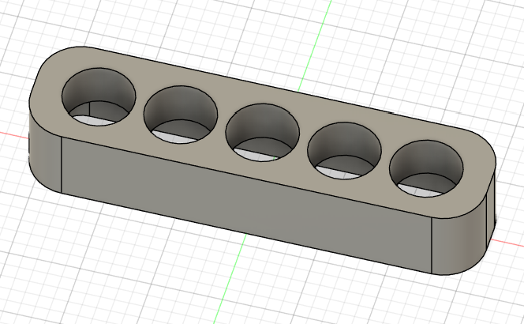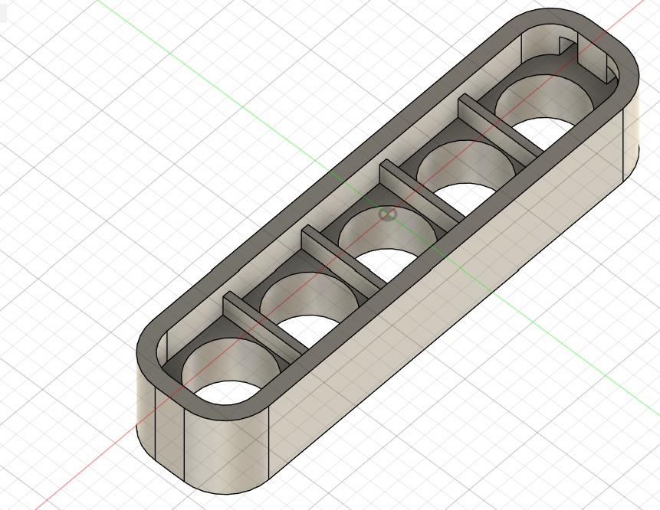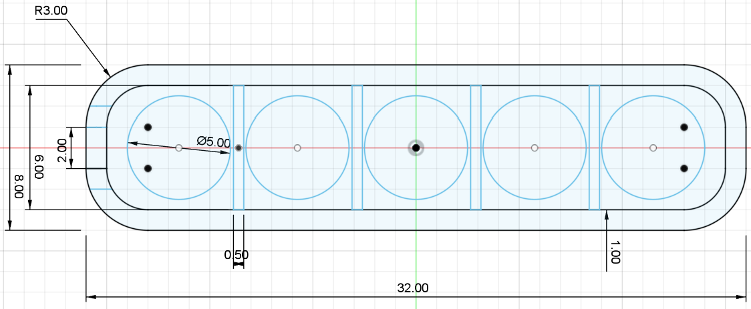
Properties:
Area 1271.807 mm^2
Density 0.008 g / mm^3
Mass 5.648 g
Volume 719.527 mm^3

Bounding Box
Length 32.00 mm
Width 8.00 mm
Height 6.00 mm

- 2S Battery Holder:
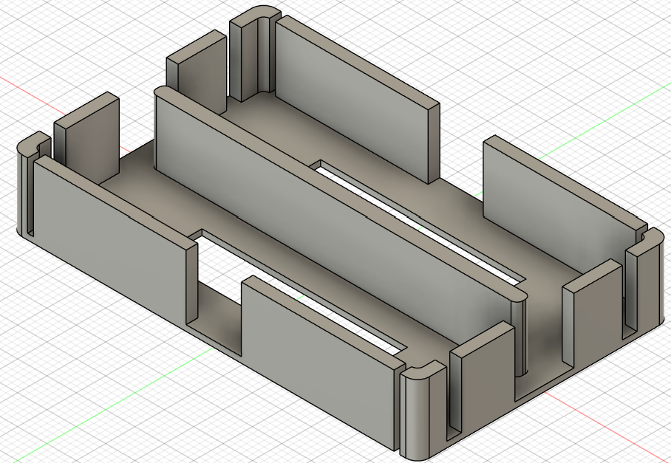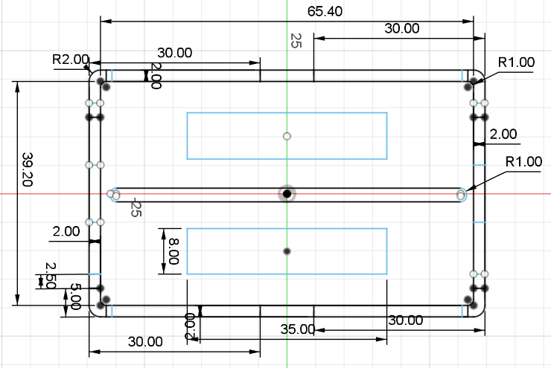
properties:
Area 10756.48 mm^2
Mass 60.146 g
Volume 7661.88 mm^3

Bounding Box
Length 69.40 mm
Width 43.20 mm
Height 12.00 mm

- Tibia Left/ Femur Right
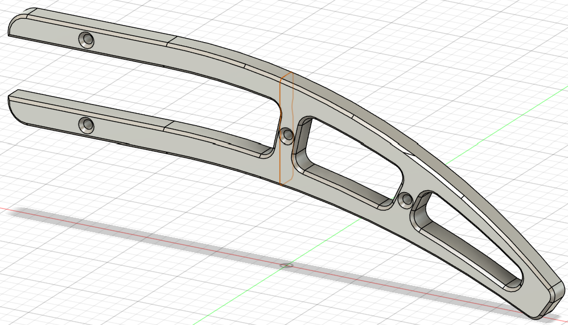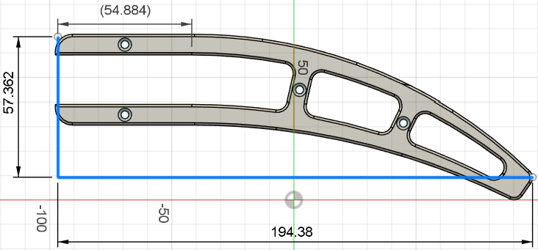

Properties:
Area 13073.055 mm^2
Mass 16.1747 g
Volume 26464.546 mm^3

Bounding Box
Length 195.402 mm
Width 8.30 mm
Height 67.695 mm
- Tibia Support:
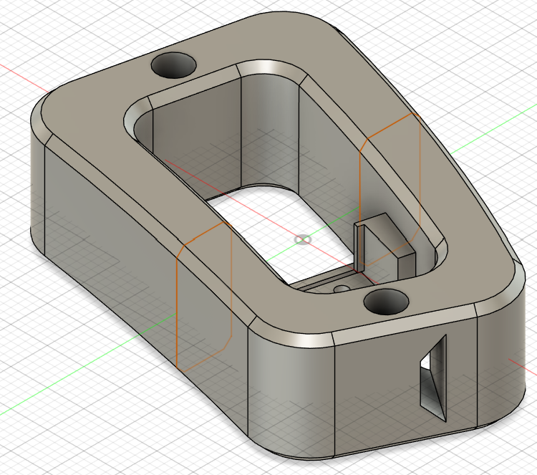 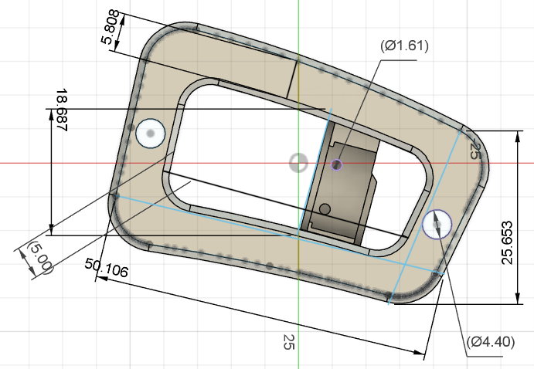
- Tibia Suspension Left/Right:
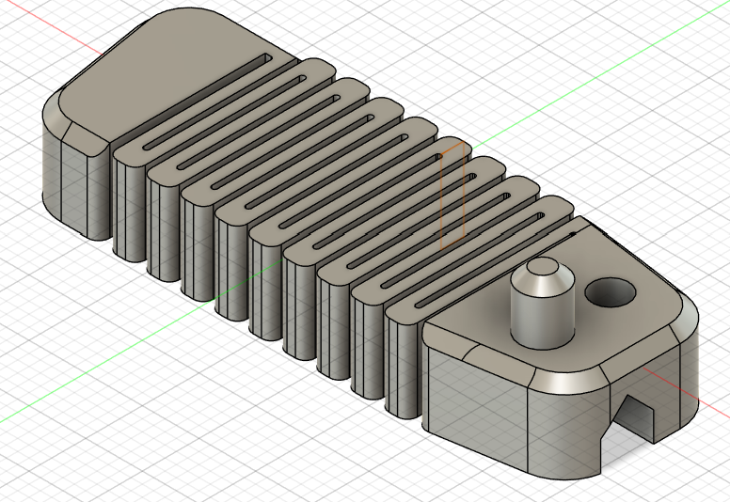 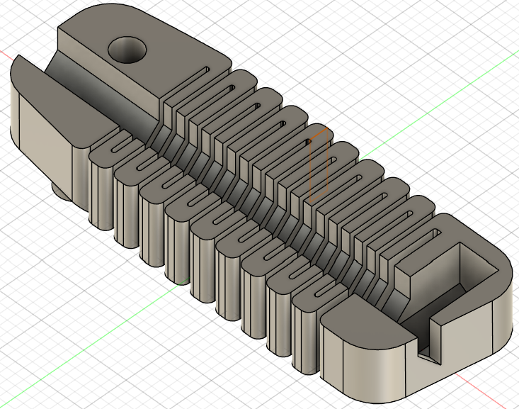 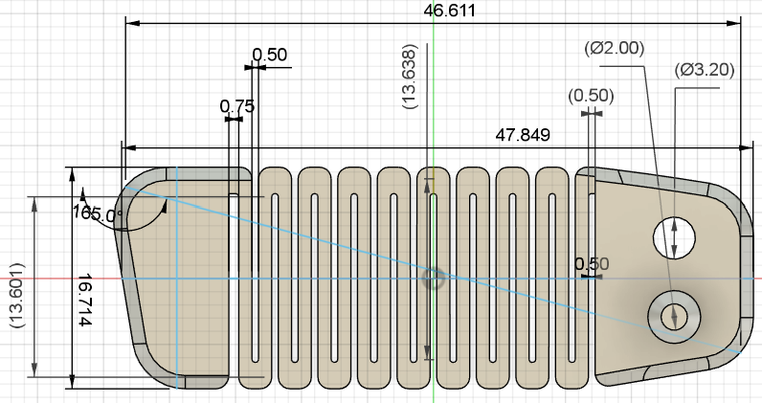
- Tibia Shaft:
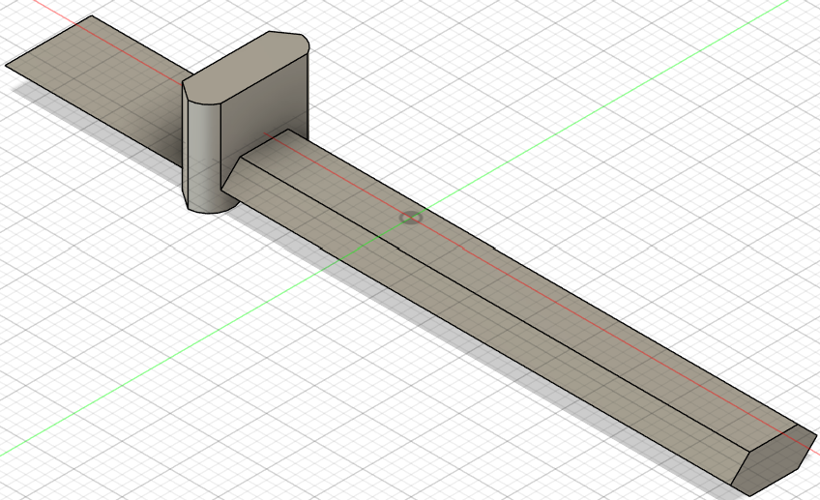
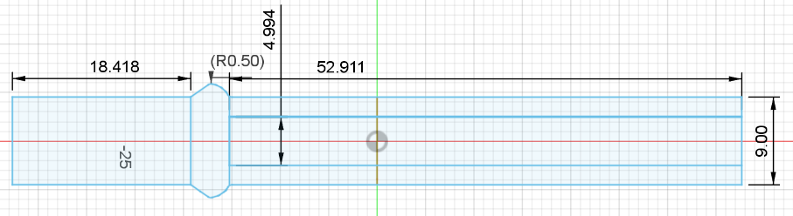
- Tibia Tip:
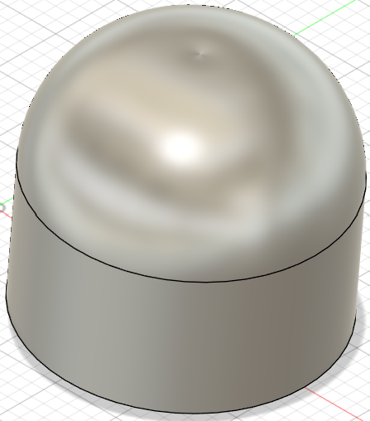 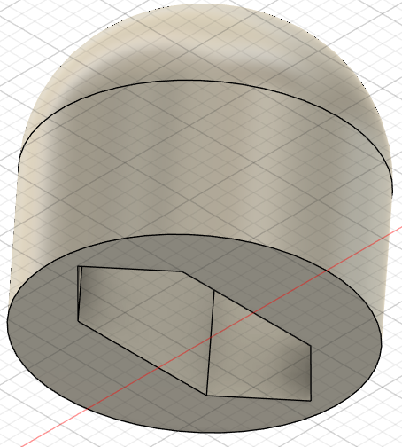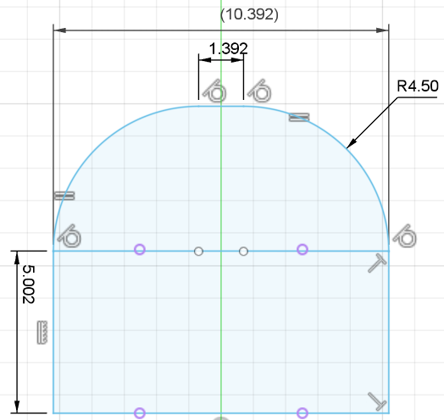
- Femur Horn:
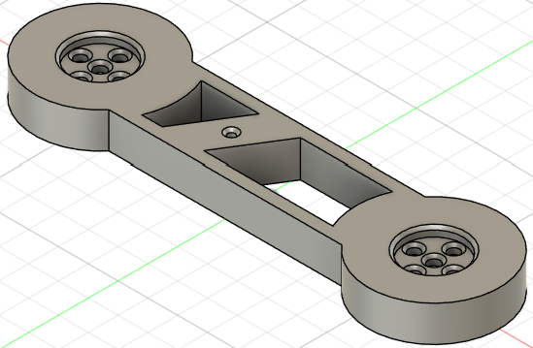 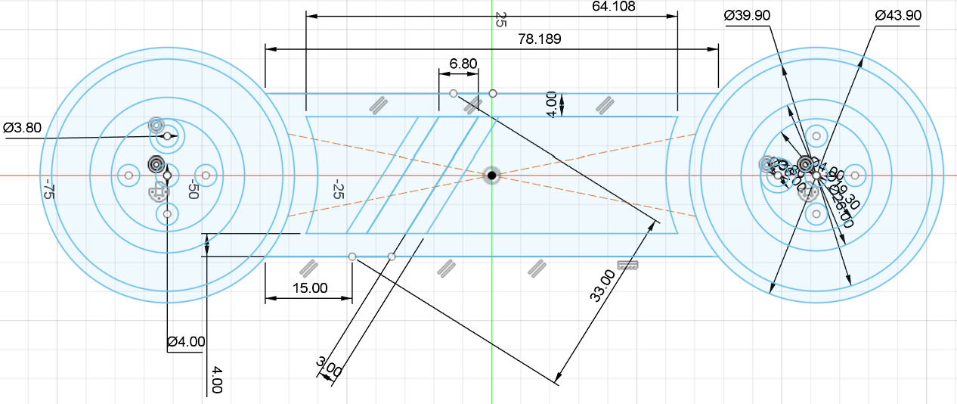
- Femur Bearing:
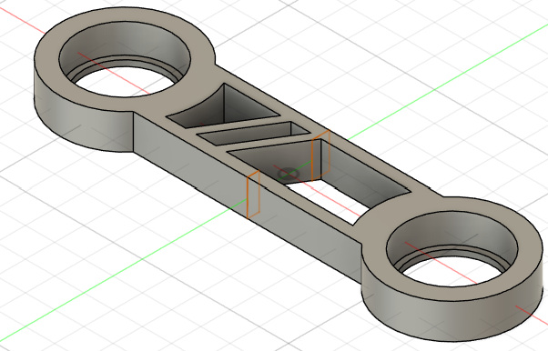 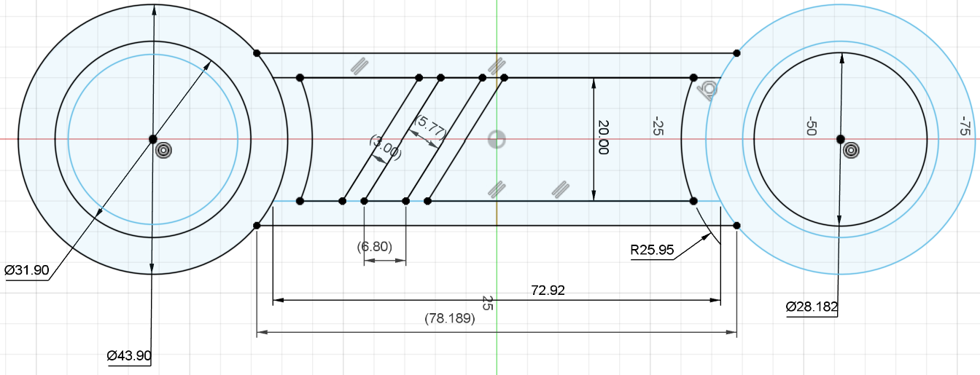
- Femur Support:
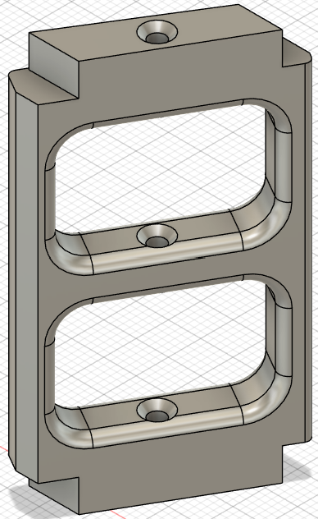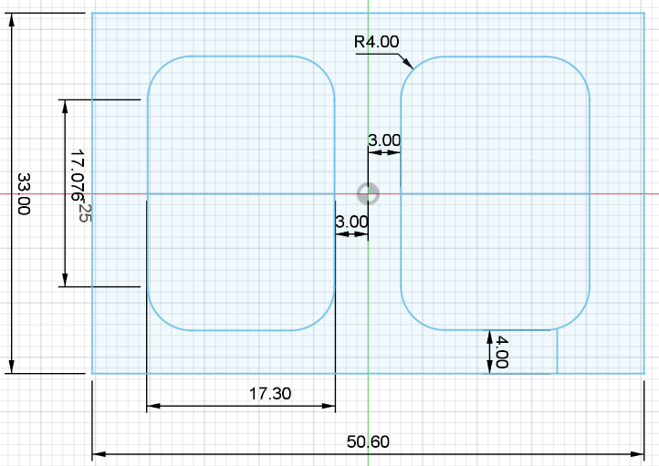
- Coxa Horn/Bearing Side:
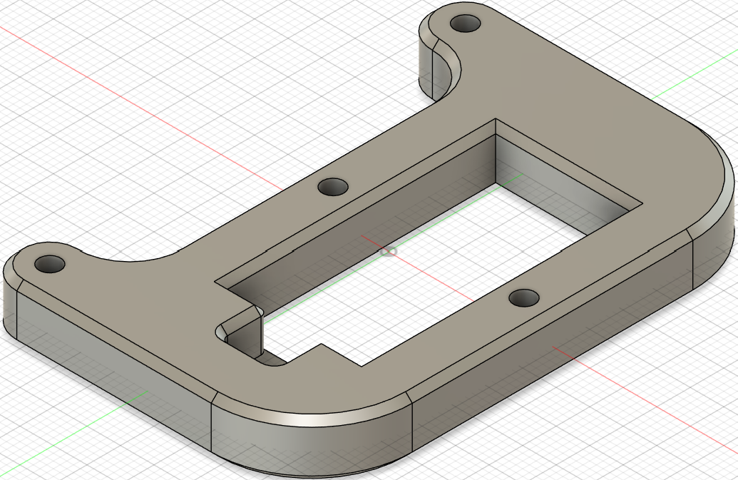 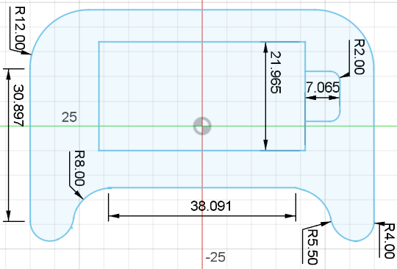
- Coxa Horn Connector:
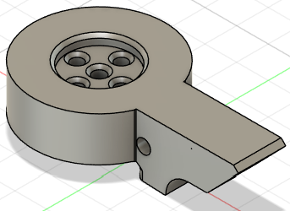 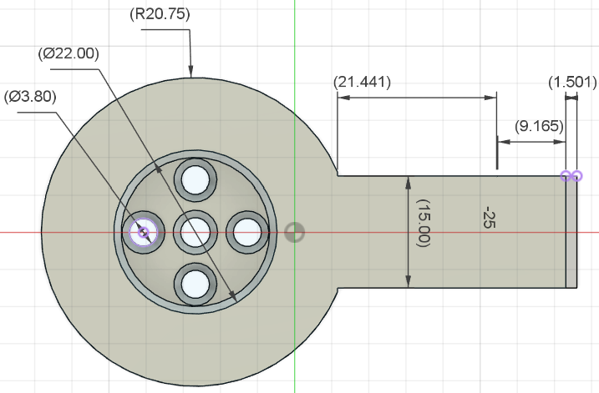
- Coxa Bearing Connector:
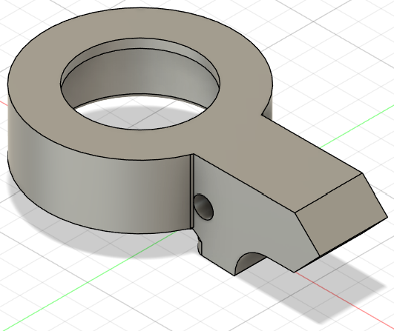 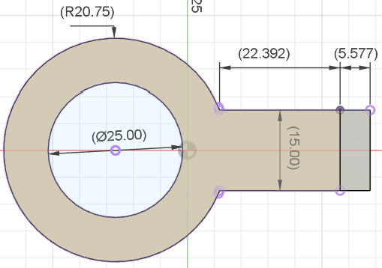
  - Body Bottom Plate:
- Body Mid:
- Body Top:

