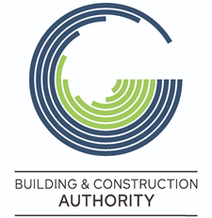
REQUEST FOR EXEMPTION FROM
REGULATION 6 - Schedule 3 – 1(a), 1(b) and 1(d) of SL 623.08
(Work outside the Permissible Hours)
All mandatory documents indicated on the form must be included at the time of submission as incomplete requests will be automatically rejected. Moreover, the Authority cannot commit to processing or determine any requests that are not submitted at least three (3) working days prior to the requested exemption date.
To be filled by the Project Architect and/or Project Manager and/or Developer and/or Contractor
PA Number:
Site Address:

Type of request | (tick as applicable)  To carry out works before 7am and/or after 8pm  To use mechanical excavators with a hydraulic hammer or pneumatic drills before 7.30am and/or after 4pm  To use mechanical excavators with a hydraulic hammer or pneumatic drills on Sundays and Public Holidays including the time  To carry out construction works on Sundays and Public Holidays including the time
Duration of Exemption | Date |  |  | Time
 |  |  |  | From |  | To
Description of Works to be carried out
Reasons why exemption is being requested and an explanation why the proposed works cannot be carried out from Monday to Saturday

Measures to be taken to reduce the nuisance to neighbours
No objection letter  (to be submitted together with this request) |  |  | Local Council (mandatory for all works)  Transport Malta (if applicable)  Others (if applicable)
Date |  | Name and Surname of Person submitting the request |  |  | Role of the person submitting the request in the project |  | Signature*
*By signing I, am declaring that I am assuming full responsibility for the reasons provided above. I also understand that the information contained in this application form will be processed by the Building and Construction Authority in accordance with the prevalent GDPR regulations and that such information may be forwarded to other entities to assist the Authority determine the acceptance or otherwise of this request.

