In Neto et al., 2016 they described in detail a procedure for precisely aligning two probes for in vivo “paired-recordings” such that the spiking activity of a single neuron is monitored with both a dense extracellular silicon polytrode and a juxtacellular micro-pipette. A “ground truth” dataset was acquired from rat cortex with 32 and 128-channel silicon polytrodes and it is available online (http://www.kampff-lab.org/validating-electrodes). A brief description of the dual-recording setup design and protocol are presented below.
Set-up design and protocol
In Figure 1a is presented a schematic of the dual-probe recording station where two aligned, multi-axis micromanipulators (Scientifica, UK) and a long working distance optical microscope are required to reliably target neural cell bodies located within ~100 µm of the polytrode electrode sites without optical guidance. A “PatchStar” (PS) and an “In-Vivo Manipulator” (IVM) are mounted on opposite sides of a rodent stereotaxic frame with different approach angles, 61° and -48.2° from the horizontal, respectively (Figure 1 b).
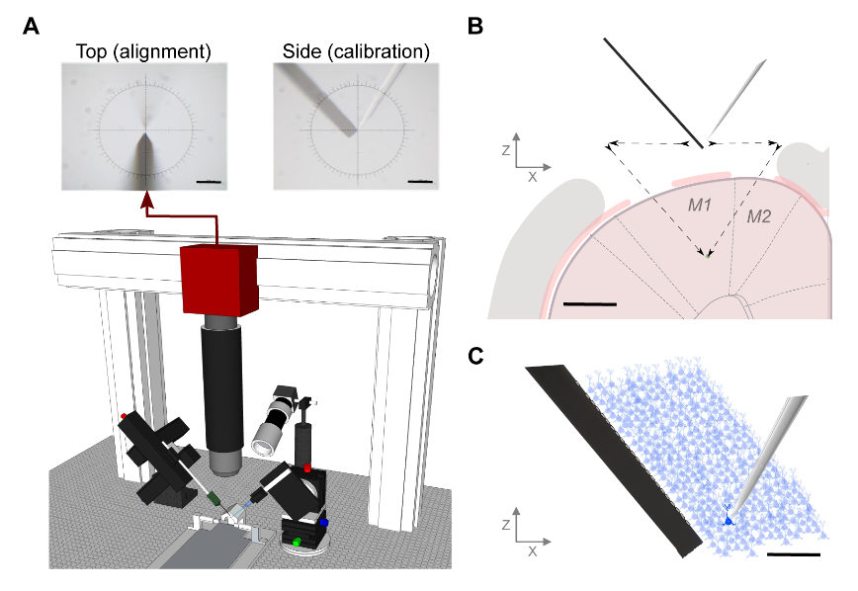
Figure 1. In vivo paired-recording setup: design and method.
(a) Schematic of the dual-probe recording station. The PS micromanipulator drives the juxtacellular pipette and the IVM manipulator drives the extracellular polytrode. The setup includes a long working distance microscope assembled from optomechanical components mounted on a three-axis motorized stage. The alignment image provides a high-resolution view from above the stereotactic frame, upper left, however a side-view can also be obtained for calibration purposes, upper right (scale bar 100 µm). (b) Schematic of a coronal view of the craniotomy and durotomies with both probes positioned at the calibration point. The distance between durotomies, such that the probe tips meet at deep layers in cortex, was around 2 mm. The black arrows represent the motion path for both electrodes entering the brain (scale bar 1mm). (c) Diagram of simultaneous extracellular and juxtacellular paired-recording of the same neuron at a distance of 90 µm between the micropipette tip and the closest electrode on the extracellular polytrode (scale bar 100 µm).

Rats (400 to 700 g, both sexes) of the Long-Evans strain were anesthetized with a mixture of Ketamine (60 mg/kg intraperitoneal, IP) and Medetomidine (0.5 mg/kg IP) and placed in the stereotaxic frame. Anesthetized rodents underwent a surgical procedure to remove the skin and the skull to expose the targeted brain region. Two reference electrodes Ag-AgCl wires (Science Products GmbH, E-255) were inserted at the posterior part of the skin incision on opposite sides of the skull.

Each paired-recording experiment began with the optical “zeroing” of both probes. Each probe was positioned, sequentially, at the center of the microscope image (indicated by a crosshair) and the motorized manipulator coordinates set to zero (Figure 1a). As shown in Figure 1b, this alignment is performed directly above the desired rendez-vous point inside the brain, as close as possible above dura, usually between 1 and 4 mm, but far enough to reduce background light reflected from the brain surface into the microscope image. The distance reported is the Euclidean distance between the tip of the pipette and the closest extracellular electrode. After both the extracellular probe and juxtacellular pipette positions were sequentially “zeroed” to the center of the microscope image, the extracellular probe was inserted first, at a constant velocity of 1 µms⁻¹, automatically controlled by the manipulator software. When the extracellular probe was in place, the juxtacellular pipette, pulled from 1.5 mm capillary borosilicate glass (Warner Instruments, USA) and filled with PBS 1x, was then lowered through a second durotomy. The juxtacellular pipette with a long thin taper had typical tip diameter of 1-4 µm and resistance of 3-7 MΩ. As the electrode was advanced towards a cell membrane, we observed an increase in the pipette resistance. If spikes were observed a slight suction was applied to obtain a stable attachment to the cell membrane. As the juxtacellular electrode was advanced through the brain, several neurons were encountered at different locations along the motion path and, consequently, at different distances from the extracellular polytrodes.
All experiments were performed with two different high-density silicon polytrodes. A commercially available 32-channel probe (A1x32-Poly3-5mm-25s-177-CM32, NeuroNexus, USA), with 177 µm² area electrodes (iridium) and an inter-site pitch of 22-25 µm, was used in the first experiments. In later experiments, they used a 128-channel probe produced in the collaborative NeuroSeeker project (http://www.neuroseeker.eu/) and developed by IMEC using CMOS-compatible process technology. These probe electrodes were 400 µm² (20 x 20 µm²) large arranged at a pitch of 22.5 µm
Extracellular signals in a frequency band of 0.1-7500 Hz and juxtacellular signals in a frequency band of 300-8000 Hz were sampled at 30 kHz with 16-bit resolution and were saved in a raw binary format for subsequent offline analysis using a Bonsai interface.

