**CS 4400 - Problem Set 10**

**Rob Johansen**

**u0531837**



1. Problem 8.10.  
   * setjmp: (C) called once, returns one or more times
   * jongjmp: (B) called once, never returns
   * execve: (B) called once, never returns
   * fork: (A) called once, returns twice
2. Problem 8.12:

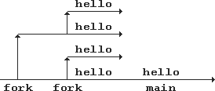

1. Problem 8.14:

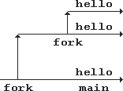

1. Problem 8.16:

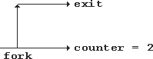

1. Problem 8.18: