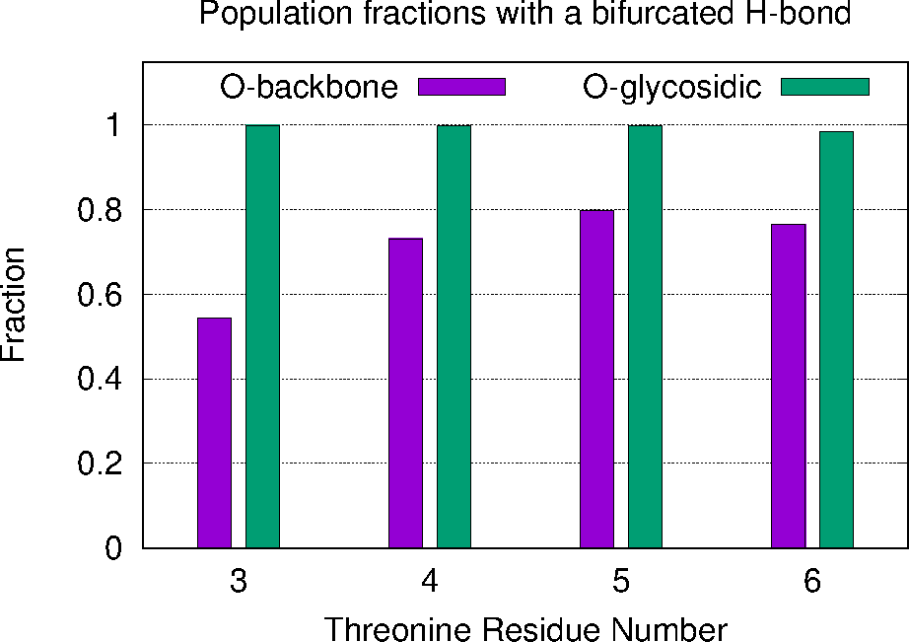

Figure BifurcatedPopulations: Fraction, per threonine, of saved frames from the MD production runs where the backbone oxygen or the glycosidic oxygen were in a geometry consistent with a bifurcated hydrogen bond. In nearly all frames where the backbone oxygen participated in a bifurcated H-bond, the same hydrogens were also in a similar geometry with the glycosidic oxygen, producing the 4-way interaction suggested in the text. See also FIGURE BackBoneDetails and SI FIGURE HeatMaps.

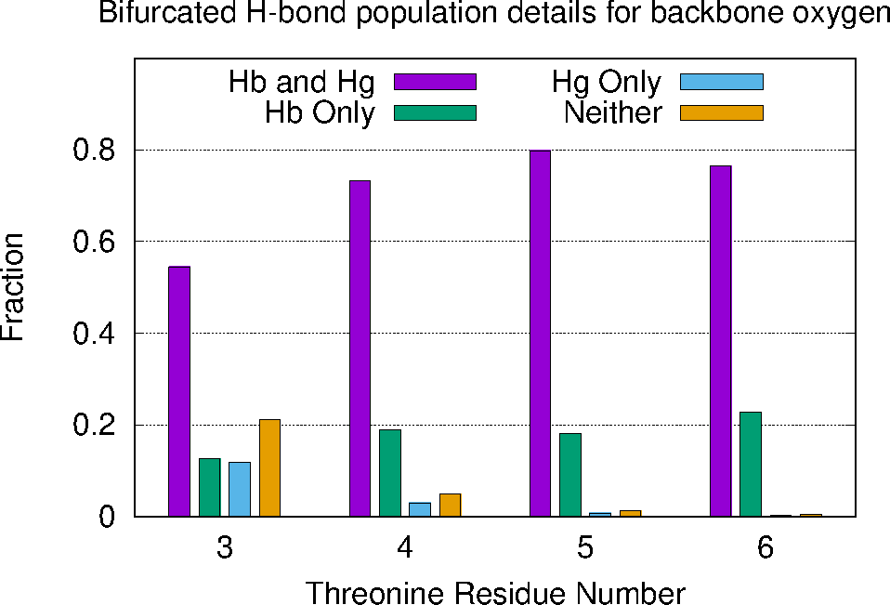Figure BackboneDetails: Fraction, per threonine, of saved frames from the MD production runs where the backbone oxygen was within 3.9 Å of the backbone hydrogen (Hb), the hydrogen from the NAc (Hg), both hydrogens or neither hydrogen.

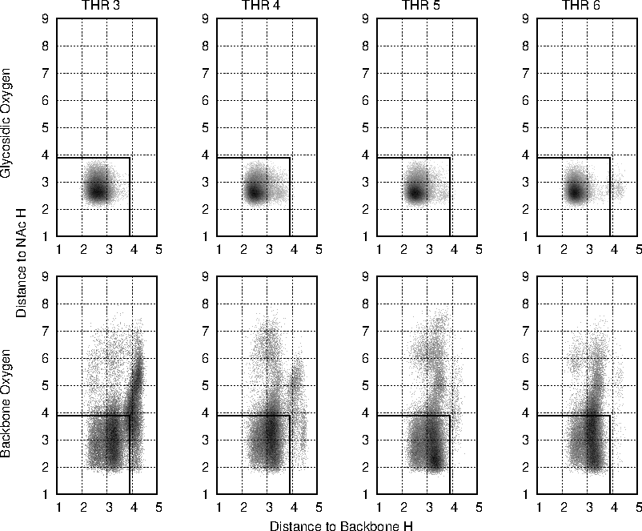

SI FIGURE HeatMaps: Heat maps representing the relative fractions of saved frames from the MD production runs that fall into the indicated geometries. Each dot represents a square 0.01 Å bin, and the darker the dot, the higher the population. The top four plots concern the glycosidic oxygen and the bottom four plots concern the backbone oxygen. Each of the four plots corresponds to the threonine residue indicated at the top. In all plots, the x-axis represents the distance from the relevant oxygen to the adjacent backbone oxygen, and the y-axis represents the distance to the hydrogen attached to the nitrogen in the GalNAc moiety. See the main text for a more precise definition of the atoms involved. All plots are scaled identically for ease of comparison. The black rectangle outlines the 3.9x3.9 Å region being used herein to define a bifurcated hydrogen bond.