2802ICT Intelligent Systems Assignment 2
Neural Network Classifier for Fashion-MNIST

s5438449, Lachlan Barnett
9/17/2026

Contents
Introduction 3
Software Design 4
Experimental Setup 6
Experimental Results 7
(a) Baseline Network Training – Table A 7
(b) Learning Rate Analysis – Table B 15
(c) Mini-batch Size Study – Table C 19
Analysis and Discussion 23
Conclusion 24
Appendix 25
nn.py source code 25
train.py source code 37

Introduction

This assignment implements a neural network classifier for the fashion-MNIST dataset. This data set contains 60,000 training images and 10,000 test images. The images are 28x28 pixels and are all grayscale, with 10 clothing classes. NumPy and the autograd library for automatic differentiation were used in the coding of this assignment. Three network depths are implemented for this task, a softmax regression classifier (784-10), a two-layer MLP with a sigmoid hidden layer (784-30-10), and a three layer MLP with two sigmoid hidden layers (784-30-30-10), tested both with and without a residual connection between the two hidden layers. The goal is to compare how architecture depth, dataset size, learning rate, and mini-batch size each affect training dynamics and final classification accuracy.

Software Design

Four network architectures are implemented in nn.py; LinearClassifier (784-10, no hidden layer), TwoLayerMLP (784-30-10, one sigmoid hidden layer), and ThreeLayerMLP (784-30-30-10, two sigmoid hidden layers), which can be instantiated either without a residual connection or with one enabled via a use_residual flag. Every hidden layer in these networks uses the sigmoid activation function, sigmoid(z) = 1 / (1 + exp(-z)), while the output layer produces raw logits with no activation applied inside forward(); softmax is applied afterwards, both when predict() converts logits to a chosen class and inside the loss function when converting logits to probabilities for cross-entropy. This satisfies the assignment’s requirement to choose an activation function for the three-layer network’s hidden layers.

The forward pass for the three-layer network computes two linear-plus-sigmoid transformations followed by one final linear transformation: z1 = X @ W1 + b1 followed by h1 = sigmoid(z1); then z2 = h1 @ W2 + b2 followed by h2_raw = sigmoid(z2); and finally z3 = h2 @ W3 + b3, which are the output logits with no further activation applied. The two-layer and linear networks follow the same pattern with one and zero hidden stages respectively. When the residual connection is enabled, the output of the first hidden layer is added directly onto the (already sigmoid-activated) output of the second hidden layer before it continues to the output layer, i.e. h2 = h2_raw + h1 rather than h2 = h2_raw. This element-wise addition is only possible because h1 and h2_raw share an identical shape of (batch_size, n_hidden); for that reason ThreeLayerMLP raises a ValueError during initialization if n_hidden1 and n_hidden2 differ while use_residual is set to True. Conceptually, the skip connection give gradients (and the raw first-hidden layer) an additive path into the second hidden layer that bypasses the second sigmoid’s own transformation entirely.

Cross-entropy loss is computed over softmax probabilities as loss = -mean(sum(y_true * log(probs), axis=1)), where probs = softmax(logits). The true labels, y_true, must first be converted to one-hot vectors by one_hot_encode() in train.py so that the element-wise product y_true * log(probs) isolates, for each sample, only the log-probability the model assigned to the correct class; negating and averaging this value across the batch yields the mean cross-entropy loss used for training. All of these operations use autograd’s wrapped numpy functions (anp.log, anp.exp, anp.sum) rather than plain numpy, which keeps the entire computation differentiable end to end.

Parameters are updated by ordinary mini-batch gradient descent params_new = params – LR * gradients, but the gradients themselves are never derived by hand. Instead, every model exposes get_params() and set_params(), which flatten all of that model’s weight matrices and bias vectors into a single one-dimensional array (and reshape them back again). This lets autograd’s grad() function treat an entire model, regardless of its depth, as a differentiable function of one flat parameter vector: a small batch_loss_fn(params) function sets the model’s parameters, runs forward(), and computes the cross-entropy loss, and grad(batch_loss_fn) then differentiates that whole chain automatically. Because autograd traces every anp operation used inside forward() and cross_entropy_loss(), no manual back propagation or chain-rule derivation is required for any of the four architectures – the same training loop in train.py works unmodified regardless of which model is passed in.

Finally, train.py is designed so that every experiment in this report can be run purely by changing command-line flags, without touching the source code. --model selects which of the three architectures (linear, mlp, mlp3) to build; --ninput, --nhidden, --nhidden2 and --noutput control layer sizes; --residual enables the skip connection for the three-layer model; --epochs, --lr and --batch_size control the training hyperparameters varied throughout Section 5; and --train_file, --test_file, --data_dir, --val_ratio and --seed control which dataset is loaded and how it is split.

Experimental Setup

All experiments use the same Fashion-MNIST test set, fashion-mnist_test.csv.gz (10,000 samples), but three different training sets: the full training set, fashion-mnist_train.csv.gz (60,000 samples), and two pruned subsets containing 50% and 10% of the original training data respectively. Unless a hyperparameter is explicitly being varied, all experiments use train.py’s default settings of 20 epochs, a batch size of 4, a learning rate of 0.01, a validation ratio of 0.2, and a fixed random seed of 42 for reproducibility. Before training begins, create_validation_split() carves off 20% of the training set for validation, sampling, proportionally from every class so the split remains stratified. Throughout training, train_model() records validation accuracy after every epoch and checkpoints the model’s parameters whenever a new best validation accuracy is reached; the test accuracy ultimately reported for each run is measured using this best-validation checkpoint rather than the parameters from the final epoch, meaning the reported result reflects the model at its best point on unseen validation data, not simply wherever training happened to end.

Experimental Results

(a) Baseline Network Training – Table A
Model | Full | 50% | 10%
Linear (784-10) | 85.45% | 85.40% | 83.54%
MLP (784-30-10) | 86.95% | 86.22% | 80.77%
MLP3 no-residual (784-30-30-10) | 86.78% | 82.40% | 10.00%
MLP3 residual (784-30-30-10) | 87.36% | 85.76% | 80.83%

Figure 1: Linear Classifier (784-10) trained on the full Fashion-MNIST training set – test accuracy 85.45%
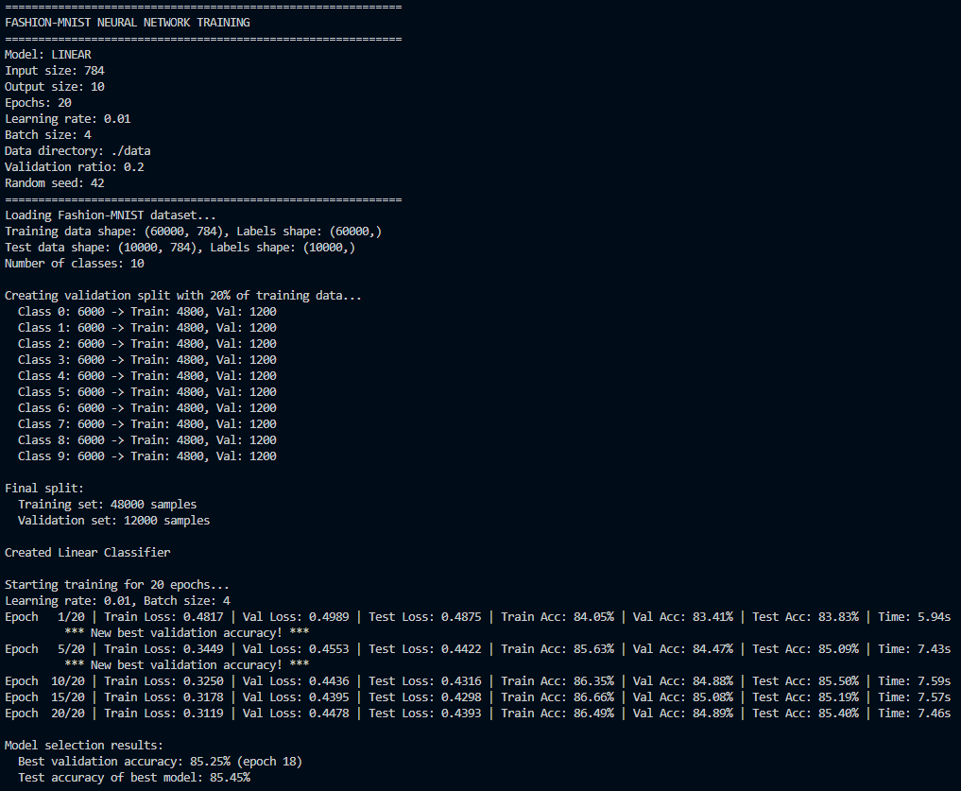
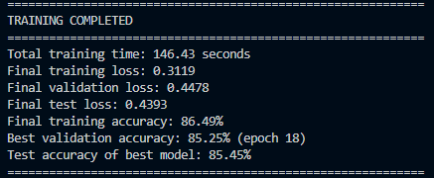

Figure 2: Linear Classifier (784-10) trained on the 50% pruned training set – test accuracy 85.40%
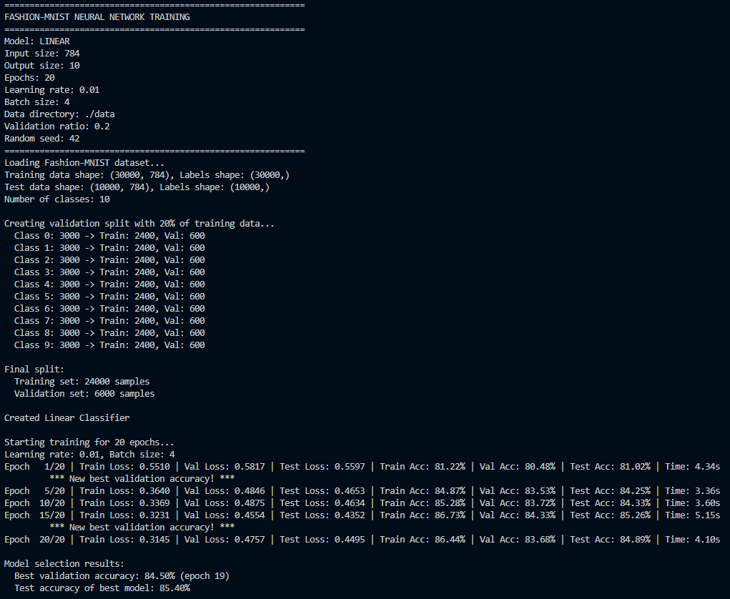
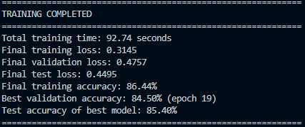

Figure 3: Linear Classifier (784-10) trained on the 10% pruned training set – test accuracy 83.54%
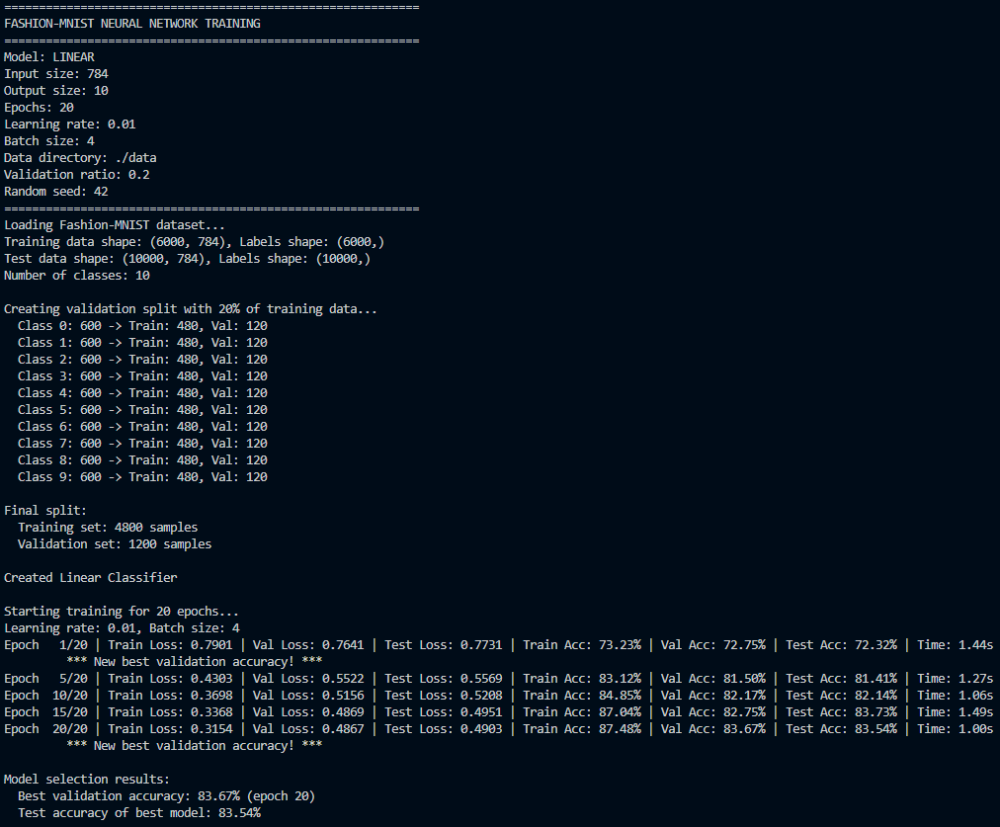
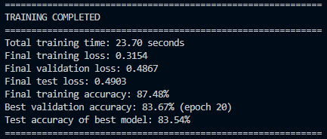

Figure 4: Two-layer MLP (784-30-10) trained on the full training set – test accuracy 86.95%
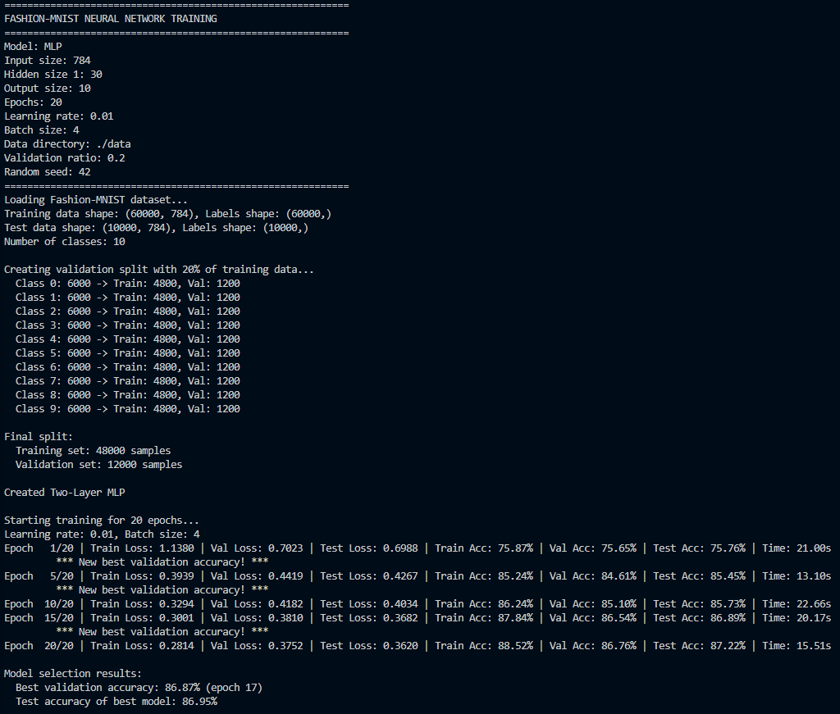
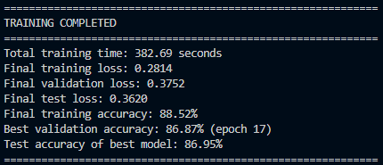

Figure 5: Two-layer MLP (784-30-10) trained on the 50% pruned training set – test accuracy 86.22%

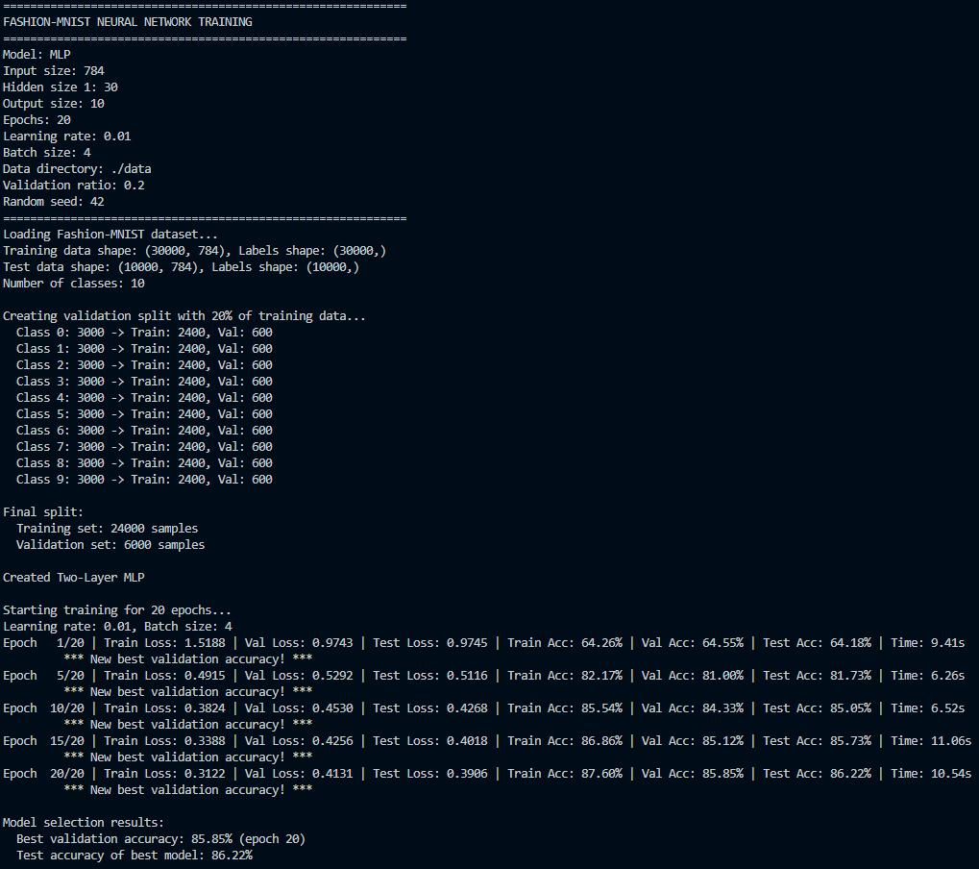
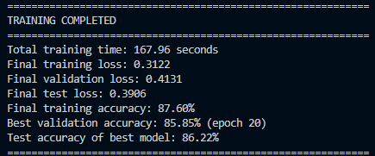

Figure 6: Two-layer MLP (784-30-10) trained on the 10% pruned training set – test accuracy 80.77%
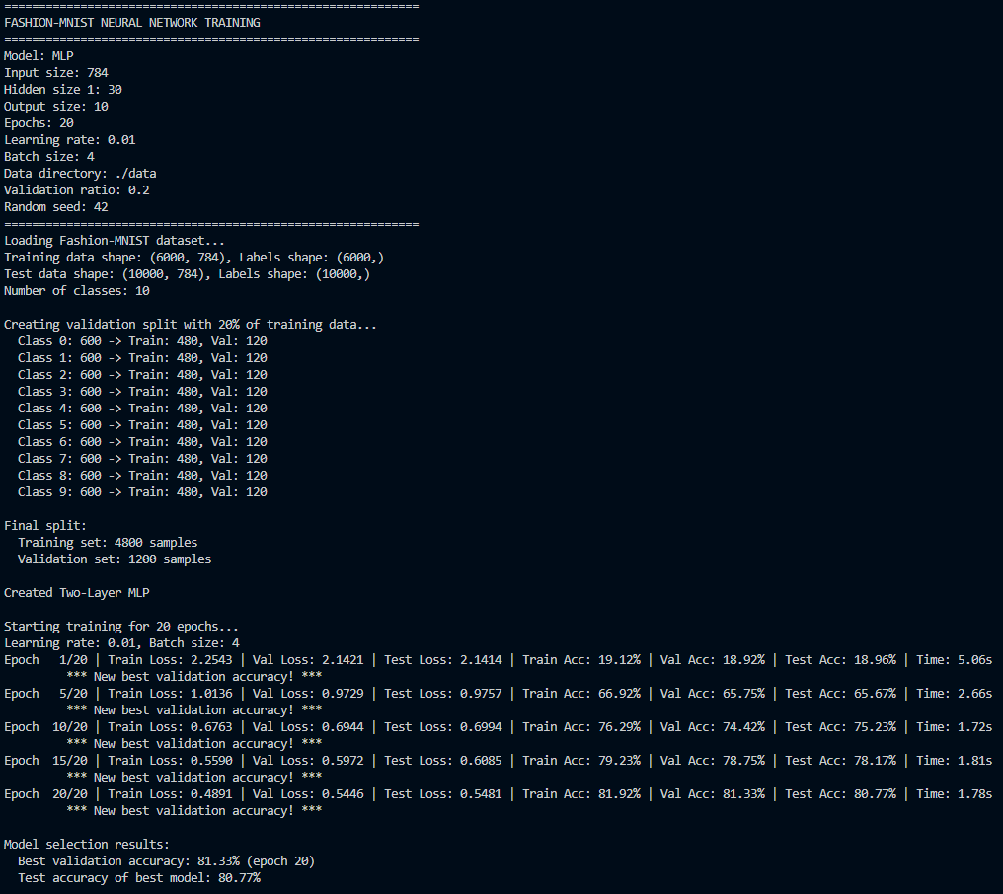
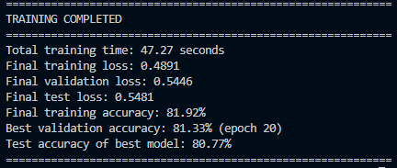

Figure 7: Three-layer MLP without residual connection (784-30-30-10) trained on the full training set – test accuracy 86.78%
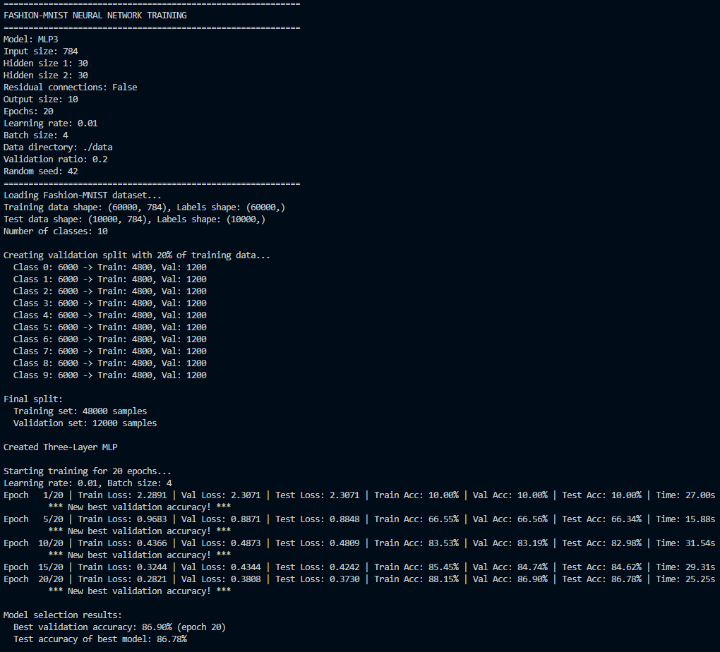
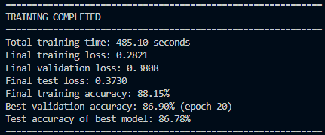

Figure 8: Three-layer MLP without residual connection (784-30-30-10) trained on the 50% pruned training set – test accuracy 82.40%
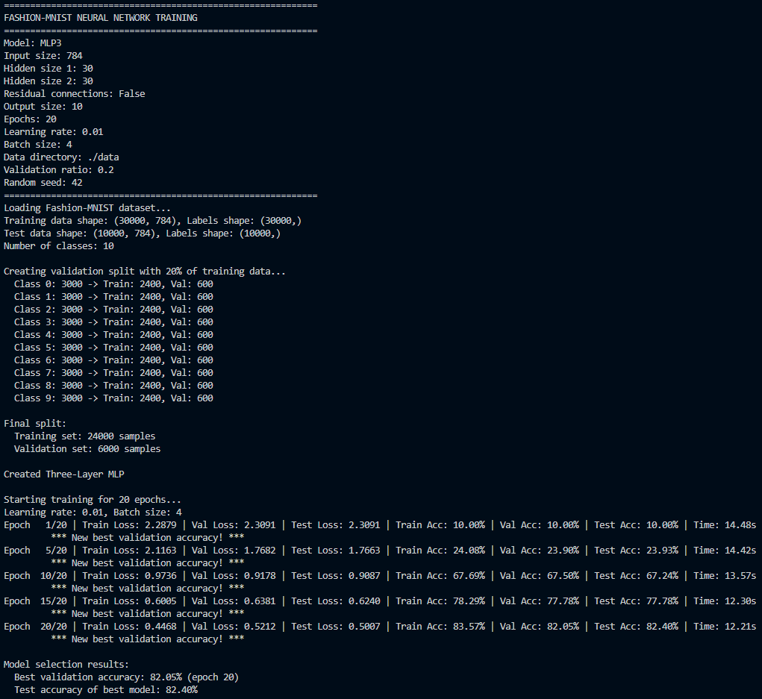
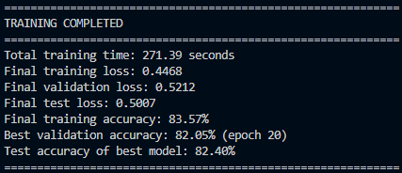

Figure 9: Three-layer MLP without residual connection (784-30-30-10) trained on the 10% pruned training set – test accuracy 10.00% (random-chance baseline)
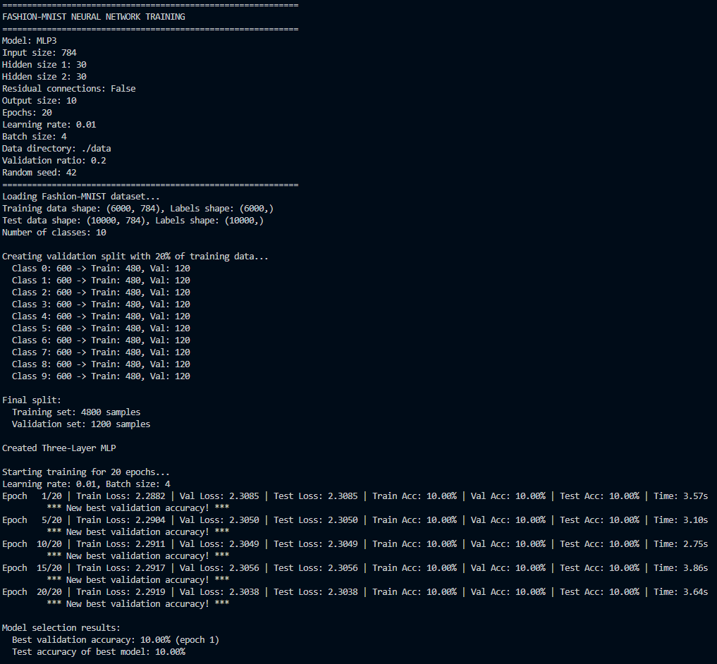
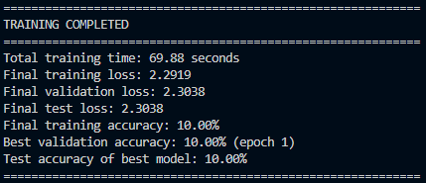

Figure 10: Three-layer MLP with residual connection (784-30-30-10) trained on the full training set – test accuracy 87.36%
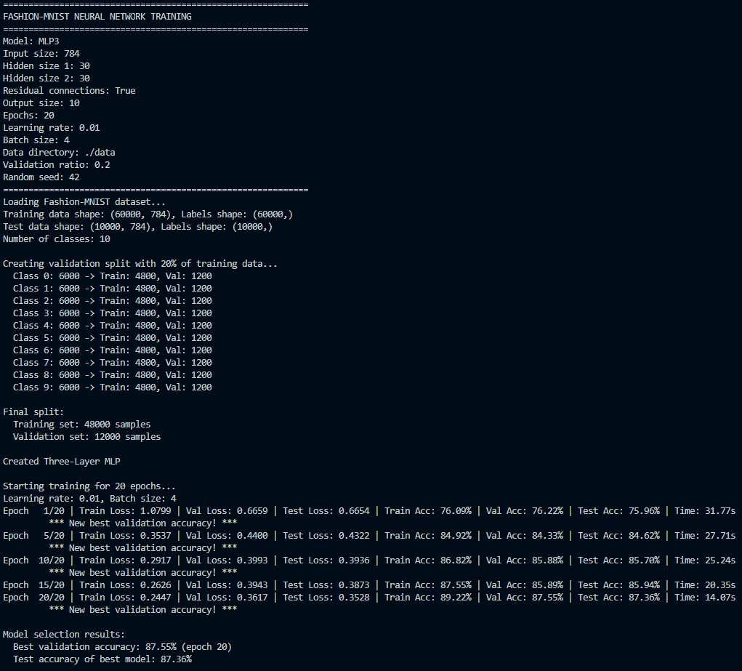
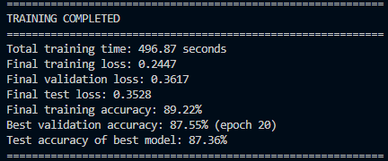

Figure 11: Three-layer MLP with residual connection (784-30-30-10) trained on the 50% pruned training set – test accuracy 85.76%
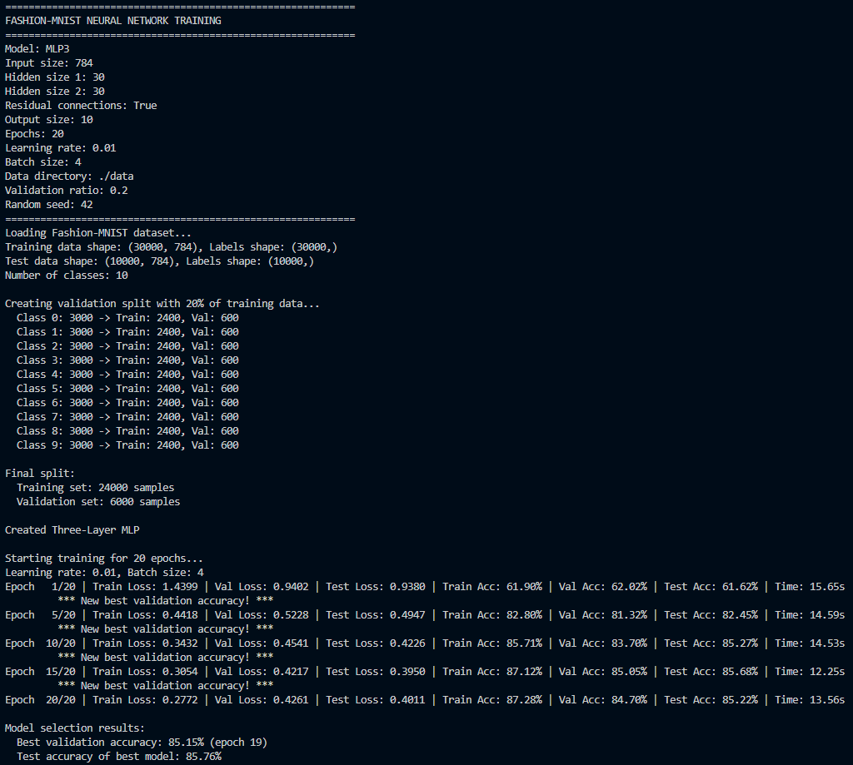
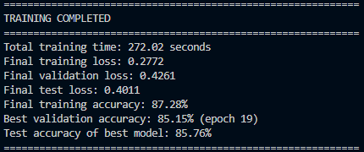

Figure 12: Three-layer MLP with residual connection (784-30-30-10) trained on the 10% pruned training set – test accuracy 80.83%
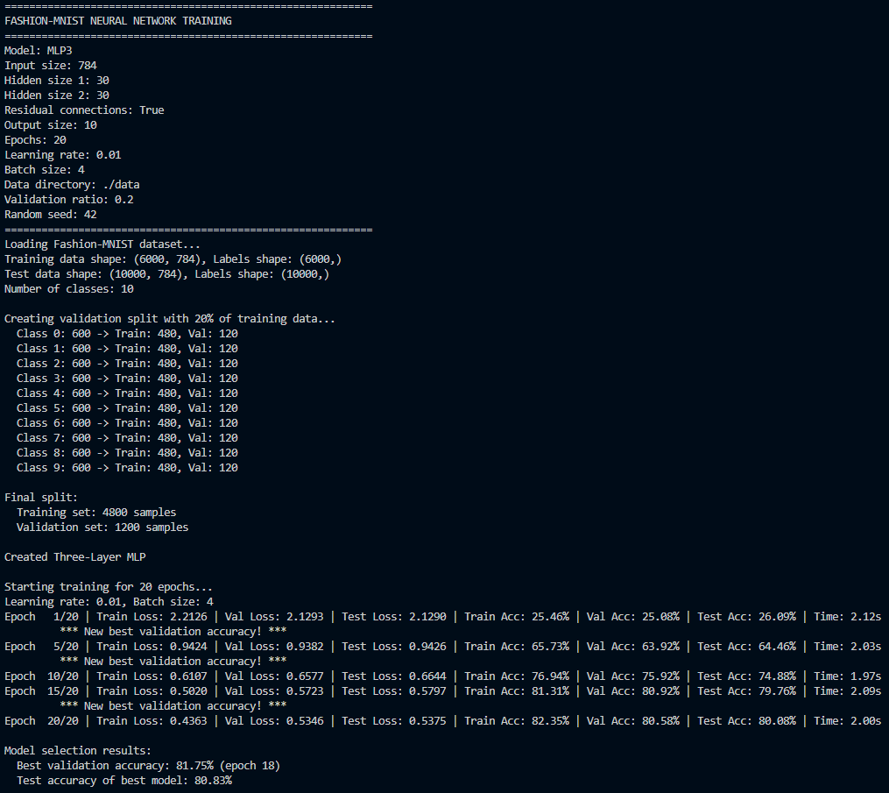
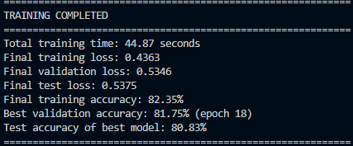

Graph 1: Test accuracy of the four network architectures (Linear, two-layer MLP, three-layer MLP without residual, three-layer MLP with residual) on the full, 50% and 10% training datasets (epochs = 20, batch size = 4, lr = 0.01)

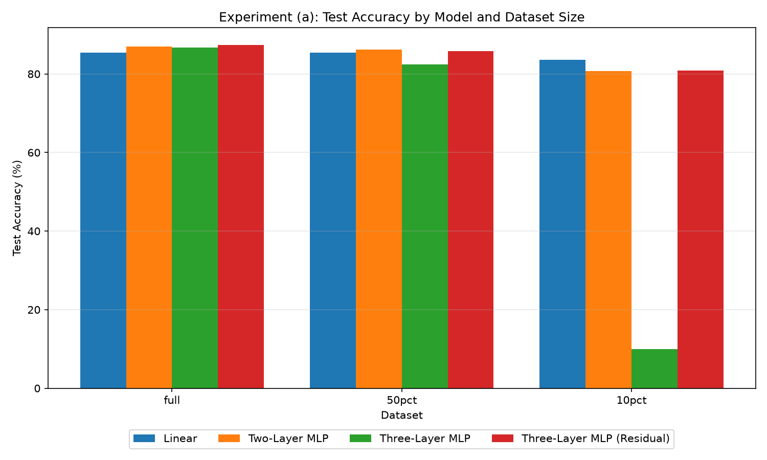

(b) Learning Rate Analysis – Table B
LR | Test Accuracy | Stable (Y/N)
0.001 | 82.49% | Y
0.01 | 87.36% | Y
1.0 | 82.81% | Y
10 | 10.00% | N
100 | 10.00% | N

Figure 13: MLP3 residual, LR=0.01, full dataset – 87.36%
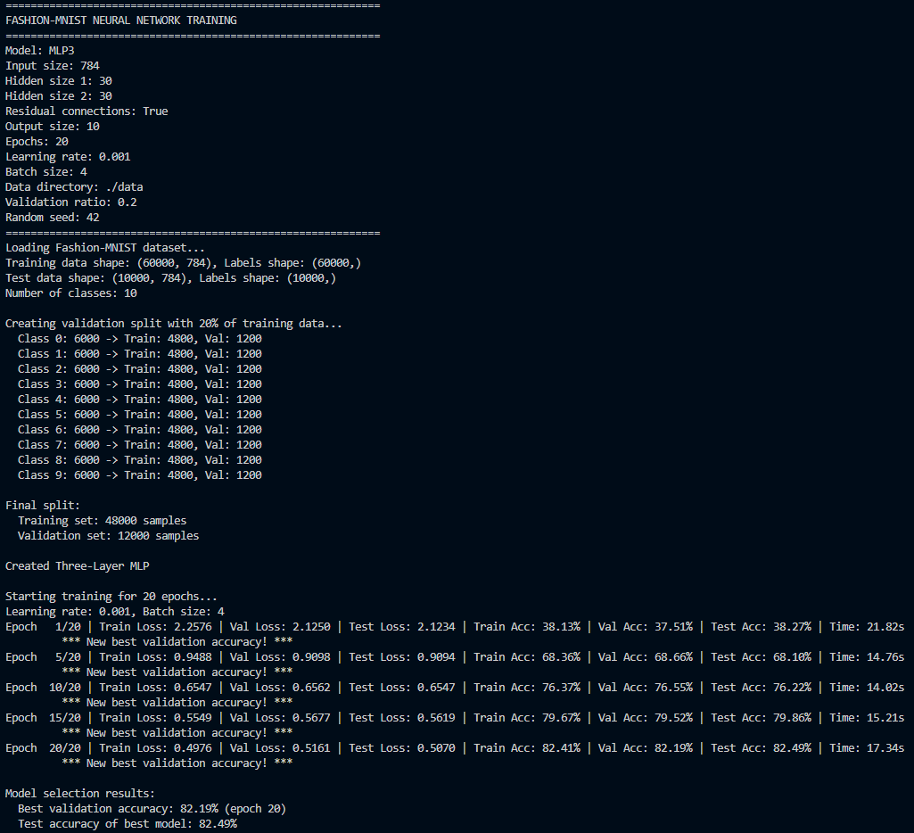
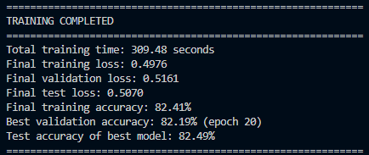
Figure 14: MLP3 residual, LR=0.001, full dataset – 82.49%
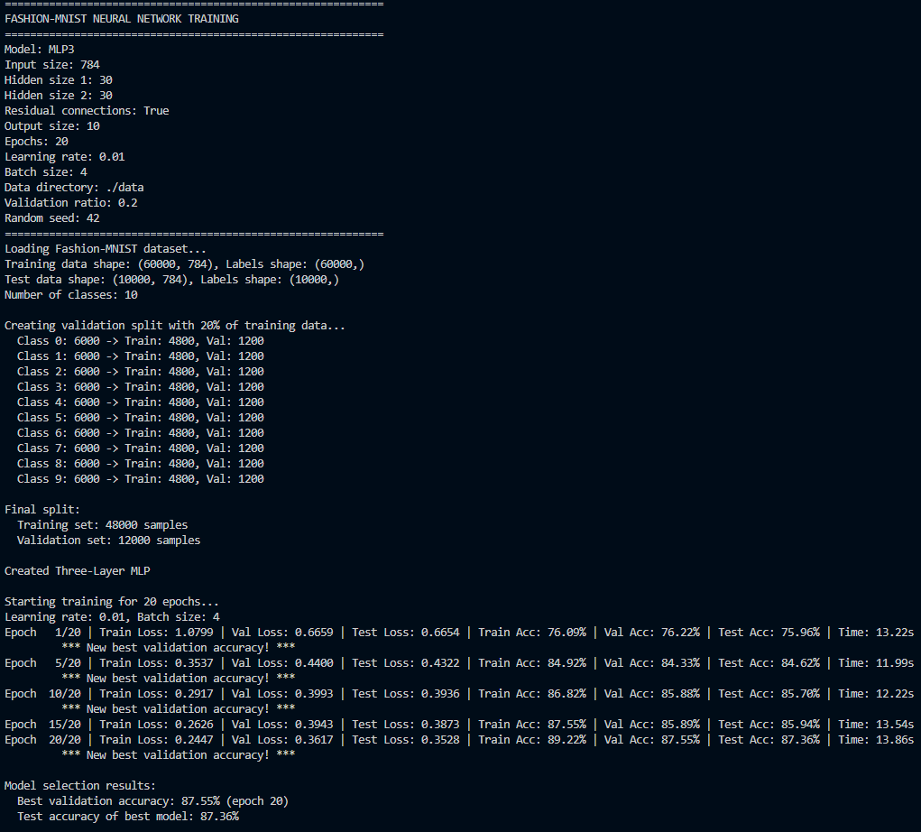
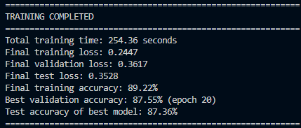
Figure 15: MLP3 residual, LR=1.0, full dataset – 82.81%
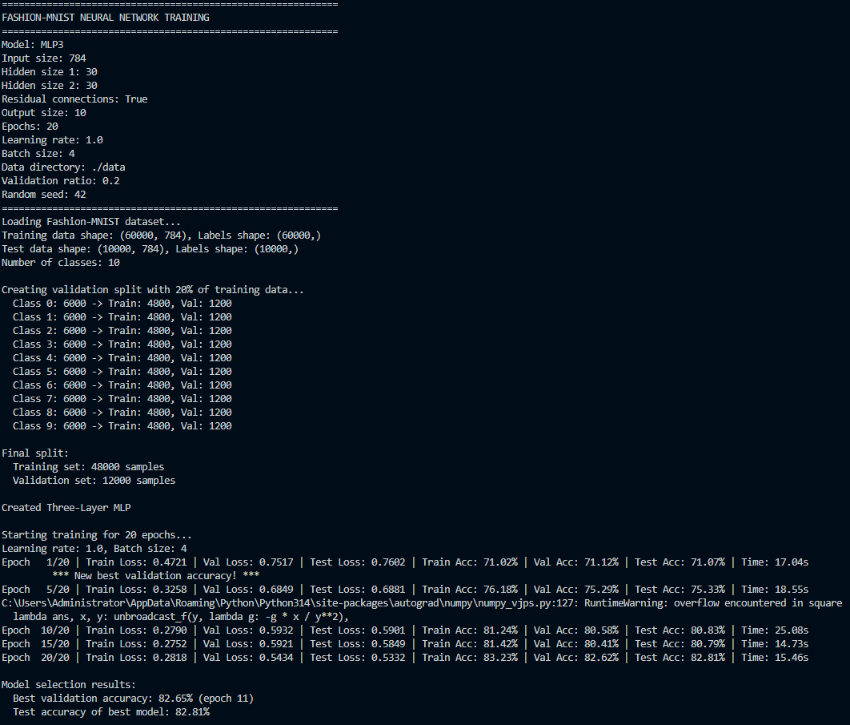
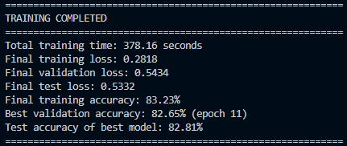
Figure 16: MLP3 residual, LR=10, full dataset – diverged, 10.00%
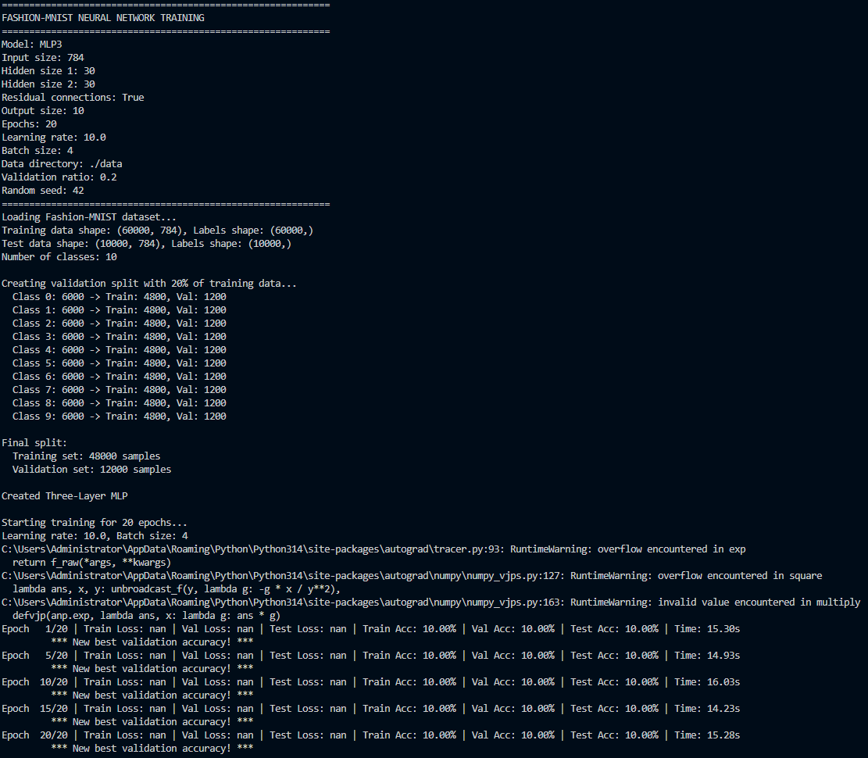
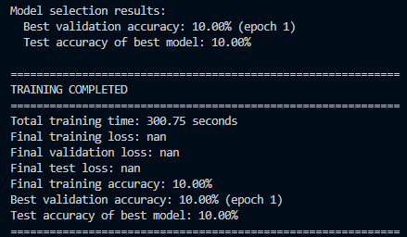

Figure 17: MLP3 residual, LR=100, full dataset – NaN loss, 10.00%
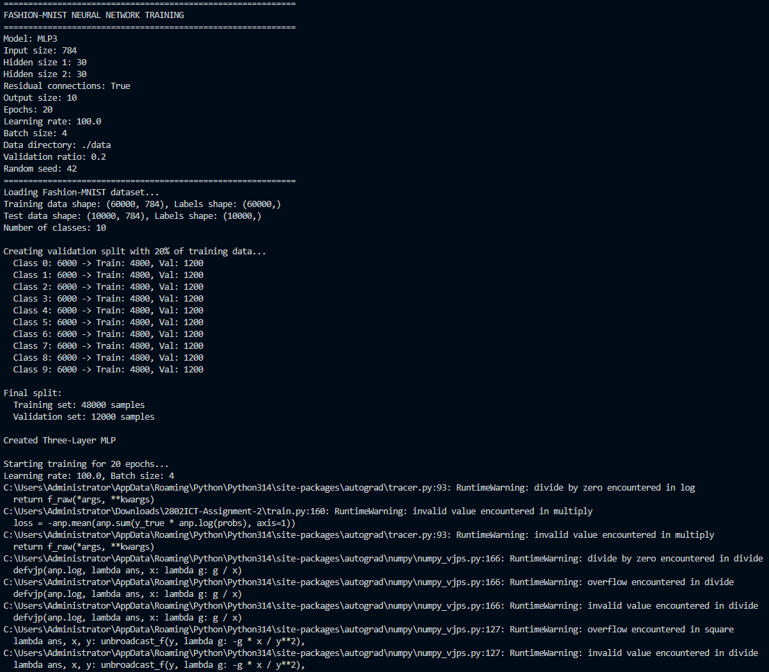

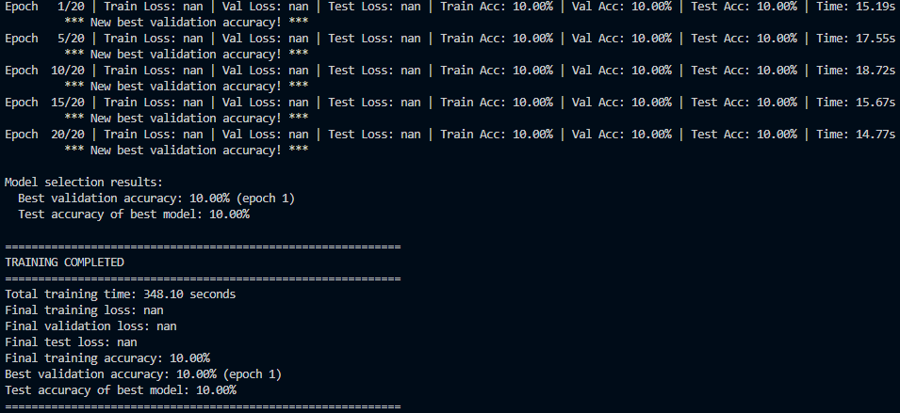

Graph 2: Graph 2: Test accuracy of the three-layer MLP with residual connection (784-30-30-10) trained on the full dataset with learning rates 0.001, 0.01, 1.0, 10 and 100. LR = 10 and LR = 100 diverged and only reached the 10% random-chance level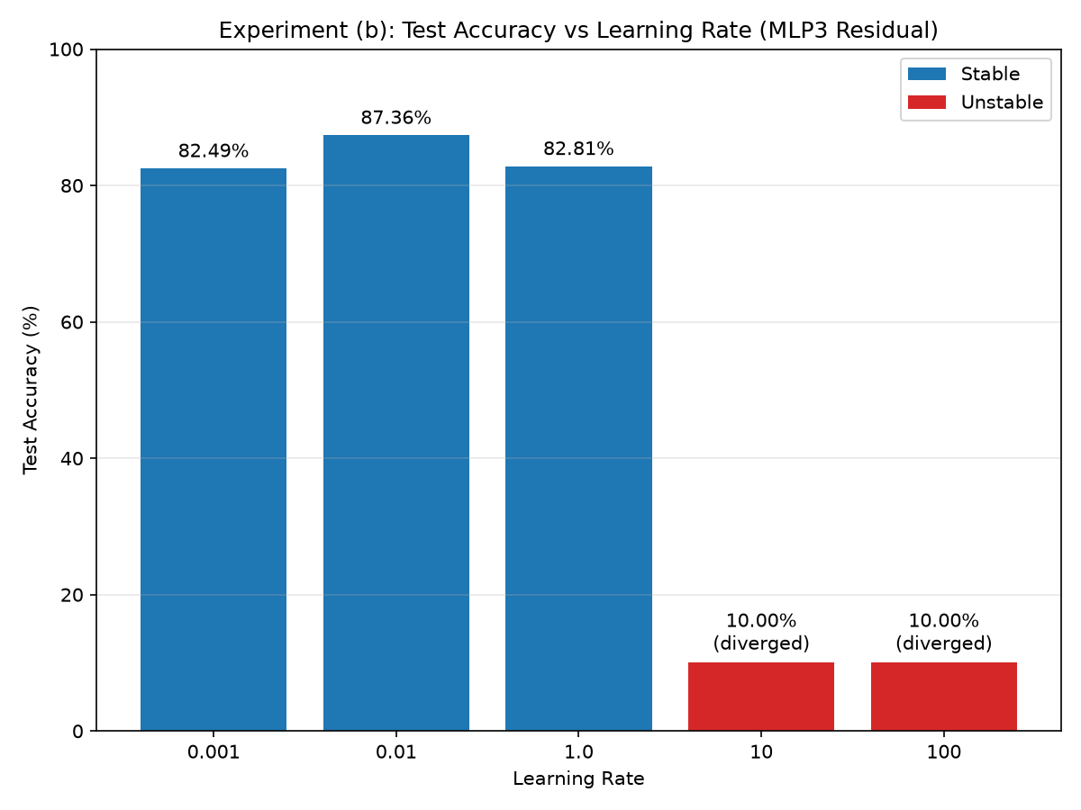

(c) Mini-batch Size Study – Table C
Batch_size | Test Accuracy | Total Training Time
1 | 87.89% | 1680.50 seconds
4 | 87.36% | 646.58 seconds
8 | 86.56% | 388.81 seconds
16 | 85.63% | 226.78 seconds

Figure 18: MLP3 residual, batch_size=1, full dataset – 87.89%
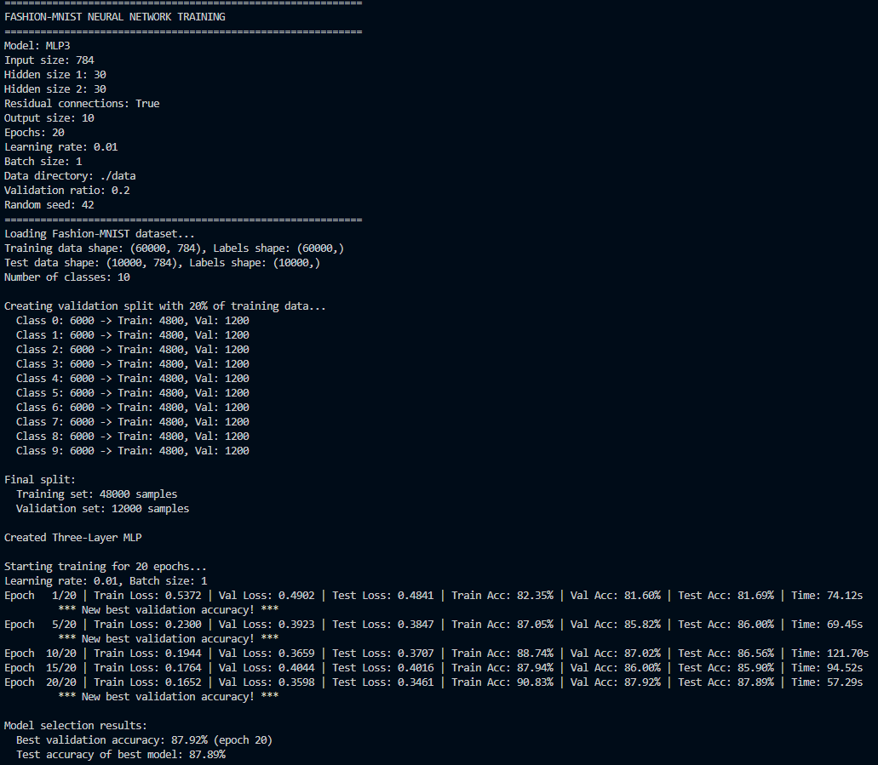
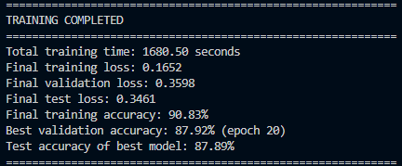

Figure 19: MLP3 residual, batch_size=4, full dataset – 87.36%
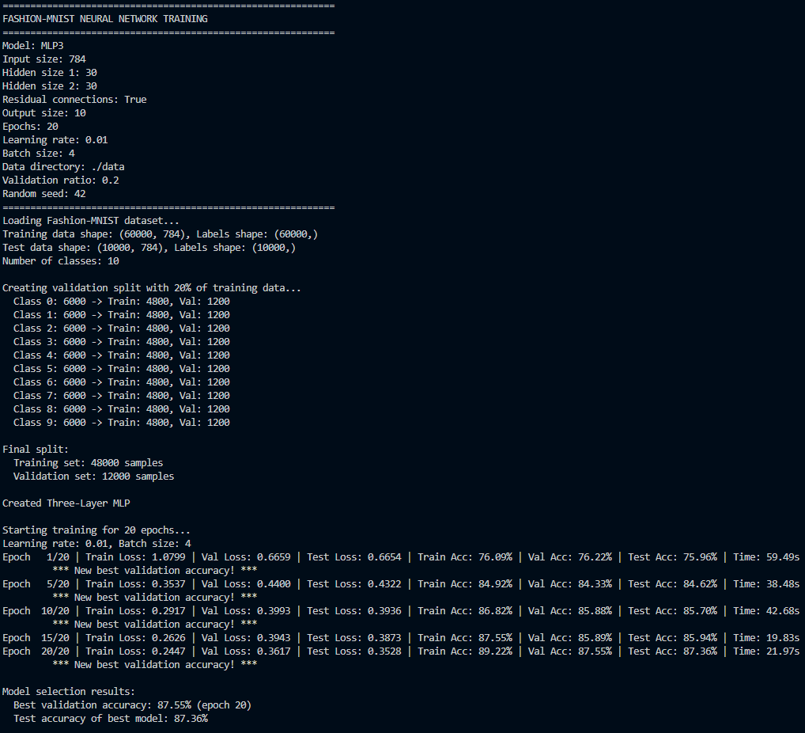
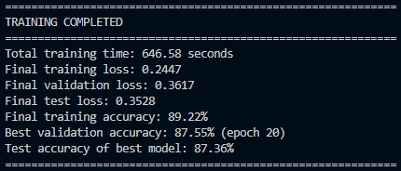

Figure 20: MLP3 residual, batch_size=8, full dataset – 86.56%
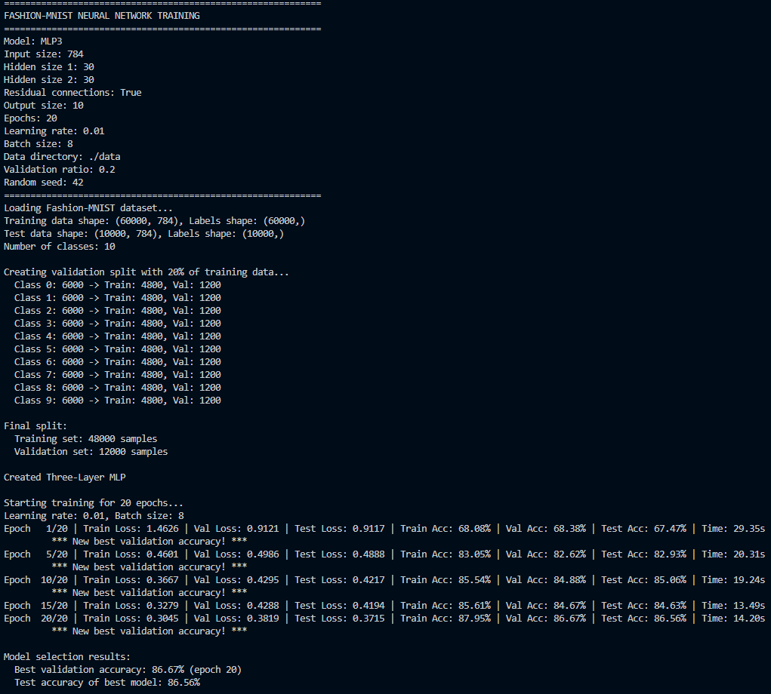
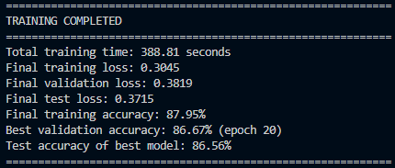
Figure 21: MLP3 residual, batch_size=16, full dataset – 85.63%
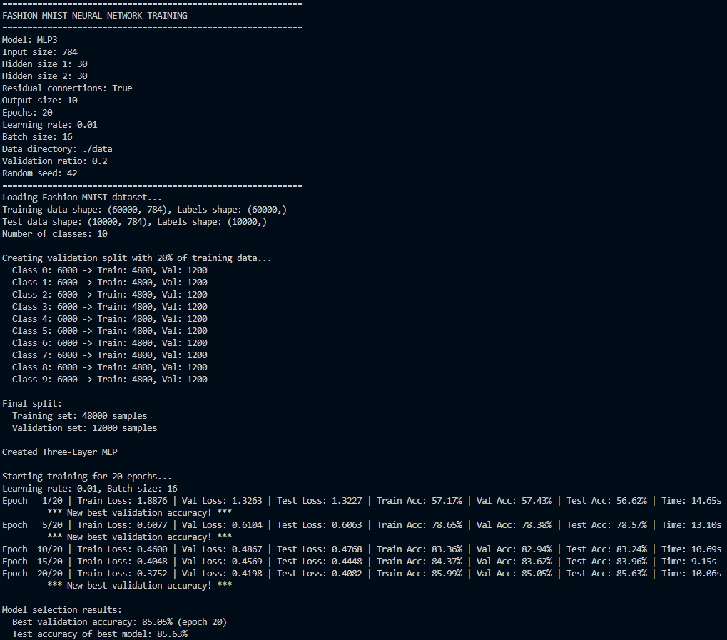
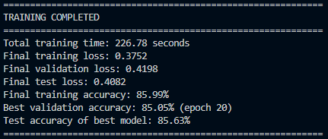

Graph 3: Graph 3: Effect of mini-batch size (1, 4, 8, 16) on the three-layer MLP with residual connection (784-30-30-10) trained on the full dataset: test accuracy (left) and total training time (right)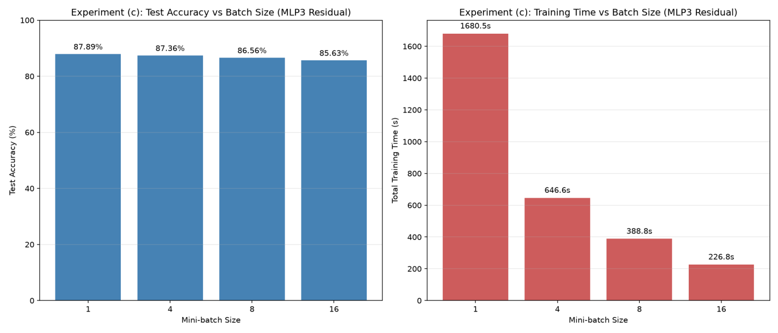

Analysis and Discussion

The baseline results in Table A show accuracy rising with both depth and the residual connection, from 85.45% (linear) to 86.95% (MLP) to 87.36% (MLP3 residual) on the full dataset, making the residual network the strongest overall as shown in Graph 1. That advantage becomes dramatic rather than marginal as training data shrinks: on the 10% pruned set, the non-residual three-layer MLP collapses to 10.00% test accuracy (random chance on a 10-class problem, see Figure 9), while the residual version still reaches 80.83%. This is direct evidence of vanishing gradients through two stacked sigmoid layers. With few samples and few updates, the ordinary back propagation path through the second sigmoid effectively dies out, and only the residual skip connection, which bypasses that sigmoid’s derivative entirely, keeps a usable gradient reaching the first layer’s weights. The same shrinkage explains the broader dataset size trend: fewer samples per class means fewer parameter updates and higher variance in the learned weights, so every model’s accuracy falls from the full to the 50% to the 10% set, but the drop is mild for the shallower models and catastrophic for the non-residual three-layer network, whose vanishing gradient weakness compounds with the small data effect.

The learning rate results in Table B match standard gradient descent step size theory. As shown in Table B and Graph 2, LR = 0.001 is stable but under converges within 20 epochs (82.49%); LR = 0.01 is the best tuned rate (87.36%); LR = 1.0 remains stable but still under converges (82.81%), showing a step size can be too large for precise convergence without diverging outright; and LR = 10 and LR= 100 fail completely, with LR = 100’s loss overflowing to NaN from the very first epoch as softmax probabilities collapsed to exactly 0 and gradients grew unbounded. The mini-batch results in Table C reflect as shown in Table C and Graph 3, batch size 1 performs the most updates per epoch (48,000, one per sample) using the noisiest individual gradient estimates, while batch size 16 performs the fewest (3,000) using the smoothest; accuracy falls monotonically as batch size increases (87.89% $→$ 87.36% $→$ 86.56% $→$ 85.63%), while training time falls just as uniformly in the opposite direction (1680.50s $→$ 646.58s $→$ 388.81s $→$ 226.78s). This is consistent with noisier, more frequent updates acting as a mild regulariser that helps the model generalize slightly better, at the direct cost of roughly 7.4x more time between batch size 16 and batch size 1 for well under a 3-percentage-point accuracy gain, a clear diminishing returns trade-off between accuracy and training efficiency.

Conclusion

Across all three experiments, the strongest performing configuration overall was the three-layer MLP with a residual connection, trained with a learning rate of 0.01 and a batch size of 1 on the full training dataset, reaching the highest test accuracy recorded in this report, 87.89%. The baseline experiment showed that both depth and the residual connection improve accuracy, with the residual connection’s benefit growing from marginal to decisive as training data shrank, protecting the three-layer network from the complete training failure (10.00% accuracy) suffered by its own non-residual counterpart on the 10% pruned dataset. The learning rate experiment confirmed 0.01 as the best tuned rate among those tested, sitting between a rate too small to fully converge within 20 epochs (0.001) and rates large enough to destabilize or entirely prevent training (10 and 100), while LR = 1.0 showed that even a stable, non-diverging rate can still under converge relative to a well tuned one. The batch-size experiment showed accuracy and training time trading off directly against each other. Batch size 1 gave the best accuracy but roughly took 7.4 times as long to train as batch size 16, which was fastest but least accurate. Taken together, these results point to the residual three-layer architecture with a learning rate of 0.01 as the clear best architecture / hyperparameter choice, with batch size representing a genuine accuracy versus time trade-off rather than a single unambiguous winner. Batch size 1 for maximum accuracy, or batch size 4 as a reasonable middle ground given it retains 87.36% accuracy (within 0.53 points of the best result) at roughly 40% of batch size 1’s training time.

Appendix

nn.py source code
import numpy as np
import autograd.numpy as anp
from autograd import grad

class LinearClassifier:
"""
Linear classifier: y = Wx + b
Network structure: [784, 10]
"""
def __init__(self, n_input, n_output):
"""
Initialize linear classifier parameters
Args:
n_input: Number of input features (784 for Fashion-MNIST)
n_output: Number of output classes (10 for Fashion-MNIST)
"""
self.n_input = n_input
self.n_output = n_output

# Initialize weights and biases with small random values
self.W = np.random.randn(n_input, n_output) * 0.01
self.b = np.zeros(n_output)

def forward(self, X):
"""
Forward pass: compute predictions
Args:
X: Input data of shape (batch_size, n_input)
Returns:
Output logits of shape (batch_size, n_output)
"""
# TODO: Implement linear transformation y = Wx + b
#
# This is a linear classifier that maps input features directly to output logits.
# You need to:
# 1. Multiply input X with weight matrix W: X @ W
# - X has shape (batch_size, n_input)
# - W has shape (n_input, n_output)
# - Result has shape (batch_size, n_output)
# 2. Add bias term b to each sample
# - b has shape (n_output,)
# - Broadcasting will handle adding bias to each batch sample
#
# Mathematical formula: output = X @ W + b
# Where @ is matrix multiplication
#
# Example:
# If X is [batch_size=2, n_input=784] and W is [784, 10], b is [10]
# Then X @ W gives [2, 10] and adding b gives final [2, 10]

output = X @ self.W + self.b
return output

def sigmoid(self, z):
"""Sigmoid activation function"""
return 1 / (1 + anp.exp(-z))

def softmax(self, z):
"""Softmax activation function"""
exp_z = anp.exp(z)
return exp_z / anp.sum(exp_z, axis=1, keepdims=True)

def predict(self, X):
"""
Make predictions using the model
Args:
X: Input data of shape (batch_size, n_input)
Returns:
Predicted class labels
"""
logits = self.forward(X)
probs = self.softmax(logits)
return np.argmax(probs, axis=1)

def get_params(self):
"""Get model parameters as a flat array"""
return np.concatenate([self.W.flatten(), self.b.flatten()])

def set_params(self, params):
"""Set model parameters from a flat array"""
W_size = self.n_input * self.n_output
self.W = params[:W_size].reshape(self.n_input, self.n_output)
self.b = params[W_size:]

class TwoLayerMLP:
"""
Two-layer Multi-Layer Perceptron with one hidden layer
Network structure: [784, 30, 10]
"""
def __init__(self, n_input, n_hidden, n_output):
"""
Initialize MLP parameters
Args:
n_input: Number of input features (784)
n_hidden: Number of hidden units (30)
n_output: Number of output classes (10)
"""
self.n_input = n_input
self.n_hidden = n_hidden
self.n_output = n_output

# Initialize weights and biases for both layers
# First layer: input to hidden
self.W1 = np.random.randn(n_input, n_hidden) * 0.01
self.b1 = np.zeros(n_hidden)

# Second layer: hidden to output
self.W2 = np.random.randn(n_hidden, n_output) * 0.01
self.b2 = np.zeros(n_output)

def sigmoid(self, z):
"""Sigmoid activation function"""
return 1 / (1 + anp.exp(-z))

def softmax(self, z):
"""Softmax activation function"""
exp_z = anp.exp(z)
return exp_z / anp.sum(exp_z, axis=1, keepdims=True)

def forward(self, X):
"""
Forward pass through the network
Args:
X: Input data of shape (batch_size, n_input)
Returns:
Output logits of shape (batch_size, n_output)
"""
# TODO: Implement the forward pass for a two-layer neural network
#
# This network has the structure: Input -> Hidden Layer -> Output Layer
# Network topology: [784] -> [30] -> [10] (for Fashion-MNIST)

# First layer: linear transformation + sigmoid activation
# TODO: Implement z1 = X @ W1 + b1, then h1 = sigmoid(z1)
#
# Step-by-step:
# 1. Linear transformation: z1 = X @ W1 + b1
# - X has shape (batch_size, n_input) = (batch_size, 784)
# - W1 has shape (n_input, n_hidden) = (784, 30)
# - b1 has shape (n_hidden,) = (30,)
# - z1 will have shape (batch_size, n_hidden) = (batch_size, 30)
# 2. Apply sigmoid activation: h1 = sigmoid(z1)
# - h1 is the output of the hidden layer, same shape as z1
#
# Variables to define:
# z1 = ... # Linear transformation result
# h1 = ... # Activated hidden layer output

# Second layer: linear transformation (no activation for output logits)
# TODO: Implement z2 = h1 @ W2 + b2
#
# Step-by-step:
# 1. Linear transformation: z2 = h1 @ W2 + b2
# - h1 has shape (batch_size, n_hidden) = (batch_size, 30)
# - W2 has shape (n_hidden, n_output) = (30, 10)
# - b2 has shape (n_output,) = (10,)
# - z2 will have shape (batch_size, n_output) = (batch_size, 10)
# 2. z2 represents the final logits (no activation applied here)
# - Sigmoid activation will be applied later in predict() or loss function
#
# Variable to define:
# z2 = ... # Final output logits

z1 = X @ self.W1 + self.b1
h1 = self.sigmoid(z1)

z2 = h1 @ self.W2 + self.b2
return z2

def predict(self, X):
"""
Make predictions using the model
Args:
X: Input data of shape (batch_size, n_input)
Returns:
Predicted class labels
"""
logits = self.forward(X)
probs = self.softmax(logits)
return np.argmax(probs, axis=1)

def get_params(self):
"""Get model parameters as a flat array"""
# TODO: Concatenate all model parameters into a single flat array
#
# This function is needed for automatic differentiation (autograd).
# The grad() function requires all parameters to be in a single array.
#
# You need to flatten and concatenate ALL parameters in the correct order:
# 1. W1: weight matrix of first layer (shape: n_input × n_hidden)
# 2. b1: bias vector of first layer (shape: n_hidden)
# 3. W2: weight matrix of second layer (shape: n_hidden × n_output)
# 4. b2: bias vector of second layer (shape: n_output)

return np.concatenate([
self.W1.flatten(),
self.b1.flatten(),
self.W2.flatten(),
self.b2.flatten(),
])

def set_params(self, params):
"""Set model parameters from a flat array"""
W1_size = self.n_input * self.n_hidden
b1_size = self.n_hidden
W2_size = self.n_hidden * self.n_output
b2_size = self.n_output

idx = 0
self.W1 = params[idx:idx + W1_size].reshape(self.n_input, self.n_hidden)
idx += W1_size

self.b1 = params[idx:idx + b1_size]
idx += b1_size

self.W2 = params[idx:idx + W2_size].reshape(self.n_hidden, self.n_output)
idx += W2_size

self.b2 = params[idx:idx + b2_size]

class ThreeLayerMLP:
"""
Three-layer Multi-Layer Perceptron with two hidden layers
Network structure: [784, 30, 30, 10] (default)
"""
def __init__(self, n_input, n_hidden1, n_hidden2, n_output, use_residual=False):
"""
Initialize MLP parameters
Args:
n_input: Number of input features (784)
n_hidden1: Number of first hidden layer units (30)
n_hidden2: Number of second hidden layer units (30)
n_output: Number of output classes (10)
use_residual: Whether to use residual connections
"""
self.n_input = n_input
self.n_hidden1 = n_hidden1
self.n_hidden2 = n_hidden2
self.n_output = n_output
self.use_residual = use_residual

# Check if residual connection is possible (hidden layers must have same size)
if use_residual and n_hidden1 != n_hidden2:
raise ValueError("For residual connections, hidden layers must have the same size")

# Initialize weights and biases for all three layers
# First layer: input to hidden1
self.W1 = np.random.randn(n_input, n_hidden1) * 0.01
self.b1 = np.zeros(n_hidden1)

# Second layer: hidden1 to hidden2
self.W2 = np.random.randn(n_hidden1, n_hidden2) * 0.01
self.b2 = np.zeros(n_hidden2)

# Third layer: hidden2 to output
self.W3 = np.random.randn(n_hidden2, n_output) * 0.01
self.b3 = np.zeros(n_output)

def sigmoid(self, z):
"""Sigmoid activation function"""
return 1 / (1 + anp.exp(-z))

def softmax(self, z):
"""Softmax activation function"""
exp_z = anp.exp(z)
return exp_z / anp.sum(exp_z, axis=1, keepdims=True)

def forward(self, X):
"""
Forward pass through the network
Args:
X: Input data of shape (batch_size, n_input)
Returns:
Output logits of shape (batch_size, n_output)
"""
# TODO: Implement the forward pass for a three-layer neural network
#
# This network has the structure: Input -> Hidden1 -> Hidden2 -> Output
# Network topology: [784] -> [30] -> [30] -> [10] (for Fashion-MNIST)
# With optional residual connections between hidden layers

# First layer: linear transformation + sigmoid activation
# TODO: Implement z1 = X @ W1 + b1, then h1 = sigmoid(z1)
#
# Step-by-step:
# 1. Linear transformation: z1 = X @ W1 + b1
# - X has shape (batch_size, n_input) = (batch_size, 784)
# - W1 has shape (n_input, n_hidden1) = (784, 30)
# - b1 has shape (n_hidden1,) = (30,)
# - z1 will have shape (batch_size, n_hidden1) = (batch_size, 30)
# 2. Apply sigmoid activation: h1 = sigmoid(z1)

z1 = X @ self.W1 + self.b1
h1 = self.sigmoid(z1)

# Second layer: linear transformation + sigmoid activation
# TODO: Implement z2 = h1 @ W2 + b2, then h2_raw = sigmoid(z2)
#
# Step-by-step:
# 1. Linear transformation: z2 = h1 @ W2 + b2
# - h1 has shape (batch_size, n_hidden1) = (batch_size, 30)
# - W2 has shape (n_hidden1, n_hidden2) = (30, 30)
# - b2 has shape (n_hidden2,) = (30,)
# - z2 will have shape (batch_size, n_hidden2) = (batch_size, 30)
# 2. Apply sigmoid activation: h2_raw = sigmoid(z2)

z2 = h1 @ self.W2 + self.b2
h2_raw = self.sigmoid(z2)

# Apply residual connection if enabled
# TODO: Implement residual connection logic
#
# Residual connections help with gradient flow in deep networks.
# The idea is to add the input of a layer to its output: h2 = h2_raw + h1
# This requires h1 and h2_raw to have the same shape (n_hidden1 == n_hidden2)
#
# If residual connections are enabled (self.use_residual == True):
# h2 = h2_raw + h1 # Add skip connection from previous layer
# Else:
# h2 = h2_raw # Use normal activation without skip connection

if self.use_residual:
h2 = h2_raw + h1 # Residual connection: add previous layer output
else:
h2 = h2_raw

# Third layer: linear transformation (output layer)
# TODO: Implement z3 = h2 @ W3 + b3

z3 = h2 @ self.W3 + self.b3

return z3

def predict(self, X):
"""
Make predictions using the model
Args:
X: Input data of shape (batch_size, n_input)
Returns:
Predicted class labels
"""
logits = self.forward(X)
probs = self.softmax(logits)
return np.argmax(probs, axis=1)

def get_params(self):
"""Get model parameters as a flat array"""
# TODO: Concatenate all model parameters into a single flat array
#
# This function is needed for automatic differentiation (autograd).
# The grad() function requires all parameters to be in a single array.

return np.concatenate([
self.W1.flatten(),
self.b1.flatten(),
self.W2.flatten(),
self.b2.flatten(),
self.W3.flatten(),
self.b3.flatten(),
])

def set_params(self, params):
"""Set model parameters from a flat array"""
W1_size = self.n_input * self.n_hidden1
b1_size = self.n_hidden1
W2_size = self.n_hidden1 * self.n_hidden2
b2_size = self.n_hidden2
W3_size = self.n_hidden2 * self.n_output
b3_size = self.n_output

idx = 0
self.W1 = params[idx:idx + W1_size].reshape(self.n_input, self.n_hidden1)
idx += W1_size

self.b1 = params[idx:idx + b1_size]
idx += b1_size

self.W2 = params[idx:idx + W2_size].reshape(self.n_hidden1, self.n_hidden2)
idx += W2_size

self.b2 = params[idx:idx + b2_size]
idx += b2_size

self.W3 = params[idx:idx + W3_size].reshape(self.n_hidden2, self.n_output)
idx += W3_size

self.b3 = params[idx:idx + b3_size]

train.py source code
import numpy as np
import gzip
import argparse
import matplotlib.pyplot as plt
import autograd.numpy as anp
from autograd import grad
import time
import os
import copy

from nn import LinearClassifier, TwoLayerMLP, ThreeLayerMLP

def create_validation_split(X_train, y_train, val_ratio=0.2, random_seed=42):
"""
Create validation set by randomly selecting samples from each class
Args:
X_train: Training features
y_train: Training labels
val_ratio: Fraction of training data to use for validation
random_seed: Random seed for reproducibility
Returns:
Tuple of (X_train_new, y_train_new, X_val, y_val)
"""
np.random.seed(random_seed)

print(f"\nCreating validation split with {val_ratio*100:.0f}% of training data...")

# Get unique classes
unique_classes = np.unique(y_train)

# Store indices for train and validation sets
train_indices = []
val_indices = []

for class_id in unique_classes:
# Get indices for this class
class_indices = np.where(y_train == class_id)[0]

# Calculate validation size for this class
class_size = len(class_indices)
val_size = int(class_size * val_ratio)
train_size = class_size - val_size

# Randomly split the class indices
np.random.shuffle(class_indices)
val_class_indices = class_indices[:val_size]
train_class_indices = class_indices[val_size:]

train_indices.extend(train_class_indices)
val_indices.extend(val_class_indices)

print(f" Class {class_id}: {class_size} -> Train: {train_size}, Val: {val_size}")

# Convert to numpy arrays and sort
train_indices = np.sort(np.array(train_indices))
val_indices = np.sort(np.array(val_indices))

# Split the data
X_train_new = X_train[train_indices]
y_train_new = y_train[train_indices]
X_val = X_train[val_indices]
y_val = y_train[val_indices]

print(f"\nFinal split:")
print(f" Training set: {X_train_new.shape[0]} samples")
print(f" Validation set: {X_val.shape[0]} samples")

return X_train_new, y_train_new, X_val, y_val

def load_fashion_mnist_data(train_file, test_file):
"""
Load Fashion-MNIST dataset from compressed CSV files
Args:
train_file: Path to training data file
test_file: Path to test data file
Returns:
Tuple of (X_train, y_train, X_test, y_test)
"""
print("Loading Fashion-MNIST dataset...")

# Load training data
with gzip.open(train_file, 'rt') as f:
train_data = np.loadtxt(f, delimiter=',', skiprows=1)

# Load test data
with gzip.open(test_file, 'rt') as f:
test_data = np.loadtxt(f, delimiter=',', skiprows=1)

# Extract features and labels
# First column is label, rest are pixel values
X_train = train_data[:, 1:].astype(np.float32)
y_train = train_data[:, 0].astype(np.int32)

X_test = test_data[:, 1:].astype(np.float32)
y_test = test_data[:, 0].astype(np.int32)

# Normalize pixel values to [0, 1]
X_train = X_train / 255.0
X_test = X_test / 255.0

print(f"Training data shape: {X_train.shape}, Labels shape: {y_train.shape}")
print(f"Test data shape: {X_test.shape}, Labels shape: {y_test.shape}")
print(f"Number of classes: {len(np.unique(y_train))}")
return X_train, y_train, X_test, y_test

def one_hot_encode(labels, num_classes):
"""
Convert labels to one-hot encoding
Args:
labels: Array of integer labels
num_classes: Number of classes
Returns:
One-hot encoded labels
"""
one_hot = np.zeros((len(labels), num_classes))
one_hot[np.arange(len(labels)), labels] = 1
return one_hot

def softmax(z):
"""Softmax activation function"""
exp_z = anp.exp(z)
return exp_z / anp.sum(exp_z, axis=1, keepdims=True)

def cross_entropy_loss(y_pred, y_true):
"""
Compute cross-entropy loss with softmax
Args:
y_pred: Predicted logits of shape (batch_size, num_classes)
y_true: True one-hot encoded labels of shape (batch_size, num_classes)
Returns:
Average cross-entropy loss
"""
# Apply softmax to get probabilities
probs = softmax(y_pred)

# TODO: Compute cross-entropy loss with softmax
#
# Cross-entropy loss measures the difference between predicted probabilities
# and true labels. It's commonly used for classification problems.
#
# Mathematical formula:
# loss = -mean(sum(y_true * log(probs), axis=1))
#
# Steps:
# 1. Apply softmax to convert logits to probabilities: probs = softmax(y_pred)
# 2. Compute element-wise: y_true * log(probs)
# - Use anp.log() for autograd compatibility
# 3. Sum across classes for each sample
# 4. Apply negative sign and take mean
#
# Example:
# If y_true = [[0, 1, 0], [1, 0, 0]] and probs = [[0.1, 0.8, 0.1], [0.9, 0.05, 0.05]]
# Then loss = -mean([log(0.8), log(0.9)]) = -mean([-0.223, -0.105]) = 0.164

loss = -anp.mean(anp.sum(y_true * anp.log(probs), axis=1))

return loss

def create_batches(X, y, batch_size, shuffle=True):
"""
Create mini-batches for training
Args:
X: Input features
y: Labels
batch_size: Size of each batch
shuffle: Whether to shuffle the data
Returns:
Generator yielding batches of (X_batch, y_batch)
"""
n_samples = X.shape[0]
indices = np.arange(n_samples)

if shuffle:
np.random.shuffle(indices)

for start_idx in range(0, n_samples, batch_size):
end_idx = min(start_idx + batch_size, n_samples)
batch_indices = indices[start_idx:end_idx]
yield X[batch_indices], y[batch_indices]

def compute_accuracy(model, X, y):
"""
Compute accuracy of the model
Args:
model: Trained model
X: Input features
y: True labels
Returns:
Accuracy as a percentage
"""
predictions = model.predict(X)
accuracy = np.mean(predictions == y) * 100
return accuracy

def train_model(model, X_train, y_train, X_val, y_val, X_test, y_test, epochs, learning_rate, batch_size):
"""
Train the model using gradient descent with validation-based model selection
Args:
model: Model to train
X_train, y_train: Training data
X_val, y_val: Validation data for model selection
X_test, y_test: Test data for final evaluation
epochs: Number of training epochs
learning_rate: Learning rate for gradient descent
batch_size: Batch size for mini-batch gradient descent
Returns:
Tuple of (best_model, training_history, best_test_accuracy)
"""
print(f"\nStarting training for {epochs} epochs...")
print(f"Learning rate: {learning_rate}, Batch size: {batch_size}")

# Convert labels to one-hot encoding
num_classes = len(np.unique(y_train))
y_train_one_hot = one_hot_encode(y_train, num_classes)
y_val_one_hot = one_hot_encode(y_val, num_classes)
y_test_one_hot = one_hot_encode(y_test, num_classes)

# Training history
train_losses = []
val_losses = []
test_losses = []
train_accuracies = []
val_accuracies = []
test_accuracies = []

# Model selection variables
best_val_accuracy = 0.0
best_model_params = None
best_epoch = 0

# Training loop
for epoch in range(epochs):
epoch_start_time = time.time()
epoch_loss = 0.0
num_batches = 0

# Mini-batch gradient descent
for X_batch, y_batch in create_batches(X_train, y_train, batch_size):
y_batch_one_hot = one_hot_encode(y_batch, num_classes)

# Define loss function for this batch
def batch_loss_fn(params):
model.set_params(params)
logits = model.forward(X_batch)
return cross_entropy_loss(logits, y_batch_one_hot)

# Get current parameters
params = model.get_params()

# Compute gradients
grad_fn_batch = grad(batch_loss_fn)
gradients = grad_fn_batch(params)

# TODO: Update parameters using gradient descent
#
# Gradient descent updates parameters by moving in the opposite direction
# of the gradient (steepest descent). This minimizes the loss function.
#
# Steps:
# 1. Multiply gradients by learning rate: learning_rate * gradients
# 2. Subtract from current parameters: params - (learning_rate * gradients)
# 3. Store result in new_params variable
#
# Note: 'learning_rate' is passed as a parameter to this function

new_params = params - (learning_rate * gradients)

model.set_params(new_params)

# Compute loss for recording with updated parameters
logits = model.forward(X_batch)
batch_loss = cross_entropy_loss(logits, y_batch_one_hot)
epoch_loss += batch_loss
num_batches += 1

# Average loss for the epoch
avg_epoch_loss = epoch_loss / num_batches
train_losses.append(avg_epoch_loss)

# Compute validation loss
val_logits = model.forward(X_val)
val_loss = cross_entropy_loss(val_logits, y_val_one_hot)
val_losses.append(val_loss)

# Compute test loss
test_logits = model.forward(X_test)
test_loss = cross_entropy_loss(test_logits, y_test_one_hot)
test_losses.append(test_loss)

# Compute accuracies
train_acc = compute_accuracy(model, X_train, y_train)
val_acc = compute_accuracy(model, X_val, y_val)
test_acc = compute_accuracy(model, X_test, y_test)
train_accuracies.append(train_acc)
val_accuracies.append(val_acc)
test_accuracies.append(test_acc)

# Model selection based on validation accuracy
if val_acc > best_val_accuracy:
best_val_accuracy = val_acc
best_model_params = copy.deepcopy(model.get_params())
best_epoch = epoch

epoch_time = time.time() - epoch_start_time

# Print progress
if (epoch + 1) % 5 == 0 or epoch == 0:
print(f"Epoch {epoch+1:3d}/{epochs} | "
f"Train Loss: {avg_epoch_loss:.4f} | Val Loss: {val_loss:.4f} | Test Loss: {test_loss:.4f} | "
f"Train Acc: {train_acc:.2f}% | Val Acc: {val_acc:.2f}% | Test Acc: {test_acc:.2f}% | "
f"Time: {epoch_time:.2f}s")
if val_acc == best_val_accuracy:
print(f" *** New best validation accuracy! ***")

# Load best model parameters
model.set_params(best_model_params)
best_test_accuracy = compute_accuracy(model, X_test, y_test)

print(f"\nModel selection results:")
print(f" Best validation accuracy: {best_val_accuracy:.2f}% (epoch {best_epoch+1})")
print(f" Test accuracy of best model: {best_test_accuracy:.2f}%")

# Training history dictionary
training_history = {
'train_losses': train_losses,
'val_losses': val_losses,
'test_losses': test_losses,
'train_accuracies': train_accuracies,
'val_accuracies': val_accuracies,
'test_accuracies': test_accuracies,
'best_epoch': best_epoch,
'best_val_accuracy': best_val_accuracy
}

return model, training_history, best_test_accuracy

def plot_training_history(train_losses, val_losses, test_losses, train_accuracies, val_accuracies, test_accuracies, model_name, best_epoch=None):
"""
Plot training history including validation curves
Args:
train_losses, val_losses, test_losses: Loss values over epochs
train_accuracies, val_accuracies, test_accuracies: Accuracy values over epochs
model_name: Name of the model for plot title
best_epoch: Epoch with best validation performance (optional)
"""
plt.figure(figsize=(15, 5))

# Plot losses
plt.subplot(1, 3, 1)
plt.plot(train_losses, label='Training Loss', color='blue', linewidth=2)
plt.plot(val_losses, label='Validation Loss', color='green', linewidth=2)
plt.plot(test_losses, label='Test Loss', color='red', linewidth=2)
if best_epoch is not None:
plt.axvline(x=best_epoch, color='black', linestyle='--', alpha=0.7, label=f'Best Val (Epoch {best_epoch+1})')
plt.title(f'{model_name} - Loss')
plt.xlabel('Epoch')
plt.ylabel('Loss')
plt.legend()
plt.grid(True, alpha=0.3)

# Plot accuracies
plt.subplot(1, 3, 2)
plt.plot(train_accuracies, label='Training Accuracy', color='blue', linewidth=2)
plt.plot(val_accuracies, label='Validation Accuracy', color='green', linewidth=2)
plt.plot(test_accuracies, label='Test Accuracy', color='red', linewidth=2)
if best_epoch is not None:
plt.axvline(x=best_epoch, color='black', linestyle='--', alpha=0.7, label=f'Best Val (Epoch {best_epoch+1})')
plt.title(f'{model_name} - Accuracy')
plt.xlabel('Epoch')
plt.ylabel('Accuracy (%)')
plt.legend()
plt.grid(True, alpha=0.3)

# Plot validation vs test accuracy comparison
plt.subplot(1, 3, 3)
plt.plot(val_accuracies, label='Validation Accuracy', color='green', linewidth=2)
plt.plot(test_accuracies, label='Test Accuracy', color='red', linewidth=2)
if best_epoch is not None:
plt.axvline(x=best_epoch, color='black', linestyle='--', alpha=0.7, label=f'Best Val (Epoch {best_epoch+1})')
plt.plot(best_epoch, val_accuracies[best_epoch], 'go', markersize=8, label=f'Selected Model')
plt.title(f'{model_name} - Val vs Test Accuracy')
plt.xlabel('Epoch')
plt.ylabel('Accuracy (%)')
plt.legend()
plt.grid(True, alpha=0.3)

plt.tight_layout()
plt.savefig(f'{model_name.lower().replace(" ", "_")}_training_history.png', dpi=150, bbox_inches='tight')
plt.show()

def main():
"""Main training function"""
parser = argparse.ArgumentParser(description='Train neural networks on Fashion-MNIST')
parser.add_argument('--model', type=str, required=True,
choices=['linear', 'mlp', 'mlp3'],
help='Model type: linear, mlp (2-layer), or mlp3 (3-layer)')
parser.add_argument('--ninput', type=int, default=784,
help='Number of input features (default: 784)')
parser.add_argument('--nhidden', type=int, default=30,
help='Number of hidden units for MLP (default: 30)')
parser.add_argument('--nhidden2', type=int, default=30,
help='Number of second hidden layer units for 3-layer MLP (default: 30)')
parser.add_argument('--noutput', type=int, default=10,
help='Number of output classes (default: 10)')
parser.add_argument('--residual', action='store_true',
help='Use residual connections for 3-layer MLP')
parser.add_argument('--epochs', type=int, default=20,
help='Number of training epochs (default: 20)')
parser.add_argument('--lr', type=float, default=0.01,
help='Learning rate (default: 0.01)')
parser.add_argument('--batch_size', type=int, default=4,
help='Batch size (default: 4)')
parser.add_argument('--train_file', type=str, default='fashion-mnist_train.csv.gz',
help='Path to training data file')
parser.add_argument('--test_file', type=str, default='fashion-mnist_test.csv.gz',
help='Path to test data file')
parser.add_argument('--data_dir', type=str, default='./data',
help='Directory containing the data files (default: current directory)')
parser.add_argument('--val_ratio', type=float, default=0.2,
help='Fraction of training data to use for validation (default: 0.2)')
parser.add_argument('--plot', action='store_true',
help='Whether to plot training history figures')
parser.add_argument('--seed', type=int, default=42,
help='Random seed for reproducibility (default: 42)')

args = parser.parse_args()

# Print configuration
print("="*60)
print("FASHION-MNIST NEURAL NETWORK TRAINING")
print("="*60)
print(f"Model: {args.model.upper()}")
print(f"Input size: {args.ninput}")
if args.model in ['mlp', 'mlp3']:
print(f"Hidden size 1: {args.nhidden}")
if args.model == 'mlp3':
print(f"Hidden size 2: {args.nhidden2}")
print(f"Residual connections: {args.residual}")
print(f"Output size: {args.noutput}")
print(f"Epochs: {args.epochs}")
print(f"Learning rate: {args.lr}")
print(f"Batch size: {args.batch_size}")
print(f"Data directory: {args.data_dir}")
print(f"Validation ratio: {args.val_ratio}")
print(f"Random seed: {args.seed}")
print("="*60)

# Load data with full paths
train_file_path = os.path.join(args.data_dir, args.train_file)
test_file_path = os.path.join(args.data_dir, args.test_file)
X_train_full, y_train_full, X_test, y_test = load_fashion_mnist_data(train_file_path, test_file_path)

# Create validation split
X_train, y_train, X_val, y_val = create_validation_split(
X_train_full, y_train_full, args.val_ratio, args.seed
)

# Create model based on type
if args.model == 'linear':
model = LinearClassifier(args.ninput, args.noutput)
model_name = "Linear Classifier"
elif args.model == 'mlp':
model = TwoLayerMLP(args.ninput, args.nhidden, args.noutput)
model_name = "Two-Layer MLP"
elif args.model == 'mlp3':
model = ThreeLayerMLP(args.ninput, args.nhidden, args.nhidden2, args.noutput, args.residual)
model_name = "Three-Layer MLP"

print(f"\nCreated {model_name}")

# Train the model
start_time = time.time()
model, training_history, best_test_accuracy = train_model(
model, X_train, y_train, X_val, y_val, X_test, y_test,
args.epochs, args.lr, args.batch_size
)
training_time = time.time() - start_time

# Final evaluation
print("\n" + "="*60)
print("TRAINING COMPLETED")
print("="*60)
print(f"Total training time: {training_time:.2f} seconds")
print(f"Final training loss: {training_history['train_losses'][-1]:.4f}")
print(f"Final validation loss: {training_history['val_losses'][-1]:.4f}")
print(f"Final test loss: {training_history['test_losses'][-1]:.4f}")
print(f"Final training accuracy: {training_history['train_accuracies'][-1]:.2f}%")
print(f"Best validation accuracy: {training_history['best_val_accuracy']:.2f}% (epoch {training_history['best_epoch']+1})")
print(f"Test accuracy of best model: {best_test_accuracy:.2f}%")

# Plot training history
if args.plot:
plot_training_history(
training_history['train_losses'], training_history['val_losses'], training_history['test_losses'],
training_history['train_accuracies'], training_history['val_accuracies'], training_history['test_accuracies'],
model_name, training_history['best_epoch']
)
plt.savefig(f"{model_name.lower().replace(' ', '_')}_training_history.png")
plt.close()

print(f"\nTraining history plot saved as '{model_name.lower().replace(' ', '_')}_training_history.png'")

print("="*60)

if __name__ == "__main__":
main()

