**AFK Video Load Remover Guide**

**Running the Program**

* Right click the Windows button and open Command Prompt

* If it opens up inside your C drive, switch drives by inputting ‘D:’ if it is on your D drive
* Navigate to the installation folder by inputting: cd *installationPath*
  + Example: cd D:\Programs\AFKVideoLoadRemover
* Run the program by inputting: AFKVideoLoadRemover.exe

**Loading the Video File**

* The load remover currently only supports 720p videos
* Use a 60fps recording if you can for the best accuracy
* You can download a run from YouTube by using [yt-dlp](https://github.com/yt-dlp/yt-dlp)
* You can also use [Stacher](https://stacher.io/) if you want a GUI. Might want to add yt-dlp to Stacher by following this guide [here](https://www.reddit.com/r/StacherIO/wiki/index/ytdlp/) if you find that downloads are slow
* Just like the other load remover, you must have the safe area on your game maxed out so that the ‘loading…’ symbol is in the correct position for the load remover
* The video must not include loads outside of the run, otherwise it will include those in the final time. The best way to trim a video is by using [lossless-cut](https://github.com/mifi/lossless-cut)

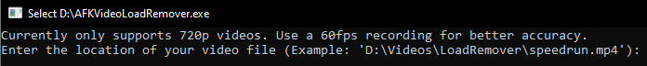

* My video file is located in: D:\Videos\LoadRemover\
* My video file is named: speedrun.mp4
* So, I will input: D:\Videos\LoadRemover\speedrun.mp4

**Unique Load Screens**

* Because of how it currently decides if a frame is a load, we have to register each unique load screen. Hopefully this can be changed in the future, but it allows it to be a lot more accurate since players can register what their load screen looks like (load screens may differ in looks from player-to-player depending on bitrate, brightness, quality)
* A HZD NG+ speedrun has 3 unique load screens:
  + The regular one
  + Entering proving
  + Exiting proving
* A HZD any% speedrun has 5:
  + Exiting ruin
  + Exiting childhood
  + The regular one
  + Entering proving
  + Exiting proving
* My speedrun.mp4 file is a HZD NG+ run, so I will input: 3

**Load Screen Timestamps**



* Load screens are registered by providing a time stamp of where each one is found in the video file
* If you tell it to look at ‘00 00 53’, it will look at the 53rd second of the video. It grabs the first frame of that second and registers that as a load screen. Make sure the beginning of the second is a load screen when choosing a timestamp
* The regular load screen can be found at 00h00m53s in my video, so I will enter: 00 00 53
* The proving entry load screen can be found at 00h04m00s in my video, so I will enter: 00 04 00
* The proving exit load screen can be found at 00h06m32s in my video, so I will enter: 00 06 32

**Debug Mode**

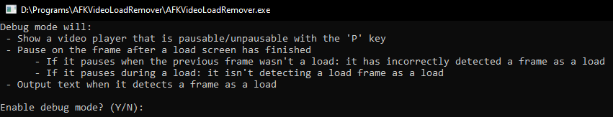

* Debug mode allows you to watch the video sped-up alongside the console to see what frames it determines as a load
* Debug mode slows down the time it takes to get our result, so I will enter: N