**Title: SuperCoolFile**

**Project/Production: [Project Name]**

**Document Number: [Document Id]**

**Version: [x]**

Table of Contents

Mermaid Test 3

Image Test 3

Grid Table 3

# Mermaid Test

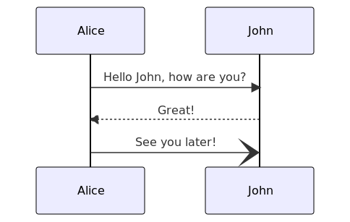

## Image Test



# Grid Table

+—————+—————+—————--+ | First Header | Second Header | Third Header | +===============+===============+=================+ | A cell that | A cell that spans multiple | | spans | columns. | | multiple rows +—————+—————--+ | | One, two cell | Red & blu2e cell| +—————+—————+—————--+ | Bananas | $1.34 | - built-in | | | | - bright color |  
+—————+—————+—————--+ | Oranges | $2.10 | - cures scurvy | | | | - tasty | +—————+—————+—————--+