**Interface Design Explanation**

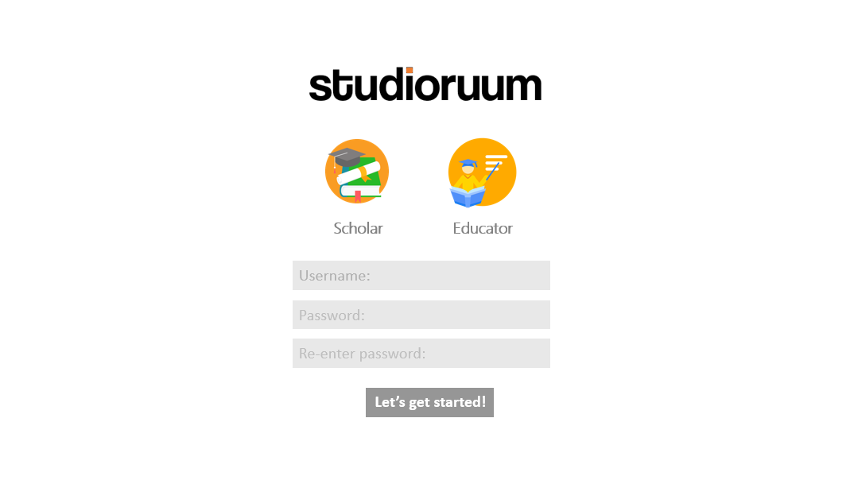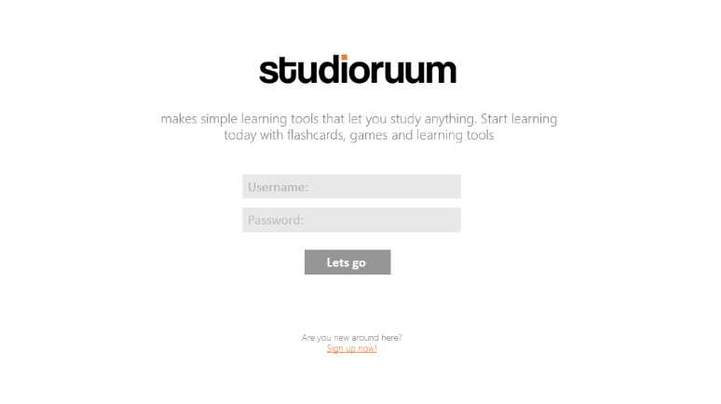In the initial design for our interface, we had to consider the form and functionality of our program. We have chosen to implement a more professional approach (whilst maintaining our accessibility) compared to the likes of competitor applications (for example Quizlet). This is denoted through our simplistic and minimalistic colour pallet (pastel) and ease of access. to We ensured to fulfil the objectives specified in the requirements whilst maintaining the theme and visual representation of our product. Our target demographic are students (age 15-25) and teachers.

User can choose their preferred account type: Scholar or Educator

Button that will take them to home page, if their account credentials are correct. Chose to used colloquial verbiage to connote accessibility, and make the program appear more user friendly.

If user is new, they can create a new account, which will lead them to the next page: create account.

Greet the user with the logo and a short sentence that explains what our program does.

**Page: 2**

**Page: 1**

Button that will take them to home page, and add the users account to the database saving there username/email, password and account type.

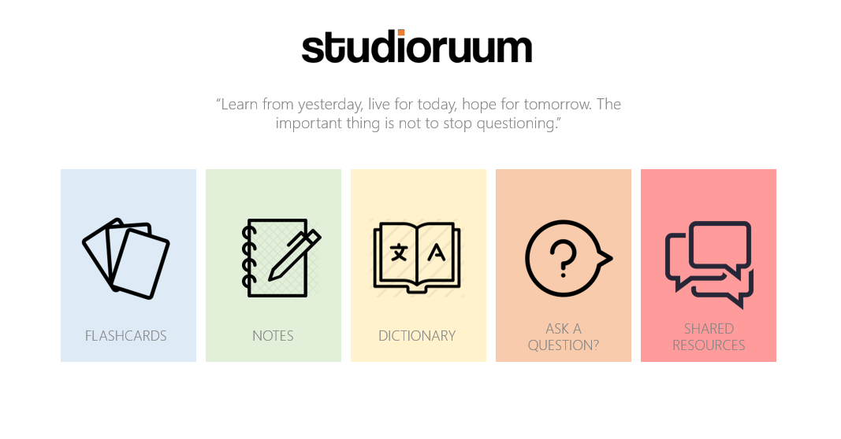

**Page: 3**

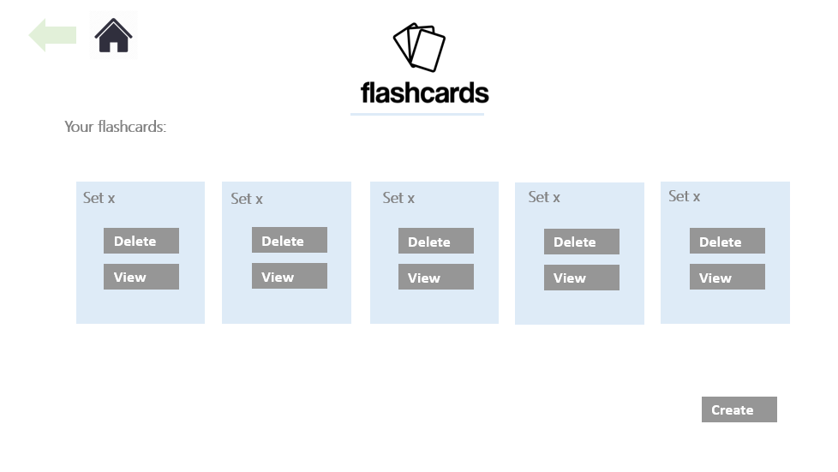

Back button used to navigate to previous page. (Can be used if the user makes a mistake)

**Page: 4**

View will take to view flash card page. (page **5**.)

Home button takes to home page

This shows the users flash card sets, and allows the user to view or delete them

This shows the users flash card sets, and allows the user to view or delete them

This indicates the page the user is on.

This will take them to the view dictionaries where they can save and delete sets of dictionaries

This will take them to the view notes where they can save and delete sets of notes

This will take them to the view flashcards where they can save and delete sets of flashcards

Short quote that used to inspire the user.

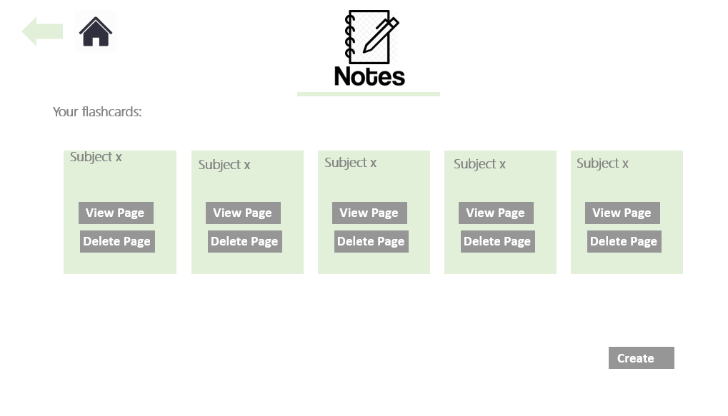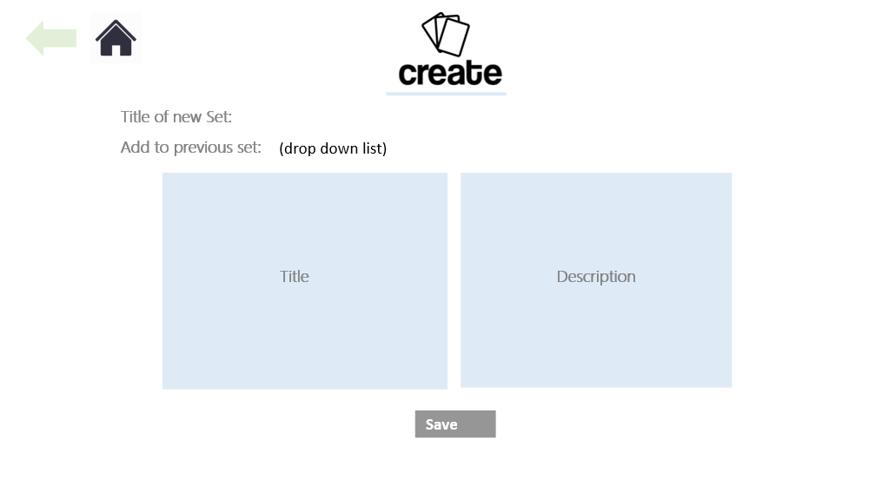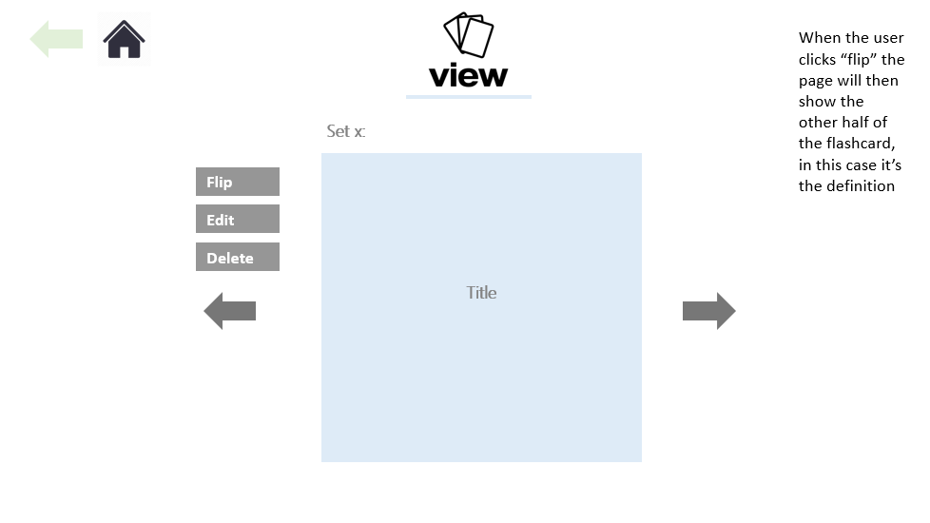

Will take you to view notes page **(page 8)**

Will take you to create notes page

**Page: 7**

**Page: 6**

**Page: 5**

Save button will save combination into database.

Edit button lets you change text in the card

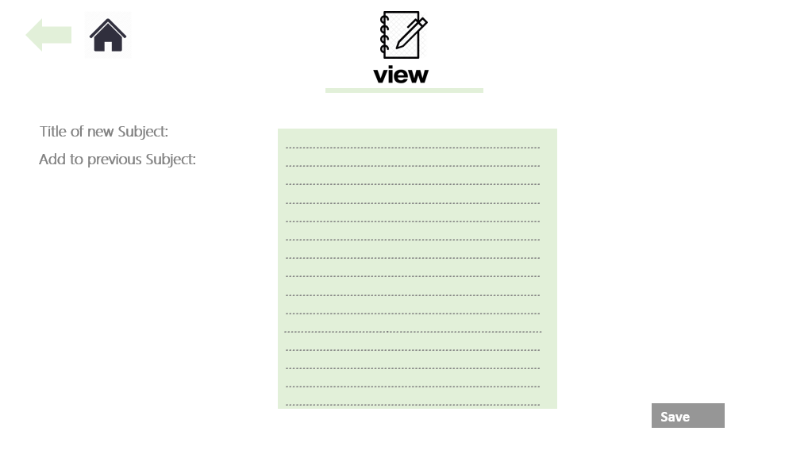

**Page: 9**

Button saves notes to the database and into the subject (new or previous)

Choose whether to name a new set or save note in another subject

**Page: 8**

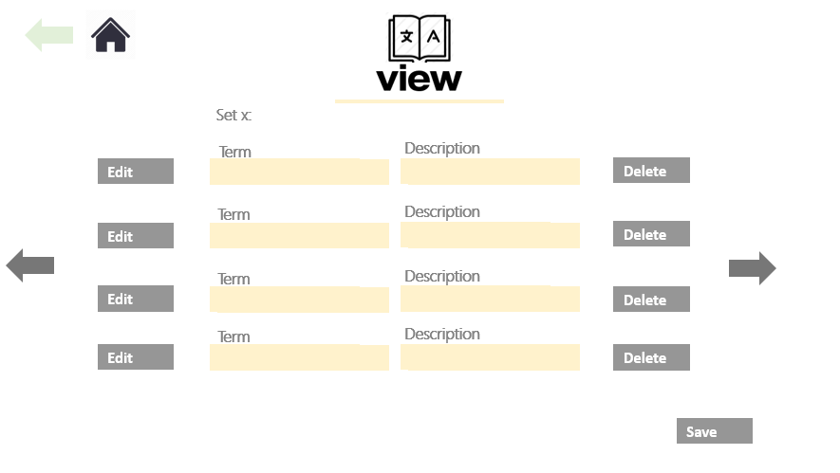

This will delete the attributes in the database.

This will delete the attributes in the database.