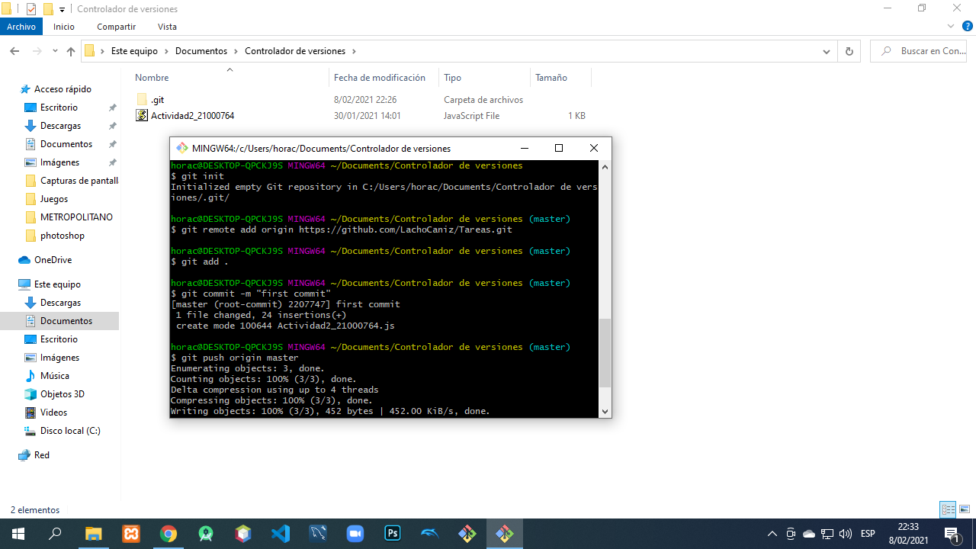

Link del repositorio
https://github.com/LachoCaniz/Tareas

