Test Case 1 (Positive): Add a single product to the shopping list
Test Case ID: TC-ATL-001
Title: Add one product to an existing shopping list from a product details page
Priority: High

Preconditions:
- User is logged in.
- At least one shopping list exists (e.g., Weekly Groceries).

Test Data:
Product: In-stock product visible on a category/PLP and has name, image, price, discount percentage, was price, weight and ‘Many in stock’ label
Shopping list: have and existing shopping list named eg.: Weekly Groceries.

Steps:
- Navigate to a product listing page (category or search results).
- Locate a specific product card.
- Open the PDP of the product
- Click on “Add to saved list” – thick the checkbox of your existing shopping list and click on “Save to list” button.
- Open the Shopping List page by clicking on the “View list” button on the notification/confirmation snackbar appearing in the bottom left corner of the page.
- Once the Shopping list view opened, refresh the page.
- Leave the Shopping list view – go to the PLP and add the same product to the cart too. (quantity = 1)
- Open the Account dropdown (top right corner of the page) and choose “Your saved list” from the list of options.
- Now you redirected to the “Your saved list“ view where your single shopping list appears with the single item in it. – click on “Show item” to open the shopping list

Expected Results:
- After step 4, a success confirmation is shown (toast/snackbar) after adding. It has a link to the shopping list.

- The selected product appears on “Your saved lists view” with correct name/image /price/discount percentage/was price/weight/many in stock label, as displayed on the product card. It appears after page refresh too.

- The selected product appears in Weekly Groceries shopping list with correct name/image /price/discount percentage/was price/weight/many in stock label, as displayed on the product card. It appears after page refresh too.

- The product on both “Your saved lists view” and Weekly Groceries shopping list, has a +Add button on it when not added to the cart.

- The product is not duplicated on “Your saved lists view”, nor on Weekly Groceries shopping list.

- When revisiting the “Your saved lists” view and the Weekly Groceries shopping list after the product was added to the cart, both indicates that currently the product is in the cart with quantity 1. Clicking on the indicator customer can increase the quantity of the product in the cart or delete it form the cart.

- When revisiting the “Your saved lists” view through the account dropdown – the text on the link leads to the Weekly Groceries shopping list is “Show item”(as there is only a single item on the list)

Test Case 2 (Negative): Attempt to add a product while not logged in
Test Case ID: TC-ATL-002
Title: Products cannot be added to shopping lists when the customer is not logged in
Priority: High

Preconditions:
- User is logged out

Test Data:
Product: any visible product on PLP/PDP.

Steps:
- Go to aldi.us in a logged-out state.
- Navigate to a product listing page
- Open a product detail page.
- Click Add to cart.
- Try to access the shopping list views via account dropdown.

Expected Results:
- There is no button on the UI to add any product to the shopping lists.
- PLP – product cards on the PLP do not have add to list option
- PDP does not have add to list option
- In the cart – products do not have add to list option
- Account dropdown is not available, so the customer cannot access shopping list views via “Your saved list” option.

Test Case 3 (Positive + edge): Add multiple products to multiple shopping lists and verify list behavior (no duplicates / correct counts)
Test Case ID: TC-ATL-003
Title: Add multiple different products; re-add one product; verify list contents and quantity/duplicate behavior
Priority: High

Preconditions:
User is logged in.
Shopping list Weekly Groceries exists and is empty.
Shopping list Weekly Groceries2 exists and is empty.

Test Data:
Products: choose 3 distinct products from different categories or search results.
Product1 (not in cart)
Product2 (in cart, quantity 1)
Product3 (in cart, quantity 2)

Steps:
- From a PDP, add Product1 to Weekly Groceries1 and to Weekly Groceries2 simultaneously (one click)

- Add Product2 to Weekly Groceries Groceries1 and to Weekly Groceries2 simultaneously (one click)

- Add Product3 Weekly Groceries Groceries1 and to Weekly Groceries2 simultaneously (one click)

- Repeat step1, step2 and step3

- Add Product1 to cart, remove Product2 from cart, reduce the quantity of Product3 in cart.

- Remove Product1 from “Groceries Groceries1” shopping list

- Make Product2 unavailable (reduce stock or set the product offer to inactive in BO)

- Refresh the page

Expected Results:
- After step 1, 2 and 3, both “Weekly Groceries1” and “Weekly Groceries2” shopping list contains the Products we attempted to add to them. After each step, the appropriate products appear on both lists. All products appear only once on both shopping list.
- On both lists, all product indicates correctly if it is in the cart or not and with what quantity it is in the cart.
- After step 4 (readding all products to both lists), the lists contents are unchanged. (no duplications of products on the shopping list)
- After step 5, on both shopping lists, all product’s cart quantity is indicated correctly.
- After step 6, Product1 is removed from “Groceries Groceries1” but not removed from “Groceries Groceries2”
- After step 7, Product2 is not removed from any of the two shopping lists but cannot be added to the cart. Unavailability is indicated on the shopping lists.
- After page reload the final state persists.

A realistic potential bug
Bug: Adding the same product twice creates duplicate entry on the shopping list

Bug report
Bug ID: BUG-ATL-014 (example)
Title: Duplicate entries created when adding the same product to the same shopping list multiple times
Product/Area: aldi.us → Shopping List
Responsible team: Customer Interaction [FE][BE]
Environment: Production environment
Site: aldi.us
Browser/Device of detection: Chrome 128 / macOS (Reproducible on all devices/browsers)
Date/Time observed: 2026-09-30 13:23 local
Severity: Medium (can become High if it affects ordering/fulfillment workflows)
Priority: High
Preconditions:
- User is logged in.
- At least 1 shopping list exists.

Steps to Reproduce:
- Search for any available product.
- On the PDP of the product, add the product to a shopping list by clicking on “Add to saved list”
- Click on “Add to saved list” again and choose the same shopping list to add to. (Attempt to add the same product to the same shopping list again.)
- Open the given shopping list.

Actual Result:

Second POST request to https://www.aldi.us/graphql?operationName=InspirationUpdateListProducts with the product’s reference and quantity 1 in the payload, responds with HTTP 200 and item duplication in the response Json
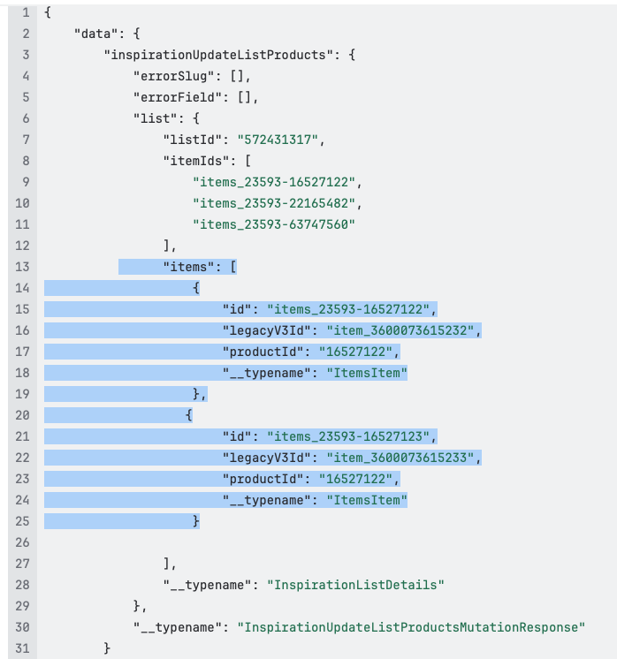
Product appears as two separate entries/entities on the shopping list views (duplicated item on the list)
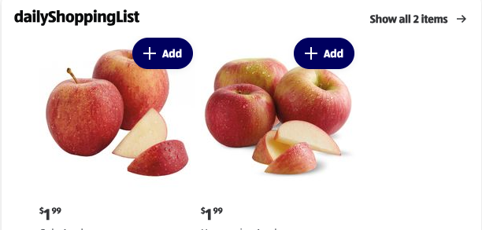
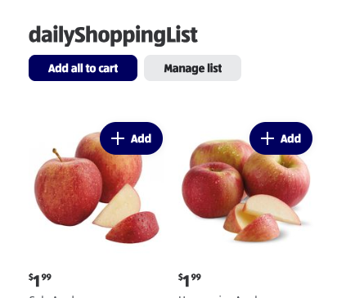

Expected Result:

Product A should appear only once; re-adding should show “Already in list” without adding the product once more.
Behind the endpoint the insertion of the product should not happen when it is already on the given list. The response code or the response Json should indicate that the entry to the list hasn’t happened and the reason – so FE could use the information and inform the customer in some way, that the product he is attempting to add to the list, is already on it.

Reproducibility: Always

Attachments/Evidence: Screenshot(s): - added to the expected section

Notes: I found the bug during the by weekly regular manual regression test execution on 2026-09-30. The bug was not present two weeks earlier at the end of the previous sprint.
I recommend the case to be covered with test automation once the bug is fixed.

Side note (not part of the bug report): on aldi.us actually when adding a product for the second time to a shopping list, the product does not get added for the second time, so no duplication, but no indication for the customer, that the product was already on the list.

