VIETNAM GENERAL CONFEDERATION OF LABOR

**TON DUC THONG UNIVERSITY**

**FACULTY OF INFORMATION TECHNOLOGY**



**NGUYỄN THẠCH TRƯỜNG LẠC - 521H0462**

**MOBILE APPLICATION**

**FOR BOOKING MOVIE TICKETS**

**HO CHI MINH CITY, 2023**

VIETNAM GENERAL CONFEDERATION OF LABOR

**TON DUC THONG UNIVERSITY**

**FACULTY OF INFORMATION TECHNOLOGY**



**NGUYỄN THẠCH TRƯỜNG LẠC - 521H0462**

**MOBILE APPLICATION**

**FOR BOOKING MOVIE TICKETS**

Instructor

**TS. Lê Văn Vang**

**HO CHI MINH CITY, 2023**

**ACKNOWLEDGMENTS**

First of all, I would like to express my deep gratitude to Mr. Mai Van Manh for wholeheartedly guiding and supporting us during the course of the java technology course as well as Ton Duc Thang University for creating conditions for us to have the opportunity to learn and develop during the past time. We would like to express our sincere thanks to everyone.

*Ho Chi Minh city, December 25 th 2023*

*Author*



*Nguyễn Thạch Trường Lạc*

**TEACHER'S CONFIRMATION AND ASSESSMENT SECTION**

Name of instructor:

Comments:

Total score according to Rubrik rubric:

*Ho Chi Minh city, Day Month Year*

*Author*

*(sign and write full name)*

**PROJECT COMPLETED**

**AT TON DUC THONG UNIVERSITY**

I hereby declare that this is the product of my own project and under the guidance of Mr. Le Van Vang; The research contents and results in this topic are honest and have not been published in any form before. The data in the tables for analysis, comments and evaluation are collected by the author himself from different sources, clearly stated in the reference section.

In addition, the project also uses a number of comments, assessments as well as data from other authors, other agencies and organizations, with citations and source annotations.**If there is any fraud, I will take full responsibility for the content of my project.** Ton Duc Thang University is not related to copyright and copyright violations caused by me during the implementation process (if any).

*Ho Chi Minh city, December 17th 2023*

*Author*

*(sign and write full name)*



*Nguyễn Thạch Trường Lạc*

**MOBILE APPLICATION**

**FOR BOOKING MOVIE TICKETS**

**SUMMARY**

The report outlines the development of a mobile application for booking movie tickets using Java on Android Studio. The application aims to enhance user experience in accessing and reserving movie tickets conveniently. Key features include user registration, a comprehensive movie listing with filtering options, interactive seat selection, a secure booking and payment system, and a booking history for users. The technology stack involves Java programming language, Android Studio as the development environment, and a database system for data storage. The report covers the system architecture, design patterns, user interface design, testing processes, and concludes with a summary of achievements and suggestions for future enhancements.

TABLE OF CONTENTS

TABLE OF CONTENTS 7

LIST OF TABLES, IMAGES, GRAPHS 9

CHAPTER 1 – INTRODUCTION 10

1.1 Background 10

1.2 Objectives 10

CHAPTER 2 – FOUNDATIONAL CONCEPTS 12

2.1 Mobile Application Development Landscape 12

2.1.1 Android Platform Overview: 12

2.1.2 Java Programming Language: 12

2.2 Core Features of the Movie Booking Application 12

2.2.1 User Authentication and Authorization: 12

2.2.2 Movie Database Integration: 13

2.2.3 Seat Selection Mechanism: 13

2.2.4 Booking and Payment Flow: 13

2.2.5 Booking History Management: 14

2.3 Development Environment 14

2.3.1 Android Studio: 14

2.3.2 Database Management: 14

Chapter 3: Demo 15

1. User Registration and Login 15

1.1 User Registration: 15

1.1.1 User Input: 15

1.1.2 Local Storage: 15

1.1.3 Confirmation Message: 15

1.2 Login System: 16

1.2.1 Credential Verification: 16

1.2.2 Error Handling: 16

1.2.3 Authentication: 17

2. Movie Listings 17

2.1 Integration with Embedded Database: 17

2.2 Filtering and Sorting: 17

3. Adding Movie and Category 17

3.1 Add Movie: 17

3.2 Add Category: 18

4. Seat Selection 19

4.1 Interactive Seat Maps: 19

4.2 Seat Preferences: 19

5. Booking and Payment 20

5.1 Streamlined Booking Process: 20

5.2 Payment Integration: 20

6. Booking History 22

6.1 Order History: 22

7. Overall User Experience 23

7.1 Navigation and UI Design: 23

7.2 Responsiveness and Performance: 23

Chapter 4: Conclusion 25

4.1 Summary of Achievements 25

4.2 Lessons Learned 25

4.3 Future Directions 26

4.4 Final Thoughts 26

4.5 Closing Remarks 27

REFERENCES 28

LIST OF TABLES, IMAGES, GRAPHS

**LIST OF IMAGES**

Image 3.1 Register section 15

Image 3.2 Login Section 16

Image 3.3 Add movie section 18

Image 3.4 Add category section 19

Image 4.1 Seat Selection Section 20

Image 5.1 Choose pay method section 21

Image 5.2 Payment Result from dashboard stripe 21

Image 6.1 Ticket Order History 22

Image 6.2 Ticket Detail Section 23

CHAPTER 1 – INTRODUCTION

1.1 Background

The continual rise in mobile technology has transformed the way individuals engage with various services, with mobile applications playing a pivotal role in offering seamless and convenient solutions. In the context of entertainment, there is a growing trend towards leveraging mobile platforms for activities such as booking movie tickets. The ubiquity of smartphones and the increasing reliance on on-the-go services make mobile applications an ideal medium for enhancing the user experience in the realm of movie ticket reservations.

1.2 Objectives

The primary objective of this report is to document the development and functionality of a mobile application designed for the specific purpose of booking movie tickets. This application seeks to address the evolving needs of users who prefer the convenience of accessing and reserving movie tickets through their mobile devices. By creating a user-friendly and efficient platform, the goal is to streamline the process of selecting, booking, and purchasing movie tickets, ultimately enhancing the overall movie-going experience.

The key objectives of the mobile application include:

* Seamless User Experience: Develop an intuitive and user-friendly interface that simplifies the process of browsing movie listings, selecting seats, and completing ticket transactions.
* Real-Time Movie Information: Integrate with a reliable movie database to ensure up-to-date and accurate information about movie schedules, genres, and other relevant details.
* Secure Booking and Payment: Implement a robust booking system with integrated secure payment gateways to facilitate smooth and secure transactions.
* User Account Management: Provide users with a personalized experience by incorporating features such as registration, login, and a booking history section.
* Scalability and Future Enhancements: Design the application architecture and features with scalability in mind, allowing for future enhancements and updates to meet evolving user expectations.

By addressing these objectives, the mobile application aspires to offer a comprehensive and efficient solution for users seeking a hassle-free and enjoyable movie ticket booking experience.

CHAPTER 2 – FOUNDATIONAL CONCEPTS

2.1 Mobile Application Development Landscape

The Android operating system, developed by Google, is a robust and open-source platform for mobile devices. Its widespread adoption makes it a standard choice for mobile application development. Android provides a versatile environment that supports a variety of devices, from smartphones and tablets to smart TVs and wearables.

2.1.1 Android Platform Overview:

Android Studio is the official integrated development environment (IDE) for Android app development. It offers a rich set of tools for designing, coding, testing, and debugging Android applications. With features like an emulator for testing on various devices and a layout editor for visual design, Android Studio streamlines the development process.

2.1.2 Java Programming Language:

Java is a primary programming language for Android app development. Its object-oriented nature and platform independence make it well-suited for creating scalable and maintainable mobile applications. Android applications are typically written in Java and then compiled into bytecode for execution on the Android Runtime (ART) environment.

2.2 Core Features of the Movie Booking Application

2.2.1 User Authentication and Authorization:

User Registration: The application includes a user registration process where users provide necessary information to create an account. This information is securely stored for future use.

Login System: A robust login system ensures secure access to user accounts. Authentication mechanisms, such as username-password validation, are implemented to protect user data.

Authorization: Authorization mechanisms are in place to control user permissions within the application. This ensures that users have appropriate access levels for specific actions.

2.2.2 Movie Database Integration:

Integration with Movie Database: The application integrates with a reliable movie database to fetch and display up-to-date information about movie listings, including details such as titles, genres, release dates, and showtimes.

Real-time Updates: The integration with the movie database includes real-time updates, ensuring that users always have the latest information on movie schedules and availability.

2.2.3 Seat Selection Mechanism:

Interactive Seat Maps: The application incorporates interactive seat maps, allowing users to visualize the seating layout of theaters. Users can easily select and choose their preferred seats.

Seat Preferences: To enhance the user experience, the application may include features for setting seat preferences, such as choosing specific rows or areas within the theater.

2.2.4 Booking and Payment Flow:

Streamlined Booking Process: The booking process is designed to be intuitive and user-friendly, guiding users through the selection of a movie, seat preferences, and ultimately facilitating a seamless booking experience.

Payment Integration: Secure payment gateways are integrated into the application to enable users to make transactions securely. This involves the implementation of encryption and other security measures to protect sensitive payment information.

2.2.5 Booking History Management:

Order History: Users have access to a booking history section, where they can view details of their past transactions. This provides a convenient way for users to track and manage their movie ticket reservations.

Cancellation: Depending on the application's features, a cancellation option may be available, allowing users to modify or cancel their bookings within specified time frames.

2.3 Development Environment

2.3.1 Android Studio:

Comprehensive IDE:

Android Studio serves as a comprehensive development environment, offering a range of tools for designing layouts, writing code, and testing applications.

Emulator for Testing:

The built-in emulator allows developers to test their applications on various Android devices virtually, facilitating thorough testing and debugging.

2.3.2 Database Management:

Database System Selection: The choice of a suitable database system, such as SQLite, Firebase,… is made based on factors like scalability, performance, and ease of integration with the Android application.

Management Tools: Database management tools are employed to streamline tasks related to data manipulation, ensuring the efficient storage and retrieval of user and movie-related data.

Chapter 3: Demo

1. User Registration and Login

1.1 User Registration:

1.1.1 User Input:

Users provide details like username, password and confirm password for registration.

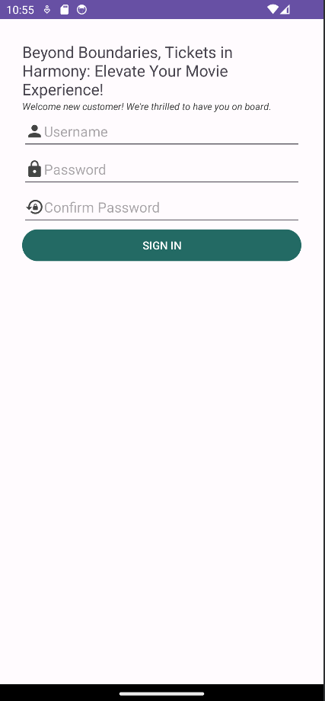

Image 3.1 Register section

1.1.2 Local Storage:

Registration details are securely stored in the embedded database (e.g., SQLite) on the user's device.

1.1.3 Confirmation Message:

Upon successful registration, a confirmation message is displayed.

1.2 Login System:

1.2.1 Credential Verification:

Secure login process verifies user credentials against locally stored data.

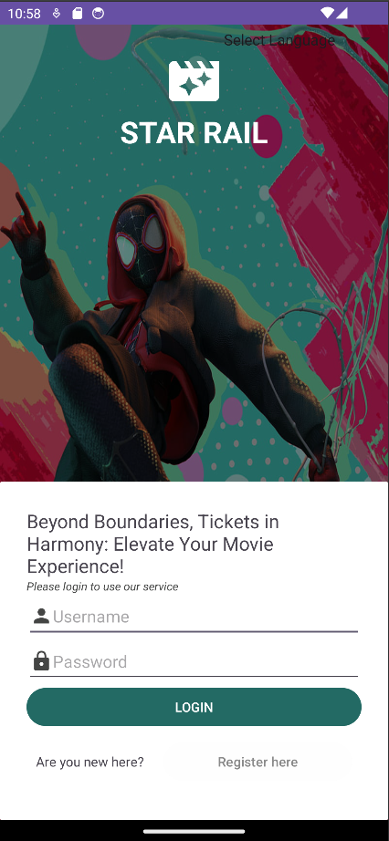

Image 3.2 Login Section

1.2.2 Error Handling:

Demonstrates handling incorrect login attempts, with error messages for invalid credentials.

1.2.3 Authentication:

Users access their accounts after successful authentication against locally stored user data.

2. Movie Listings

2.1 Integration with Embedded Database:

* Local Data Retrieval: Seamless integration fetches real-time information about movie listings from the embedded database.
* Offline Functionality: Access movie details offline, stored locally in the embedded database.
* Dynamic Updates: Real-time updates occur as users apply filters, sorting locally stored data.

2.2 Filtering and Sorting:

* Local Queries: Users filter and sort movies based on preferences using local queries on the embedded database.
* Interactive UI: An interactive interface allows users to refine movie listings based on genres, languages, and release dates locally.
* Offline Accessibility: Filtering and sorting features are available even when the device is offline.

3. Adding Movie and Category

3.1 Add Movie:

* Input Movie Details: Admin or authorized users can input movie details, including title, genre, price, movie poster and showtimes.
* Local Storage: Movie details are securely stored in the embedded database on the user's device.
* Confirmation Message: A confirmation message is displayed upon successful addition of a new movie.

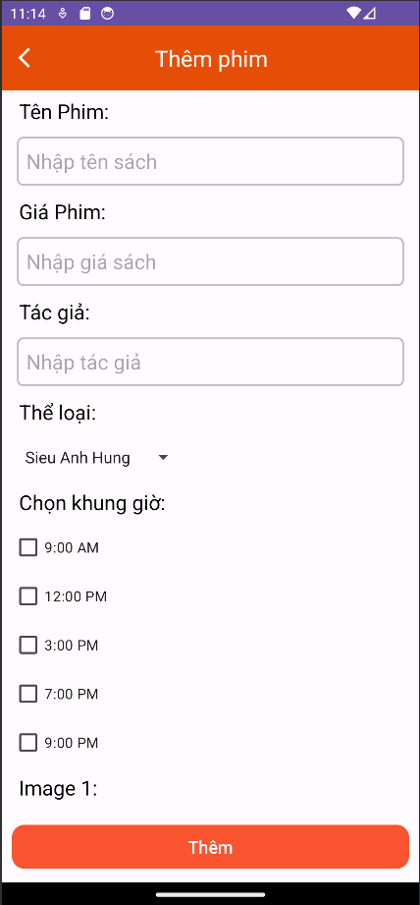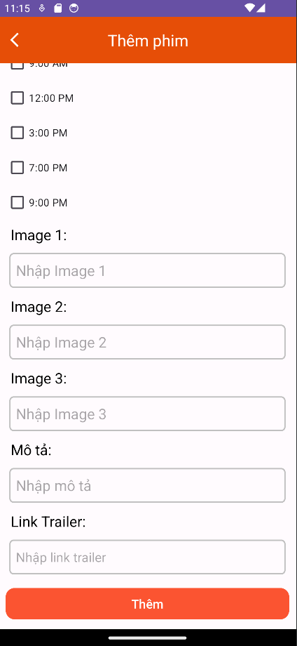

Image 3.3 Add movie section

3.2 Add Category:

* Input Category Details: Admin or authorized users can add movie categories.
* Local Storage: Category details are securely stored in the embedded database on the user's device.
* Confirmation Message: A confirmation message is displayed upon successful addition of a new category.

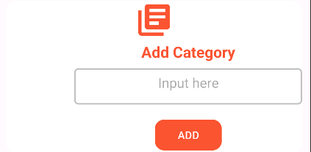

Image 3.4 Add category section

4. Seat Selection

4.1 Interactive Seat Maps:

4.1.1 Visualization: Users visually explore interactive seat maps for theaters with locally stored seat availability data.

4.1.2 Local Storage: The application stores seat availability information in the embedded database, ensuring offline access to seat maps.

4.1.3 Real-time Updates: Real-time updates occur as users interact with the seat map, reflecting changes based on locally stored data.

4.2 Seat Preferences:

4.2.1 User Configuration: Users can set seat preferences, such as choosing specific rows or areas within the theater.

4.2.2 Local Adaptation: The application adapts to user preferences using locally stored data in the embedded database.

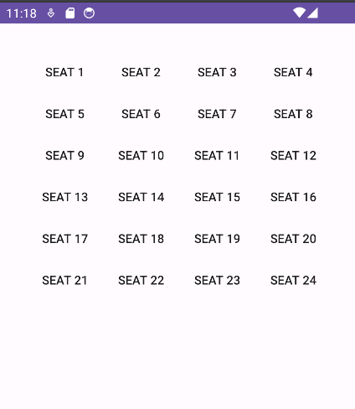 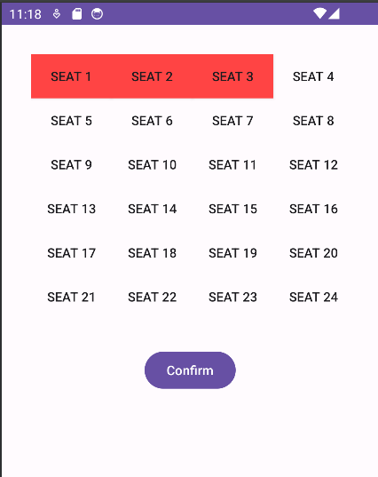

Image 4.1 Seat Selection Section

5. Booking and Payment

5.1 Streamlined Booking Process:

5.1.1 Step-by-Step Demonstration: Demonstrates the step-by-step booking process, from selecting a movie to choosing seats, with booking information stored locally.

5.1.2 Confirmation: Users receive confirmation messages upon successful booking, indicating that the transaction has been recorded in the embedded database.

5.2 Payment Integration:

5.2.1 Secure Transaction: Showcases the secure payment gateway integration for seamless and secure transactions, emphasizing encryption and data protection.

5.2.2 Transaction Logging: Details of payment transactions are logged locally in the embedded database for reference and order history.

5.3 Payment Options:

5.3.1 Choose Payment Method: Users can choose between Cash on Delivery (COD) or Visa for payment.

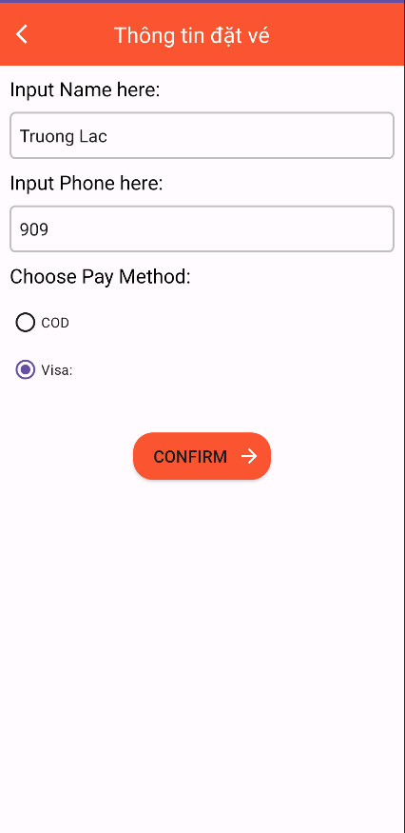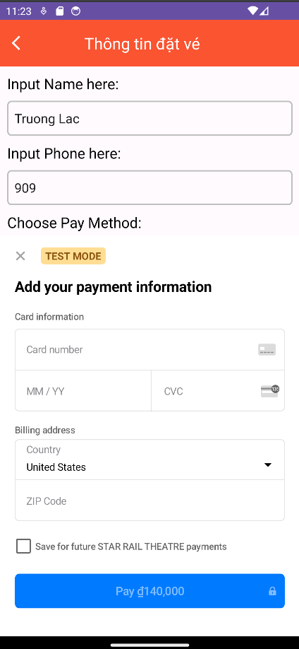

Image 5.1 Choose pay method section

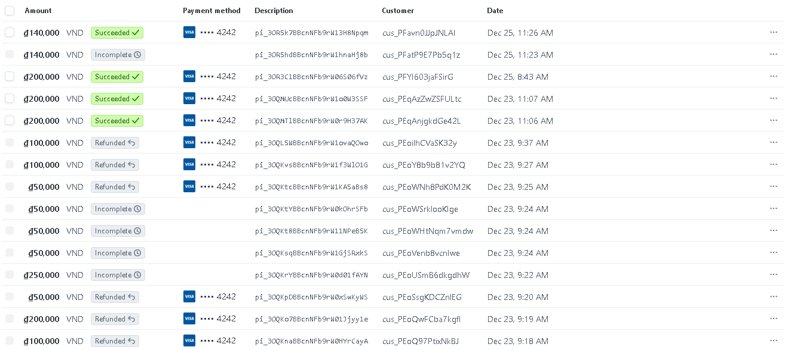

Image 5.2 Payment Result from dashboard stripe

5.3.2 Local Processing: Payment details are processed locally, and the chosen payment method is stored in the embedded database.

6. Booking History

6.1 Order History:

6.1.1 Accessing Past Transactions: Users can access a booking history section to view details of past transactions stored in the embedded database.

6.1.2 Offline Access: Users can view their booking history even when offline, as the information is locally stored.

6.1.3 Transaction Details: Each transaction entry includes comprehensive details about the booked movie, selected seats, and the transaction date.

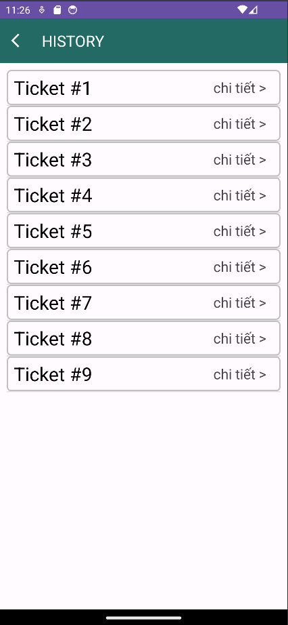

Image 6.1 Ticket Order History

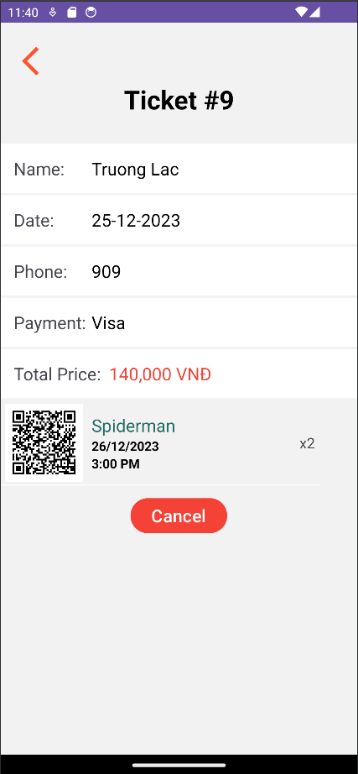

Image 6.2 Ticket Detail Section

7. Overall User Experience

7.1 Navigation and UI Design:

7.1.1 Intuitive Interface: Showcases the intuitive navigation and user interface design that contributes to an enjoyable and easy-to-use experience.

7.1.2 User-Friendly Controls: Emphasizes user-friendly controls and interactive elements for smooth navigation through the application.

7.2 Responsiveness and Performance:

7.2.1 Smooth Interactions: Emphasizes the responsiveness of the application, ensuring smooth interactions and quick loading times.

7.2.2 Optimizations: Highlights any performance optimizations implemented to enhance the overall user experience, such as caching and data compression.

Chapter 4: Conclusion

4.1 Summary of Achievements

* User-Friendly Interface: The movie booking application successfully delivered a user-friendly interface, allowing users to seamlessly navigate through the registration, movie selection, and booking processes.
* Comprehensive Movie Listings: The integration with an embedded database provided real-time and comprehensive movie listings, enhancing the overall user experience.
* Secure Booking and Payment: The streamlined booking and payment processes, including the option for Cash on Delivery (COD) or Visa, ensured secure and convenient transactions.
* Booking History Management: Users could easily access and manage their booking history, providing a transparent record of past transactions.
* Intuitive Seat Selection: The interactive seat map feature allowed users to visually explore and select seats easily, contributing to a positive and intuitive user experience.
* Responsive Design: The application demonstrated responsiveness and performance optimizations, guaranteeing smooth interactions and quick loading times for users.

4.2 Lessons Learned

* Database Selection: The choice of an embedded database proved to be effective for the offline-first approach, ensuring data availability and responsiveness.
* Payment Integration: Integrating secure payment gateways required careful consideration of encryption methods and user data protection, providing valuable insights into financial transaction security.
* User Journey Mapping: Mapping the user journey allowed for a deeper understanding of user interactions, leading to improvements in the overall flow and navigation.
* Adaptability: The application's adaptability to user preferences, especially in seat selection and movie filtering, highlighted the importance of customization in enhancing user satisfaction.

4.3 Future Directions

* Enhanced User Personalization: Future updates could focus on enhancing user personalization, allowing users to set preferences for movie recommendations and seat selection.
* Integration with External Services: Exploring partnerships with external services, such as loyalty programs or streaming platforms, could add value to the application and enrich the user experience.
* Server-Side Enhancements: To accommodate a growing user base, considerations for potential server-side enhancements and optimizations will be crucial.
* Load Testing: Ongoing load testing and performance monitoring will be integral to maintaining the application's responsiveness as user numbers increase.

4.4 Final Thoughts

* Evolution of Ideas: Reflecting on how initial concepts evolved throughout the development process, showcasing the adaptability and creativity of the team.
* Team Dynamics: Highlighting the positive team dynamics that contributed to a collaborative and innovative environment.
* User-Centric Vision: Reiterating the user-centric vision of the application and its ongoing commitment to providing a seamless movie booking experience.
* Adaptability: Emphasizing the application's adaptability to emerging industry trends and user expectations.

4.5 Closing Remarks

* Gratitude to Users: Expressing gratitude to the user base for their engagement, feedback, and continued support.
* Encouragement for Feedback: Encouraging users to continue providing feedback for ongoing improvements and enhancements.
* Summarizing the Journey: Providing a concise summary of the movie booking application development journey, emphasizing its significance in transforming the movie-going experience.
* Looking Forward: Closing with an optimistic outlook, expressing excitement for the future of the application and its potential impact on the user community.

REFERENCES

1. Bill Phillips, Chris Stewart, and Kristin Marsicano (2019), *Android Programming: The Big Nerd Ranch Guide*
2. Dawn Griffiths and David Griffiths (2017), *Head First Android Development*
3. Michael Burton and Donn Felker (2015), *Android App Development For Dummies*
4. Neil Smyth (2018), *Android Studio 3.0 Development Essentials - Android 8 Edition*
5. Reto Meier (2018), *Professional Android 4th Edition*
6. Barry A. Burd (2019), *Android Application Development All-in-One For Dummies*