**5CA Counter Application**

**Description.**  
This application was created to help agents count their productivity. Besides, they can track their activities (meetings, trainings, etc) and emergencies (OFF sick days, etc).

All DATA is stored in the .txt file and can be observed/analyzed in the future.

**Interface.**  
OFF mode

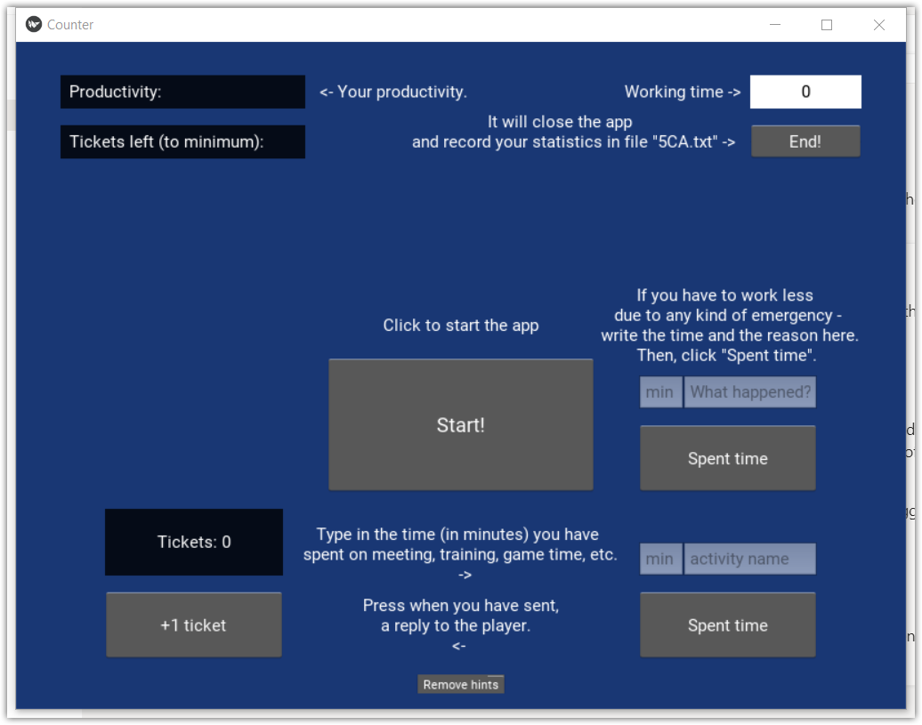

ON mode (+ without hints)  
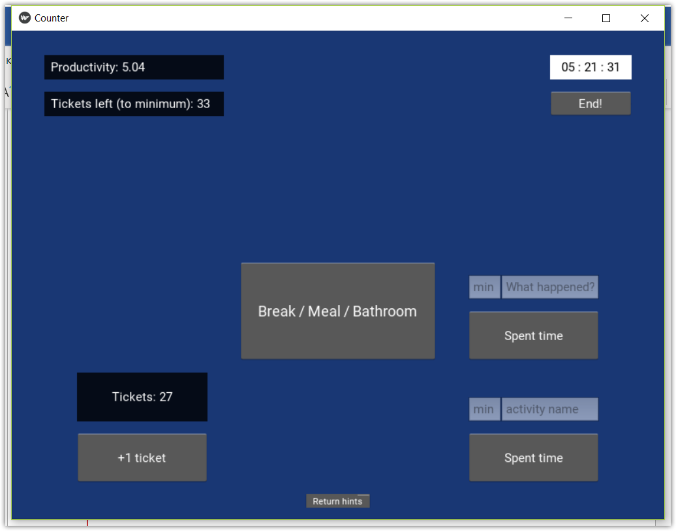

**Logic.**

When you click Start, timer in the right corner starts to count time. When you have Break / Meal / go to the bathroom, you click the middle button and timer pauses.

When you send a response to the player, you click “+1 ticket”. Since this moment we have a simple calculation: Productivity = amount of tickets / time; Tickets left = current min CPH * 8 working hours.

Bottom center button will hide/show all hints (you can see them on the first screenshot).

Bottom right button is used to track all your other activities and it doesn’t influence your productivity or amount of tickets you have to do.

The button above should be used in case you have any kind of emergency. It will deduct the amount of tickets you have to do to reach min goal and track the leave.

The main button of this App is located below the timer. It should be pressed only once, right after your shift. It will close the App and write all information into the 5CA.txt file.

**5CA.txt**

That how this file looks like.  
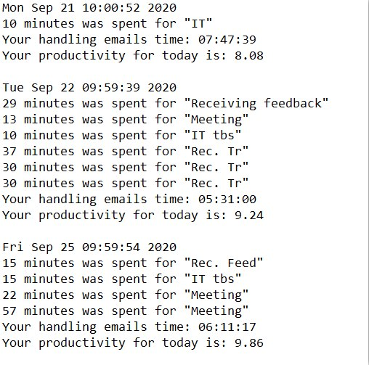

**Features.**

You can add the ticket even without clicking the button. All you need to do is press F to... Press F9 while timer is running.