library(ggplot2)
library(readxl)

#Ler excel
name <- 'electricity.xlsx'
link <- 'https://web.tecnico.ulisboa.pt/~paulo.soares/pe/projeto/electricity.xlsx'
download.file(link, name)
input <- readxl::read_xlsx(name)

#Definir valores em interesse
startYear <- 2015
countries <- c("IEA Total", "Hungary", "Iceland")
energies <- c("Renewables")

#Filtrar dados para obter apenas os dados em interesse
data1 <- subset(input, YEAR >= startYear)
data2 <- subset(data1, COUNTRY %in% countries)
data <- subset(data2, PRODUCT %in% energies)

#Modificar dados para melhor compreensão
data$MONTH <- sprintf("%02d", as.numeric(data$MONTH))
data$share <- as.numeric(data$share) * 100

data$date = paste(data$MONTH, data$YEAR, sep = "/")

#Desenhar gráfico
ggplot(data, aes(x = date, y = share , color = COUNTRY, fill = COUNTRY, group = COUNTRY)) +
geom_line() +
scale_y_continuous(limits = c(0, 100)) +
labs(title = "Percentage of electricy produced by renewable sources", x = "Date", y = "Renewables Percentage (%)") +
theme_minimal() +
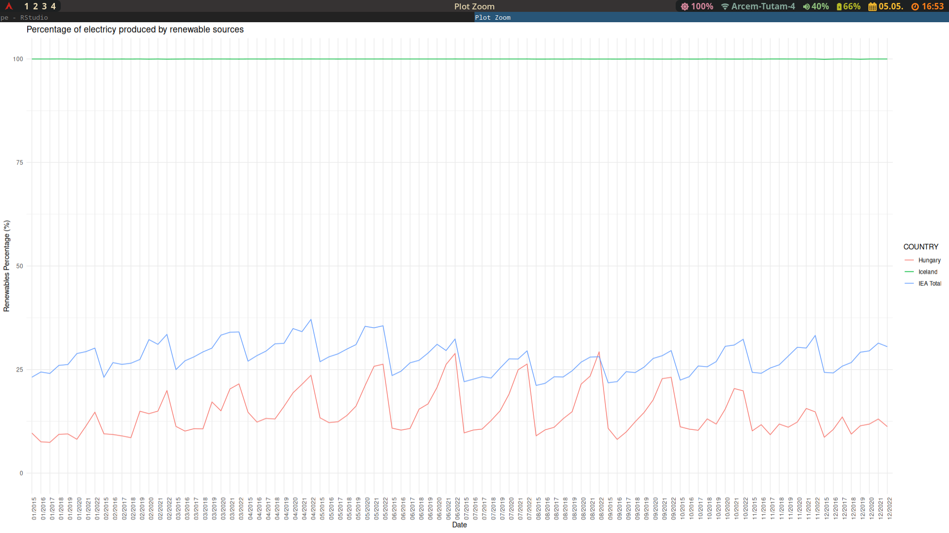
theme(axis.text.x = element_text(angle = 90, hjust = 1))

