Smart water fountain

"Our smart water fountain incorporates advanced sensorsto conserve water by automatically turning off when no one is present."

"With personalized design options, our innovative fountain creates a unique experience for users while promoting water conservation."

"Using presence detection technology, the fountain intelligently turns on when someone approaches, providing water only when needed."

"By integrating touch-sensitive controls, users can easily activate and deactivate the fountain, ensuring water is not wasted."

"Our smart water fountain combinestechnology and sustainability, making it an eco-friendly solution for public spaces, offices, and homes."

Code:

/*

PIR sensor tester

*/

int ledPin = 12; // choose the pin for the LED int inputPin = 23; // choose the input pin (for PIR sensor) int pirState = LOW; // we start, assuming no motion detected int val = 0; // variable for reading the pin status

void setup() {

pinMode(ledPin, OUTPUT); // declare LED as output

pinMode(inputPin, INPUT); // declare sensor as input

**Serial**.begin(9600);

}

void loop() {

val = digitalRead(inputPin); // read input value

if (val == HIGH) { // check if the input is HIGH digitalWrite(ledPin, HIGH); // turn LED ON

if (pirState == LOW) {

// we have just turned on

**Serial**.println("Motion detected!");

// We only want to print on the output change, not state

pirState = HIGH;

}

} else {

digitalWrite(ledPin, LOW); // turn LED OFF

if (pirState == HIGH) {

// we have just turned of

**Serial**.println("Motion ended!");

// We only want to print on the output change, not state

pirState = LOW;

}

}

}

Stimulation:

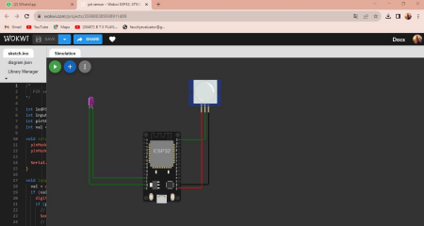

Used component:

>ESP32

>pir sensor

>bulb represent the water fountain

Pin Assignments:

The pin assignments are defined using const int variables to specify the pin numbersfor the presencesensor, touch sensor, and fountain relay. Adjust these valuesto match your specific hardware

connections.

Variables:

Two boolean variables are used: is Person Present and is Fountain On. These flagstrack the presence of a person and the state of the fountain, respectively.

Setup:

In the setup() function, the pin modes are set for the presence sensor (input), touch sensor (input with pull-up resistor), and fountain relay (output).

LINK:

<https://wokwi.com/projects/378939235795927041>