

Proposal Created For:

Indianapolis Airport Authority (IAA)

Request for Proposals (RFP) for:
Oracle E-Business Suite (EBS) Upgrade and Migration to Oracle Cloud Infrastructure (OCI)

February 25, 2026

Contents
RFP Documents and Forms 4
General Information 5
Company Information 5
Project Understanding 6
Representative Experience for Primary Services 8
Primary Services 10
Migration and Implementation Approach 10
1. OCI Migration Strategy (Including Integration Migration) 13
2. Testing and Quality Assurance 15
3.1 Testing Objectives 15
3.2 Testing Environment Preparation 15
2.3 Testing Phases 16
3. Cut-Over and Go-Live Approach 17
4.1 Objective 17
4.2 Pre Go-Live Preparation 18
4.3 Cutover Execution Activities 18
4.4 Hypercare Support 20
4.5 Downtime Minimization Approach 20
4. Knowledge Transfer and Documentation 21
5.1 Approach of Training / Knowledge Transfer Session: 21
5.2 Trainer Enablement Sessions by iteria.us: 21
4.3 Technical & Administrative Training 22
4.4 Training Deliverables: 22
5. Project Management and Governance 23
Timeline 24
Proposed Staffing 26
Cost Details 33
Optional Services 35
Cost Details 37
Exhibit A: iteria W9 Form 38

RFP Documents and Forms
E-Verify Certificate – Please Reference attachment- iteria E-VerifyForm.pdf
Supplier A Form – Please Reference attachment- iteria Supplier A Form Final 2026.pdf
W9 Form – Attached as an Exhibit to Proposal- See Exhibit A: iteria W9 Form
Proposal Form – Please Reference attachment- iteria Proposal Form.pdf

General Information

Company Information
iteria – US (iteria) is pleased to present our formal response to Indianapolis Airport Authority’s Request for Proposals (RFP) for Oracle E-Business Suite (EBS) Upgrade and Migration to Oracle Cloud Infrastructure (OCI).
iteria.us, a Certified Oracle Partner, was founded in 2015 as a S Corporation and is registered at the following location / state:

1712 Pioneer Ave, Suite 1983
Cheyenne, WY 82001

With satellite offices in both Wisconsin and Illinois, iteria brings localized resources to the Indianapolis Airport Authority.

iteria is a certified member of the Oracle Partner Network in good standing and has been an Oracle Partner since its inception in 2015. iteria provides services only on the Oracle Suite of Applications providing implementation services, managed services / support, and custom development.

iteria’s founders have been working in the Oracle circle for over 30 years and we pride ourselves in the fact that we focus only on Oracle technologies, offering our clients superior knowledge and skills to get you the most out of your Oracle Suite of Applications.

iteria offers a full range of services, including, but not limited to:

- EBS Upgrades
- Program / Project Management
- Net new / add-on module implementations
- Oracle Fusion Implementations
- Managed Services / Support
- AI Consulting
- Custom Development
- Test as a Service

Contact Information:
Brian Schell
President & CEO

Project Understanding
The objective of this project is to upgrade the existing Oracle E-Business Suite (EBS) environment from R12.2.3 to the latest certified R12.2.15 release and migrate the complete application workloads from the current on-premises infrastructure to
Oracle Cloud Infrastructure (OCI).
This initiative is intended to improve overall system performance, scalability, security posture, high availability, disaster recovery readiness, and long-term application supportability while reducing infrastructure management overhead and operational risks associated with legacy on-premises deployments.
The scope of this engagement includes:
- Technical upgrade of Oracle EBS Application and Database Tier
- Migration of all application components to OCI IaaS
- Migration and validation of customizations and extensions
- Migration of concurrent processing framework
- Network reconfiguration and secure connectivity setup
- Backup, monitoring, and disaster recovery configuration
- Post-upgrade system stabilization and performance tuning
- The above applied Upgrade and Migration is supported for PROD, DEV and TEST environments.

In addition to the core EBS upgrade and infrastructure migration, it is understood that the existing EBS environment is tightly integrated with multiple external enterprise systems and middleware platforms. These integrations include:
- Application-to-Application Interfaces
- Web Service/API-based Integrations
- Batch Data Transfer Mechanisms
- Secure File Transfer (SFTP/FTP) Interfaces
- Identity and Access Management (SSO) Integrations
- Third-Party Enterprise Application Integrations
- Middleware-based Data Exchange Platforms

As part of this migration initiative, all inbound and outbound integration points between EBS and external systems such as enterprise asset management platforms, property management systems, financial reporting tools, and other business-critical applications will be assessed, migrated, reconfigured, and validated within the OCI-hosted environment.
Integration-specific activities will include:
- Identification and documentation of all existing interface endpoints
- Migration of integration configurations to OCI network framework
- Updating of IP whitelisting and firewall rules
- Reconfiguration of file transfer paths and directories
- API endpoint remapping and validation
- DNS and Load Balancer configuration updates
- Security policy alignment with OCI IAM standards
- End-to-end interface testing post migration

The upgraded OCI-hosted EBS environment will ensure that all dependent upstream and downstream applications continue to exchange transactional and master data seamlessly without impacting existing operational workflows.
Our implementation methodology follows a structured Phased Migration Approach, designed to minimize disruption to business operations through detailed planning, environment cloning, controlled upgrade execution, comprehensive integration testing, user validation, and clearly defined rollback and contingency planning.
This approach ensures:
- Business continuity during migration
- Preservation of integration integrity
- Minimal application downtime during cutover
- Controlled transition to OCI infrastructure
- Seamless interoperability between EBS and integrated enterprise systems

  - Summarized Costs
  - Please reference attachment- iteria Cost File.pdf

Representative Experience for Primary Services
Large Public Sector Organization – WebCenter Upgrade & OCI Deployment
- Client Name: Airport Authority of India
- Project Name: OCI Migration, Web-Centre, & Upgrade
- Project Manager: Rajasekhar Ravichandran
- Project Scope: Migration of On-Premises to OCI with upgrade of database from 11i to 19c with Web Centre Content Migration, Performance Tuning, Application & Forms Migration and Upgrade of the Forms versions.
- Your Firm’s Role and Major Activities: Assessment and Planning of Migration strategy, Content and application Migration, Performance Tuning and optimization, Security and compliance implementation.
- Project Outcomes: Improved system scalability and performance, Enhanced security and compliance with industry standards, Successful go-live with minimal downtime.
- Contract Dates/Duration: March 2024 – July 2024
- Post-migration support: July 2024 - Sep 2024

Large Public Sector Organization – WebCenter Upgrade & OCI Deployment
- Client Name: Baliga
- Project Name: OCI Migration, Web-Centre, & Upgrade
- Project Manager: Rajasekhar Ravichandran
- Project Scope: Migration of On-Premises to OCI with upgrade of database from 10g to 12c with Web Centre Content Migration, Performance Tuning, Application & Forms Migration and Upgrade of the Forms versions.
- Your Firm’s Role and Major Activities: Assessment and Planning of Migration strategy, Content and application Migration, Performance Tuning and optimization, Security and compliance implementation.
- Project Outcomes: Improved system scalability and performance, Enhanced security and compliance with industry standards, Successful go-live with minimal downtime.
- Contract Dates/Duration: 2018 - 2019
- Post-migration support: Converted to AMC

Financial Services Firm – High-Security WebCenter on OCI
- Client Name: Gain Credit
- Project Name: Web-Centre Migration of Documents
- Project Manager: Rajasekhar Ravichandran
- Project Scope: Migration of Documents from WebCenter to 3rd Party Application
- Your Firm’s Role and Major Activities: Assessment and Planning of Migration strategy, Content and application Migration, Performance Tuning and optimization, Security and compliance implementation.
- Project Outcomes: Documents migrated from Repository to 3rd Party Application
- Contract Dates/Duration: Apr 2019 – Jun 2019
- Post-migration support: 2 Weeks

Large Private Sector Organization – Oracle EBS Upgrade & OCI Deployment
- Client Name: Mahle
- Project Name: Oracle EBS Upgrade (R12.1.3 to R12.2.13) and Migration to OCI
- Project Manager: Rajasekhar Ravichandran
- Project Scope: Upgrade of the existing Oracle E-Business Suite (EBS) environment from R12.1.3 to R12.2.13 and migration of application and database tiers from on-premises infrastructure to Oracle Cloud Infrastructure (OCI).
- Your Firm’s Role and Major Activities: Assessment and Planning of Migration strategy, Content and application Migration, Performance Tuning and optimization, Security and compliance implementation.
- Project Outcomes: Successful upgrade of Oracle EBS from R12.1.3 to R12.2.13 and migration from on-premises infrastructure to OCI, resulting in improved performance, scalability, and system stability.
- Contract Dates/Duration: Nov 2023 – Jan 2024
- Post-migration support: 4 Weeks

Primary Services

Migration and Implementation Approach
Migration Strategy Description
The proposed upgrade strategy involves performing a structured technical upgrade of the existing Oracle E-Business Suite environment from version R12.2.3 to the latest certified R12.2.x release within a controlled and isolated environment hosted on Oracle Cloud Infrastructure (OCI).
A Clone–Upgrade–Validate–Migrate approach will be adopted to minimize business disruption and ensure that production workloads are not directly impacted during the upgrade process.
The upgrade will be executed in the following stages:
Phase 1: Source System Assessment
- Perform technical assessment of the existing EBS R12.2.3 environment
- Identify installed modules, patch levels, and AD/TXK code levels
- Review database compatibility and required upgrade pre-requisites
- Analyze customizations including:
  - Custom forms
  - Reports
  - Interfaces
  - Extensions
  - Personalization
- Identify integration touchpoints including:
  - External API-based integrations
  - Middleware-based interfaces
  - SFTP/File-based data transfers
  - Batch concurrent interface programs
  - SSO-based identity integrations

Phase 2: OCI Target Environment Provisioning
- Provision Compute instances for Application Tier
- Provision Database Tier infrastructure
- Configure network components such as:
  - Virtual Cloud Network (VCN)
  - Subnets
  - Security Lists
  - Route Tables
  - Load Balancers
- Configure secure connectivity (VPN / FastConnect)
- Establish IAM roles and access control policies

Phase 3: Environment Cloning to OCI
- Clone existing production database to OCI-hosted upgrade environment
- Configure upgraded Application Tier
- Synchronize file systems (RUN & PATCH)
- Perform AutoConfig validation

This ensures that the production environment remains untouched during upgrade execution.
Phase 4: Technical Upgrade Execution
- Apply required AD and TXK Delta patches
- Upgrade Oracle EBS Technology Stack
- Upgrade database components (if applicable)
- Validate Online Patching (ADOP) framework
- Compile invalid objects
- Rebuild database statistics

Custom code objects will be recompiled and validated during this phase.
Phase 5: Integration Compatibility Review
All inbound and outbound integrations between EBS and external enterprise systems will be reviewed to identify upgrade impact.
Activities include:
- Validation of integration programs
- Interface re-registration
- API endpoint verification
- Middleware connectivity testing
- File transfer path validation
- Update of network dependencies such as:
  - IP Address Changes
  - Hostname Changes
  - Port Mapping
  - DNS Routing

Necessary reconfiguration will be performed to ensure continued communication between:
- EBS and enterprise applications
- EBS and third-party systems
- EBS and file transfer gateways
- EBS and authentication providers

Why This Upgrade Strategy is Recommended
- Enables execution in isolated environment without impacting production
- Allows validation of customizations prior to go-live
- Supports seamless integration endpoint reconfiguration
- Minimizes business downtime during cutover
- Provides fallback option to legacy production system
- Ensures all dependent systems are validated before migration
- Reduces post-upgrade integration failure risk

Sequence of Upgrade Activities
- Infrastructure provisioning in OCI
- Production database cloning
- Application tier configuration
- EBS technical upgrade execution
- ADOP validation
- Customization revalidation
- Integration endpoint reconfiguration
- System integration testing
- User Acceptance Testing (UAT)
- Performance benchmarking

Rollback and Contingency Plan
- Maintain legacy on-premises production system in parallel
- Perform full database backup prior to upgrade
- Capture system snapshots at each milestone
- Revert to legacy environment in case of validation failure
- Restore pre-upgrade database backup if required
- Repoint integration endpoints to legacy system

Assumptions & Prerequisites
Assumptions:
- Access to production backup
- Availability of integration documentation
- Valid licensing for upgraded environment
- Network connectivity between OCI and on-prem

Prerequisites:
- OCI tenant provisioning completed
- Source system health check completed
- Latest patch compatibility verified
- Integration access credentials available
- SSO and external endpoint details shared

OCI Migration Strategy (Including Integration Migration)
Sequence of Activities
Phase | Activity
Infrastructure | OCI VCN, Subnets, Security List
Application | Application Tier Migration
Database | RMAN/Data Pump Migration
Middleware | Integration Service Migration
Network | Load Balancer Configuration
Security | IAM policy & SSO setup
Integration | Endpoint Mapping
File Transfer | SFTP configuration
Testing | Interface Validation
DR | Backup & Cross Region Replication

Integration Migration Approach
As per RFP Section 3.2.4 & 3.9:
iteria will:
- Identify all Integration Points (Appendix B)
- Capture:
  - Source System
  - Destination System
  - Protocol Used
  - File Transfer Mechanism
  - API / Middleware Dependency

- Update:
  - OCI Private IP Mapping
  - DNS Routing
  - Firewall Rules
  - SFTP Locations
  - Web Service Endpoints

Reconfigure integrations between:
- EBS ↔ PROPworks
- EBS ↔ Hexagon EAM
- EBS ↔ Concur
- EBS ↔ Amazon Procurement
- EBS ↔ GL Wand
- EBS ↔ File Transfer Tools
- Below mentioned tools will be migrated to OCI
  - Discoverer
  - Open database Connectivity (ODBC)
  - SQL server Data Lake
  - Invoice Register

Rollback & Contingency Plan
- Maintain parallel On-Prem Production until Go-Live
- Database Backup & Snapshot at Each Phase
- OCI Snapshot at Each Phase
- DNS Reversion
- Fallback DNS Routing
- Revert Application Tier from Backup AMI
- Restore Database using RMAN Backup
- Repoint Legacy Integration Endpoints

Testing and Quality Assurance

3.1 Testing Objectives
The objective of the Testing and Quality Assurance phase is to ensure that the upgraded Oracle E-Business Suite environment migrated to Oracle Cloud Infrastructure (OCI) functions seamlessly across all in-scope business modules and continues to exchange data reliably with all integrated third-party enterprise applications as identified in the Project Specifications and Integration Matrix (Appendix B).
The testing phase will validate:
- Functional integrity of Financial Modules
- Procurement and Inventory transactions
- Project Accounting functionality
- Data migration accuracy
- Application performance under peak load
- Security compliance and access control
- End-to-end business process execution
- All inbound and outbound integrations between:
  - Oracle EBS and PROPworks
  - Oracle EBS and Hexagon EAM
  - Oracle EBS and Concur
  - Oracle EBS and Amazon Procurement
  - Oracle EBS and GLWand
  - Oracle EBS and External Financial Systems
  - Oracle EBS and Tools
  - Oracle EBS and Identity Authentication (SSO) Platforms

3.2 Testing Environment Preparation
Prior to commencement of testing activities:
- Upgrade and migration will be completed in TEST/UAT OCI environments
- Integration endpoints will be remapped to OCI network configuration
- File transfer paths and middleware connectivity will be reconfigured
- Security certificates and authentication services will be validated
- Concurrent Managers and Workflow Mailer will be verified
- Load Balancer and DNS routing will be configured

Environment readiness will be validated before proceeding to execution phases.

Testing Phases

Unit Testing (UT)
Scope:
- General Ledger (GL)
- Accounts Payable (AP)
- Accounts Receivable (AR)
- Fixed Assets (FA)
- Cash Management (CM)
- Oracle Projects
- Purchasing (PO)
- iProcurement
- Inventory

Activities:
- Validation of business transaction screens
- Concurrent request execution
- Financial posting verification
- Inventory movement validation
- Project cost capture
- Custom report validation
- Approval workflow validation

System Integration Testing (SIT)
Objective:
Validate end-to-end ERP business flows including:
- Procure-to-Pay
- Record-to-Report
- Asset Lifecycle
- Project Accounting Transactions
- Inventory Procurement Cycle
Activities:
- Cross-module transaction validation
- Accounting entry validation
- Data migration validation
- Batch job execution testing
- Approval hierarchy testing

Integration Testing (Third-Party Applications)

As per RFP integration scope, testing will include validation of:

External System Integrations:

S.No | Integration | Validation Activity
1 | PROPworks | Property financial transaction sync
2 | Hexagon EAM | Asset & Maintenance data exchange
3 | GLWand | General Ledger Reporting Tool
4 | Amazon Procurement | Procure Supplies and Goods
5 | Concur | Record, Tracking, and management of employee expenses and reimbursement.
6 | File Transfer System | Batch Interface Execution
7 | External Reporting Tool | Financial data extraction
8 | SSO Identity Systems | User authentication

Activities:
- API connectivity validation
- File transfer validation (SFTP)
- Middleware endpoint testing
- Network firewall rule validation
- IP whitelisting verification
- DNS endpoint validation

Cut-Over and Go-Live Approach

4.1 Objective
The objective of the Cut-Over and Go-Live phase is to transition the upgraded Oracle E-Business Suite environment from the on-premises infrastructure to the target environment hosted on Oracle Cloud Infrastructure (OCI) with minimal disruption to business operations while ensuring data consistency, integration continuity, and system stability.
This phase is critical to ensure that all migrated application modules and integrated third-party enterprise systems continue to operate seamlessly in the OCI-hosted production environment.

4.2 Pre Go-Live Preparation
Prior to production cutover:
- Completion of Unit Testing
- System Integration Testing (SIT)
- User Acceptance Testing (UAT) Sign-off
- Performance Benchmarking Validation
- Security Compliance Verification
- Integration Endpoint Configuration Validation
- Business Approval for Go-Live Window

A mock cutover rehearsal will be conducted in advance to simulate the go-live activities and validate execution timelines.

4.3 Cutover Execution Activities
Step 1: Final Data Synchronization
- Freeze production transactional activities
- Perform incremental data synchronization from On-Prem to OCI
- Validate migrated financial balances
- Validate open procurement transactions
- Validate inventory quantities
- Validate project accounting data

All batch jobs and pending transactions will be executed prior to synchronization.

Step 2: Disable Legacy Transactions
To prevent data inconsistency:
- Disable user login access in On-Prem Production
- Stop Concurrent Processing
- Suspend Interface Execution
- Pause Integration Middleware
- Stop SFTP Batch Transfers

This ensures no transactional changes occur during the migration window.

Step 3: Execute Final Backup
- Perform full RMAN database backup
- Capture application tier file system snapshot
- Backup integration configuration files
- Capture middleware endpoint configuration

Backup will be retained for rollback contingency if required.

Step 4: Integration Endpoint Reconfiguration

- Update API endpoints
- Update SFTP file transfer paths
- Update IP whitelisting
- Update firewall rules
- Reconfigure DNS routing
- Update Load Balancer configuration
- Update SSO authentication endpoints

Validate communication between:
- Oracle EBS and PROPworks
- Oracle EBS and Hexagon EAM
- Oracle EBS and External Financial Systems
- Oracle EBS and Identity Provider

Step 5: Switch DNS to OCI
- Update DNS entries
- Activate OCI Load Balancer
- Redirect user access to OCI-hosted environment
- Validate user authentication
- Validate application access

This marks the official production switchover.

Step 6: Post Go-Live Validation
Immediately after cutover:
- Validate financial transaction processing
- Validate procurement workflows
- Validate inventory transactions
- Validate project accounting
- Validate concurrent request execution
- Validate integration-triggered transactions
- Validate report generation

Step 7: Monitor System Stability
Continuous monitoring will be performed for:
- CPU utilization
- Memory usage
- Database wait events
- Concurrent Manager performance
- Interface execution
- Integration latency
- User session response time

Real-time alerts will be configured for proactive issue detection.

4.4 Hypercare Support
Post Go-Live support will include:
- Continuous system monitoring
- Immediate defect resolution
- Integration monitoring
- Performance tuning
- Concurrent request optimization
- User access issue resolution
- Workflow and approval monitoring
- Interface reconciliation
- RMAN Backup Monitoring

Daily stabilization reports will be shared with stakeholders during this period.

4.5 Downtime Minimization Approach
Downtime will be minimized through:
- Pre-validated upgrade rehearsals
- Parallel environment preparation
- Incremental data synchronization
- Controlled production freeze window
- Integration endpoint pre-configuration

Knowledge Transfer and Documentation

5.1 Approach of Training / Knowledge Transfer Session:

To ensure effective knowledge transfer and long-term operational sustainability post-upgrade, a Train-the-Trainer (TTT) approach will be adopted for the upgraded Oracle E-Business Suite environment hosted on Oracle Cloud Infrastructure (OCI).
Under this model, the iteria.us Functional and Technical Consulting Team will initially train designated IAA Super Users / Business Trainers, who will subsequently conduct end-user training sessions across respective departments within Indianapolis Airport Authority.

Identification of IAA Trainers:
- Finance (GL, AP, AR, FA, CM)
- Procurement (PO, iProcurement)
- Inventory & Supply Chain Modules
- System Administration Team

These selected users will act as:
- Internal Subject Matter Experts (SMEs)
- First-Level Support Post Go-Live
- Departmental Trainers for End Users

5.2 Trainer Enablement Sessions by iteria.us:
iteria.us will conduct structured instructor-led training sessions covering:
    - Application Process Changes
      - New features introduced in upgraded Oracle EBS version
      - UI and navigation changes
      - Modified business workflows
      - Integration touchpoints with third-party applications
      - Role-based access control changes
    - Module-Wise Functional Training
      - Updated transaction flows
      - Configuration impacts due to upgrade
      - Reporting structure changes
      - Data entry and approval hierarchy changes
      - Exception handling procedures
      - Period-end and year-end process updates

Technical & Administrative Training
    - OCI environment overview
    - Application login URL changes
    - Backup and restore process
    - Concurrent Manager monitoring
    - Interface monitoring procedures
    - Patch deployment methodology
    - User provisioning and responsibility management
    - Basic troubleshooting and log analysis
    - Performance monitoring dashboards

This enables IAA’s internal IT team to independently manage:
    - Routine system monitoring
    - First-level issue diagnosis
    - User access administration
    - Integration monitoring post Go-Live

Training Deliverables:
- Module-wise User Manuals
- Step-by-Step Process Documents (SOPs)
- Updated Business Process Flow Diagrams
- Quick Reference Guides (QRGs)
- Recorded Demo Sessions
- Frequently Asked Questions (FAQs)
- Known Issues and Workaround Documentation

All materials will be aligned with:
- Upgraded application environment
- IAA-specific business processes
- Integrated third-party systems (if applicable)

Project Management and Governance

Governance Model Includes:
- Weekly Status Meetings
- Risk & Issue Tracking
- Change Management Process
- Steering Committee Reviews
- Milestone-Based Deliverables
- SLA Monitoring

Resource Allocation:
iteria.us Team: Includes the following:
- Project Managers (onshore and offshore)
- OCI Architects,
- Oracle Apps DBAs
- OIC Integration Specialists
- Oracle EBS Technical Consultant
- Oracle EBS SCM Functional Consultant
- Oracle EBS Finance Functional Consultant
- Security Specialists
- Testing Teams

IAA Team: Includes the following:
- Project Manager
- IT Support Team
- Infrastructure / Security Teams
- Business Stakeholders

Project Governance Model:
- Steering Committee: Monthly strategic oversight.
- PMO Team: Bi-weekly progress review.
- Technical Working Group: Weekly execution updates.
Project Control Mechanisms:
- Weekly status reports.
- Risk tracking and escalation framework.
- Performance monitoring dashboards.

Timeline
Proposed High-Level Implementation Timeline (Estimated: 28–32 Weeks):

Phase | Activity Description | Duration | Key Stakeholder Involvement | Milestone
Phase 1 | Project Initiation & Planning | 2 Weeks | IAA IT Leadership | Project Kick-off
Phase 2 | Environment Assessment & Readiness | 3 Weeks | IAA Infra + Apps Team | Current State Assessment
Phase 3 | OCI Landing Zone Setup | 2 Weeks | IAA Infra Team | OCI Provisioning Complete
Phase 4 | EBS Upgrade – DEV Instance | 4 Weeks | Iteria.us Technical Team | DEV Upgrade Completed
Phase 5 | Integration Remediation & Configuration | 3 Weeks | Integration Owners | Interface Validation
Phase 6 | Conference Room Pilot (CRP) | 2 Weeks | IAA Functional SMEs  B | Business Flow Validation
Phase 7 | System Integration Testing (SIT) | 3 Weeks | Functional Teams | SIT Sign-off
Phase 8 | Performance & Security Testing | 2 Weeks | Infra + Security Team | Performance Benchmarking
Phase 9 | UAT Preparation | 1 Week | Testing Team | UAT Readiness
Phase 10 | User Acceptance Testing (UAT) | 3 Weeks | IAA Business Users | UAT Sign-off
Phase 11 | Production Upgrade Rehearsal (Mock Run) | 2 Weeks | Iteria.us + IAA IT | Downtime Validation
Phase 12 | Final Data Migration & Cut-over Planning | 1 Week | Project Steering Team | Go-Live Approval
Phase 13 | Production Go-Live | 1 Week | All Stakeholders | System Live on OCI
Phase 14 | Hypercare Support | 3–4 Weeks | Iteria.us Support Team | Stabilization Complete

Key Milestone Gates
- Completion of OCI Infrastructure Provisioning
- Successful Upgrade of DEV and TEST Instances
- Integration Remediation for Third-Party Systems
- CRP Sign-off from Functional SMEs
- SIT Sign-off from IAA IT Team
- UAT Sign-off from Business Owners
- Mock Cut-over Validation
- Go-Live Readiness Review
- Production Deployment
- Hypercare Exit Approval

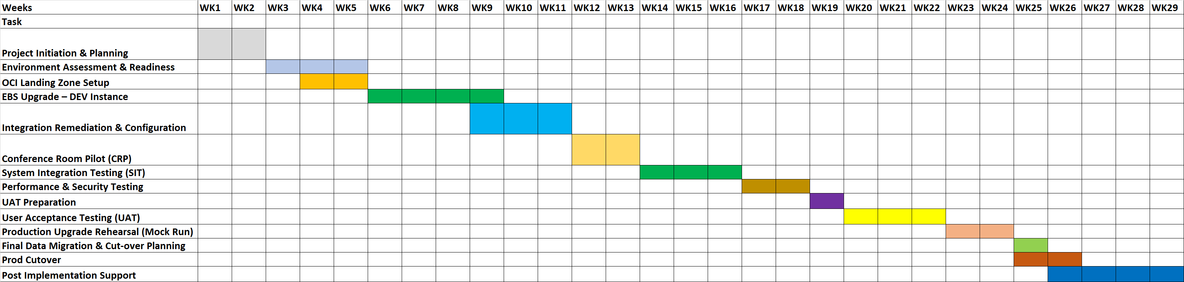

Stakeholder Availability Considerations
To align with IAA staff availability:
- UAT sessions will be conducted in staggered batches across Finance, Procurement, SCM and Integration modules
- SIT and CRP walkthroughs will be scheduled during agreed business-user engagement windows
- Production cut-over will be planned during a low transactional activity period (e.g., weekend / fiscal close-off window)
- Steering Committee reviews will be conducted at the end of each milestone phase

Proposed Staffing
Resumes will be provided under confidential separate cover once the project timeline has been finalized.
All iteria resources are employees of iteria and are seasoned professionals who are hand selected for projects based on skillsets, location, and cultural fit. iteria does not staff projects based on “bench” and does not just randomly assign resources to RFP responses. We look at multiple aspects and fit before assigning resources.
Our typical staffing for projects of this nature is:
Professional Profiles & Certifications
- Oracle EBS R12 Certified Implementation Specialist
- Oracle Cloud Infrastructure Architect Professional
- OCI Foundations Associate
- PMP Certified Project Managers
- Oracle Database Administration Certified Professionals
- Years of experience (7+yrs–20+ years for Leads)
- Number of Oracle EBS upgrade projects delivered: 4
- Number of OCI migration engagements completed: 3

- Organizational Chart
  - 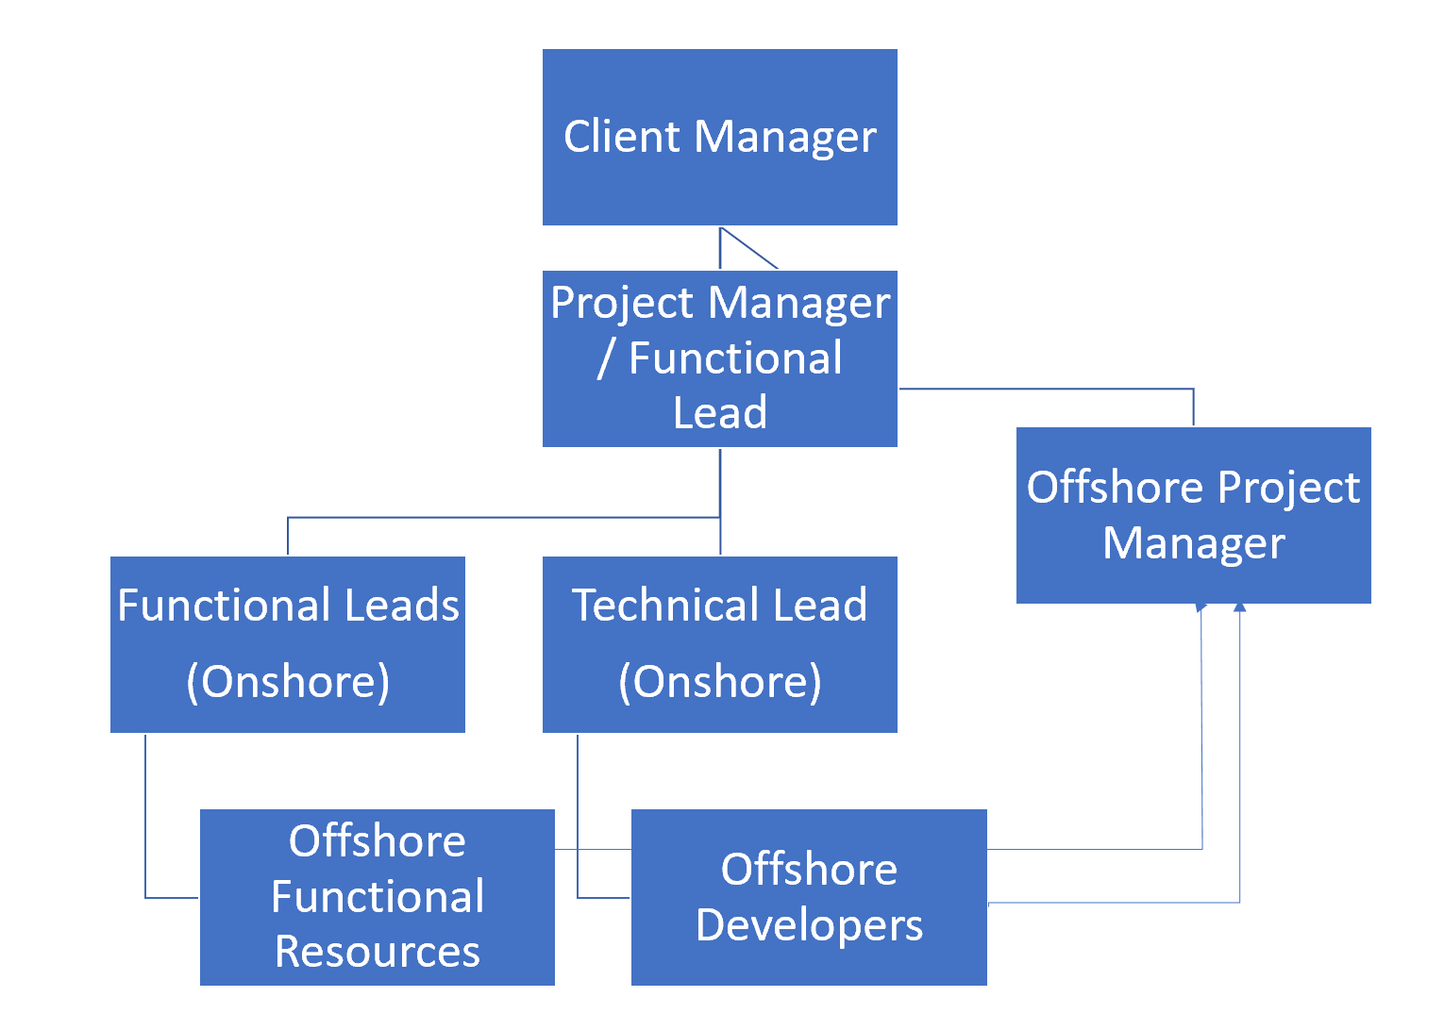
iteria roles specifically for the IAA Upgrade Project include:
To successfully deliver the Oracle E-Business Suite (EBS) upgrade and migration to
Oracle Cloud Infrastructure (OCI), ITERIA.US proposes a structured, role-based staffing model consisting of executive oversight, project governance, functional consulting, technical architecture, integration specialists, and cloud infrastructure experts.
The staffing plan ensures:
- Strong governance and executive accountability
- Dedicated module-level functional ownership
- Deep technical upgrade expertise
- OCI-certified cloud architecture support
- Clear escalation and communication channels
- Balanced onshore-offshore delivery model

Executive & Governance Layer
1. Executive Sponsor (iteria.us – Onshore)
Role: Strategic Oversight
Responsibilities:
- Executive-level governance
- Risk mitigation oversight
- Steering Committee engagement
- Contractual compliance assurance
- Escalation resolution

2. Project Manager / Lead (Onshore)
Role: Overall Project Accountability / Architecture
Responsibilities:
- End-to-end delivery ownership
- Budget and resource governance
- Milestone validation
- Executive reporting to IAA leadership
- Cross-functional alignment
- Project planning and scheduling
- Resource coordination
- RAID log management (Risks, Assumptions, Issues, Dependencies)
- Weekly status reporting

3. PMO Analyst (Offshore)
Role: Project Coordination & Documentation
Responsibilities:
- Meeting minutes and documentation
- Timeline tracking
- Action item follow-up
- Reporting dashboard maintenance
- Offshore Team Coordination
- Issue / Task Tracking

4. Finance Functional Lead (Onshore)
Functional Consulting Team
Each functional lead will be responsible for module-specific upgrade validation, configuration, testing support, and user enablement.
Modules:
- General Ledger (GL)
- Accounts Payable (AP)
- Accounts Receivable (AR)
- Cash Management (CM)
- Fixed Assets (FA)

Responsibilities:
- Upgrade impact assessment
- Configuration review
- Financial reconciliation validation
- UAT coordination
- Business process revalidation

5. Procurement & SCM Lead (Onshore)
Modules:
- Purchasing
- iProcurement
- Inventory
- BOM (if applicable)

Responsibilities:
- Procurement workflow validation
- Supplier interface validation
- Inventory reconciliation
- Integration validation

Technical & Upgrade Team
6. EBS Technical Architect (Onshore)
Role: Upgrade Strategy Owner
Responsibilities:
- R12.2.3 to Latest EBS upgrade planning
- Online patching validation
- Custom code remediation
- Object impact assessment
- Performance tuning strategy

8. Apps DBA Lead (Offshore)
Responsibilities:
- EBS patching and upgrade execution
- ADOP cycle management
- Cloning strategy
- Backup & recovery planning
- Database performance tuning
- Production cutover execution

9. Technical Developer (Offshore)
Responsibilities:
- Custom object remediation
- Report validation
- Interface adjustments
- Workflow customization review

OCI & Infrastructure Team
10. OCI Cloud Architect (Onshore)
Responsibilities:
- OCI Landing Zone design
- Network architecture planning
- Security configuration
- Load balancer configuration
- DR architecture design

OCI Infrastructure Engineer (Offshore)
Responsibilities:
- Compute provisioning
- Block volume setup
- Storage configuration
- IAM role configuration
- Backup automation setup

Integration Team
Integration Architect (Onshore, FTE)
Responsibilities:
- Third-party system integration strategy
- API and SFTP architecture validation
- Middleware configuration
- Endpoint migration planning

Interface Developer (Offshore)
Responsibilities:
- Interface code updates
- Endpoint redirection
- Error handling enhancement
- Integration testing support

Testing & QA Team
QA Lead (Onshore, FTE)
Responsibilities:
- Test strategy preparation
- SIT coordination
- UAT governance
- Defect tracking oversight

Test Analyst (Offshore, FTE)
Responsibilities:
- Test script preparation
- Execution support
- Defect documentation
- Regression validation

Resource Classification
Role Category | Resource Type
Executive Sponsor | Full-Time Employee (Onshore)
Program Director | Full-Time Employee (Onshore)
Project Manager | Full-Time Employee (Onshore)
Functional Leads | Full-Time Employees (Onshore)
Technical Architect | Full-Time Employee (Onshore)
OCI Architect | Full-Time Employee (Onshore)
Oracle Apps DBA | Offshore Dedicated Resources
Oracle Developers | Offshore Dedicated Resources
QA Analyst | Offshore Dedicated Resources

Staffing Model Summary
The proposed staffing approach ensures:
- Dedicated module ownership
- Strong technical upgrade expertise
- Certified OCI cloud architecture support
- Controlled offshore delivery efficiency
- Clear accountability and governance

  - IAA Staffing Expectations
Project Governance:
Governance Level | Key Responsibilities | Participants | Meeting Frequency
Executive Steering Committee | Strategic decisions, budget approvals, scope changes | IAA IT Leadership, iteria.us Executives | Monthly
Project Management Office (PMO) | Track progress, resolve risks, approve changes | IAA Program / Project Manager, iteria.us Project Manager / Lead | Bi-Weekly
Technical Working Groups | Execution, troubleshooting, sprint reviews | IAA IT Team, iteria.us Engineers | Weekly

Note: This phased timeline ensures a structured upgrade and migration path while maintaining operational continuity for Indianapolis Airport Authority’s critical business functions.

  - Staffing Assumptions and Dependencies
  - iteria typically does not use sub-contractors and has no intention at this time.
  - iteria’s methodology does account for the use of both on-shore and offshore resources.
  - Based on IAA’s response to the questions regarding acquiring the software and that IAA will be purchasing the software via its existing provider, the following components will be required in order to complete the project and will be IAA’s responsibility to purchase / license the below components:
- OCI Service | Global Product Code (GPC) | Purpose
Compute -Virtual Machine | B88328 | App Tier / DB Tier
Compute -Bare Metal | B88330 | High Performance DB
Block Volume Storage | B88331 | DB + Apps FS
Object Storage | B88332 | RMAN Backup
Load Balancer | B88333 | EBS External Access
Site-to-Site VPN | B88334 | On-Prem Connectivity
FastConnect | B88335 | Dedicated Network
File Storage Service | B88336 | Shared APPL_TOP
Monitoring Service | B88337 | Infra Monitoring
Logging Service | B88338 | Audit Logs
Oracle Integration Cloud (OIC) | B88341 | Interfaces (Middleware)

Staffing Management and Continuity
iteria projects are staffed with Senior Resources and Executive oversight. In the even of staff departure, the Senior Management and Executive Leadership involvement ensures the project knowledge stays with the project and the team and allows us to minimize any effect a staffing change may impact the project.

Cost Details
  - Please reference attachment- iteria Cost File.pdf
  - Expenses –
  - Travel Expenses will be reimbursed based on actuals and expense policies will fall in line with IAA policies. Travel expenses include airfare, mileage (if driving to IAA), hotels, food or per diem (based on IAA’s policy rate).
  - iteria’s methodology accounts for on-site presence during key critical times of the project. These include but are not limited to:
  - Requirements Gathering
  - Protype Sessions
  - Testing (SIT and UAT)
  - Go-Live
  - Post Implementation Support.

Optional Services
Under separate contract, iteria can offer Managed Services / Support. The scope and level of service can be finalized with IAA.
iteria’s service offerings can include any of the following:

Managed Services Scope and Process Description
iteria can provide Managed Services for the Oracle Fusion Suite of Applications. iteria has the ability to provide L1, L2, and L3 services, or as instructed, which may include testing services.
Report development can be included in scope under a Time and Materials basis; however, larger reports will need a specifications document and an hour estimate which be approved by client before development will begin.
Development enhancements should require approval by client before development can begin. iteria will provide an overview of the enhancement request, an hour estimate and will present that to the client for review and approval.
Managed Services Scope includes, but is not limited to:
- All Fusion Applications
- Testing Services
- Report Développent
- Process Issues
- ‘How to’ Issues
- Interfaces to/from other systems

Level 1 Support includes:
  - Primary review of all Support tickets
  - Initial triage of the issue(s)
  - Monitoring and error handling through the integration dashboard (OIC)
  - Schedule Jobs error handling
  - User Provisioning
  - Data Access
  - Code Combination Maintenance
  - Report Development, based on skillset

Level 2, Level 3 Support includes:
  - Complex support issues
  - Error corrections
  - Systemic Changes / Corrections
  - Monitoring and error handling through the integration dashboard (OIC)
  - Schedule Jobs error handling
  - Quarterly Patch Testing
  - Payroll Support
  - Enhancement Requests

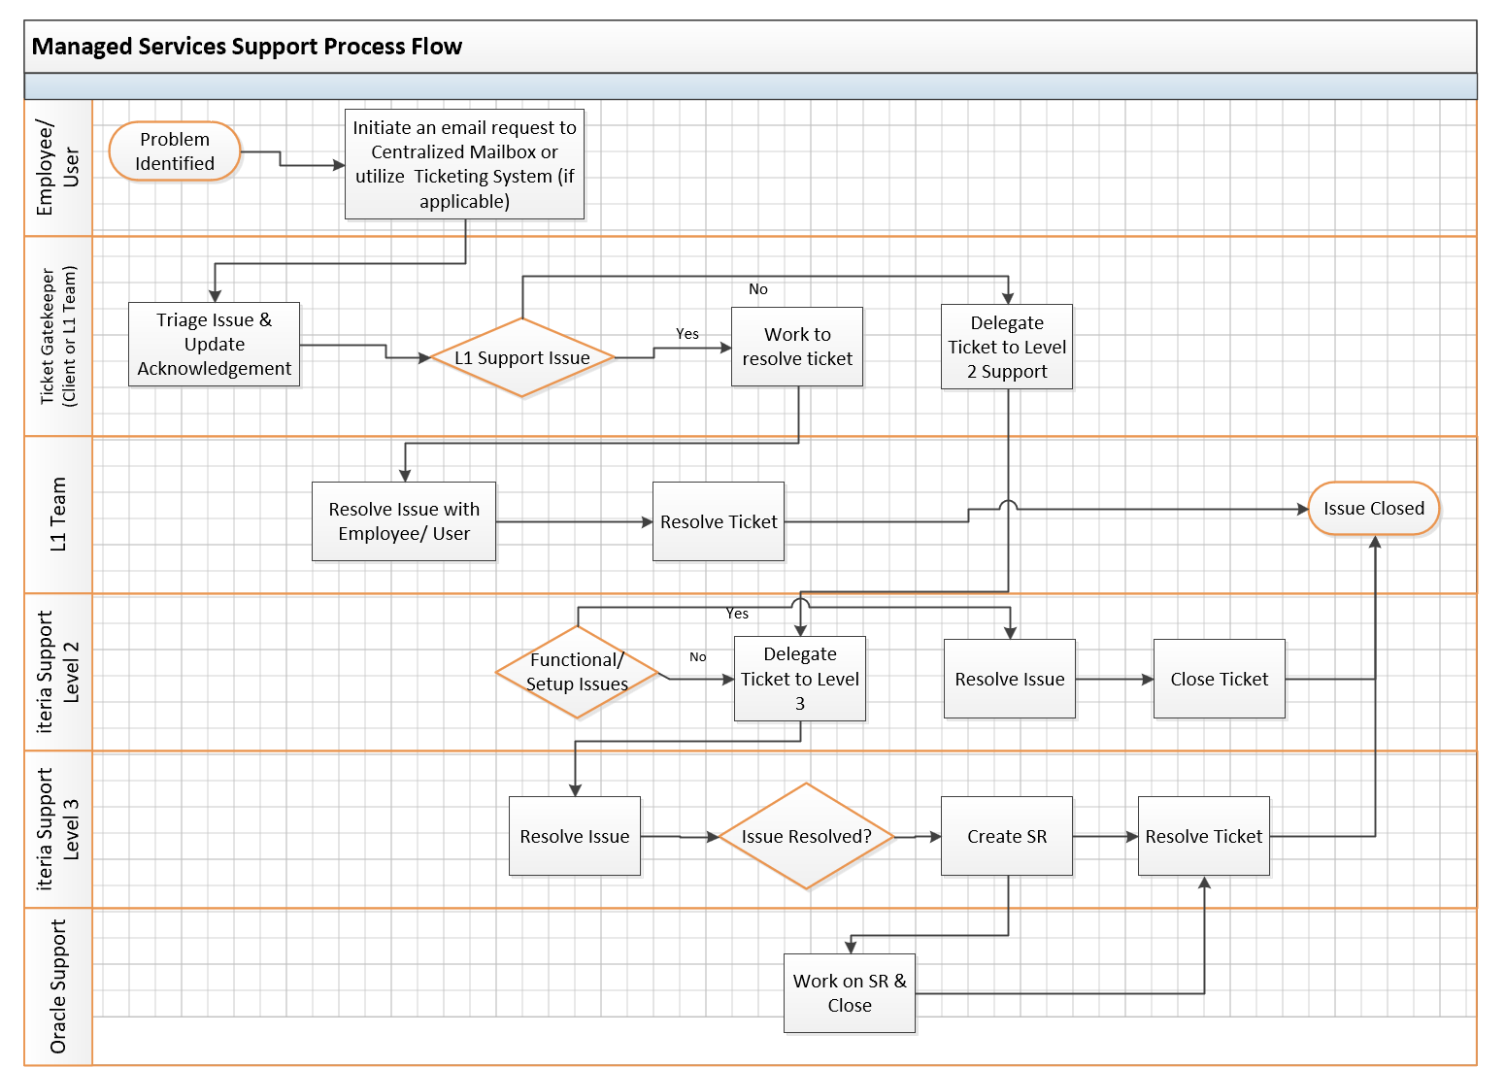

Support tickets will be emailed to a centralized support mailbox. This will go to L1 team or client’s IT Department. The ticket will be reviewed if it falls within the L1 category and/or if it can be resolved by client. If it can be resolved by client, an available representative will acknowledge receipt of the service request and begin work on the issue.
Tickets will be worked on based on the following standards:
- Severity 1 – Mission Critical Severity – there is a major cause of business disruption due to the associated ticket.
- Severity 2 – High Severity – the associated ticket is high severity and major business functions are impacted
- Severity 3 - Medium Severity – the associated ticket is of medium severity and needs to be resolved as quickly as possible.
- Severity 4 – Low Severity – the associated ticket is low severity and can be worked on as time permits.

SLA Severity Definition
1 – Critical Impact
- Application failure creates serious business and financial exposure
- The application failure impacts a large number of employees
- There is no acceptable workaround to the problem

2 – High Impact
- Application failure creates serious business and financial exposure
- The application failure impacts a large number of employees
- There is an acceptable workaround to the problem

3 – Medium Impact
- Application failure creates low business and financial exposure
- The application failure impacts a small number of employees
- There is an acceptable workaround to the problem

4 – Minimal Impact
- Application failure creates minimal business and financial exposure
- The application failure impacts couple of employees
- There is an acceptable workaround to the problem

If the ticket cannot be resolved internally or is an L2 / L3 issue, it will be forwarded to the iteria help desk. The ticket will be reviewed as to the issue and severity and will be worked on

Cost Details
Please reference attachment- iteria Cost File.pdf

Exhibit A: iteria W9 Form
