

Proposal Created For:

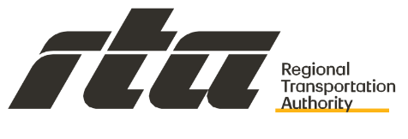

Request for Proposals (RFP)
Event No. 317 (2025) for
Human Capital Management (“HCM”) System
Software, Implementation, and Services

February 17, 2026

Contents
Cover Letter 2
Proposed Software 3
Project Approach 6
IT and Functional Requirements 6
Attachment A- IT Requirements: 6
Attachment B- Functional Requirements: 7
Project Approach and Implementation Methodology 21
Ongoing Support and Maintenance 27
Project Schedule 31
Qualifications 32
Firm 32
Appendix I – References Form 33
Key Personnel 36
Organizational Chart 36
Table of Exceptions 37
Financial Background 37
Insurance 37
Joint Venture Agreement 39
Liens, Suits and Judgments 39
Executable Forms 39
Appendix F – Non-Collusion Affidavit 40
Appendix G- Vendor/Contractor Certifications 41
Appendix H- RTA Certifications and Assurances 43

Cover Letter
To: Regional Transportation Authority

iteria – US (iteria) is pleased to present our formal response to Regional Transportation Authority HCM System Software, Implementation, and Services Solicitation
Event Number: 317 (2025)
Solicitation Title: Human Capital Management (“HCM”) System
Software, Implementation, and Services

iteria.us, a Certified Oracle Partner, was founded in 2015 as a S Corporation and is registered at the following location / state:
1712 Pioneer Ave, Suite 1983
Cheyenne, WY 82001

With satellite offices in both Wisconsin and Chicago, iteria brings localized resources to the Regional Transportation Authority.

iteria provides services only on the Oracle Corporation Suite of Applications providing implementation services, managed services / support, and custom development. iteria’s founders have been working in the Oracle circle for over 30 years and we are pride ourselves in that we focus only on Oracle technologies, offering our clients superior knowledge and skills to get you the most out of your Oracle Suite of Applications.

After serving in Executive roles across several consulting firms, iteria’s founders started iteria to bring consulting back to its fundamentals. Many firms had become overly focused on the bottom line and lost sight of their customers’ needs. iteria knew they had to bring consulting back the basics and focus on those customer’s needs.

We strive to implement solutions that not only meet but exceed our clients’ needs while preserving the integrity of Oracle Applications—ensuring future upgrades never require unnecessary rework. We specialize in integrations and build solutions that truly align with the customer’s requirements, not those that simply take the “easy route” or shortcut the process.

The Oracle applications offer tremendous flexibility, often providing multiple paths to achieve a solution. iteria specializes in dissecting those solutions and examines the impacts both upstream and downstream to achieve the desired results. This approach ultimately delivers a high-quality solution and enables our clients to fully maximize the value of the Oracle Suite of Applications.

iteria is proposing a complete solution for both software and implementation of the Oracle Corporation HCM Application. Our experience in the applications and technology of the Oracle Suite of products coupled with our consultants who specialize in the services presented in this proposal, ensures Regional Transportation Authority (RTA) has a business partner that offers the appropriate solutions and services to make sure the user experience and issues are addressed professionally and in a timely manner.

iteria has received and acknowledges the following Addendums as part of the RFP issued by Regional Transportation Authority:

Addendum No 1 released 12/18/2025
Addendum No 2 released 1/5/2026
Addendum No 3 released 1/27/2026

As part of our overall response, iteria is partnering with the following firms:
- Oracle Corporation – Developers of Proposed Software
- Mythics LLC. – Reseller of the Oracle Software Licensing

We understand that this process is of great importance, so we thank you for the opportunity you have given us and are confident that this relationship will be to the benefit of both organizations.

We look forward to working with Regional Transportation Authority during your RFP Selection Process.
Sincerely,

Brian Schell
President & CEO
630-240-4072
brian.schell@iteria.us

Proposed Software
Human Capital Management Overview
HCM Base Cloud - Key Features
- Manage a diverse workforce using a single global person record
- Comprehensive position management and multi-tier working relationships
- Robust and extensible workflow, approvals, and delegation engine
- Built-in extensibility to accommodate specific business requirements
Oracle Cloud HCM is a complete suite for Employee Data and People Processes, designed to support the employee life cycle from hire to retire by providing the innovation, scalability, and security the organization needs today and in the future. It is built natively in Cloud, relying on a single underlying data, security, and workflow model which ensures that employee information stays current, accurate and safe across all people processes. The Oracle solution is comprehensive connecting every human resource process, and every person, to make work more human and organizations more agile.
Oracle HCM transforms the traditional administrative functions of HR departments—recruiting, training, payroll, compensation, and performance management—into opportunities to drive engagement, productivity, and business value. The industry’s most complete cloud solution enables organizations to simplify managing people and build the best talent. Organizations can manage growth while adapting to needs through an HR foundation and gain actionable insights so they can execute the best talent management strategies. A simple, user-friendly experience and embedded role-based decision support transform the system from a transactional to an intelligence-driven application.
Each employee in the organization will have a single centralized location where all information about that employee is stored, including the following:
- Personal Information – Photo, name, address, phone numbers, contact
- Professional Information – Competencies, skills, willingness to relocate, work history, trainings/learnings, education
- Compensation/Salary History – Current and past compensation details
- Job History – Current and past job role details (transfers, promotions, terminations, rehires)
- Documents of Record – Paystubs, licenses, certifications
- Performance History – Goals, reviews, succession plan histories
Benefits Administration - Key Features
- Design benefit programs suited to the County’s strategy and organizational culture
- Implement the County’s benefits policy using Fast Formulas
- Re-useable sets of eligibility criteria
- Complete benefits enrollment processing
- Flex credits
The benefits the County offers tell employees and candidates about the type of organization the County is and the County’s culture. With the configuration and flexibility, Oracle Benefits enables the County to evolve and adapt benefits to the unique needs of the County’s workforce, and market conditions, to form an integral part of any compensation package and flexibility from one size fits all plans to highly tailored and targeted benefit packages that selectively target different segments of the workforce with different benefit packages.
In Oracle Benefits, participants can:
- Compare benefits and make selections based on eligibility rules
- View and accept configured terms and conditions
- Elect coverage for themselves and their dependents
- Select primary care physicians for applicable plans
- View and print a confirmation statement
- Complete additional certifications or designation action items

Workforce Compensation - Key Features
- Compensation Plans can quickly be created, modelled, and rolled out to meet changing business needs
- Compensation Budgets can be rolled up or down across the organization
- Data modeling and entry in a spreadsheet environment
- Embedded analytics
- Total Compensation Statements
Paying employees correctly is key to staff retention and performance. With Oracle Cloud HCM, the organization can manage and control individual salaries, bonuses, and incentives. Even complex collective agreements dictating seniority-based processing rules to higher salary grades or grade steps is supported, giving the County a complete tool set to meet the needs of different worker populations. Oracle Compensation includes a robust set of compensation components which can be used to define, model, and implement compensation practices for all the County’s employees. These compensation elements include:
- Base Pay
- Salary Basis
- Grade Step Progression
- Individual and Workforce Compensation
- Total Compensation Statement

Payroll - Key Features
- Rules-based payroll solution
- Payroll dashboard for strategically managing payroll processes
- Payroll cycle flows and checklists with embedded analytics can include your specific steps
- Complete control over processing rules with Fast Formula
- Automated retroactive processing
Oracle has made payroll simpler and smarter by uniting Payroll, HCM, and Time and Labor (T&L) within a single platform. Oracle Payroll is a powerful and flexible application that will give payroll professionals more control over processes and data. For example, payroll professionals can access and audit data continuously throughout the payroll cycle instead of waiting until pay period close. In addition, Oracle Payroll offers self-service on any device where employees can view pay slips, update banking information, view year-end statements, and much more.
Oracle Payroll is fully integrated with Oracle Sub Ledger Accounting and Oracle Cash Management. This integration allows standardization, automates processes, and rationalizes systems to increase operational efficiency. Oracle Sub Ledger Accounting allows multiple accounting representations for a single business event, resolving conflicts between corporate and local fiscal accounting requirements. It retains the most granular level of details in the accounting model, with different summarization options in the General Ledger, allowing full auditability and reconciliation. This increases the transparency and enables full auditability of the transaction and accounting data.

Absence Management – Key Features
- Manage holiday schedules
- Define absence plans and entitlements to meet the County’s policies
- Easily configure workers’ eligibility for plans and entitlements
- Capture planned and unplanned absences
- Proactively monitor absence trends
Managing absence can be complex, with multiple plans, overlapping entitlements and variations. Absence management in Cloud HCM has been designed to improve the efficiency of absence tracking by providing end users with an engaging and simple experience when requesting leave and checking their vacation balance.
Time and Labor - Key Features
- Quick and Easy Time Entry and Submission
- Comprehensive & Configurable Timecard Capabilities
- Configurable Real-Time Rules Engine
- Flexible Time Entry Approvals
Oracle Time & Labor is a comprehensive, easy-to-use, rules-based time recording and management system designed to give the County maximum visibility and control over its most valuable asset: its people. It’s a configurable and flexible module which helps the County accurately capture worked time, manage schedules, handle time-card approvals and administer various otherwise time-consuming tasks.
Oracle Time & Labor uses standard approval mechanisms for managing timecard approvals. The delivered approval styles of line and project manager can be used as is or extended to multi-level or more complex routing as required. A mass timecard approval capability enables a group of timecards to be reviewed at summary level and approved in one click.

Career Development - Key Features
- Explore roles in the organization to cover potential opportunities
- Identify future potential roles as careers of interest
- Build a development plan and goals directly tied to careers of interest
- View and complete related learning to address gaps in skills and competencies
- Comparisons of job and employee profiles such as competencies, licenses, degrees, languages, and other job requirements, can identify the best-fit person for a job or vice-versa
Talent management encompasses a wide variety of processes related to performance, skills, and people development. Having the tools to grow, motivate, and encourage employees to deliver against objectives long term, directly impacts the bottom line, and drives important HR deliverables like retention, engagement, and employee experience.

Career Development capabilities will allow the County to:
- Help employees progress in their careers and identify career opportunities in line with their skills and interests
- Enable internal talent mobility by eliminating skills gaps, employing recommended learning, relevant to the employee’s role and interests
- Leverage embedded collaboration capabilities to connect with mentors and identify and network with colleagues in interesting roles to gain first-hand experiential information about careers of interest.
Dynamic Skills - Key Features
- Detect, standardize, and recommend skills for employees
- One centralized place to view & manage skills and development
- Personalized, AI-driven resources to help employees grow
- Enriched talent processes via AI-powered skills suggestions
- Effectively manage talent supply chain
Skills are at the core of every talent process in an organization; they are the fuel that powers An organization’s health, growth, and agility. Using skills to underpin talent processes creates an equitable approach to hiring, promotion, and development and improves productivity in the organization.
Learning - Key Features
- Create media rich tutorials comprised of video, formal learning, documents, or external sources
- Embed learning in HR and talent processes
- Personalized learning recommendations drive employee engagement and upskilling efforts across the organization
- Learn how you wish through easy content accessibility anytime, anywhere including offline
- Empowered learning initiatives - Empower subject-matter experts to create learning communities and initiatives without relying on learning and development staff
Oracle Learning natively combines bite-sized, peer-to-peer social learning with comprehensive support for the management and delivery of corporate online and in-class learning and compliance programs. Users can easily identify all their required learning and ensure they comply. Our advanced recommendation engine analyzes all the engagement data around different learning items and combines it with the user’s profile to generate highly relevant learning recommendations.
Learning Connect
Oracle Cloud HCM learning library has full native support for learning content resources like SCORM, AICC, pdf-files, assessments, videos, weblinks and more.
To further enhance the learning experience and leverage suite benefits while enjoying content from various training providers, Cloud HCM can be extended with Learning Connect which is a set of out-of-the-box integrations to popular learning providers like Skillsoft, LinkedIn Learning, Intuition, Biz Library and Open Sesame.
Talent Review and Succession Planning - Key Features
- Talent review dashboard with full page views of succession plans, talent pools, and analytics
- Comprehensive administration and management of meetings including pre-meeting tasks for participants
- Custom fields to store specific information about talent review meetings
- Visibility options for talent review meeting notes and tasks
- Succession plans by job, position, or incumbent

Performance Management - Key Features
- Complete Goal Tracking - Track progress and results for the team or organization throughout the whole year with Goal Plans that are automatically assigned to the employees based on eligibility profiles. Allow employees to add new or library goals to accommodate their own objectives. View and update goals from anywhere on a smartphone with mobile responsive goals. Managers will be able to quickly see the status of the goals of their direct reports, to coach and guide them towards completion
- Collaborate & Align – Employees will have the ability to share goals with their peers which will foster more collaboration and foster a common purpose. Organizational goals can be published to share the strategy across the business and at all levels
- Tie goals to skills and certifications - Tracking personal growth for career development by linking goals to competencies, creating goal-related tasks with tangible action items, enabling employees to set both development and performance goals to support their career growth are key to driving productivity across the organization
- Meaningful evaluation of goals & competencies - The seamless integration of Goals and Performance Management within Oracle Cloud HCM enables the County to always be up-to-speed with point-in-time evaluations of goal achievements. The embedded analytics will give invaluable insights to managers and executives, enabling them to have a unified view of the people, monitor progress and act as needed

Project Approach

IT and Functional Requirements
Complete the IT and Functional Requirements (Attachments A and B) as part of the Technical Proposal. To complete the matrix, each proposer must assign one of the four (4) codes defined in the table below, by selecting the vendor response from a drop-down menu. Clarifying comments can be added in the “Comments” field to provide additional information or context related to the availability of the functionality.

Attachment A- IT Requirements:
ATTACHMENT A
IT Requirements
IT Requirements |  | Mandatory or Desirable  (Select an answer from the drop-down options) | Vendor Response (Select an answer from the drop-down options) | Vendor Comments
1 | The system must have both password and transmission security (active directory pass through authentication from network) with SSO, that restricts access to system and detects and flags any  errors during the electronic transfer | Mandatory | Yes
2 | The system must have the ability to receive secure data  transmission over the internet | Mandatory | Yes
3 | Menu driven with on-screen prompts and help screens throughout to  guide users through the processing operations | Mandatory | Yes
4 | Validation mechanisms to ensure that all data is correct when  entered | Mandatory | Yes
5 | Input and output controls, acceptable for balancing, control totals  and related measures as incorporated into the HRIS | Mandatory | Yes
6 | While the system will be cloud based, each proposer shall specify any hardware and software requirements needed to operate its  system successfully | Mandatory | Yes
7 | Each proposer shall certify that its system can import data generated by another system. Proposers must specify file formats that are acceptable. In addition, each proposer shall certify that its system can download any information stored in it to any of the common  report writing software products | Mandatory | Yes with configuration | Using a middleware like Oracle Integration Cloud
8 | Each proposer shall provide associated costs for data migration from current system to their system. We will decide the amount of data to  migrate after the proposals are received | Mandatory | Yes
9 | Each proposer shall provide options for file integrations between its  system and other 3rd party systems | Mandatory | Yes
10 | Mobile friendly with the ability to access and complete from any  electronic device | Mandatory | Yes
11 | Each proposer shall identify if their system offers a mobile  application for iPhone and/or Android | Desirable | Yes
12 | Each proposer shall identify the schedule and details around if  system updates occur impacting the HRIS availability online | Mandatory | Yes
13 | The system should provide controlled access to data based on user  roles and permissions. | Mandatory | Yes
14 | The system should maintain comprehensive audit trails of user  activity, including logins, data access, and modifications. | Mandatory | Yes
15 | Integrate with Microsoft network | Mandatory | Yes
16 | Configurable role-based security | Mandatory | Yes
17 | Data Conversion & Mitgration - Support historical data migration  from current payroll system and HR and benefits platforms | Mandatory | Yes | Cleansing of the data will be RTAs  responsibility

Attachment B- Functional Requirements:
Please see attachment: iteria ATT_B_FunctionalRequirements_Final Response.xlsx

Project Approach and Implementation Methodology
Provide a detailed strategy and approach to implementing the product solution. Provide details about the project plan, milestones, training, and change management strategies.
iteria’s Overall Implementation Approach
iteria.us proposes a step-by-step approach with its implementation methodology to complete the implementation and development of the assigned tasks. As part of our methodology, iteria.us will:
- Conduct a Boundary Confirmation session to discuss RTA’s overall goals both near term and future to better plan for an overall implementation approach.
- Perform Solution Analysis sessions with the business to cover overall requirements.
- Document / Review the requirements and the solution with the Business Users
- Obtain sign-offs and approvals from the business
- Upon approval of solution, begin development
- Evaluate the data and the roadmap for conversion
- Review and design interfaces
- Conduct smoke testing
- Conduct multiple prototype sessions
- Support User Acceptance Testing
- Provide Train-the-Trainer training
- Develop / provide complete configuration documentation
- Review final output with Business and get final sign-offs

Embedded within our overall approach, you will find specific details around:
- Overall Project Management approach
- Configuration and process design approach
- Data conversion
- Interface approach
- Testing approach
- Training approach
- Final cutover/transition to new system

Scope and Deliverables
Based on the requirements provided by RTA and the modular footprint provided in the RFP, iteria has prepared a high-level timeline and implementation schedule for the HCM Project.
The following section describes our overall Implementation Methodology:
- Overall Project Management
- Reviewing key decisions and integration points from the Requirements Sessions
- Business Process Re-engineering
- Data Extraction and Cleansing
- Solution development
- Interface Review and Development
- Testing
- Training
- Go-Live Cutover
- Post Implementation Support
- Managed Services

Overall Project Management
Projects of this magnitude are most successful when a full‑time Project Manager is dedicated to driving progress, maintaining alignment, and ensuring the delivered solution meets the needs and expectations of end users. This role is essential for keeping requirements clear, decisions timely, and the project moving with purpose.
While Fusion implementations typically avoid heavy customization, they still require thoughtful evaluation of business processes and key decision points. These decisions drive configurations to insure the system is configured to truly support RTA.
iteria’s methodology is built around delivering the best solution for our customers. We take pride in extending the applications without customizations whenever possible, ensuring the system works for RTA while preserving Oracle’s upgrade path.
iteria’s Project Manager partners closely with RTA’s PM and functional leads to keep the project on track, ensure decisions are well‑informed, and confirm that RTA’s needs remain front and center throughout the implementation.

Requirements Sessions
Requirement sessions are RTA’s opportunity to define the system and business needs for your new HCM solution. iteria’s methodology centers on detailed, collaborative sessions that walk-through RTA’s day-to-day activities—not simply filling out a spreadsheet of wants and needs. We meet directly with RTA staff to review current functionality, identify gaps, and understand the business processes that drive your operations.
A key differentiator in iteria’s approach is the depth and breadth of our functional expertise. Our leads are cross-trained across multiple modules, enabling them to guide discussions with a full understanding of how decisions in one area impact upstream and downstream processes across the Oracle Suite. This integrated perspective helps avoid conflicting requirements and ensures the solution is designed holistically rather than in isolated silos.
Our approach encourages active participation from RTA during requirements and solutioning sessions. By asking targeted, product-informed questions specific to RTA’s operations, we help drive toward a more complete and sustainable solution. Because Oracle’s applications are naturally integrated, recognizing how a decision in one module affects another is essential to building a configuration that works end-to-end.
iteria’s methodology ensures these sessions are not passive reviews but active working sessions that shape configuration choices, highlight opportunities to refine business processes, and ultimately deliver a more complete, efficient, and future-ready solution.

Business Process Re-engineering
Business process re-engineering will be essential for this project. To fully leverage the capabilities of the Fusion platform, processes must be evaluated through the lens of RTA’s business needs and aligned with the realities of a modern Cloud environment. In some cases, this will require adjusting existing processes; in others, long-standing practices may need to remain in place, and the software must be configured to support them.
iteria works closely with RTA to review current processes, identify where change is beneficial, and ensure decisions are driven by business value—not by “the way it has always been done.” At the same time, we recognize that certain processes cannot change, and our team is skilled at configuring Oracle applications to accommodate those requirements without introducing customizations.
Our ability to think creatively, maximize the native capabilities of Oracle Fusion, and design solutions that balance innovation with operational reality is one of Iteria’s core strengths.

Data Extraction and Cleansing
The Fusion applications support open API technology, enabling flexible and efficient data conversion. While conversion data is often initially provided in spreadsheet format, populating a spreadsheet is only one step in the overall conversion process. iteria develops the extraction routines required to transform source data into the templates needed by Oracle HCM Cloud.
Data cleansing is a critical component of the conversion effort and will require participation from RTA staff to scrub, validate, and confirm the accuracy of the data. iteria will work closely with RTA’s team to make informed cleansing decisions and ensure the data meets the quality, formatting, retention, and compliance standards defined by RTA.
Depending on the outcomes of the Requirements Sessions, new data structures may be introduced as part of the future-state system. When this occurs, translations between legacy and new values will be required. As part of iteria’s approach, we partner with RTA to identify the data that must be converted and build the necessary extraction and translation routines to map old structures to new ones.

Solution Development
iteria.us will provide detailed solution process-flow documentation that outlines not only the system configuration but also the end-to-end business processes that RTA can follow once HCM Cloud is live. These solution documents will serve as the foundation for developing comprehensive testing plans, training materials, and execution schedules.
The documentation will also identify any gaps within the Fusion applications and clearly describe how those gaps will be addressed—whether through approved extensions or personalization’s. This ensures full transparency around solution design decisions and provides RTA with a complete view of how the final system will operate

Interface Development
As part of our overall solution, iteria has included the Oracle Integration Cloud (OIC) as the middleware. The middleware tool is the gateway tool to manage integrations to / from third-party systems. We are proposing the middleware as a central repository tool so transactions can be tracked and errors identified.
In addition to OIC, native integration tools allowing customers to build their own integrations include:
- RESTful APIs are available for near-real-time integration
- SOAP web services are available
- Flat file loader tools
- Flat file extract tools
- ATOM feeds are triggered by events that occur about status of selected data elements.
Data formats supported include XML, JSON, CSV, XLS, etc.
For EDI, Oracle Cloud Applications supports XML out-of-the-box. EDI can be enabled using Oracle Platform-as-a-Service (PaaS). Third-party products can map EDI into XML. The approach described is a commonly implemented mapping.

The middleware is a very powerful tool and provides us the technology to perform functions inside the middleware to perform look-ups or manage / handle the data, as needed. This allows us to account for system deficiencies or minimize re-work of your legacy applications or systems. As an example, if you had data with certain values, old COA, old element names, and you do not want to re-configure your legacy system, via the middleware we are able to perform a translation so the data can flow to / from Oracle and the third-party system without a need for a re-write.

Additionally, as part of our methodology, accounting for / planning for errors is an important facet of our approach. When developing interfaces, it is critical that you plan for errors. Interfaces are great until the data fails. Capturing and identifying errors is usually an afterthought, only after it occurs. During interface planning / development, iteria’s methodology accounts for error handling up front. We will walk the teams through the processes and identify the types of errors we can expect and build / document the process for each interface as to how errors are captured and who should be notified, and where the corrections should be made.

The methods of how interfaces are built / sent is defined for each interface. Some may be SFTP, EDI, or flat file even. We will review each interface for the types of data as well as the methods and protocols that are supported for each one.

Testing
Testing is a critical component of the project and is Regional Transportation Authority’s opportunity to make sure the system is configured to transact business based on requirements and the configured solutions / approaches. iteria’s methodology includes numerous testing phases of the project:
- Conference Room Pilot (CRP)
- System Integration Testing (SIT)
- User Acceptance Testing (UAT)

During these phases, RTA will test concepts, processes, and system functionality to various degrees. Users will follow detailed test scripts, document the results, and a tracking system will be used to track any issues or defects.
Successful testing is based on having well defined testing scripts and coordinating internal resources so test cases are executed in a timely manner. iteria will provide overall guidance and tracking services during the testing phases of the project to assist in coordinating RTA’s resources and to work to make sure issues are rectified.

Training
The best coordinated project can be deemed a failure if the staff is not properly trained. iteria is proposing a “train-the-trainer” methodology, where we will train key users or “super users” who will then be responsible to train RTA’s end user population. As part of our approach, we will work with RTA to help assess the capabilities of RTA staff.
- Does RTA have people that are capable of conducting training?
- Knowing the skillsets of your users, what training methods / materials are best suited for your staff?
- Does your internal staff have the bandwidth to conduct training during the project in the allotted time frame?
- Do you have facilities where training can be conducted?

Preparing for these types of questions early on in the Project Plan / Methodology will minimize any surprises and help alleviate any unnecessary change orders and cost overruns. If RTA does not have the bandwidth to internally review these types of questions, iteria can provide assistance in this area as part of our overall Project Management Services.

Go-Live Cutover
Cutover weekend / Go-Live is a multi-day 24 X 7 process. This requires a detailed Business Continuity Plan and strong coordinated efforts in order to be successful. Items that need to be addressed during this cycle can include:
- Data extracts and conversion processes
- Following the Business Continuity Plan
- Accounting for downtime during the process.
- Shutting down legacy applications
- Re-directing interfaces
- Coordinating access to the facilities 24 x 7
- Final configuration review
- Coordinating the go / no-go decision

As part of our overall Project Management Services, iteria works with RTA for the Go-Live Cutover to make sure the Cutover Plan is being followed, ensuring the communication channels are open to RTA’s Executives during the process as we work through the extractions and preparing of final data for conversion and final configurations.

Support / Help Desk
iteria has proposed / budgeted post implementation support services as part of the initial contract. We have included 4 weeks of post implementation support as part of our overall proposal. During this phase, iteria serves as L1, L2, L3 support as well as does knowledge transfer to RTA’s staff as part of the transition.

Ongoing Support and Maintenance
Provide information on ongoing support and maintenance including copies of any agreements that your firm would require signing and the standard SLA document. All documents will be subject to negotiations. The proposal must detail how support will be provided when changes/configurations need to be updated and how support will be provided when advanced technical support is required.
Proposal shall outline when additional costs and/or time that will be required. Include additional details about the following:
- Discuss escalation paths for system issues, including critical system-wide issues. Discuss the experience level of the personnel within each of these escalation paths.
- Discuss frequency of system improvements and configuration changes.
- Explain the communication process used to provide status updates to users.
- Discuss how complex system issues are managed.
The response must also contain a proposed timeline for completing the tasks as applicable.
As previously mentioned, iteria has included post-implementation support services as part of the initial contract, providing four weeks of dedicated assistance following go-live. During this period, iteria serves as the primary L1, L2, and L3 support resource while also conducting structured knowledge transfer to RTA staff to ensure a smooth transition.
Our support model leverages both onshore and offshore teams, enabling around-the-clock coverage. iteria typically utilizes a ticketing system to log and track all support issues, ensuring transparency and timely resolution. In addition, our team will be on-site for the full 30-day post-implementation support window, working directly with RTA staff to address questions and resolve issues in real time as they arise.
This combined approach ensures continuity, rapid response, and a seamless handoff to RTA’s internal teams.
Once the Post Implementation Support Phase is completed, iteria will migrate to Managed Services.
Under the Managed Services Agreement, iteria offers / can provide the following and/or any combination thereof:
- L1, L2, L3 Support
- Regression Testing Support

Under iteria’s support module, we go beyond just supporting the Oracle Software, but support your processes, access control, data errors, interface errors. Additionally, we can support your “how to” questions that may arise from your end-users. iteria’s services are broken down as follows:

Level 1 Support includes:
- Primary review of all Support tickets
- Initial triage of the issue(s)
- Monitoring and error handling through the integration dashboard (OIC)
- EDI error handling
- Coordination and Primary Lead of Quarterly Patching Testing

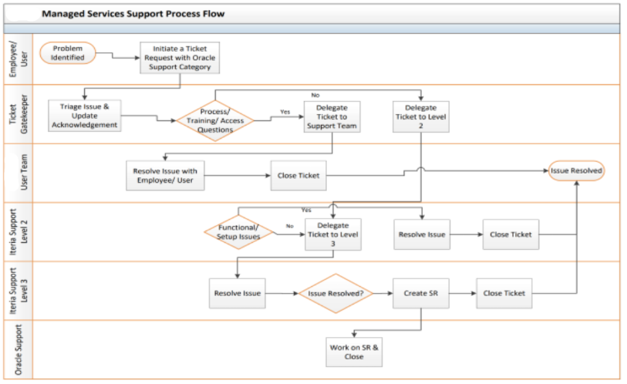
An available representative will acknowledge receipt of the service request and begin work on the issue.
Tickets will be worked on based on the following standards:
- Severity 1 – Mission Critical Severity – there is a major cause of business disruption due to the associated ticket.
- Severity 2 – High Severity – the associated ticket is high severity and major business functions are impacted
- Severity 3 - Medium Severity – the associated ticket is of medium severity and needs to be resolved as quickly as possible.
- Severity 4 – Low Severity – the associated ticket is low severity and can be worked on as time permits.

The following SLA Response time will be followed:
- Severity 1 – iteria consultants will respond within 1 hour of receiving notification and begin working on the issue.
- Severity 2 – iteria consultants will respond within 4 hours of receiving notification and begin working on the issue.
- Severity 3 – iteria consultants will respond within 8 hours of receiving notification and begin working on the issue.
- Severity 4 – iteria consultants will respond within 16 hours of receiving notification and begin working on the issue.
SLA Severity Definition
1 – Critical Impact
- Application failure creates serious business and financial exposure
- The application failure impacts a large number of employees
- There is no acceptable workaround to the problem

2 – High Impact
- Application failure creates serious business and financial exposure
- The application failure impacts a large number of employees
- There is an acceptable workaround to the problem

3 – Medium Impact
- Application failure creates low business and financial exposure
- The application failure impacts a small number of employees
- There is an acceptable workaround to the problem

4 – Minimal Impact
- Application failure creates minimal business and financial exposure
- The application failure impacts couple of employees
- There is an acceptable workaround to the problem

iteria is flexible in defining what the scope of services are ultimately decided as part of Managed Services.

Project Schedule
iteria has proposed a 9-month project schedule based on the expected growth indicated by the RTA (July 2026 – April 2027). This would allow for requirements gathering for the rules needed for the additional staffing.
The approach can be reviewed and finalized as part of detailed discussions. If the existing counts of 100 people are only to be considered this could be reduced to 6 months (July 2026 to January 2027 Go-Live and reduce overall implementation costs.

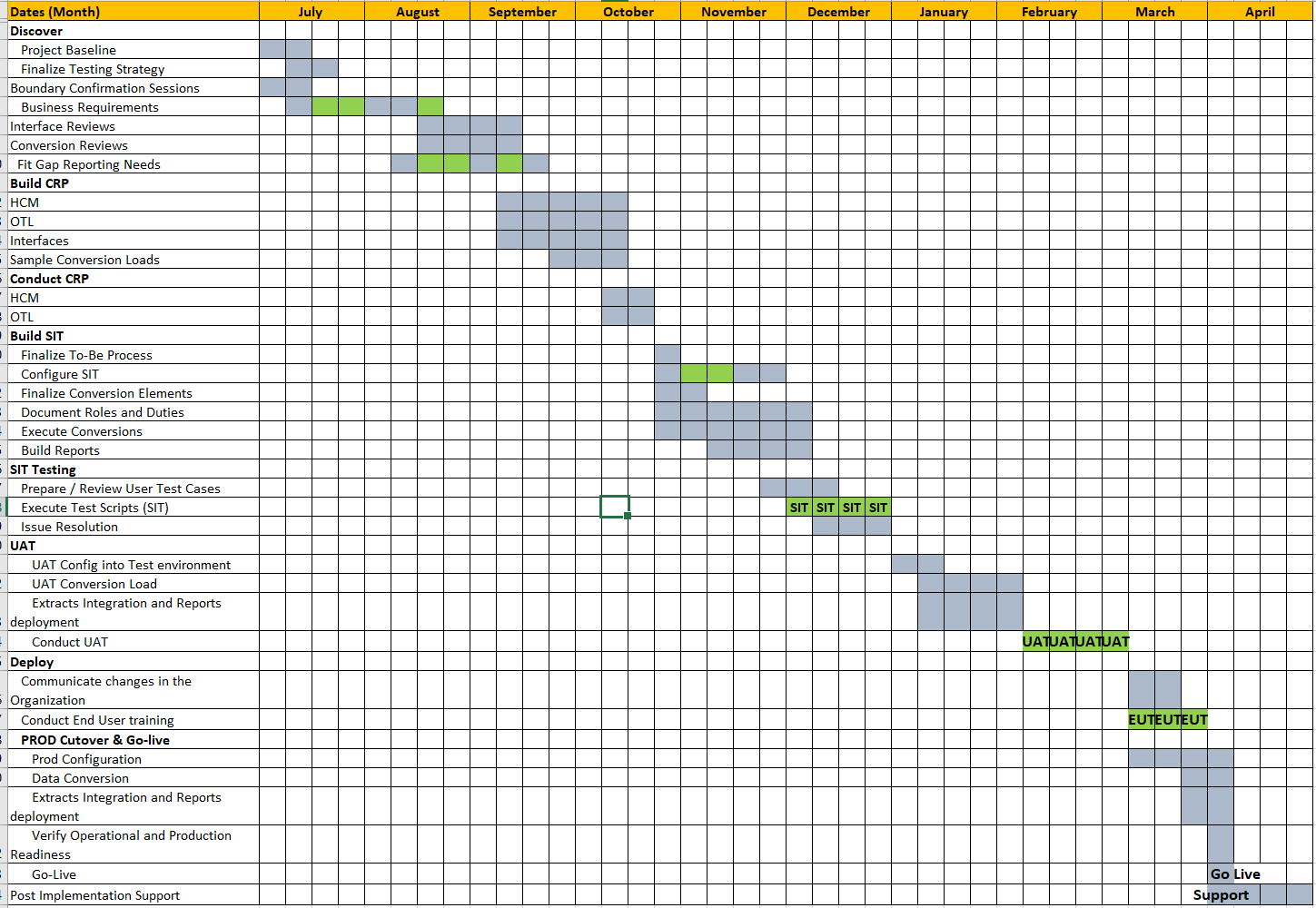

Qualifications

Firm
Proposers must present applicable firm qualifications in this section covering the Proposer’s experience on similar or relevant projects, if any, with transit or municipal accounts. The firm must have at least five (5) years of experience performing work similar to that described in Section IV, Scope of Services of this RFP. The firm shall provide three (3) references for comparable projects completed within a five-year period from the date of issuance of this RFP using the attached Vendor References Form provided in Appendix I.

Appendix I – References Form
Reference 1 Contact Information
Reference Name | Fond du Lac County |  |  | Initial Date of Work with Contact | 3/1/2024
Contact Name | Tammy Pinno-Supple |  |  | Original Contract Term | 9 Months
Address | 160 S Macy St  Fond du Lac, WI 54935 |  |  | Any Contract Extensions | Managed Service
 |  |  |  | Termination Date of Contract | On-going
 |  |  |  | Reason for Termination | N/A
Contact Title | Finance Director |  |  | Telephone Number | (920) 906-4771
E-mail | tammy.pinno@fldco.wi.gov |  |  | Fax Number | N/A
Nature of Relationship with Company
Approximate $ Size of the Contract |  |  | To be provided by reference
Services provided/Software Implemented |  |  | Net new implementation of the Oracle Fusion Suite of Applications (Finance, HCM, Payroll, Projects, EAM)
Name of Vendor Project Manager and Client Project Manager |  |  | Vendor Project Manager- Brian Schell, President & CEO  Client Project Manager - Tammy Pinno-Supple
Detailed Description of Your Responsibilities
Roles & Responsibilities: |  | iteria served as the prime on the project. There were many challenges in front of us requiring us to re-baseline the project and re-work the solutions. As part of our role, iteria needed to step in and re-evaluate some third-party solutions, provide additional client-side Project Management, and add technology applications to provide a more robust solution.  iteria was able to work within a very limited time frame and budget to completely re-work the implementation and redevelop the entire footprint to develop a robust solution that automates many of the County’s processes and successfully implemented the project on budget and on-time.
Were you the Prime Contractor? |  | Yes
Subcontractors & Responsibilities: |  | N/A – no subcontractors were utilized

Reference 2 Contact Information
Reference Name | Outagamie County |  |  | Initial Date of Work with Contact | 12/5/2025
Contact Name | Michelle L. Uitenbroek |  |  | Original Contract Term | 12 Months
Address | 320 S Walnut St  Appleton WI 54911 |  |  | Any Contract Extensions | N/A
 |  |  |  | Termination Date of Contract | N/A
 |  |  |  | Reason for Termination | N/A
Contact Title | Finance Director |  |  | Telephone Number | 920-832-1674
E-mail | michelle.uitenbroek@outagamie.org |  |  | Fax Number | N/A
Nature of Relationship with Company
Approximate $ Size of the Contract |  |  | To be provided by reference
Services provided/Software Implemented |  |  | Net new implementation of Oracle Fusion Suite of Applications (Finance, HCM, Payroll, Projects, EAM)
Name of Vendor Project Manager and Client Project Manager |  |  | Vendor Project Manager- Brian Schell, President & CEO  Client Project Manager- Michelle Uitenbroek, Finance Director​  Valarie Wunderlich, Human Resources Director
Detailed Description of Your Responsibilities
Roles & Responsibilities: |  | iteria serves as the prime on the project leading a full-scale Oracle Fusion Implementation. The County is migrating form completely manual processes to automated process. Heavy focus is on Change Management and streamlining process.
Were you the Prime Contractor? |  | Yes
Subcontractors & Responsibilities: |  | N/A – no subcontractors are utilized

Reference 3 Contact Information
Reference Name | Chicago Transit Authority (CTA) |  |  | Initial Date of Work with Contact | August 2015
Contact Name |  |  |  | Original Contract Term | 1 Year
Address | 567 W Lake St.  Chicago, IL 60661 |  |  | Any Contract Extensions | Yes
 |  |  |  | Termination Date of Contract | August 2024
 |  |  |  | Reason for Termination | Projects were completed
Contact Title |  |  |  | Telephone Number
E-mail |  |  |  | Fax Number
Nature of Relationship with Company
Approximate $ Size of the Contract |  |  | To be provided by reference.
Services provided/Software Implemented |  |  | iteria served multiple roles at CTA:  - Client Manager Oracle EBS R12 Upgrade – iteria was in charge of manager CTA resources and multiple implementation staff  - iteria served as Internal Project Manager form multiple projects at the CTA, ensuring on-time on budget project completion
Name of Vendor Project Manager and Client Project Manager
Detailed Description of Your Responsibilities
Roles & Responsibilities: |  | iteria served multiple roles at CTA:  - Client Manager Oracle EBS R12 Upgrade – iteria was in charge of manager CTA resources and multiple implementation staff  - iteria served as Internal Project Manager form multiple projects at the CTA, ensuring on-time on budget project completion
Were you the Prime Contractor? |  | Yes
Subcontractors & Responsibilities: |  | N/A

Key Personnel
This section must contain the resumes for all personnel who will be involved in the project. The Proposer must identify the contractor representatives, their specialized experience, and professional qualifications as it relates to this project as described in Section IV, Scope of Services. Key personnel must have at least three (3) years of experience in performing work similar to that of this RFP. Regional Transportation Authority reserves the right, for any reason, to request and secure replacement personnel from the firm to substitute for any or all persons previously selected.

Resumes will be provided under confidential separate cover once the project timeline has been finalized.
All iteria resources are employees of iteria and are seasoned professionals who are hand selected for projects based on skillsets, location, and cultural fit. iteria does not staff projects based on “bench” and does not just randomly assign resources to RFP responses. We look at multiple aspects and fit before assigning resources.

Organizational Chart
Proposers must provide an organizational chart showing the groups of personnel that will be working with the RTA, such as account representatives, account support contacts, help center structure, escalated technical support groups, etc.
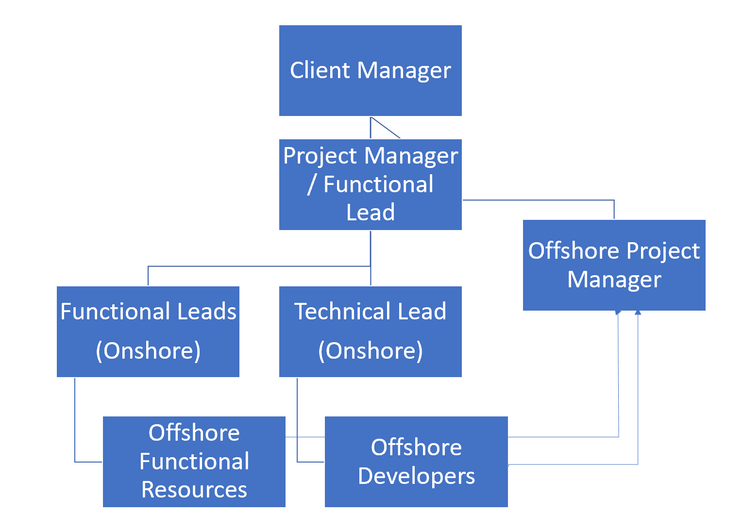

Table of Exceptions
Proposers must state whether they will or will not fully comply with the requirements as defined in this RFP and shall provide a detailed list of exceptions to the Scope of Services or other RFP requirements, including the sample agreement in Appendix A and all other exhibits and appendices. This list must be in table form (Appendix K) and must identify the page, section number, provision, and the specific exception, nonconformance, and/or substitute language proposed. Acceptance of a Proposal does not indicate that the RTA agrees to any exceptions raised by a Proposer. Failure to identify any specific items of noncompliance will result in RTA assuming compliance, and the RTA will not accept any exceptions to any requirements set out in this RFP that were not listed in the Proposal. TRTA, at its sole discretion, may reject any exception within the submittal.
- No exceptions to the Scope of Services or other RFP requirements.
- iteria cannot provide final pricing of Managed Services portion of the contract until the final footprint and interfaces are finalized as part of the overall solution.

Financial Background
Documents supporting a firm’s financial stability and ability to perform the contract must be included as well. Proposers must provide financial statements (audited, upon request) for the past year and information pertaining to any past bankruptcy, contract defaults, and violations of any regulatory acts. This information will be used to determine vendor responsibility. Proposers may be required to provide subcontractor(s)’ financial statements upon request.
iteria is a privately held corporation that has been in existence since 2015. Financials are confidential and can be provided under separate cover.

Insurance
Proposers shall provide evidence of their current business insurance at the time of submittal. The successful Proposer shall procure and maintain during the term of the contract, at the Proposer’s expense, insurance as described in Appendix D. The Certificate of Insurance (“COI”) verifying such insurance must be provided to the RTA within ten (10) days following award of a contract.

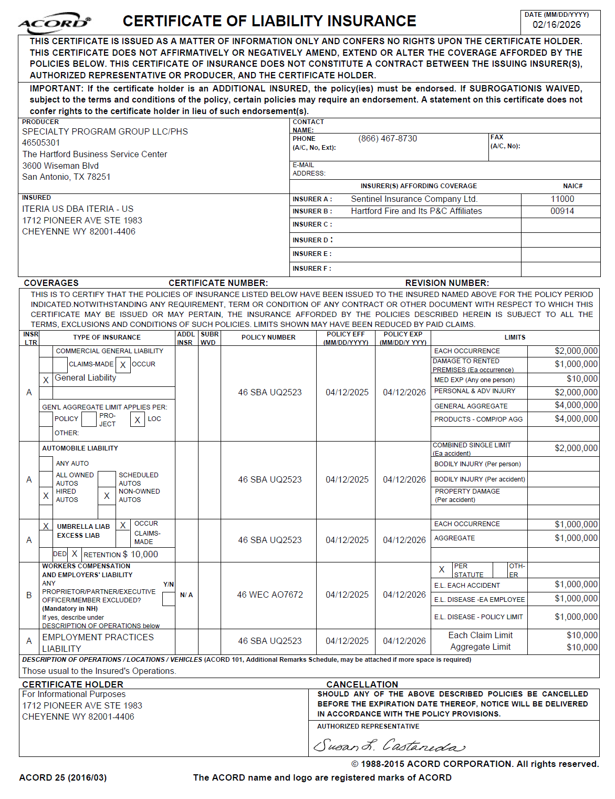

Joint Venture Agreement
Firms entering a joint venture must submit a copy of its joint venture agreement, and all required submittals must be signed by a principal of each joint venture partner including, but not limited to, subcontractors’ information submittals and DBE Plans [if applicable]. Indicate N/A if the Proposer will not be part of a joint venture agreement.
N/A – no joint ventures or agreements exist

Liens, Suits and Judgments
Proposers shall include a detailed description of any disputes they currently are involved in, as well as, a complete list of any lawsuits, judgments occurring within the last five (5) years, and all current liens pending. Indicate N/A if the Proposer does not have any disputes described above.
N/A – iteria has no liens or judgements against us

Executable Forms
Proposers shall complete and submit with their proposal response the following forms:
APPENDIX F – NON-COLLUSION AFFIDAVIT
APPENDIX G – VENDOR/CONTRACTOR CERTIFICATIONS
APPENDIX H – RTA CERTIFICATIONS AND ASSURANCES

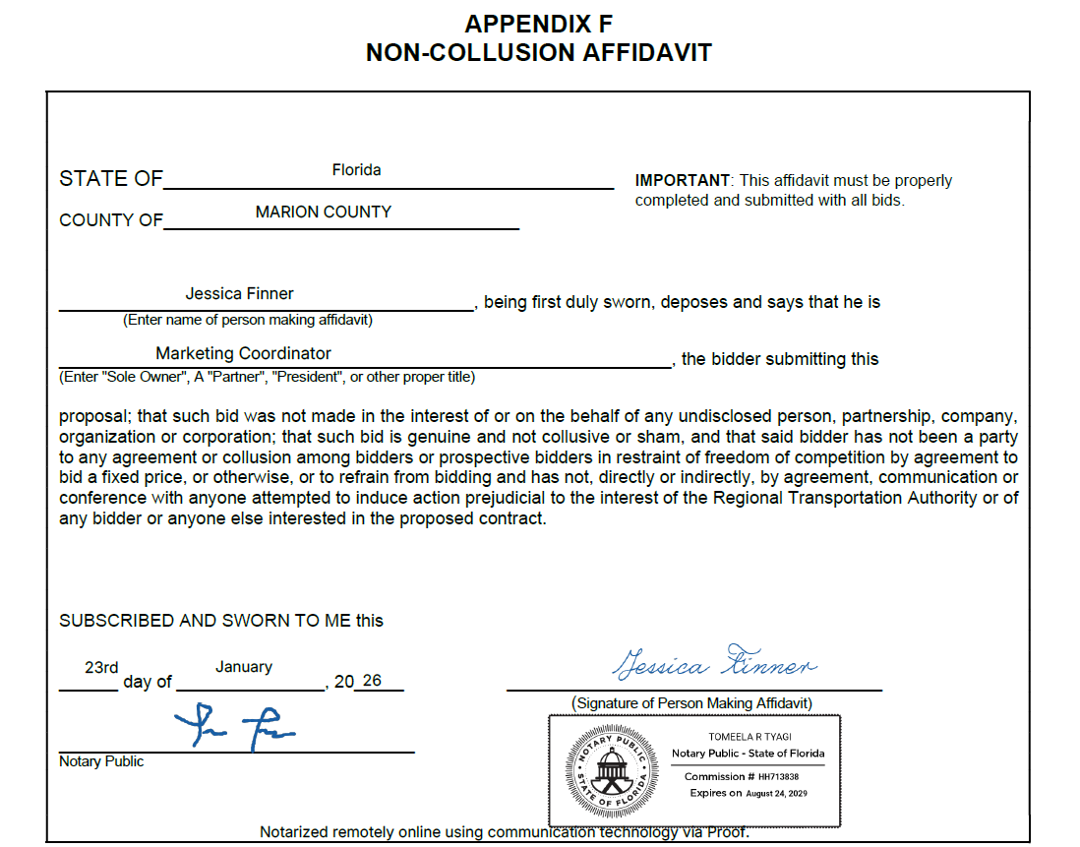
Appendix F – Non-Collusion Affidavit

Appendix G- Vendor/Contractor Certifications
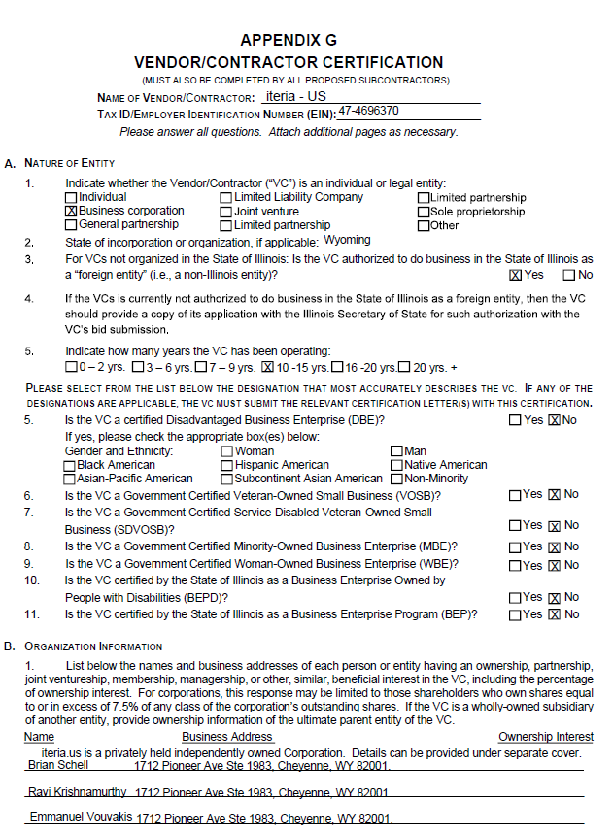

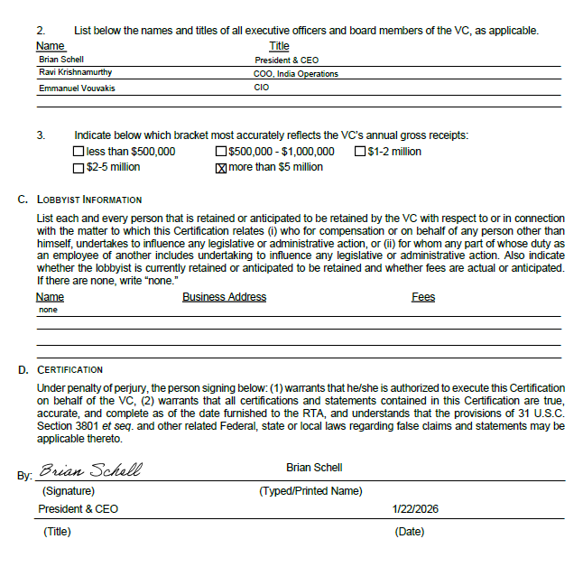

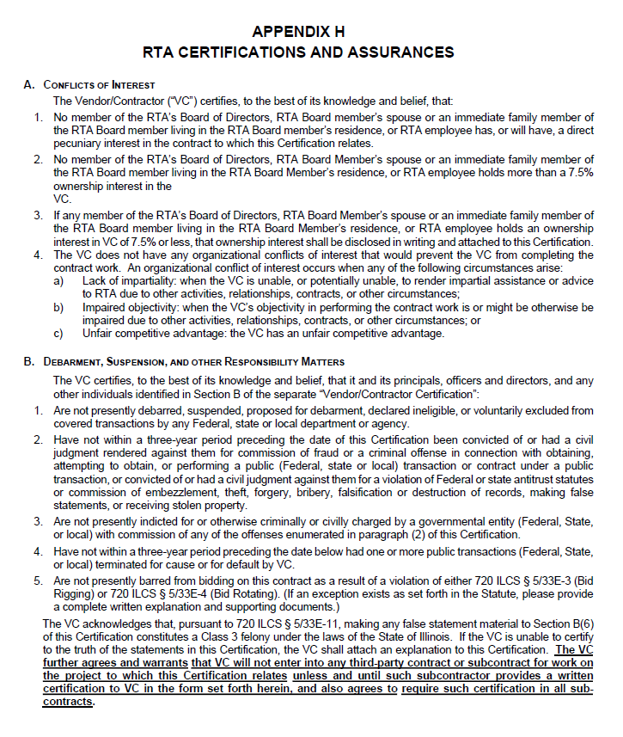
Appendix H- RTA Certifications and Assurances

