

Proposal Created For:

Village of Schaumburg

PROJECT REQUEST
2025-RFP-070
HUMAN RESOURCES INFORMATION SYSTEMS SOLUTION AND IMPLEMENTATION SERVICES

December 9, 2025

Table of Contents
Cover Letter 3
Understanding of Project 5
Project Manager(s) and Key Project Personnel 7
Summary of Proposals and Experience 8
Fees 11
Certificate of Insurance 14
Attachments 15

Cover Letter
To: Village of Schaumburg
iteria – US (iteria) is pleased to present our formal response to the Village of Schaumburg
PROJECT REQUEST 2025-RFP-070
HUMAN RESOURCES INFORMATION SYSTEMS SOLUTION AND IMPLEMENTATION SERVICES
iteria.us, a Certified Oracle Partner, founded in 2015 as a S Corporation in the state of Wyoming and registered in Good Standing in the state of Illinois.

With satellite offices in both Wisconsin and Illinois, iteria brings localized resources to VoS.

iteria is proposing a complete solution of both software and implementation of the Oracle Corporation Fusion Cloud HCM Suite of Applications. Our experience in the applications and technology of the Oracle Suite of products coupled with our consultants who are specialized in the services presented in this proposal, ensure VoS has a business partner that offers the appropriate solutions and services to make sure the user experience and issues are addressed professionally and in a timely manner.

The Oracle software provides the most modern, complete, and secure platform and applications in the marketplace today, engineered to work together and address the goals of Vos. For over 40 years, and through three distinct eras of computing, Oracle has been a worldwide leader in technology and applications. It is by this unparalleled experience and the breadth and depth of our solutions that Oracle’s Cloud Solutions are unmatched in our industry. Throughout this response, we will differentiate Oracle broadly, but for now we will focus on three primary distinctions:
- Complete – Oracle builds and engineers hardware, database, middleware, business intelligence and world-class applications into a single unified integrated platform. Importantly, each one of these capabilities can stand alone as a market leader. When combined, they uniquely provide the fully comprehensive, seamless cloud platform needed to achieve the City’s vision.
- Modern – The functionality and the technical underpinnings that support Oracle’s consumer-grade user experience are built and engineered from the ground up for the modern age of information science with strict consideration for accessibility standards, while incorporating emerging technologies such as AI and machine learning sooner and more effectively than anyone else.
- Secure – Oracle’s tenure as a technology leader is characterized by participation in countless security-related boards across multiple industries, helping firmly establish many of the standards that govern global security today. Noting the complete nature of our solutions stated above, Oracle manages security standards within each element of the proposed platform. We provide redundant layers of security enveloping all aspects of the functional and technological enterprise.
Over the past several years, Oracle’s Cloud solutions have emerged as the leading Finance, Budgeting and HCM Cloud solutions for businesses and public sector agencies alike. Oracle is proud of the recognition and market leading position that industry analysts have assigned to those products. Oracle is recognized as a leader in numerous industry analyst vendor evaluations. Many of them can be found on the Oracle Industry Analyst Report page at https://www.oracle.com/corporate/analyst-reports.html.
In summary, no other cloud application can match the breadth and depth of Oracle’s experience and platform, and no other solution can approach the array of modern innovation, complete functional depth, and industry-leading security Oracle delivers.

iteria’s founders have been working in the Oracle circle for over 30 years and we are pride ourselves that we focus only on Oracle technologies, offering our clients superior knowledge and skills to get the most out of your Oracle Suite of Applications.

iteria is partnering with the following firms as part of our response:
Oracle Corporation – Developers of Proposed Software
Mythics LLC. – Reseller of the Oracle Software Licensing

We look forward to working with VoS during your RFP Selection Process.

Sincerely,

Brian Schell
President & CEO

Understanding of Project
iteria was founded in 2015, after its founders having spent over 30 years working with the Oracle Suite of Applications, saw the need to bring consulting back to basics. iteria prides itself on bringing solutions to its clients that are unique to the situation and not based on a cookie cutter approach or the bottom line. We do not take the easy path to solve a problem or develop a solution. We strive to deliver the best solutions for the case at hand and bring our years of experience to each implementation.
We have a proven successful track record and we have succeeded where others have failed. We have no desire to be the biggest firm but we strive to be the best.
After having served as Executive roles for a few other consulting firms, iteria’s founders started iteria to bring consulting back to its basics. Firms were too focused on the bottom line and not concerned about the customers’ needs. iteria brings consulting back to the basics.

We strive to implement solutions that work for the client’s need while preserving the integrity of Oracle Applications so upgrades do not need to be re-worked. We specialize in integrations and build solutions that meet the customer’s needs and not those that are the “easy route” or simple approach.

iteria provides services only on the Oracle Corporation Suite of Applications providing a full array of services including:
- implementation services
- managed services / support
- custom development

iteria’s founders have been working in the Oracle circle for over 30 years and we are pride ourselves that we focus only on Oracle technologies, offering our clients superior knowledge and skills to get the most out of your Oracle Suite of Applications.

The Oracle applications are extremely flexible, providing multiple ways in which a solution can be achieved. iteria specializes in dissecting those solutions and examines the impacts both upstream and downstream to achieve the desired results. This ultimately delivers a quality solution to our clients and allows them to maximize the benefits of the Oracle Suite of Applications.

iteria’s overall methodology goes back to the basics. Implementations are more successful when there is an on-site presence. However, we do not need to be on-site just to be on-site. On-site presence will come in waves based on the phase of the project we are on. The exact schedule itself will be one of the first items reviewed upon project start, as we recognize IHDA’s staff will most likely have their existing full-time jobs / duties to also contend with.

iteria’s Overall Implementation Approach
iteria.us proposes a step-by-step approach with its implementation methodology to complete the implementation and development of the assigned tasks. As part of our methodology, iteria.us will:
- Conduct a Boundary Confirmation session to discuss IHDA’s overall goals both near term and future to better plan for an overall implementation approach.
- Perform Solution Analysis sessions with the business to cover overall requirements.
- Document / Review the requirements and the solution with the Business Users
- Obtain sign-offs and approvals from the business
- Upon approval of solution, begin development
- Evaluate the data and the roadmap for conversion
- Review and design interfaces
- Conduct smoke testing
- Conduct multiple prototype sessions
- Support User Acceptance Testing
- Provide Train-the-Trainer training
- Develop / provide complete configuration documentation
- Review final output with Business and get final sign-offs

Embedded within our overall approach, you will find specific details around:
- Overall Project Management approach
- Configuration and process design approach
- Data conversion
- Testing approach
- Training approach
- Final cutover/transition to new system

Scope and Deliverables
Based on the requirements provided by IHDA and the modular footprint provided in the RFP, iteria has prepared a high-level timeline and implementation schedule for the HCM Project.

Key areas of a project of this nature include:

- Overall Project Management
- Reviewing key decisions and integration points from the Requirements Sessions
- Business Process Re-engineering
- Data Extraction and Cleansing
- Solution development
- Interface review and development
- Testing
- Training
- Go-Live Cutover
- Post Implementation Support

Project Manager(s) and Key Project Personnel
Clearly identify the professional staff person(s) who would be assigned as your Area/Regional Manager(s) and provide resumes. The proposal should indicate the abilities, qualifications and experience of these individuals and provide resumes.
iteria will use dedicated resources on the project, both onshore / on-site and offshore.
The on-site resources assigned to VoS are senior resources and are specialists in their area(s), but we also have limited resources VoS will work with on a day-to-day basis. All staff assigned on-site are senior resources who are either certified and/or cross trained in multiple modules.
All iteria resources report to the Client Manager / Project Manager that is assigned to your project. The Client Manger is a C-Suite member of the iteria team. The Project Manager, at a minimum is part of the iteria Leadership team.
For each functional area, there is a lead who will then have staff reporting to him/her.
Additionally, for the offshore team, there is a local C-Suite Member overseeing the team as well as a day-to-day offshore Project Manager to help with transition from shift to shift as tasks move from onshore to offshore and vice versa.
As previous mentioned, iteria’s overall methodology goes back to the basics. Implementations are more successful when there is an on-site presence. However, we do not need to be on-site just to be on-site. On-site presence will come in waves based on the phase of the project we are on. The exact schedule itself will be one of the first items reviewed upon project start, as we recognize Vos’s staff will most likely have their existing full-time jobs / duties to also contend with. The following table illustrates an initial estimate of when we would be on and off-site.
Phase | Percentage On-site
Requirements Gathering | 100%
Documentation | 25%
Document Review | 100%
CRP Build | 25%
CRP Execution | 100%
Interface / Conversion Development | 25%
SIT Build | 25% - 50%
SIT Execution | 100%
Training | 100%
Go-Live | 100%
Post Implementation Support | 100%
There are a lot of factors that will ultimately contribute to the final schedule such as VoS staff availability, keeping travel costs in check, and ROI for being on-site and readily available. Over the years, iteria has found it more beneficial to be on-site during the key times of the project to read the room and facial expressions as we discuss various topics, especially during requirement gathering, etc. As previously mentioned, iteria does not implement based on spreadsheets and questionnaires, we have detailed conversations and interactive design sessions.
For those resources who are flying, we typically are on-site Monday – Thursday. For those resources, who are local, driving to VoS, such as our Illinois and Wisconsin based resources, we are on-site Monday – Thursday / Friday, depending on where we are in the project. We want to be mindful of the VoS’s time and realize you may need time away from the project for your daily jobs.

Summary of Proposals and Experience

Reference Table
Reference Number: 1
Governmental Entity Name: Fond du Lac County
What is the approximate staff count of the Entity? 1,000
What is the approximate population served by the Entity? 104,000
Project narrative:
Net new implementation of the Oracle Fusion Suite of Applications (Finance, HCM, Payroll, Projects, EAM)
Contact Information
Address: 160 S Macy St
City, State, Zip: Fond du Lac, WI 54935
Reference Contact Name: Tammy Pinno-Supple Title: Finance Director
Phone No.: (920) 906-4771 Email Address: Tammy.pinno@fdlco.wi.gov
Start Date of Project: 3/1/24 Go-Live Date: 12/22/24
Project Information
Scope of Modules installed: Financials, HCM, Payroll, EAM, Projects

Reference Table
Reference Number: 2
Entity Name: Industries for the Blind and Visually Impaired (IBVI)
What is the approximate staff count of the Entity? 200
What is the approximate population served by the Entity? Not-for-Profit
Project narrative:
New implementation, implementing full suite of Oracle Fusion Financials, HCM, SCM, OCC
Contact Information
Address: 445 Curtis Rd
City, State, Zip: West Allis, WI 53214
Reference Contact Name: Nicole Christman Title: Business Analyst
Phone No.: 414-778-3057 Email Address: Nicole.Christman@ibvi.org
Start Date of Project: Jan 2018 Go-Live Date: Jul 2018; Oct 2018; Apr 2020
Project Information
Scope of Modules installed: Oracle Fusion Financials, HCM, SCM, OCC

Reference Table
Reference Number: 3
Governmental Entity Name: Winzer Corporation
What is the approximate staff count of the Entity? 300
What is the approximate population served by the Entity? Corporation
Project narrative:
New Implementation and Managed Services
Full Suite of Fusion Financials, SCM, and WMS
Contact Information
Address: 4060 E Plano Pkwy
City, State, Zip: Plano, TX 75074
Reference Contact Name: Ed Conrey Title: VP of IT
Phone No.: (214) 341-2122 x4594 Email Address: ed.conrey@winzerusa.com

Start Date of Project: Apr 2021 Go-Live Date: Mar 2023
Project Information
Scope of Modules installed: Financials, SCM, WMS

Reference Table
Reference Number: 4
Governmental Entity Name: Stanford University
What is the approximate staff count of the Entity? 4,000
What is the approximate population served by the Entity? Not-for-profit
Project narrative:
Net new implementation
Contact Information
Address: 450 Jane Stanford Way
City, State, Zip: Stanford, CA 94305
Reference Contact Name: Bernard Suva Title: Director - HCM Functional Solutions Architect - Technology & HR Analytics
Phone No.: 424.394.8464 Email Address: suvab@stanford.edu
Start Date of Project: Jan 2025 Go-Live Date+*:
Project Information
Name and Version of software system installed: Oracle Fusion HCM / Payroll
Scope of Modules installed: HCM / Security

Reference Table
Reference Number: 5
Governmental Entity Name: National Industries for the Blind
What is the approximate staff count of the Entity? 100
What is the approximate population served by the Entity? Not-for-profit
Project narrative:
new install; custom development
Contact Information
Address: 3000 Potomac Ave
City, State, Zip: Alexandria, VA 22314
Reference Contact Name: Mallik Balla Title: Director IT
Phone No.: 224-388-1288 Email Address:
Start Date of Project: Jun 2019 Go-Live Date: Jan 2020
Project Information
Name and Version of software system installed: Oracle Fusion / Oracle OCC
Scope of Modules installed: Financials, Fixed Assets, OCC, Custom Dev

Fees
Provide a chart which breaks down the hourly rates for the various types of inspections, plan review, office assistance, or other relevant fees associated with this project.
iteria is proposing the following schedule:
- Project Start – May 2026
- Go-Live – January 2027
We are proposing the full suite of HCM applications, including payroll.
The exact module list is:
- Human Capital Management (HR Suite)
- Payroll
- EPM (Budgeting)
- Time and Labor (OTL)
- Recruiting
- Talent Management
- Workforce Health and Safety
- Workforce Scheduling
- Learning

The high-level schedule would be:

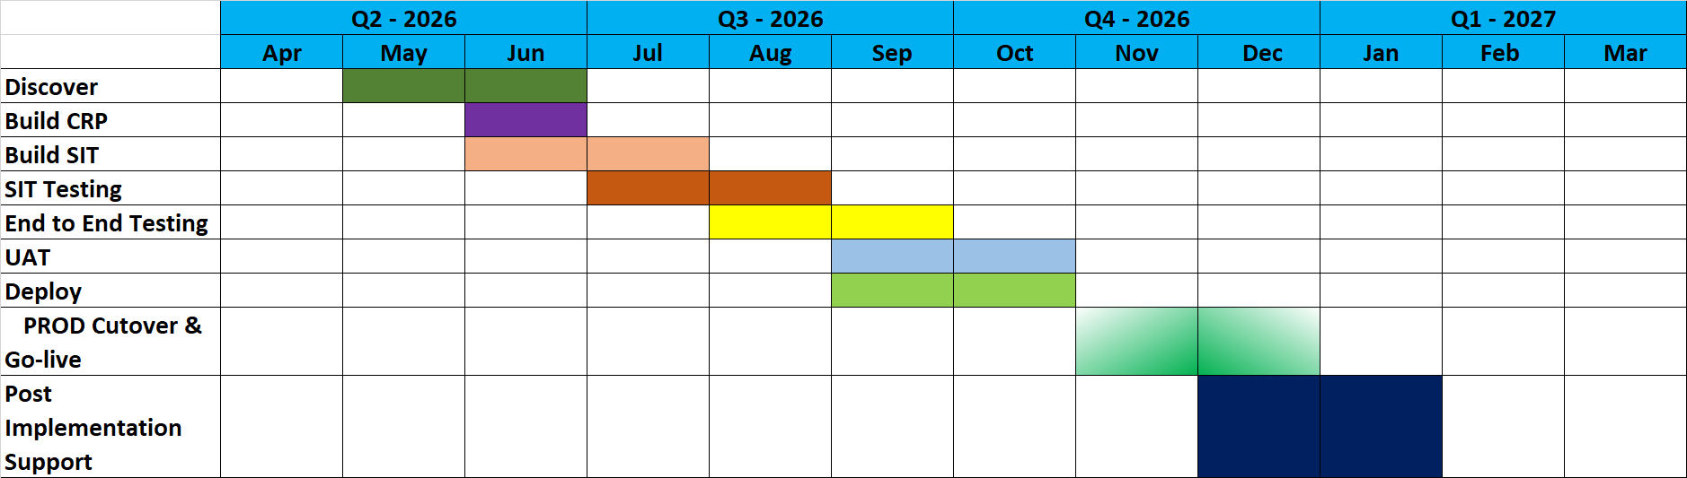

Deliverables for a project of this nature would include:
Deliverable Name | Description | Format
Project Plan | Project plan for the project with detailed tasks | MPP
Business Requirement Documents (BRD) | Detailed Business process document for each functional area / module with current state process mapping to future business processes. | Word / PDF
Interface List and methods | Identify the need of interface and finalize the method of communication between the systems. | Excel
Reports Master List | Identify the need of reports from all Functional and HCM areas. | Excel
Instance Strategy | A strategy document to procure and maintain HCM and Integration applications and maintain them till go-live. | PDF
Data Conversion Strategy | Finalize all Business objects to me migrated with amount of history. | PDF
Security Matrix Template | A document describing who from VoS can access what functionality and data from the applications | Excel
Communication Plan |  | Word
Configuration Cookbooks | Detailed workbook that contacts setups done in the application for feature references include:  1. Configurations migrations between instances.  2. Transition between consultants. | Excel
Interface Specification Documents | Detailed specification documents for each interface | Word
Reports Functional Specification Document | Detailed specification requirement documents for each report | Word
Data Conversion Mapping Document | Detailed specification document for each conversion routine
Test Plan | Detailed Testing Plan for SIT and UAT
Training Schedule | Lists the various types of trainings, number of classes, and schedule | Word / Excel
Training Material for each module | Custom training material based on the system configuration | Word / Power Point
Change Management / Communication Plan | Identifies various communications throughout the project as well as areas where change will require more communication / effort | Word
Test Plan | List Test Cases and the plan to execute those test cases | Word / Excel
Issue Tracker | List any issues resulting form both SIT and UAT. | Excel or Ticketing System
Cutover Plan | Migration plan detailing out what is needed and when as well as roles and responsibilities and timings | Word / Excell
Go-Live | Milestone when the system is Live | Milestone
Completion of Post Implementation Support | Completion of 30 days post implementation support | Milestone

\

Certificate of Insurance
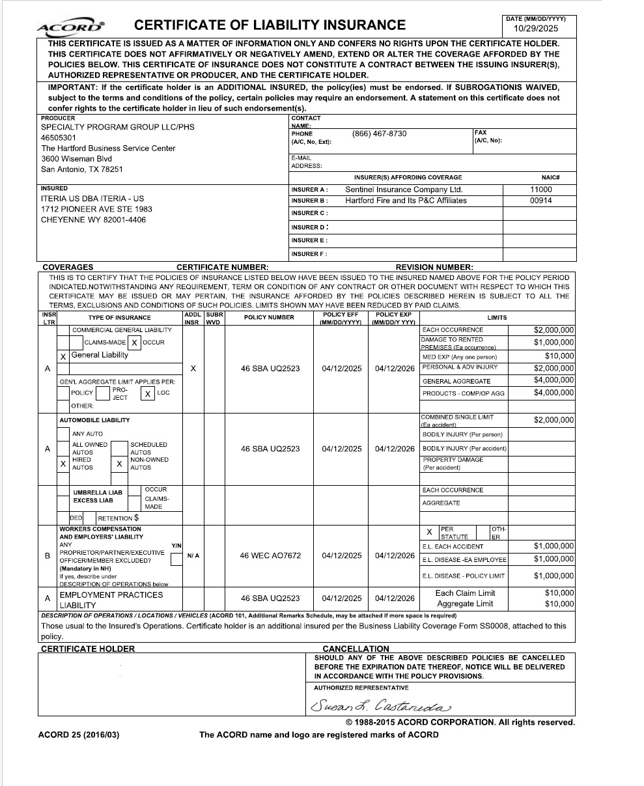

Attachments
Please find these files included with our response as separate documents.
Additional Response Files
- HCM_Requirements_for_Village _Oracle.xlsx
Additional Oracle Information
- Village of Schaumburg - system quality question 2.pdf
- Village of Schaumburg - system quality question 3.pdf
Pricing Supporting Detail
- Oracle Module Break Down.pdf

