**Project Timeline:**

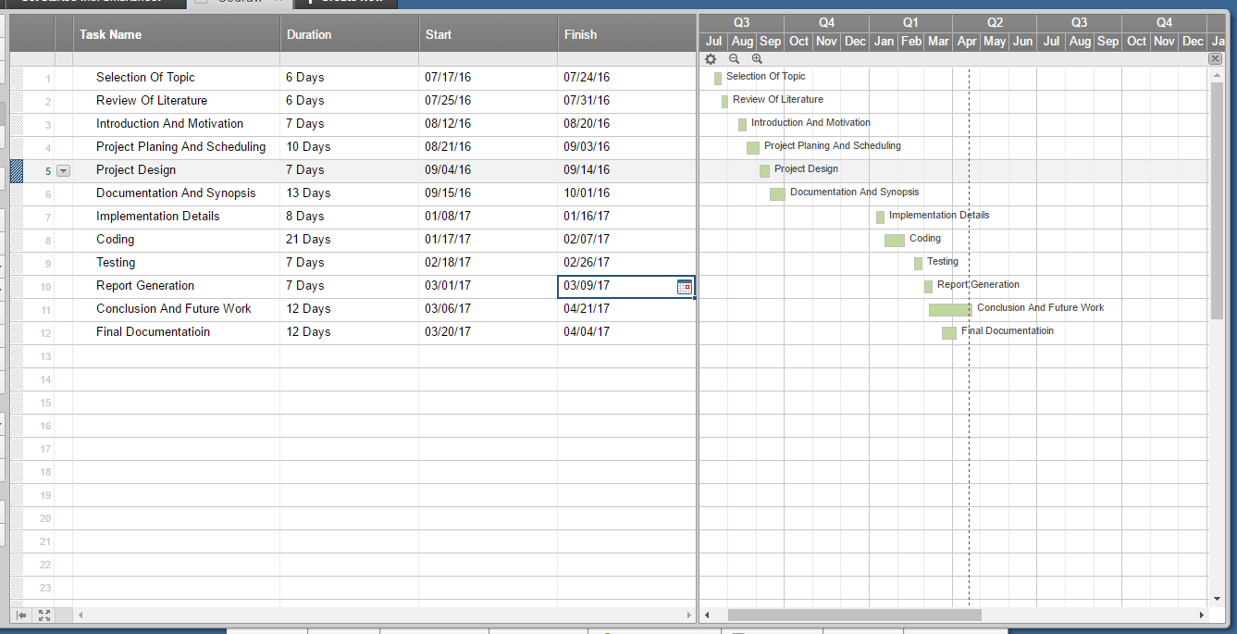

Figure 3.1: Project Timeline