**CHAPTER 3**

**PROJECT ANALYSIS AND DESIGN**

**3.1** **Project Timeline & task distribution**

**Gantt chart:**

A **Gantt chart** is a type of bar chart, developed by Henry Gantt in the 1910s, that illustrates a project schedule. Gantt charts illustrate the start and finish dates of the terminal elements and summary elements of a project. Terminal elements and summary elements comprise the work breakdown structure of the project.

A Gantt chart, commonly used in project management, is one of the most popular and useful ways of showing activities (tasks or events) displayed against time. On the left of the chart is a list of the activities and along the top is a suitable time scale. Each activity is represented by a bar; the position and length of the bar reflects the start date, duration and end date of the activity. This allows you to see at a glance:

* What the various activities are.
* When each activity begins and ends.
* How long each activity is scheduled to last.
* Where activities overlap with other activities, and by how much.
* The start and end date of the whole project.

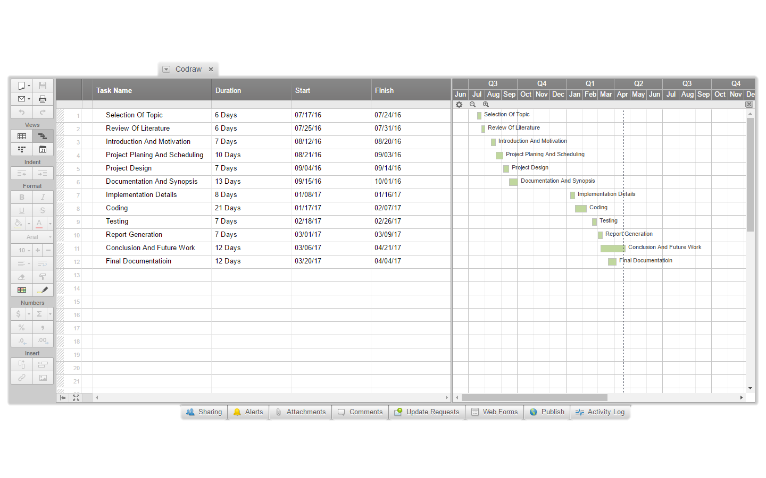

.

|  |  |  |  |  |  |  |  |
| --- | --- | --- | --- | --- | --- | --- | --- |
|  |  |  |  |  |  |  |  |
|  |  |  | Table 3.1 Task Distribution | | |  |  |
|  |  |  |  |  |  |  |  |
|  | **Tasks List** | | **Assigned to** | | |  | **State** |
|  |  |  |  |  |  |  |  |
|  | Defining Project goal | | Purvisha Khunt | | |  | Completed |
|  |  |  | Dhruv Tank | | |  |  |
|  |  |  | Jignesh Lad | | |  |  |
|  |  |  |  |  |  |  |  |
|  | Plan project | | Purvisha Khunt | | |  | Completed |
|  |  |  | Dhruv Tank | | |  |  |
|  |  |  | Jignesh Lad | | |  |  |
|  |  |  |  |  |  |  |  |
|  | Analysis | | Purvisha Khunt | | |  | Completed |
|  |  |  | Dhruv Tank | | |  |  |
|  |  |  | Jignesh Lad | | |  |  |
|  |  |  |  |  |  |  |  |
|  | Gui design | | Purvisha Khunt | | |  | Completed |
|  |  |  | Jignesh Lad | | |  |  |
|  |  |  |  |  |  |  |  |
|  | Implementation | | Purvisha Khunt | | |  | Completed |
|  |  |  | Dhruv Tank | | |  |  |
|  |  |  |  |  |  |  |  |
|  | Testing | | Dhruv Tank | | |  | Completed |
|  |  |  | Jignesh Lad | | |  |  |
|  |  |  |  |  |  |  |  |
|  | Final reports and presentation | | Purvisha Khunt | | |  | Completed |
|  |  |  | Dhruv Tank | | |  |  |
|  |  |  | Jignesh Lad | | |  |  |
|  |  |  |  |  |  |  |  |



* 1. **Development Methodology**

This section describes the project as per the various stages of the Software Development life cycle. The model of software development life cycle used in this project is the waterfall method. The Waterfall Method is comprised of a series of very definite phases, each one run intended to be started sequentially only after the last has been completed, with one or more tangible deliverables produced at the end of each phase of the waterfall method of SDLC. Essentially, it starts with a heavy, documented, requirements planning phase that outlines all the requirements for the project, followed by sequential phases of design, coding, test-casing, optional documentation, verification (alpha-testing), validation (beta-testing), and finally deployment/release.

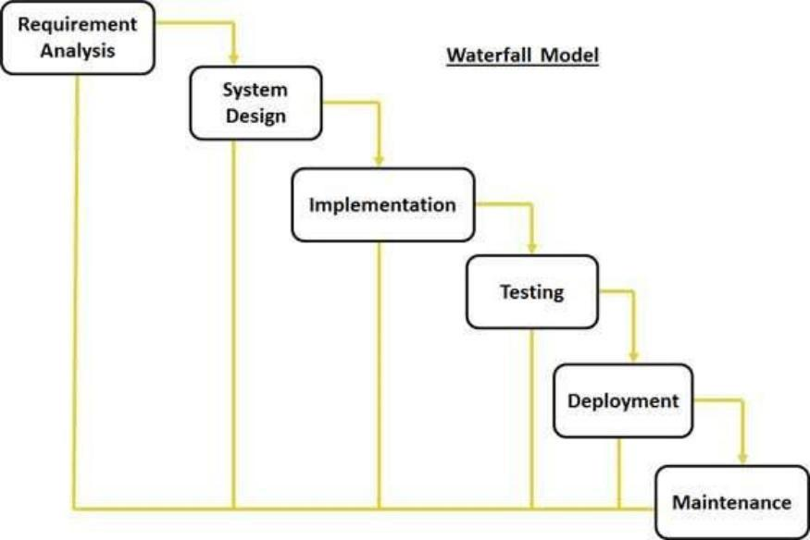

Figure 3.2: Waterfall Model

**Requirement Analysis:** Existing system is time consuming and requires more amountof cost. The confidentiality of data provided by existing system is also poor. Thus all the above stated problems are resolved in the proposed system. It will provide better data confidentiality and is less time consuming.

**System Design:** It includes translation of the requirements specified in the SRS into a logicalstructure that can be implemented in a programming language. The output of the design phase is a design document that acts as an input for all the subsequent SDLC phases. The design of this software is simple and user friendly containing main activities, namely: (a) Interactive User Interface (b) About Form (c) Class Diagram Editor (d) Activity Diagram Editor.

**Coding/Implementation:** The project is implemented using the C# language in Visual Studio. Microsoft Visual Studio is an integrated development environment (IDE) from Microsoft. It is used to develop computer programs for Microsoft Windows, as well as web sites, web apps, web services and mobile apps. Visual Studio uses Microsoft software development platforms such as Windows API, Windows Forms, Windows Presentation Foundation, Windows Store and Microsoft Silverlight. It can produce both native code and managed code.

**Testing:** It includes detection of errors in the application. The testing process starts with a test plan that recognizes test-related activities, such as test case generation, testing criteria, and resource allocation for testing. The code is tested and mapped against the design document created in the design phase. The output of the testing phase is a test report containing errors that occurred while testing the application. Testing has been done for each of the individual activities of the project.

**Maintenance:** It includes implementation of changes that software might undergo overa period of time, or implementation of new requirements after the software is deployed at the customer location. The maintenance phase also includes handling the residual errors that may exist in the software even after the testing phase [4].

1. **Design Details**
2. **Use Case Diagram**

A use case diagram at its simplest is a representation of a user's interaction with the system that shows the relationship between the user and the different use cases in which the user is involved.

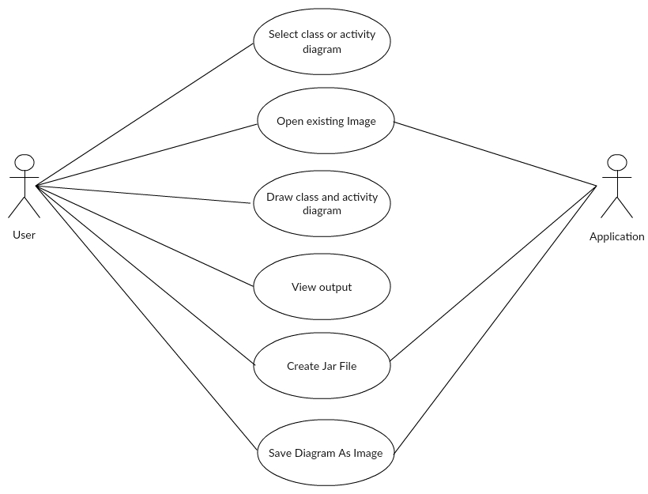

Figure 3.2: UseCase Diagram

1. **Data Flow Diagram**

A data flow diagram (DFD) is a graphical representation of the "flow" of data through an information system, modeling its process aspects. Often they are a preliminary step used to create an overview of the system which can later be elaborated. DFDs can also be used for the visualization of data processing (structured design).

A DFD shows what kind of information will be input to and output from the system, where the data will come from and go to, and where the data will be stored. It does not show information about the timing of processes, or information about whether processes will operate in sequence or in parallel.

UML diagrams

Code Converter

Figure 3.4: Data flow level 0

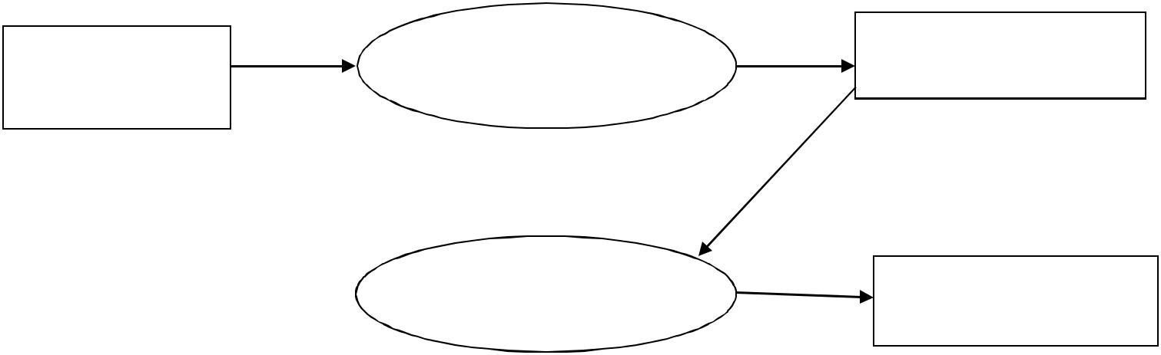

|  |  |  |
| --- | --- | --- |
| UML Diagrams | Prepare Class Diagram | Class Diagram |
|  |  |
|  |  |

|  |  |
| --- | --- |
| Code Generation | Code Convertor |
| Algorithm |  |
| Figure 3.5: Data flow level 1 |  |



|  |  |  |
| --- | --- | --- |
| UML Diagram | Preare Activty diagram | Activity Diagram |
|  |  |
|  |  |

Code Generation Algorithm code converter

|  |  |
| --- | --- |
|  |  |
|  |  |
| Figure 3.6: Data flow level 2 |  |

**3. Control Flow Diagram**

Select Class or Activit yDiagram

UML Diagrams

Code

Takes UML diagram as input

Generates java code

Figure 3.5: Control flow level 0

Draw Class or Activity Diagram

Class or Activity Diagram

Code Generator

UML Diagrams

UML Diagrams

Sends Diagram data to translator

Generates Java Code

Figure 3.6: Control flow level 1