Decision Tree:

The validation curve for max_depth and max_leaf_node show that

KNN:
Starting with default values of the KNN classifier, the learning curve for k shows superior performance for both training and validation sets. The curves slightly slope down near k=30. So this value was used moving forward.

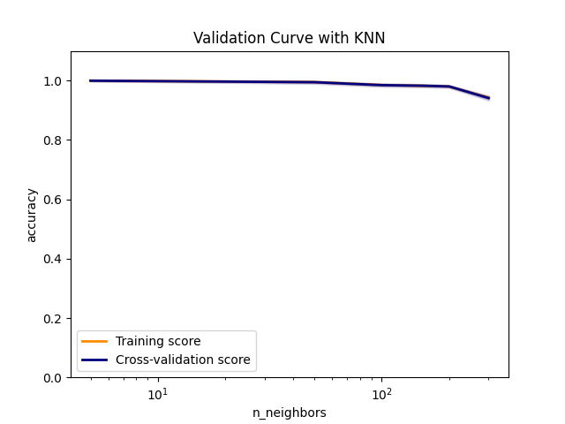
Using k = 30, the performance of model was recorded using four distance metrics ['manhattan', 'cosine', 'minkowski', 'euclidean']. They all appear to show good results with similar fit_time. Since minkowski has lower score_time, this distance metric was selected.

k distance_metric test_accuracy train_accuracy fit_time score_time
0 30 manhattan 0.998923 0.998923 0.001670 0.107545
1 30 cosine 0.997230 0.997500 0.001913 0.224055
2 30 minkowski 0.996461 0.997076 0.002355 0.051841
3 30 euclidean 0.996615 0.997076 0.002214 0.071952

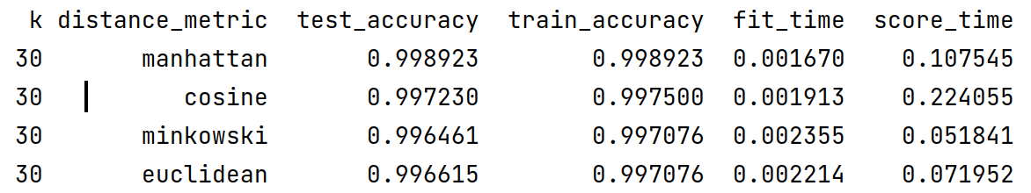

Similarly, uniform and distance weights were compared with each other. since distance weights have lower score_time and performed slightly better, it was selected for the model:

k weights test_accuracy train_accuracy fit_time score_time
0 30 uniform 0.996614 0.996923 0.002271 0.073156
1 30 distance 0.998462 1.000000 0.002476 0.053173

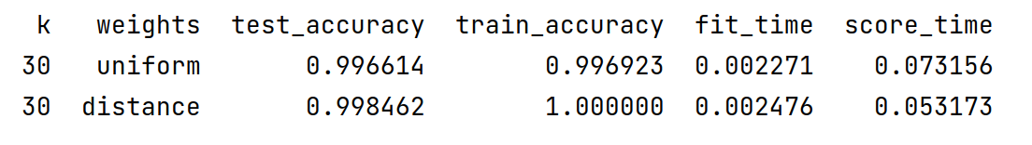
Learning curve shows test curve converging to train score near accuracy = 1, which indicates this is a good model as the error for both train and test is low and they converge so the model is not overfit or underfitting.
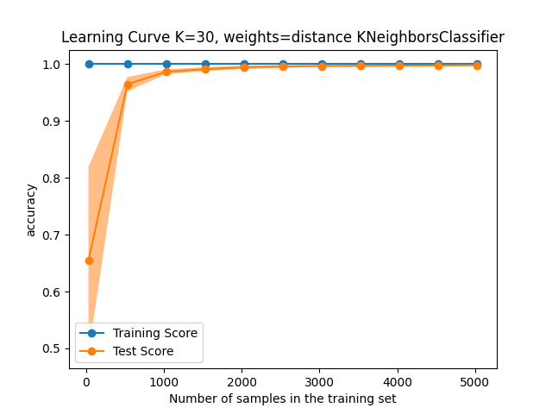

To make it less sensitive to noise, model performance was evaluated for two higher value k. As the learning curves show a small gap starts appearing between the training and test curves as they approach the end of the x-axis. This was expected as the
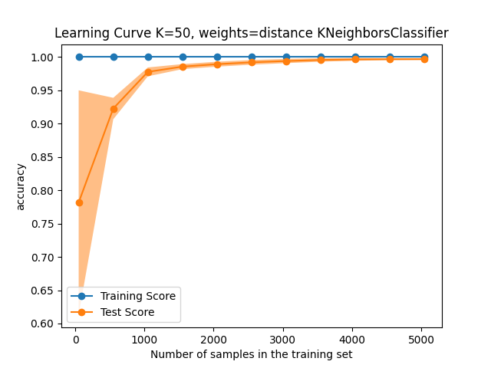
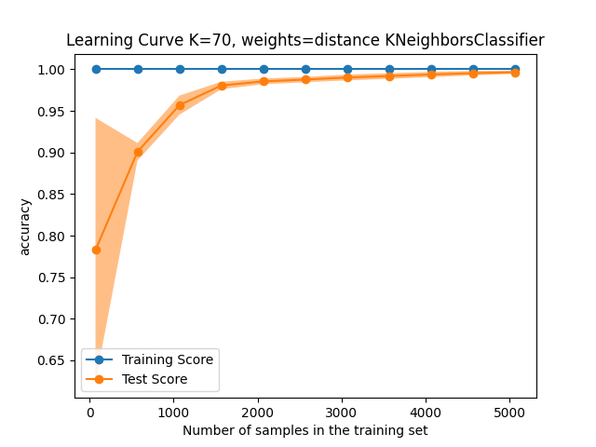

SVM:
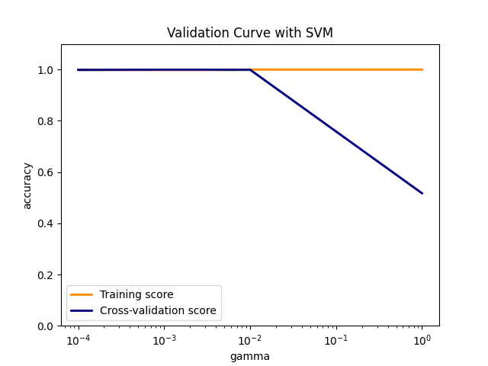
Gamma values in the range of [0.0001, 1] were used. As the validation curve indicates, the model performance starts going down around gamma of 0.008.

Validation curve results:
kernel tolerance test_accuracy train_accuracy fit_time score_time
0 linear 0.001 1.000000 1.000000 0.041136 0.014983
1 poly 0.001 0.999538 1.000000 0.470482 0.085888
2 rbf 0.001 0.999231 0.999962 0.304974 0.164286
3 sigmoid 0.001 0.990768 0.990652 0.075974 0.023617

Four kernels were tested [ 'linear', 'poly', 'rbf','sigmoid']. The learning curve for linear kernel consistently showed good performance. ‘poly’ and ‘rbf’ also showed good performance (~0.99 accuracy), but linear kernel shows slightly better performance and the test and training curves fully converge at 1 where the other two do not. All three show high accuracy for both training and test sets. This is an indicator of good model that doesn’t have overfitting or underfitting. The score and training time is also shorter for linear kernel. This indicates the dataset is linear. For sigmoid kernel, the learning curve is oscilating and in some sections test dataset shows better performanc. This indicates that the model has not been able to learn the data very well. Adding more data or more features may improve the model.

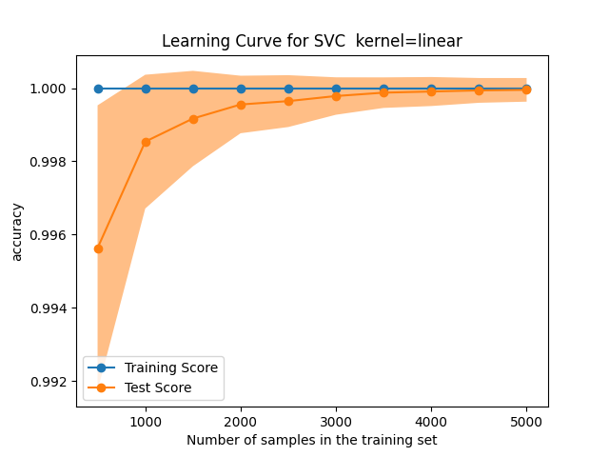

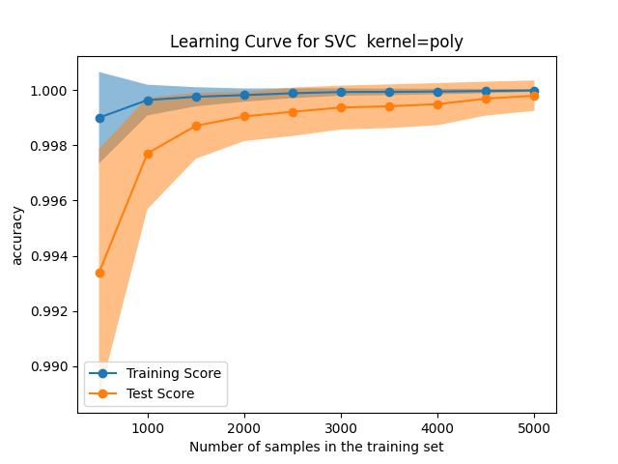
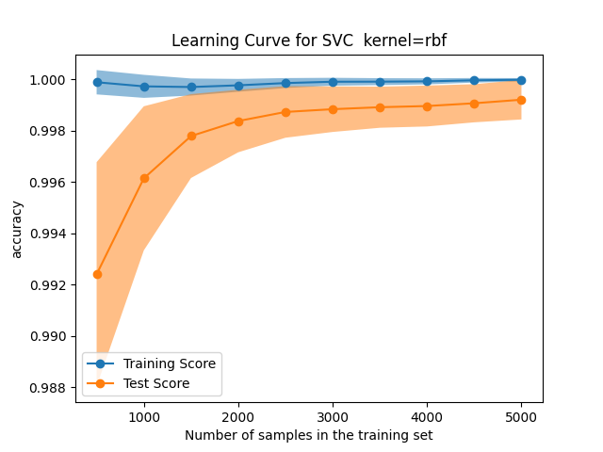

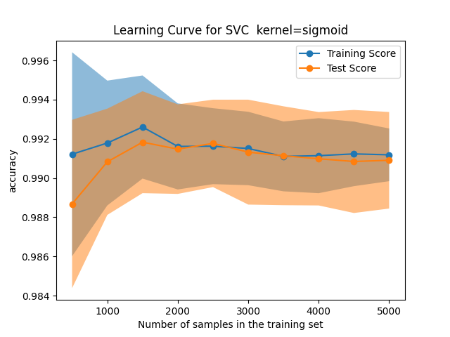

To speed up the algorithm, tolerance was increased from default of 0.001 to 0.1. However, all the kernels showed the same performance as the default tolerance. Similarly, using balanced_weight option or not did not change the curves. This was expected as the dataset not fully but close to balanced .

Dataset 2
DT:
step 1)

KNN: Starting with default values of the KNN classifier and weights=’distance’, the learning curve for both training and testing are very flat and do not change with k. Train set has perfect score while test set doesn’t and there is a big gap between them. This indicates overfitting.
This can be seen in the validation table as well as the learning curve for weights=distance too:
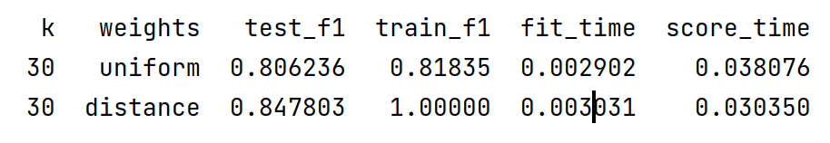

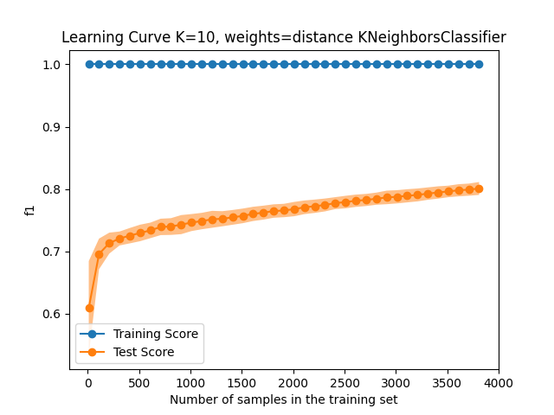

When the weights is changed to uniform, the validation curve shows convergence near k=30. So weights=uniform and k=30 were selected.

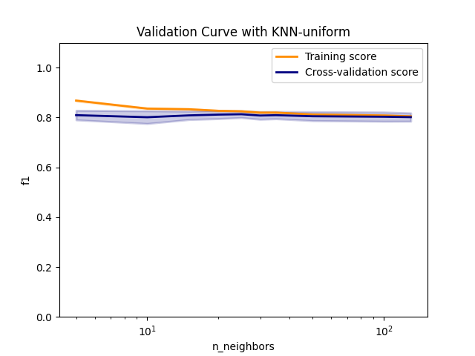
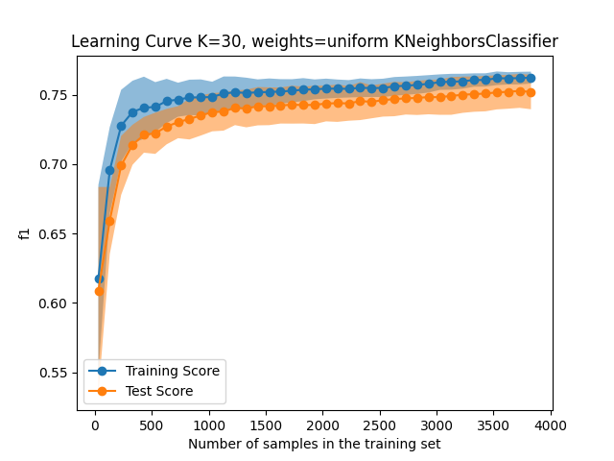
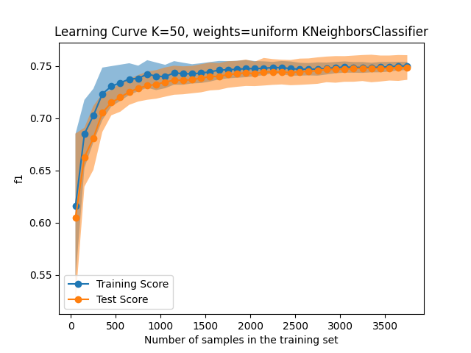
When looking at learning curve for k=30, both train and test curves score around 0.75, which is not a very high score. There is a small gap between the two, which indicates there is slight overfitting issue. K was increased to 50 to help remove the gap between the two lines:

Since the train and test curve converge at a lower score, the model has high bias and low variance issue, underfitting the training data. One solution to improve the model is to increase the features, which is not feasible here. The other solution is to use more complex algorithms.

Validation table for four metrics ['manhattan', 'cosine', 'minkowski', 'euclidean'].ndicate similar performance. Since euclidean has lower fit/score time, this distance metric was selected.
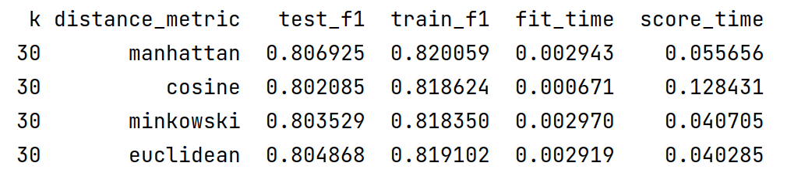

SVM:

using default parameter values, a validation curve was generated using the gammas in the range of [0.0001, 10] . The f1-score sees slight improvement up to gamma=5. This value is used moving forward. Lower value gammas were found to show low performing learning curves.
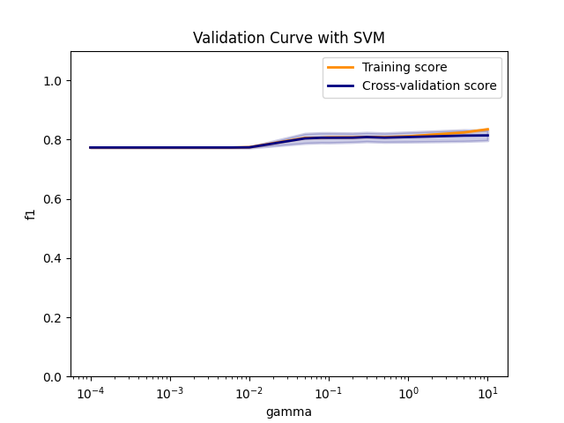

Learning curves for four kernels [ 'linear', 'poly', 'rbf','sigmoid'] were generated. Linear kernel is not fitting the model well and in some areas test score is higher than training. This indicates that the data is not linear. Poly and rbf kernels seem to learn the model better. Train and test curves converge around f1=0.76. There is a small gap between the two curves. This gap could likely be narrowed by using more training data. The score of 0.76 is not high, which indicates high bias and low variance, underfitting. The issue may possibly be resolved by adding more features or using more complex models.
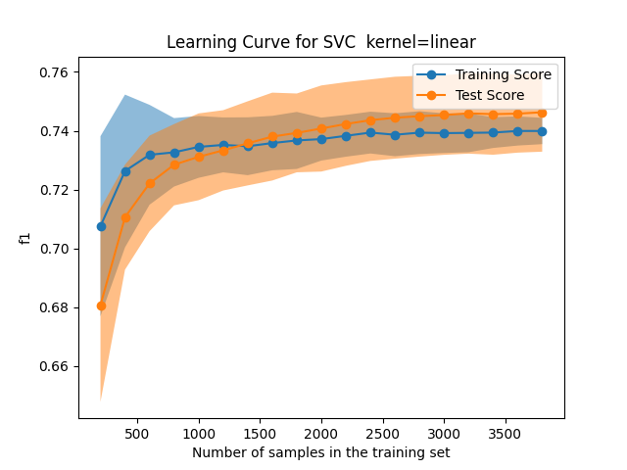

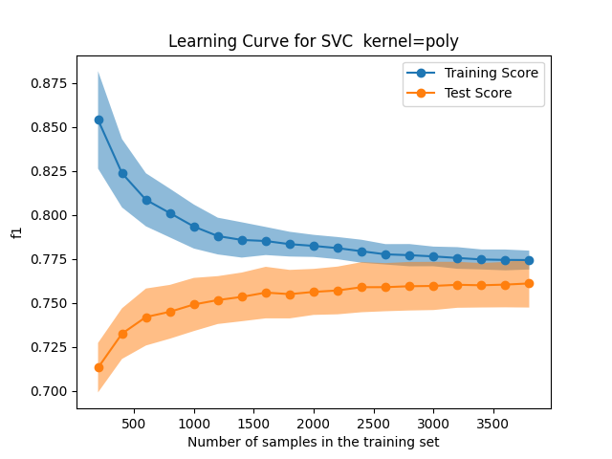

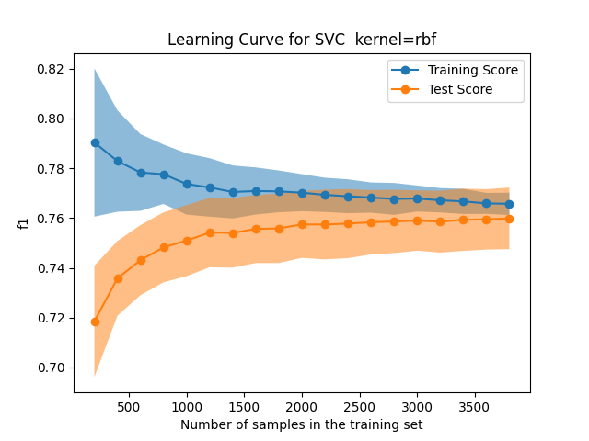

Between the two poly and rbf kernels, poly has a lower score time while rbf has a better train time. Since a model is trained once and can be scored multiple times, poly kernel was selected.
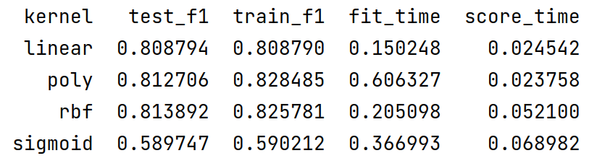

Class_weight was another parameter considered to be None or balanced. The model performance was the same for both.

